

**BULE HORA UNIVERSITY**

**COLLEGE OF INFORMATICS**

**DEPARTMENT OF SOFTWARE ENGINEERING**

COURSE TITTLE: -SOFTWARE ENGINEERING TOOLS AND PRACTICES

COURSE CODE: Seng5331

**TITTLE: BULE HORA UNIVERSITY CAFETERRIA MANAGEMENT SYSTEM**

**GROUP ASSIGNMENT**

**NAME ID.NO**

1. **KOMARSAN BERHANU --------------------------------------RU3491/14-0**
2. **DAWIT OBSA--------------------------------------------------- -RU3327/14-0**
3. **ABENEZER ZEWUDU ----------------------------------------RU1629/14-0**
4. **BARO NAME-----------------------------------------------------RU3606/14-0**

SUBMITTED TO:MOHAMMED.B

SUBMITTED DATE:19/4/2024

BULE HORA ETHIOPIA.

**TABLE CONTENT**

**CONTENT PAGE**

**CHAPTER ONE**  ----------------------------------------------------------------------- 1

**1 INTRODUCTION** ----------------------------------------------------------------- 1

**1.1** Description of the existing system -------------------------------------------- 1

**1.2** Objective of project-------------------------------------------------------------- 2

1.3 Methodology and tools of the project ---------------------------------------- 2

1.4 Scopes of our project and limitation ------------------------------------------ 2

1.5 Benefits of the project ---------------------------------------------------------- 3

**CHAPTER TWO** ------------------------------------------------------------------------- 3

**2 REQUIREMENT ANALYSIS**--------------------------------------------------------- 3

2.1 Functional requirements analysis --------------------------------------------- 4

2.2 Non-functional requirement analysis ----------------------------------------- 4

2.3 Resource requirement analysis ------------------------------------------------ 4

2.4 overview of current system ---------------------------------------------------- 5

**CHAPTER THREE** ------------------------------------------------------------------------ 5

**3 REQUIREMENT SPECIFICATION** -------------------------------------------------- 5

**3.1** Automated Meal Card Ticking System Overview -------------------------- 5

3.2 Student Information Registration --------------------------------------------- 6

3.3 User Interface and Interaction ------------------------------------------------- 6

3.4 Security and Access Control --------------------------------------------------- 7

3.5 Testing and Validation ---------------------------------------------------------- 7

**CHAPTER FOUR** -------------------------------------------------------------------------- 7

**4 IMPLEMENTATION, TESTING AND VALIDATION** -------------------------- 7

**4.1** Implementation ---------------------------------------------------------------- 7

4.2 Testing and Validation --------------------------------------------------------- 10

**4.2.1** Unit Testing -------------------------------------------------------------------- 10

**4.2.2** Usability Validation ---------------------------------------------------------- 13

4.3 Use case diagram**,** Class diagram **&** Sequence diagram ----------------- 14

5 Report Of Our Project ------------------------------------------------------------ 16

CHAPTER

**1.** Introduction

Bule Hora university is Located 470 km south of Addis Ababa, Bule Hora University is one of the Ethiopian government's higher education establishments. Founded as a third-generation university by the federal government of Ethiopia in 2003 E.C.   
The main campus is situated in Bule Hora Town in the western Guji Zone of Oromia Regional State.   
One of the organizational systems that supplies meals for university students is the cafeteria management system. It falls under the university's college. Through observation, document analysis, and interviews, we gather data about the system. The administrative, staff, and employee components make up the three core parts of this system. There are two senior managers in addition to the staff and employees. Another issue with the student ordering system is that it's really challenging and time-consuming way. We talked about a solution with the workers and administration. Our goal is to provide Bule Hora University with a computerized dining system.

**1.1 Description of the existing system**

The existing system of BHU student cafe management system perform different task. The most popular task performed in the system.

* Thicker for student meal card
* Generating report
* And different kind of meal card are prepared
* Cost sharing

**Player in existing system:**

Players are a participant in the system, or a person who get benefit from the system, by acting different tasks in the system. The main players of cafe management system are:

* Student
* Manager
* Ticker
* Student service

**Major function of existing system**

* Major function of existing system Major function of bule hora campus student cafe management system is preparing meal card every year.
* Ticking meal card of students every time when students want to eat food.
* Preparing cost sharing fill form every semester and storing it as the document.

**Statement of problem**

This is used to identify and understand the problem of existing system or current system.

Some activity such as ticking meal card and controlling the sequence of students and prevent student from two time eating id done manually.

The manual system has the following problems.

**Time consuming:** since it is a manual system each activities are done by human power each activity consumes time.

for example when employee or tickers wants to tick meal card of one student it needs to check all boxes to search the current boxes that he wants to thick, while all this activities are need times it consume the time and take more time than the automated system.

**The security problem:** while all students should have to wait until the meal card of student in front of him is ticked by the ticker the student in the behind may disturb when he competes with the student in front of him toward the ticker therefore the security of cafe may be disrupted with this.

**Ticking meal card is not easy:** for ticking the meal card the thicker must have to check all boxes of meal card to search the current box ticker identify the box by using date that he wants to thick on it therefore ticking meal card is not an easy task.

**Updating the manual meal card is not an easy task:** In every year the manual meal card is expired and it needs to take anew meal card every year if it is a manual updating is not a difficult matter while it is renewed or updated by the machine thicker easily. While the manual meal card is need a new photo every year there can be extravagance of photo every year, if its automated while your name and your photo are encoded one time it is not need always a new photo.

**1.2 Objective of project**

Our goal is to replace the manual meal card ticking system with an automated ticking machine.

Main function of our project is ticking meal card by the machine and generate report every year automatically. Also our new machine is going to register all information about all student that get service from cafe.

Like: registering all days every time when student uses a machine to tick a meal card.

**Specific objective:**

* Saving time
* Ticking meal card manually
* Generating report every time automatically
* Saving human resource by using machine
* Registering the day of tick
* Saving money paid for updating meal card

**1.3 Methodology and tools of the project**

Methodology is the process of Domain analysis, Defining the problem, Requirements gathering,Requirements analysis and Requirements specification.

**1.4 scopes of our project and limitation**

**Scope of our project**

The scope of our project to make a system, a system that record the time and attendance of the users(student) and ticking the meal card of student automatically.

**Limitation of our project**

Limitation of this project is the area which project cannot focus as its scope.

* Calculation of cost sharing of food
* Specifying the food time
* Scheduling
* Food preparation

**1.5 Benefits of the project**

Benefit of this project is reducing the time consumed over all the performance process cafe management system of Bule Hora University main campus and keeping quality among other facilities.

**A. Tangible Benefits**:

An automated ticketing system reduces the need for manual labour in managing meal cards.

Automated machines can process meal card transactions swiftly and accurately.

Faster processing times mean shorter queues and improved service for students.

The automated system generates reports automatically, providing valuable insights.

As your student population grows, an automated system can handle increased meal card transactions seamlessly.

Scalability ensures that the system remains efficient even during peak hours or busy academic seasons.

**B. Intangible Benefits**:

Quicker meal card processing means less waiting time for students.

Students appreciate efficient services, leading to higher satisfaction levels.

The automated system registers all student information accurately.

Tracking who uses the cafe services becomes easier, enhancing accountability.

Staff members can focus on other essential tasks instead of manual ticketing.

Employees can allocate their time to more meaningful interactions with students.

**CHAPTER TWO**

**2. REQUIREMENT ANALYSIS**

Requirement analysis is general property related with activity and tasks of the proposed system.

Requirement is a condition or capability proposed by a software or system component in order to solve a real-world problem.

so, as we recognized in our project requirement that existed in our project is look like these

* To reduce problem of existing system
* To increase effective time management
* To increase resource management
* Increasing performance of the work by machine
* Increasing efficiency ways of ticking student meal card
* Generally, to put the whole system under a single machine that reduce human effort, time and resource management.

**2.1 Functional requirements analysis**

Functional requirement is behaviour of the system that support user goals, task or activities It is the function s or service of the system These functional requirement capture the intended behaviour of the system this behaviour may be expressed as service, tasks or function the system is required to perform these are listed below:

* The expected machine or software aimed to search and accept student meal card and display report to server
* The main point expected from our machine or software is the capability to tick and check student meal card
* The system reflects the result of ticking student meal card by showing different colour or sound
* As to be the software can minimize ticker role in the ways ticker can simply control system
* The system record information of the meal card and generate report to server to whether the user use twice or not.

**2.2 Non-functional requirement analysis**

Non-functional requirement deals with behavioral property that the system must have Non-functional requirement is constraint and quality of the system It is how well the system provides service for the user these include: -

* Performance
* Speed
* Reliability
* Maintainability
* Cost
* Security

**2.3 Resource requirement analysis**

There are two types of resource requirement analysis those are: -

* Software
* Hardware

**Hardware requirement analysis**

* Card Reader
* Display Screen
* Processing Unit
* Connectivity
* Power Supply
* Enclosure
* Monitor
* Keyboard
* Processor
* Mouse

**Software requirement analysis**

* Card Reading Algorithm
* User Interface (UI)
* Transaction Logic
* Error Handling
* Communication Protocol
* Security Measures
* Database Management System (DBMS)
* Backend/API
* Authentication and Authorization
* Reporting Module
* Data Validation and Sanitization
* Logging and Auditing
* Backup and Recovery Mechanism

**2.4 overview of current system**

Current system is an existing system that are working manually, all activity performing in the system like ticking meal card, generating report, recording information, diagnosis information and many other works are being working manually. Practical activity in existing system Many practical works in existing system that are in manual working are

* Ticking meal card: it is the ticker activity of existing cafe management system, it is every meal card have to be ticked by ticker manually for each student.
* Generating report: an activity of generating report in cafe management system in server office, it has to be recorded by worker of service office manually

**Overview of proposed system**

A proposed system instead of existing system is changing manual ticking system to automated machine.

**Practical works in proposed system**: a proposed system is going to works with automated way that is every meal card has to be ticked by machine that has automated to tick meal card Which is every student have come to machine and insert their electronic meal card into automated machine that prepared for ticking meal card, as soon as student insert meal card to machine the machine have to tick, record or read bar code in the electronic meal card automatically.

Then the machine has to alert when it finished its works to get out meal card from the machine. **Recording information**: this proposed machine has to have storage that store the student meal card calculation like date, time name and ID number.

After that the manager and other workers that need information from machine in simple way, they can get full information from storage of proposed system. That machine has to have an alert sound when some student tries to repeal insert electronic meal card into machine that call police.

**CHAPTER THREE**

**3. REQUIREMENT SPECIFICATION**

**3.1 Automated Meal Card Ticking System Overview**:

The system aims to replace the existing manual meal card process with an automated solution.

* The primary function is to tick meal cards using the machine and generate an annual report automatically.
* Additionally, the system will maintain a comprehensive record of all students who receive services from the cafe.

**Meal Card Ticking**:

The system should have a mechanism to read and validate student meal cards.

When a student swipes their card, the system should mark their attendance for the meal.

If the card is invalid or expired, the system should notify the user.

**Automated Reporting**:

At the end of each year, the system should generate a comprehensive report summarizing meal card usage.

The report should include details such as the number of meals consumed by each student, trends, and any anomalies.

Export the report in a suitable format (e.g., PDF, Excel).

**3.2 Student Information Registration**:

* Upon card swiping, the system should capture relevant student information:
* Name
* Student ID
* Date and time of the meal
* Type of meal (breakfast, lunch, dinner)
* Store this information securely for future reference.

**3.3 User Interface and Interaction**:

* The system should have an intuitive interface for users (students, café staff, and administrators).
* Students should easily swipe their cards at designated terminals.
* Cafe staff should have access to a dashboard for monitoring meal card activity.
* Administrators can view reports and manage system settings.

**3.4 Security and Access Control**:

* Implement user roles and permissions:
* Students: Card swiping only
* Cafe staff: Access to meal card data
* Administrators: Access to reports and system configuration
* Protect sensitive student data and ensure compliance with privacy regulations.

**Integration with Existing Systems**:

If applicable, integrate the meal card system with other campus systems (e.g., student databases, financial systems).

**3.5 Testing and Validation**:

Rigorously test the system:

* Card swiping accuracy
* Report generation
* Data storage and retrieval
* Validate against real-world scenarios and edge cases.

**Maintenance and Support**:

Regularly update the system to address any issues or enhancements.

Provide user support and training for café staff and administrators.

**Chapter four:**

**4 Implementation, Testing and validation**

**4.1 Implementation**

**System Architecture and Components**:

Design the overall system architecture, considering hardware and software components.

Key components include:

* **Card Reader**: The hardware device that reads student meal cards.
* **Database**: To store student information, meal transactions, and reports.
* **Reporting Module**: Responsible for generating annual reports.

**Card Swiping Mechanism**:

* Develop or acquire a reliable card reader that can scan and validate student meal cards.
* Implement logic to handle different card types.
* Ensure secure communication between the card reader and the system.

**Student Information Database**:

Create a database schema to store student details:

* Student ID
* Name
* Contact information
* Meal plan details (if applicable)
* Implement CRUD (Create, Read, Update, Delete) operations for student records.

**Meal Card Ticking Logic**:

When a student swipes their card, the system should:

* Verify the card’s validity (expiration date, authenticity).
* Associate the card with the student.
* Record the meal transaction (date, time, type of meal).
* Deduct the appropriate meal count from the student’s balance (if applicable).

**Automated Reporting**:

Develop a reporting module that:

* Aggregates meal data over the year.
* Generates an annual report summarizing:
* Total meals served
* Most popular meal times
* Trends (e.g., seasonal variations)
* Anomalies (e.g., excessive meals by a student)
* Export the report in a suitable format (PDF, Excel).

1. **User Interfaces**:

* Create user interfaces for different stakeholders:

**Students**:

* Swipe their cards at designated terminals.
* Receive notifications.

**Cafe Staff**:

* Monitor meal transactions.
* Handle exceptions (e.g., lost cards).

**Administrators**:

* Access reports.
* Manage system settings (e.g., meal plans, card validity).

1. **Security and Access Control**:

Implement role-based access control:

* Students: Card swiping only.
* Cafe staff: Access to meal data.

Administrators: Full access.

Encrypt sensitive data (e.g., student IDs, card numbers).

1. **Integration and Testing**:

Integrate the system with existing campus infrastructure (if any).

Rigorously test:

* Card swiping accuracy.
* Data storage and retrieval.
* Report generation.

1. **Deployment and Training**:

* Deploy the system in cafe locations.
* Train cafe staff and administrators on system usage.
* Monitor system performance and address any issues.

1. **Maintenance and Scalability**:

* Regularly maintain and update the system.
* Plan for scalability as the student population grows.

**4.2 Testing and Validation**

**4.2.1 Unit Testing**:

Test individual components in isolation:

**Card Reader**:

* Verify that the card reader accurately detects and reads meal cards.
* Test with valid and invalid cards.
* Check for edge cases (e.g., damaged cards, partially swiped cards).

**Database Operations**:

* Test CRUD operations (Create, Read, Update, Delete) on student records.
* Confirm that student information is stored correctly.

**Reporting Module**:

Validate report generation:

* Ensure accurate aggregation of meal data.
* Check formatting and data consistency.
* Use testing frameworks (e.g., JUnit, pytest) for automated unit tests.

1. **Integration Testing**:

Test interactions between system components:

**Card Swiping and Database Integration**:

Simulate card swipes and verify that data is correctly stored in the database.

**Database and Reporting Integration**:

Generate sample meal data and validate report output.

**User Interfaces**:

Test user interactions (swiping cards, accessing reports) through the interfaces.

**Security and Access Control**:

Ensure that access permissions are enforced correctly.

Test scenarios where unauthorized access is denied.

Address any issues arising from component interactions.

**1: Card Swiping and Meal Ticking**:

Swipe a valid meal card.

Verify that the system records the transaction.

Check the student’s meal count.

**2: Invalid Card**:

Swipe an expired or invalid card.

Confirm that the system rejects the swipe.

Display appropriate error messages.

**3: Reporting**:

Generate an annual report.

Validate the report’s content and format.

**4: Student Information Registration**:

Register a new student.

Verify that their details are stored correctly.

Cover positive and negative test cases.

**Performance Testing**:

Assess system performance under load:

**Card Swiping Speed**:

* Simulate multiple card swipes simultaneously.
* Measure response time.

**Database Queries**:

* Execute complex queries (e.g., retrieving meal history for all students).
* Monitor query execution time.

**Report Generation**:

Generate large reports (e.g., for all students).

Evaluate processing time.

Optimize any bottlenecks identified.

**Security Testing**:

Verify security measures:

**Data Encryption**:

Ensure sensitive data (e.g., student IDs) is encrypted.

**Access Control**:

Attempt unauthorized access (e.g., as a student trying to access reports).

Confirm that access is restricted.

**Injection Attacks**:

Test for SQL injection vulnerabilities.

Validate input sanitization.

**Usability Testing**:

Involve real users (students, cafe staff, administrators):

Observe their interactions with the system.

Gather feedback on usability, intuitiveness, and any pain points.

Make necessary adjustments based on user input.

**Regression Testing**:

After any system updates or bug fixes, retest existing functionality.

Ensure that new changes do not break existing features.

**Documentation and Training**:

Document the testing process, including test cases and results.

Train cafe staff and administrators on using the system effectively.

**4.2.2 Usability Validation**:

Involve real users (students, cafe staff, administrators):

* Observe their interactions with the system.
* Gather feedback on usability, intuitiveness, and any issues.
* Make necessary adjustments based on user input.

**Security and Privacy Validation**:

**Data Protection**:

* Ensure that sensitive student information (IDs, names) is securely stored.
* Validate encryption mechanisms.

**Access Control**:

* Test user roles (students, staff, administrators):
* Verify that access permissions are enforced correctly.
* Attempt unauthorized access to confirm restrictions.

**Privacy Compliance**:

* Ensure compliance with privacy regulations (e.g., GDPR).
* Protect student privacy by avoiding unnecessary data exposure.

1. **Performance Validation**:

**Card Swiping Speed**:

* Measure the time taken for card swipes.
* Ensure it meets acceptable response times.

**Database Queries**:

* Execute complex queries (e.g., retrieving meal history for all students).
* Monitor query performance.

**Report Generation**:

* Generate large reports (e.g., for all students).
* Evaluate processing time.

1. **Scenario Testing**:

Validate the system against common scenarios:

**1: New Student Registration**:

* Register a new student.
* Confirm accurate data storage.

**2: Card Swiping and Ticking**:

* Swipe valid and invalid cards.
* Verify correct meal counting.

**3: Annual Report Generation**:

* Generate an annual report.
* Check data accuracy and formatting.

**Documentation and Training Validation**:

Review system documentation:

* User manuals
* Troubleshooting guides

Conduct training sessions for cafe staff and administrators:

* Assess their understanding of system usage.

**Deployment Validation**:

* Deploy the system in a real cafe setting.
* Monitor its performance during actual usage.
* Address any issues promptly.

**4.3 Use case diagram, Class diagram & Sequence diagram**

**Use case diagram**

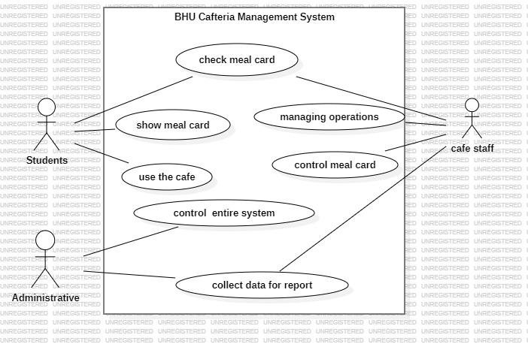

**Actors of use case diagram**

* Students
* Cafe staff
* Administrator

**Class diagram**

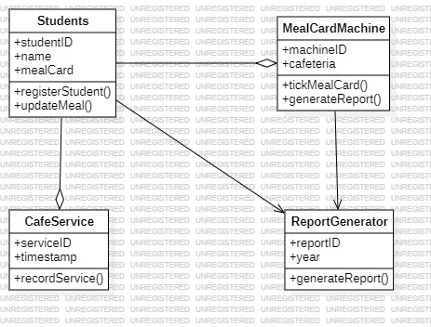

1. **Classes**:

* **Student**: Represents a student who uses the meal card.
* **Ticking Machine**: Represents the automated machine responsible for ticking meal cards.
* **Cafe Service**: Represents the services provided by the cafe (e.g., breakfast, lunch, dinner).
* **Report Generator**: it collects data of student who use the cafe.

**Sequence diagram**

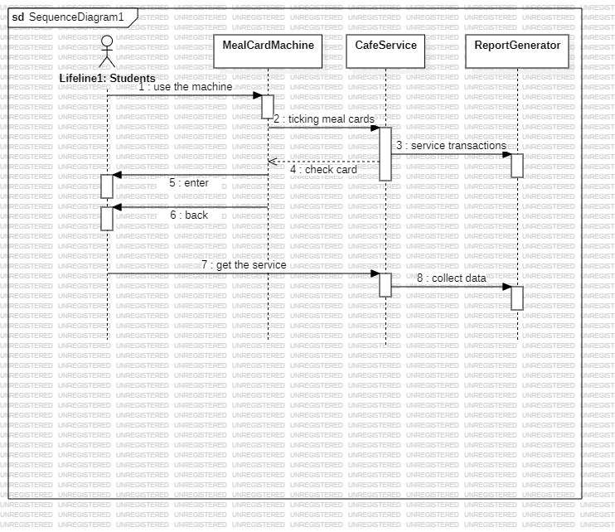

**CHAPTER FIVE: REPORTS FOR OUR PROJECT**

**Report on Bule Hora University Cafeteria Management System**

The cafeteria management system at Bule Hora University is crucial for providing meals to students. However, the current student ordering system is complex and time-consuming. To address this issue, we aim to introduce a computerized dining system.

**Description of Existing System:**

The existing system involves meal card issuance, report generation, and meal card preparation. It includes students, managers, tickers, and service personnel. Key functions include annual meal card preparation, validation, and cost-sharing documentation.

**Problem Statement:**

Manual processes in the existing system lead to time consumption, security concerns, and difficulty in meal card ticking and updating.

**Project Objective:**

Our goal is to transition to an automated system for meal card ticking. This includes automated ticking, report generation, and student information registration.

**Methodology:**

The project will follow a structured approach involving domain analysis, problem definition, requirements gathering, analysis, and specification.

**Scope and Limitations:**

The project will focus on recording user attendance and automatically ticking meal cards. Limitations include handling cost-sharing calculations and food scheduling.

**Benefits:**

The project offers tangible benefits such as reduced manual labor, faster processing, shorter queues, scalability, and improved efficiency. Intangible benefits include enhanced student satisfaction and increased staff productivity.

**Requirement Analysis:**

Functional requirements include acceptance and reporting, meal card verification, feedback mechanism, user control, and recordkeeping. Non-functional requirements cover performance, speed, reliability, maintainability, cost, and security.

**Resource Requirements:**

Hardware requirements include computers, printers, and scanners. Software requirements comprise a database management system, application software for meal card processing, and reporting tools.

**Conclusion:**

The Bule Hora University Cafeteria Management System project aims to improve efficiency and service quality by automating meal card ticking. This report outlines the objectives, challenges, and benefits associated with the project.