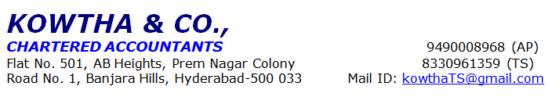
LIQUID INCOME PROGRAM REPORT

Name of the applicant: Mr. XXXX
Name of the co-applicant: Mrs. XXX
Business name: M/S. XXXX
Constitution: <<Proprietorship>>:
Visited Address: XXXXX

Loan Requested: Rs. 60, 00,000/-

Purpose of loan: Flat purchase.
Date of Visit: 13-03-2025
Person Met: Mr. XXX
About the applicant and its businesss:
- MR. XXX is applicant aged 34 years, under graduate and native is Addanki.
- Applicant started business under the name of M/s. XXXXX since 2022.
- It is a sole proprietorship business concern, applicant is proprietor of the business and applicant manages all the business activities.
- Nature of the business is saloon services, having overall 5 years of experience in same field.
- Business provides services like hair cutting, facials, waxing, pedicure and manicure etc.
- He also provides special works in the bridal makeup for marriages and other functions.
- He charges around Rs. 300/- to Rs. 3,000/- per person based on service provided.
- He also does outdoor services and charges around Rs. 15k to 25k based on service.
- He does around 5-6 functions per month.
- Customers are general public who are living around the same location.
- He purchases stock at local market at Hyderabad and online mode.
- He is running business from rented premise and he pays rent amount of Rs. 60,000/- per month.
- During the PD, observed that there are 5 chairs, 3 pedicure and manicure chairs and 4 facials beds observed in the premises
- There are four workers working in this parlour under her and she pays salary amount of Rs. 50,000/- per month.
- All business transactions will be done in cash.
- Neighbor check done we got positive feedback about the applicant.
- Hence Status of the case is Negative.

Applicant’s family details:
Co Applicant Name: XXX - Age - 30 years Relation – Wife.
Assets:
NA
Customers – Reference numbers-
Other Incomes: Nil
Existing Loan details: Nil
Bank name | Type of Loan | Loan amount  (In Rs.) | EMI/Interest  (In Rs.) | Total Tenure  /completed  [in months]
SBI | PL | Rs. 11 Lakhs | Rs. 34,750/- | Open

Banking Details:
Bank name | A/c No | A/c Type
AXIS Bank |  | CA

ITR, Receipts, Verification, GP Margin & Expenses details:
- NA
Comfort Factor: -
- Business name board seen.
- Verified Rental agreement, trade license, Bank statements, kacha records.
- He has 05 years of experience in this field.

Discomfort Factor: -
- Not provided IT, Bank Statement and Bills.
- During the observation, UPI scanner was in the name of A Reddy. However, KYC has been verified applicant name is Mr. Ayyappa Swamy
Recommendations: Status of PD is Negative (Phone-Pe linked bank account was showing other name of Mr. A Reddy and firm name is Heaven Family beauty.)
Disclaimer if any: We estimated financials, purely based on the valid documents provided by the applicant.

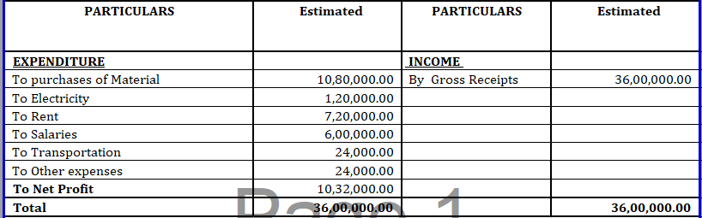

- Total Gross disposable Income (A) Rs. 3, 00, 000/-per month
- Total Obligations (B) Rs. 2, 14,000/- per month.
- Net Disposable Income (C = A – B) Rs. 86,000/- per month
Gross disposable income is sum of Net profit & interest depreciations
- Business premises photo with customer& Vendor’s Self to be attached in this report.

Business Photos:

