KOWTHA & CO., CHARTERED ACCOUNTANTS 9490008968
Flat No. 501, AB Heights, Prem Nagar Colony
Road No. 1, Banjara Hills, Hyderabad-500 033 Mail ID: kowthaTS@gmail.com

DCB BANK LTD
PD & VERIFICATION REPORT

Date Of Visit | : | 12-02-2025
Person(S) Met | : | Mr. XXXX

Name | : | Mrs. XXXX
Designation | : | Proprietor
Years Of Service | : | 10 Years

Borrower’s Name and Address | : | MrsXXXXX  Residence address: XXXX  Business Address: - XXXX
Other site(s) of the Borrower / site(s) | : | -
Constitution of Borrower | : | Proprietor
Details of Directors & Proprietor | : | Mrs. XXXX (Proprietor)  of M/S. XXXX, her education qualification is below 10th class and native of Warangal.
Name | Age (in Yrs) |  | Qualifications | Responsibilities | Share holding Pattern (in %)
Mrs. XXXXX | 40 |  | Below 10th class | [Proprietor] | -

- History
Year of Establishment | : | 2014
Any change in Ownership | : | No
Registration / Affiliations | : | Yes
Any awards won | : | -
Any change in registered office | : | -
Legal proceedings | : | -
Disputes | : | -

- Business Activities
Business Profile | : | Nature of the business is jewellery works
Products | : | Gold & Silver Works

3) Business Set-up
Office set-up with overall look |  | : | - Applicant is not available during pd. So, pd done with Co-Applicant.  - Applicant started the business with the name M/S. XXXX in the year 2014.  - It is sole proprietorship business and applicant is the sole proprietor of business and Applicant’s spouse manages all business activities.  - Nature of the business is making and selling of gold & silver ornaments.  - He provides Goldsmith services.  - He makes all types of gold and silver ornaments.  - He makes Gold and silver ornaments like chains, Rings, ear rings, Bracelets, pendants etc.,  - He also makes silver ornaments like anklets, Silver Lockets, Silver rings etc.,  - He charges 4%-5% as wastage on 10 grams of gold and 10%-15% on 100 grams of silver while making ornaments  - This wastage is his income.  - Besides that, he also provides small repairing services which he charges as per work.  - Customers will give old gold or he purchases gold in market which is required for making ornaments.  - It is a Seasonal business and business will be high in marriage and festival seasons like Diwali, Dussehra, Dhanteras, Varalakhsmi Pooja festival etc.,  - On an average he makes around 100 kgs to 150 kgs of silver.  - Major customers are general public and jewellery shops.  EXPENSES:  - He is running the business in owned premises.  - 20 employees are working under this business and he pays Rs. 3,00,000/- per month.  Transactions:  - Major business transactions are done through cash/bank in his business
Plant and Machinery |  | : | 30,00,000/-
Office Equipment |  | : | -
Workers and Salaries |  | : | 20 employees are working under him and paying the salaries amount of Rs. 3,00,000/- per month
No. of Employees | Type |  |  | Average pay
20 members | Employees |  |  | Rs. 3,00,000/- per month

Details of ALL Loans as on
Bank | Type of Loan | o/s Amount/ | EMI
Federal Bank | OD | 65,00,000/-
Federal Bank | - | 60,00,000/- | 54,000/-
Karnataka | - | 40,00,000/ | 34,000/-
SBI | HL | 33,00,000/- | 33,000/-
Lending Kart | BL | 15,00,000/- | 52,000/-
HDB | BL | 3,00,000/- | 15,000/-
Kinara Capital | BL | 30,00,000/- | 96,530/-
Groth Socre | BL | 1,00,00,000/- | 1,58,287/-
Piramal | HL | 36,00,000/- | 42,000/-
HDFC | VL | 15,00,000/- | 22,267/-

Personal Assets of Proprietor
S.No. | Assets | Value
1. | 303 sq. yards of house at Warangal | 3.5 Cr
2. | 186 sq yards of house | 2 Cr
3. | 160 sq yards of house | 1 Cr
4. | 100 sq yards of house | 1.5 Cr
5. | 100 sq yards of house | 1.5 Cr
6 | 246 sq yards of open land | 1 Cr

- Details of Customers / Clients: Not Applicable- Walk in Customers.
S. No | Name of Customers | Location | Contact No
1. | XXX | XXX | XXX
2.

- Details of Suppliers:
S. No | Name of Suppliers | Location | Contact No
1. | -

- Sister Companies :
Name of firm | Business Profile | Turnover | Net Profit
- | - | - | -

- Insurance Details
Insurance Company Name: -
Due they are taking the exemptions by taking the Children Education Fee:
Assets Covered | Cover Note No. / Policy No | Valid up to | Sum Assured | Assured Covered
- | - | - | - | -

- Performance after last audited financials
Last available financial statement period | : | A.Y. 2024-25, F.Y.2023-24
Recent summary financials ( up to a period not more than two months old) | :
Advance taxes paid (for current A.Y.) | :
Change in Borrowings (from F.Y. 20-21 to F.Y. 21-22 ) | :
Change in Capital (from F.Y. 22-23 to F.Y. 23-24 ) | :
Change in Turnover from F.Y. 22-23 to F.Y. 23-24 ) | : | -
Last 6 months turnover as per GST returns | : | -
Net profit % on sales | :
Debtors Positions as on | :
Creditors Position As on | :

- Other Business Interests of the Proprietors: NIL

- Banking details & Statutory obligations:
Bank Name:  Branch : |  | SBI  WARANGAL
Account Number | :
Account type | : | Current account
Banking since | : | 10 Years
Evidence of statutory dues being paid on time PF, PT and EIC (Employee related) | : | -
Municipal and Corporation taxes (BST, CST & MVAT) | : | -
Last utility payment made (Electricity) | : | -

- Activity levels at the time of CPA visit
Number of employees & workers  Observed | : | 20 Employees
Level of activity as well as overall observation of business (description of Production / Delivery / Customers) | : | His annual turnover is around Rs. 6,00,00,000/- and net margin is around 3.6%.
Photographs of Business activity, set up and stock level | : | Good

- Loan Purpose

Details of End-Use of Funds:
End-Use of Funds (incl Cash out use) | Business Expansion
Loan Required | Rs. 2,00,00,000/-
EMI Comfortable With | Rs.2,00,000/- per month

- Details of Property to be mortgaged:

Property Details (address) | : | 186 Sq. yards house at Warangal
Name of the property owner | : | Applicant
Usage of property | : | For residence purpose
Occupancy status | : | Property Occupied by applicant
Estimated Value as per customer |  | Rs.2 Cr

- Verification
- Details of Sales and Purchases during the Period from as follows: as per applicant’s oral information
Months | Purchases(Rs.) | Sales (Rs.)
-

- Documents Verified
- GST certificate
- ITR’s
- Bank Statement
- Visiting card

- Concluding impressions:

- We got 07 Years positive feedback from neighbor check
- Good feedback received during TPC.

Date: 12-02-2025

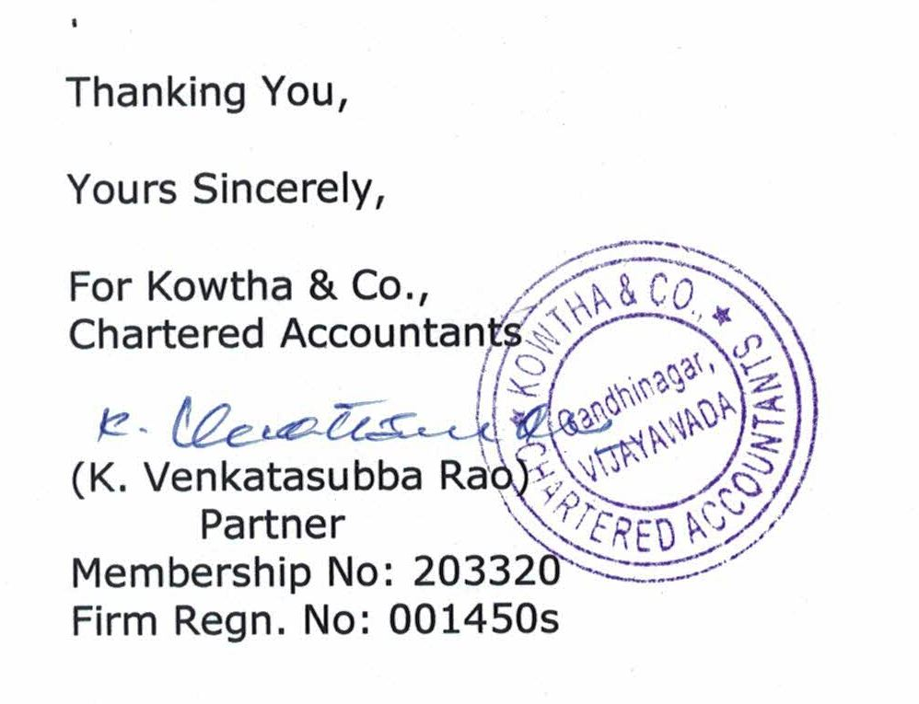

PHOTOS: -

