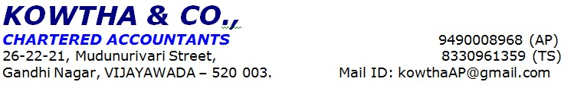
PD Sheet - Self Employed Applicant
Prospect No. | IL11069731 |  | NOTE: Please tick/circle as applicable
Basic Details
Name | Mrs.XXX
Marital Status | Single | Married | Divorced | Others
Educational Qualification | Below 10th | 10th Pass | 12th Pass | Diploma/ITI Certification | Graduate | PG/Professional Certification
Category | General | SC | ST | OBC | Others
Number of Dependents | Children | 02 | Adults | 02 | Others
Number of years in Current Residence | <=1 Year | 1-3 Years | 3-5 Years | >5 Years
Current residence house size | 1 RK | 1 BHK | 2 BHK | >2BHK
If <1= Year, then Previous Address | NA |  |  | Number of Years stayed at that Address | NA
Number of Years in Current City | <=3 Years | >3 Years
If <=3 Years in current city, then mention | Previous City | - | Number of Years In that City | -+
 | Reason for Change | -
Parents Staying with? | Self | Separate | Expired
Usage of Property after Purchase | Self-Occupancy | Investment | Others | Renting Purpose
Brief Comments/Observation of the case | Date Of case Initiated 07-05-2025  Date Of Appointment Provided 08-05-2025  Initiated Address XX  Visited Address XX  Residential Address XX  Contact Information XXX  Loan Amount Required Rs.7lakhs  Purpose Of the Loan House construction  Profile Initiated M/s XXX  Family Details  - Applicant XXX is aged 30 year an 10th class and native of Eluru.  - Her spouse XXX is aged 31 years has studied Degree and own auto driving .  - Her Son XXX aged 3years  - Her son XXX age of 5months  - Her mother in law XXX age of 46years  - Her father in law age of 55years  Applicant’s Profile  - Applicant Mrs. XXX has studied 10th class and her native of XXX.  - Applicant runs business in the name of M/s XXX  - It is a sole proprietorship business and applicnat is sole proprietor of the business  - Applicant has 8 years of Experience in this field.  - She has 2 own Sewing Machines for Business Purpose.  - She stitches ladies’ dresses.  - She stitches 30 to 50 langa’s per daily and she charges Rs.10/- to Rs.15/- per each langa.  - She also stitches Normal Blouse, Lining Blouse, Saree falls, and dresses works as per customer requirement.  - She charges around Rs. 50/- to Rs. 700/- for stitching, she charges the amount based on item and design.  - She Purchase stock from Needles, Threads, hooks, canvas and buttons from local market in Eluru.  - 1 workers are working in business and She pays on an average Rs.5,000/- per month  - Her customers are general public.  - Applicant is running the business in relative premises but she is not paying any rent to her relative.  - Neighbor enquiry is done and we got Positive response about the applicant.  Concerns  - He didn’t provide business vintage documents  - We observed temporary business name board  - During the visit there is no worker in business  - She did not provide kacha records.  - She did not provide UPI Payments.  - Address mismatch for initiated premises and visited premises  Other Observations:  - We observed good level of business activity and stock in visited address  - We observed 2 machine in business  Income Details: -  Income  Gross Receipts 25,000/-  Add Other Income (Related To The Business Only)  Total (A) 25,000/-  Less Expenses  Purchase 5,000/-  Salaries 5,000/-  Electricity 1,000/-  Other Expenses 1,000/-  Total (B) 12,000/-  Net Profit (A-B) 13,000/-  Net margin 52%  Other Incomes:  Applicant husband is auto driver and he earns Rs.25,000/- to Rs.30,000/- per month  REFERENCE DETAILS  XXXXX  STATUS OF THE CASE:-  - Negative (Address mismatch for initiated address and visited address)
Name of PD Officer | Mr. Naveen
Date of Discussion | 08-05-2025 | Signature of the PD Officer | Mr.Naveen

Disclaimer Clause:
This report (including any attachments) has been prepared based on verbal information provided by the person contacted. IIFL HOME FINANCE LTD will be solely responsible for any actions taken on this report and any liabilities directly or indirectly accruing from such actions. M/s. KOWTHA & CO will not be held liable in any case.

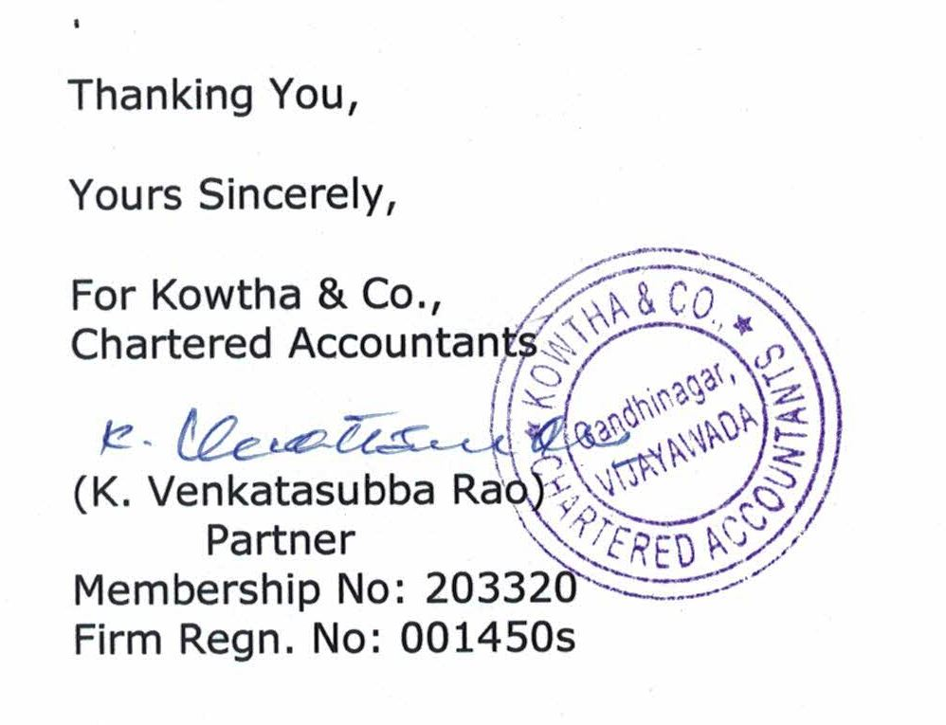

PHOTOS:

