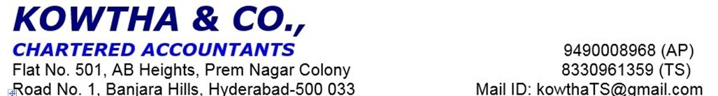

LOS ID: Dated: 07-05-2025

Client Name: XXX
Client Address: XXX

Sub: LIP Visit(s) Report

Sir,
Pleaserefertoyourinstructionsonthecaptionedmatter. In this connection, we submit our report as under:

Case Details
Reference Number( LOS ID)
Name of Applicant | XX
Co – Applicant | XX
Type of Borrower | XX

Meeting Details
Address Visited | XX

Person Met | XX
Contact No | XX
Date of Visit | 07-05-2025

Business owner Details
Name | Age | Qualification | Occupation | Relation | Remarks
 | 48 | Degree | Business | Applicant | -
 | 57 | Degree | Business | Co-Applicant | -
Family Details
About Applicant: Mrs. XXX, aged 48 years, she is a graduate and native of XX.
About Co-applicant: Mr. XXX, aged 57 years, he is a graduate and native of XX.
And their family details:
- Mr. XXXX – Son – 25 years – Degree – Partner
- Mr. XX – Son – 21 years – Degree – Student

Business Details(Separate for additional business)
Business Name | M/s. XXX
Type of Entity | Partnership Firm
GST Number | XXX
Legal Name | Mrs. XX (As verified from GST Registration)
Trade Name | M/s. XXX (As verified from GST Registration)
Last GST Return  (As per GST records) | NA
Establishment | 06 years
Shop Address | XX
Shop Ownership | Owned/ Rented.
Godown | NA
Godown Ownership | NA
Nature of Business | Trading of Toys and Kids ware
Product Details and ( please also comment on Vintage of the product deals by the firm & Future changes if any) | NA
Business Process | - Business name is M/s. XXX  - It is a Partnership Firm which was started in 2019.  - Partners are Mrs. XXXand XX sharing profit and losses are 60:40 ratios respectively.  - Applicant is a managing partner and she takes care of all the business activities.  - Nature of Business is Trading of Toys and kids ware.  - She sells all types of Gifts, Children Garments, Play School Items, Cradles, Baby Cycles and Electronics Vehicles etc.  - She purchases stock from Karimnagar, Vijayawada and Hyderabad.  - She sells these items in wholesale and retail rates.  - There are 05 employees are working under the applicant and she pays salaries amount of Rs. 75,000/- per month.  - Applicant is running her business at rented premises and she pays rent amount of Rs. 1,40,000/- per month.  - She has maintaining around Rs. 50,00,000/- in this Premise.  - Neighbour check done, we got positive feedback about the Applicant.  - The Status of the case is Positive.
Margins | As estimated, his monthly turnover is of Rs. 15,00,000/- approx. and he gets net profit margin of 9.00% approx. in this business.
Documents Observed | - Purchase Bills  - GST Registration Certificate  - Bank Statements
Activity Observed | - Fivecustomer’s walk-ins during the time PD conducted.  - Size of shop: - NA

Inputs/Purchases
Details of Inputs | -
Purchase Details | -
Order Cycle | -
Avg Order Qnty | -
Credit Terms | -
Other Remarks | -

Outputs/Supply
Market for Output | -
Mode of Marketing | -
Type of Customers | -
Credit Terms | -
Stock of Finished Goods | -

Employee Details
No. of Employees | 05 workersin this Business
Salary Details | -
PF/ESI Applied | -

Trade References - Suppliers
Name of Suppliers | Contact Details
-

Trade References - Customers
Name of Customer | Contact Details
XX | XX

Other sources of Income
Source of Income | Details
Rental Income | NA

Loans Details
Name of Bank / Institution | Product | Loan amount | EMI | POS | Remarks
 |  |  |  | - | -

Applicant's main Banking Details
Bank Name | Account Holder name | Account type |  | No of year | Limit of CC/OD | Remarks
Kotak Bank | Applicant | Current A/c |  | - | - | -

End Use
He wants Loan amount of Rs. 65,00,000/- for purpose of Business Development and take over.

Own contribution
Particulars | Remarks
Source of own contribution ( Loan proposed) | - -

Net Worth
Sr. No | Type of property / Other investments like gold , LIC , FC etc., | Owner name | Approx. Market value | Years of ownership

Particulars | Coordinates
Latitude | 18.433235
Longitude | 79.133648

Disclaimer:
The report contains information provided by the Applicant met. The information is provided verbally and could be verified only to a limited extent. RBL will be solely responsible for any actions taken on this report and any liabilities directly or indirectly accruing from such actions.

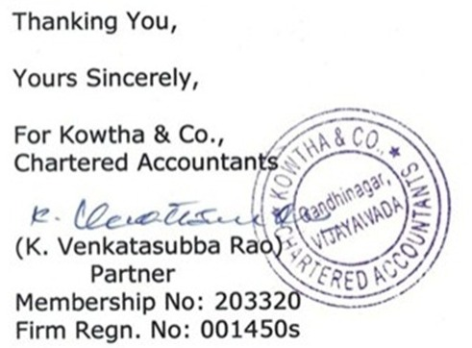

Photographs taken during visit

