📂Day-1 https://youtu.be/fI13-OYNmcw 📂Day-2 https://youtu.be/gStlVJp8T4Q

Webex link: https://nareshit.webex.com/nareshit/j.php?MTID=md6dca36ec6e0cc29f5f0e3215874717c

contact :

Dear students...please save this fee details & payment procedure Data science 8:30am Mr.Prakash senapati Without videos--21,000 With videos : 27,000 Acount details Name: Naresh I Technologies A/C No 50200022639833 Bank: HDFC A/C Type: Current Account IFSC Code: HDFC0001627 MICR Code: 500240035 Branch Code: 001627 Branch: Ameerpet Or Phonepe or Google Pay follow the below Razor pay payment link https://rzp.io/l/NareshITech for any queries contact Mr. Naga Babu--9063042468 Mr.Preem--7997997901

from nagababu to Everyone09:26

Dear student's... Any non technical doubts about fee structure or anything.. please contact our Naresh IT team admin Online admin number Mr.Naga babu--9063042468 Mr.Preem--7997997901

pages.razorpay.compages.razorpay.com

Pay for Course Fee by Naresh i Technologies

Software Installation: <https://nareshit.webex.com/nareshit/url.php?frompanel=false&gourl=https%3A%2F%2Ft.ly%2FYoRAA>

**Task 1:** Numbers and Arithmetic operation(+-*/,//) using python in Google Collab

**Day1:** Roadmap to course, which job roles needs which tools, how to install anaconda, how to write code in google collab, python basics like numbers and arithmetic operators.

**Anaconda navigator** - > found so many tools there.

**Anaconda prompt** - > it similar to our command prompt

**Jupyter notebook** -> here we can run pyhton code

**Spyder** -> we can run python code for single line or cell or multiple lines like that.

**Day 2 (Feb 25)**

1. Revision of python importance and job roles
2. Install anaconda

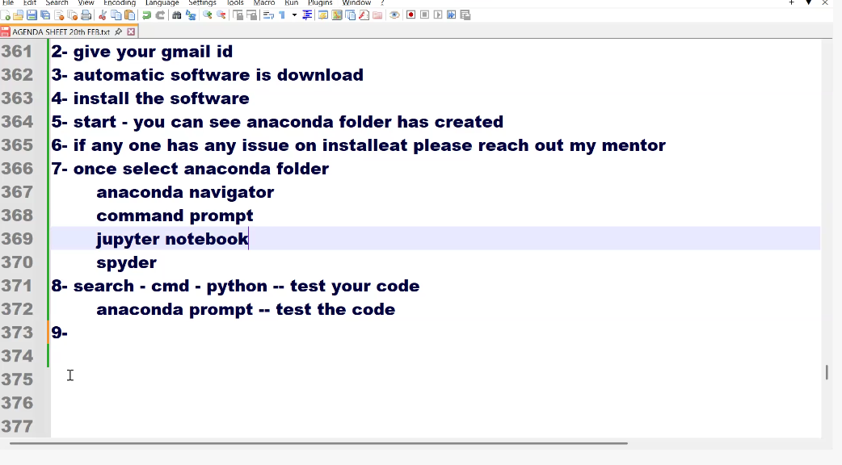

Task1: open the jupert notebook, check all the coding like type code,click on plus,click on run,what is code,markdown(heading),raw

Number -> Integer (INT)

Text - > String (ends with ‘,”,’’’)

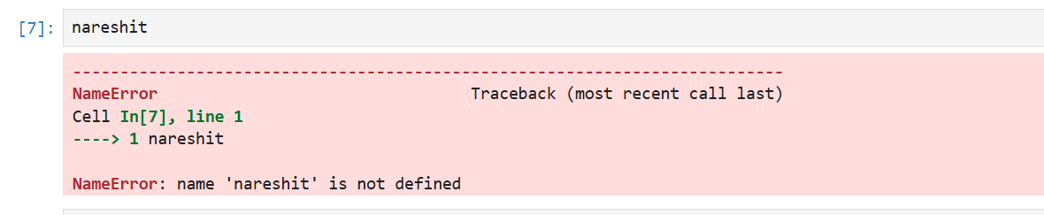

VARIABLE

Day 3

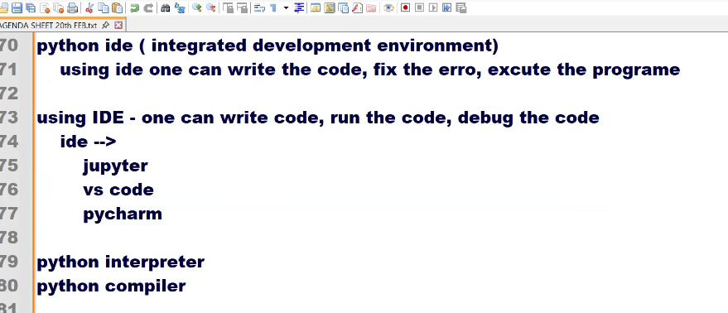

Variable rules:

Does not start with number, and variables shouldn’t contain any special characters except _.

27 Feb:

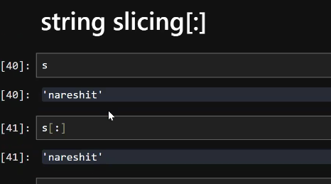

28 Feb:

After payment please send me below details on WhatsApp (9063042468) Payment screenshot Name : Mobile No : Email I'd : Course : Data science Faculty name :mr.Prakash senapati timings-8:30am Class mode : online

from nagababu to Everyone

09:40

Dear students... Please complete your payment procedure Data science 8:30am Mr.Prakash senapati Without videos--21,000 With videos : 27,000 Acount details Name: Naresh I Technologies A/C No 50200022639833 Bank: HDFC A/C Type: Current Account IFSC Code: HDFC0001627 MICR Code: 500240035 Branch Code: 001627 Branch: Ameerpet Or Phonepe or Google Pay follow the below Razor pay payment link [https://rzp.io/l/NareshITech](https://nareshit.webex.com/nareshit/url.php?frompanel=false&gourl=https%3A%2F%2Frzp.io%2Fl%2FNareshITech) for any queries contact Mr. Naga Babu--9063042468 Mr.Preem--7997997901

from nagababu to Everyone

09:48

Paid students For *Permanent Login Details* and *Google Classroom Notes access* , please fill out the form in the link below (this is required): Full Stack Data Science & AI @ 8:30 AM (IST) by Mr.Prakash senapati [https://forms.gle/Mw8VMzcUp4ApkJBL8](https://nareshit.webex.com/nareshit/url.php?frompanel=false&gourl=https%3A%2F%2Fforms.gle%2FMw8VMzcUp4ApkJBL8)

Send to:

kodi prakash senapati (Host, presenter)