
CSA15 Cloud Computing and Big Data Analytics
CO1 AT2 - Digital Concept Map and Service Model Matrix
Individual Student Submission Template

Student and Faculty Details
Student Name | KONATHAM MAHESH | Register Number | 192311014
Class / Section |  | Slot | B
Course Code | CSA1512 | Course Title
Capstone Title | SafeWalk Cloud Route Intelligence Using Crowd Reports and Risk Heatmaps
Submission Date | 13/07/2026
Faculty Name | DR. RAJESH BABU C | Employee ID
Department | CSE

Assessment Brief
Course Outcome | CO1 - Explain the evolution, architecture, characteristics, service models, and emerging paradigms of cloud computing.
Assessment Type | Individual concept mapping, service-model responsibility analysis, and capstone-cloud interpretation.
Assessment Focus | Each map must show key nodes, link labels, relationship meaning, and a logical hierarchy. The response must connect cloud fundamentals to the student's own perception of the capstone title.
Submission Mode | Editable DOCX + exported diagram evidence + GitHub repository link submitted in Google Classroom.
Permitted Tools | draw.io / diagrams.net, Lucidchart, Miro, Canva, PowerPoint, Google Drawings, or equivalent diagramming tool.
Individual Rule | Every student must submit their own concept map, matrix, capstone-cloud mapping, and reflection. The capstone title may be shared by a team, but the assessment answer must not be common.
Total Marks | 100 marks

Code of Conduct and Student Assurance
Academic Integrity Statement
This assessment must be completed individually. Students may discuss the capstone domain with their team, but the concept map, service model matrix, explanations, GitHub evidence, and reflection submitted here must be individually prepared.
Student Assurance | I confirm that this submission represents my own understanding of CO1 concepts and my individual interpretation of the selected capstone title.
Tool Use | I have used digital tools only for diagram preparation, organization, and presentation. I have not copied another student's diagram, matrix, or explanation.
Evidence | I have uploaded the required files to my GitHub repository and submitted the repository link / evidence link through Google Classroom.
Student Signature
Date

Procedure for Preparing the Digital Concept Map
Use the following procedure to prepare the diagram and upload evidence. Students who already know another diagramming tool may use it, but the exported evidence and source file must still be submitted.
- Open https://app.diagrams.net/ or the desktop version of draw.io / diagrams.net.
- Choose Device, Google Drive, or OneDrive as the save location according to availability.
- Create a blank diagram and name the file as CSA15_CO1_AT2_RegisterNumber_Concept_Map.drawio.
- Place the capstone title at the center or as a clearly visible anchor node.
- Add major cloud nodes: cloud definition, cloud evolution, cloud architecture, service models, deployment models, virtualization, web services, SOAP, REST, APIs, elasticity, scalability, resource pooling, measured service, and emerging paradigms.
- Connect nodes with labeled arrows such as uses, depends on, enables, scales through, communicates through, belongs to, supports, provides, consumes, or controls.
- Use colors meaningfully: one color for service models, one for cloud characteristics, one for API/web-service concepts, and one for capstone-specific elements.
- Export the final diagram as PNG or PDF. Keep the editable .drawio source file also.
- Paste the exported diagram image or screenshot in this DOCX under Task 1.
- Upload the DOCX, exported PNG/PDF, and .drawio file to GitHub, then submit the GitHub link in Google Classroom.

GitHub Submission Procedure
Step | Required Action | Expected Evidence
1 | Create or use your individual GitHub account. | GitHub profile link.
2 | Create a repository named CSA15-CO-Assessments-RegisterNumber or use the repository instructed by faculty. | Repository URL.
3 | Create a folder named CO1_AT2 inside the repository. | Folder visible in repository.
4 | Upload this completed DOCX, exported diagram PNG/PDF, and editable .drawio source file. | At least three evidence files uploaded.
5 | Add a short README.md explaining the capstone title and files submitted. | README visible in the AT2 folder.
6 | Submit the GitHub folder link in Google Classroom. | GCR submission with repository/folder link.

Assessment Questions and Student Response Sections
Important
The capstone project may be developed by a team, but every response below must be written from the individual student's own perspective. Do not submit a common team answer.

Task 1 - Digital Cloud Concept Map
Create one integrated digital concept map for CO1. The map must show key nodes, link labels, relationship meaning, and a logical hierarchy. It must also connect the concepts to your selected capstone title from your individual perspective.
Mandatory Concept Group | Minimum Concepts / Nodes to Include
Cloud Fundamentals | Definition, characteristics, benefits, limitations, on-demand access, measured service.
Cloud Evolution and Drivers | Hardware evolution, internet software evolution, distributed systems, cost economics, mobility, remote access, big data growth.
Architecture and Deployment | Front-end, back-end, network layer, data center, management software, public/private/hybrid/community cloud.
Service Models and Responsibility | IaaS, PaaS, SaaS, XaaS, provider responsibility, user responsibility, shared responsibility.
Virtualization and Web/API Layer | Virtual machine, hypervisor, abstraction, resource pooling, multi-tenancy, web services, SOAP, REST, API request/response.
Capstone Connection | Your capstone users, app/module, cloud backend, database/storage, dashboard/analytics, scalability and elasticity idea.
Paste exported concept map image / screenshot here. Resize neatly within this white space.
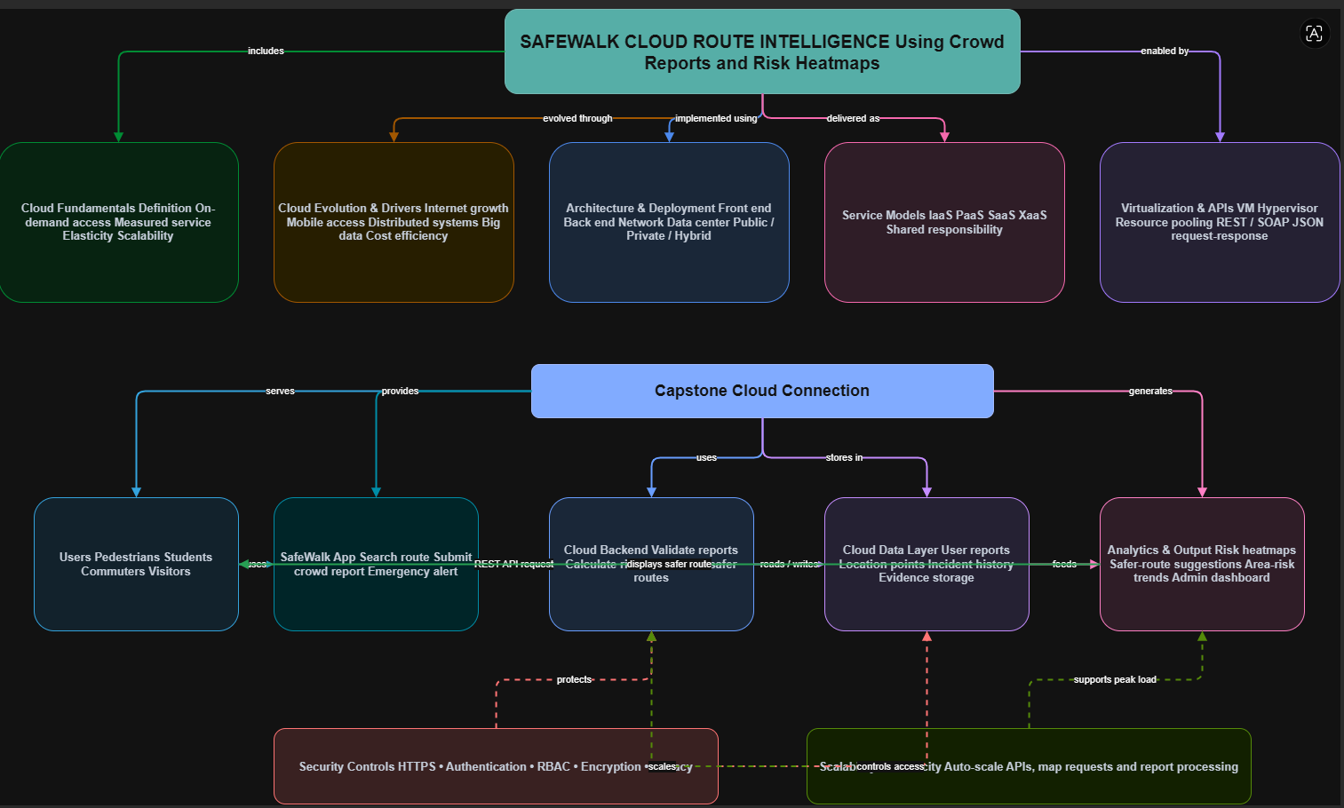

Brief explanation of your concept map: explain the most important nodes, link labels, hierarchy, and capstone connection.

Brief Explanation of the Concept Map
The concept map begins with Cloud Computing as the central concept, showing its relationship with cloud fundamentals, evolution, architecture, service models, virtualization, and web APIs. The hierarchy starts from the core cloud concepts and branches into key components such as Cloud Fundamentals, Cloud Evolution, Architecture & Deployment, Service Models, and Virtualization & Web/API Layer. These sections are connected using meaningful link labels such as includes, evolved through, implemented using, delivered as, and enabled by, which clearly explain the relationships between concepts.

Task 2 - Service Model Matrix
Complete the matrices by making technical decisions for your capstone project. Select only the rows that are relevant to your capstone design. If a row is not used, write a short technical reason instead of leaving it blank.
Your answer should show how responsibility shifts between cloud provider and student development team, and how the chosen services support the capstone workflow, API design, storage, security, scalability, and evidence submission.

Task 2A - Service Model Responsibility Matrix
Service Model | Capstone Role / Module | Provider Responsibility | Student Responsibility | Evidence to Submit
IaaS | Virtual servers, cloud storage, and networking for SafeWalk | Provides virtual machines, storage, networking, and infrastructure maintenance | Configure servers, deploy backend application, and manage resources | Cloud infrastructure configuration screenshot
PaaS | Backend application, REST APIs, and business logic | Provides runtime environment, database services, and deployment platform | Develop APIs, implement risk calculation, and integrate cloud services | API deployment or backend screenshot
SaaS | SafeWalk web/mobile dashboard for users and administrators | Hosts the application, manages updates, and ensures availability | Design user interface, dashboards, and report management | Dashboard or application screenshot
XaaS / Specialized Service | Maps API, Location Services, Notification Service, Analytics | Provides map services, geolocation, notifications, and analytics tools | Integrate APIs, configure alerts, and use analytics services | Maps API integration or notification screenshot

Task 2B - Capstone Cloud Service Decision Matrix
Cloud Layer / Function | Selected Tool or Service | Data / Resource Handled | API or Integration Path | Security / Scaling Note
Client Access and UI | SafeWalk Mobile/Web Application | User login, route search, crowd reports | REST API over HTTPS | Secure user access with authentication
API / Backend Logic | Node.js / Express Cloud Backend | Report validation, route calculation, risk scoring | REST API | Auto-scaling backend services
Authentication and Identity | Firebase Authentication | User accounts and login credentials | OAuth 2.0 / JWT | Multi-factor authentication and secure access
Database / Structured Records | Firebase Firestore / MySQL | User reports, locations, incident records, risk scores | REST API | Encrypted database with role-based access
File / Object Storage | Firebase Storage / Cloud Storage | Evidence images, uploaded files, reports | Storage API | Secure object storage with backup
Monitoring / Logs / Usage Metrics | Google Cloud Monitoring / Cloud Logging | Application logs, API usage, performance metrics | Monitoring API | Continuous monitoring and automatic alerts
Analytics / Reporting Output | Looker Studio / Power BI Dashboard | Risk heatmaps, safer routes, usage reports | REST API & Database Integration | Scalable analytics with real-time visualization
Technical justification: Explain why the selected cloud service pattern fits your capstone project's users, data, API flow, scalability, and security needs.

The selected cloud service pattern is suitable for the SafeWalk Cloud Route Intelligence Using Crowd Reports and Risk Heatmaps project because it supports different users, real-time data processing, secure API communication, and future growth. Pedestrians, students, commuters, and administrators can access the SafeWalk application through a mobile or web interface from any location. The cloud backend provides continuous availability and allows users to search for safer routes, submit crowd reports, and view risk heatmaps without depending on a local server.
The project handles structured data such as user details, locations, incident reports, risk scores, and route records, along with unstructured data such as uploaded evidence images. A cloud database is suitable for storing structured records, while object storage can securely manage images, reports, and logs. This separation improves data organization, retrieval speed, and storage efficiency.

Task 3 - Capstone Cloud Flow Mapping
Study the sample architecture-flow template below. Redraw it in draw.io / diagrams.net using your own capstone architecture. Replace every generic label with your actual user role, screen, API endpoint, backend logic, cloud storage, analytics output, security control, and scalability or elasticity decision.
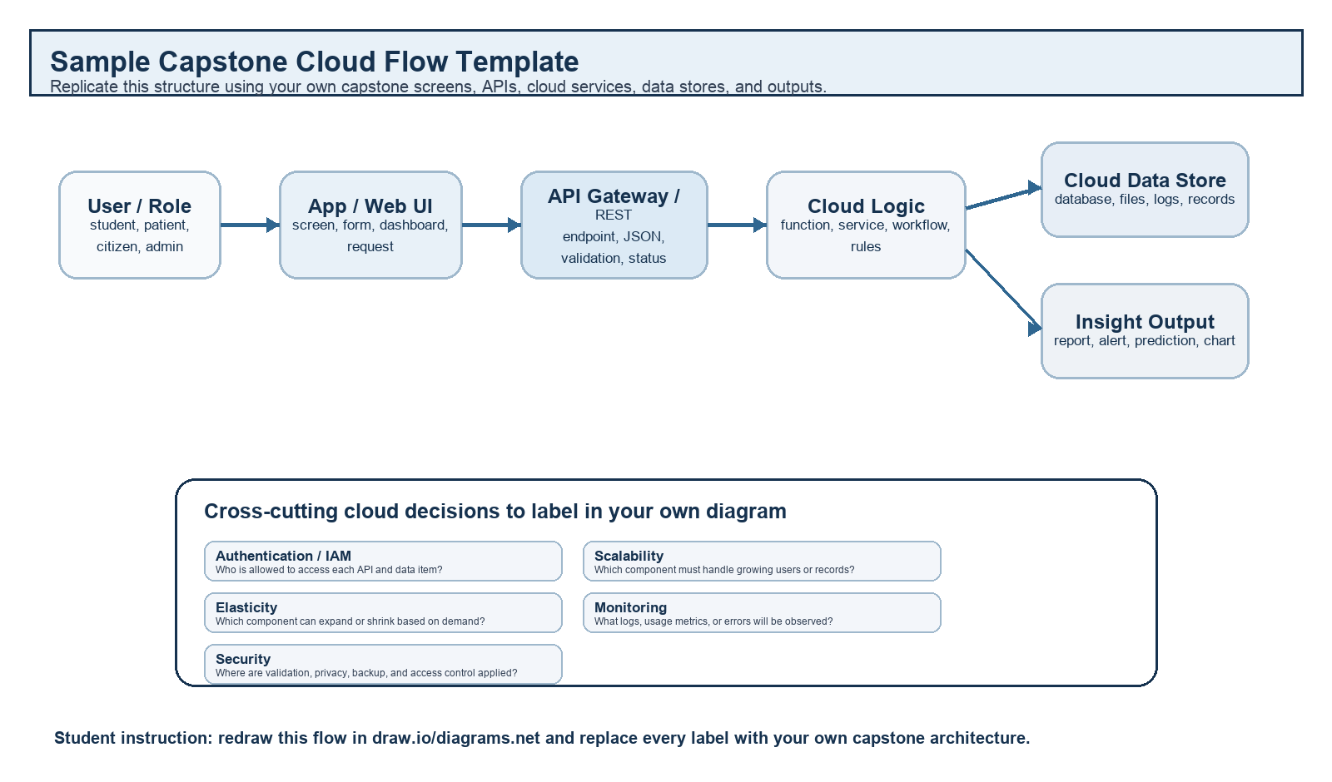
Student Drawing Requirement
Do not copy the sample as it is. Use it as a layout model, then create your own capstone-specific flow diagram with meaningful labels, arrows, data movement, API names, and cloud service choices.
Flow Component | Student Entry
Flow Component | Student Entry
User role and action | Pedestrian, student, commuter, or visitor searches for a safer route or submits a crowd report about an unsafe location.
Frontend / app screen | SafeWalk mobile/web application containing the login screen, map screen, route-search page, crowd-report form, risk-heatmap view, and alert screen.
API endpoint and method | POST /reports to submit a crowd report, GET /safe-route to receive safer route suggestions, and GET /risk-heatmap to retrieve risk-level data for different locations.
Backend processing rule | The backend validates the user and report, checks location and incident details, calculates a risk score, combines crowd reports with historical data, and ranks available routes according to safety.
Cloud database / storage operation | The cloud database stores user details, location coordinates, crowd reports, incident history, route records, and calculated risk scores. Object storage stores uploaded evidence images, reports, and system logs.
Response, alert, report, or dashboard output | The system returns the recommended safer route, route risk score, updated risk heatmap, high-risk-area alert, and analytical dashboard showing incidents and safety trends.
Paste your redrawn capstone cloud-flow diagram here

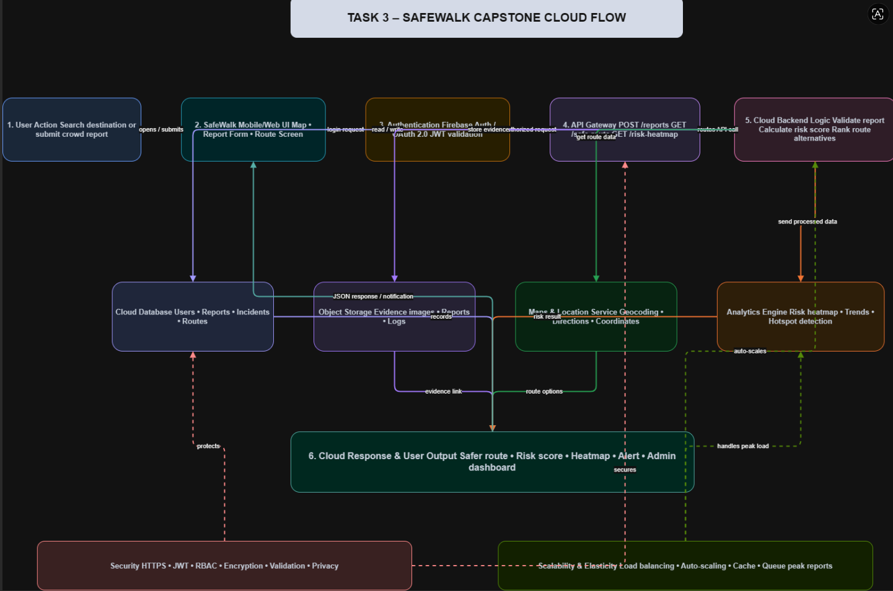

Brief explanation: explain one complete request-response path from user action to cloud response.
The cloud flow diagram illustrates the complete request-response process of the SafeWalk Cloud Route Intelligence Using Crowd Reports and Risk Heatmaps system. The workflow begins when a user opens the SafeWalk mobile application to search for a safe route or submit a crowd report about a risky location. The user is authenticated through a secure login mechanism before the request is sent to the cloud using REST APIs. The cloud backend validates the request, processes the location and incident information, calculates the risk score, and stores the data in the cloud database and object storage.
The backend also communicates with the maps service to obtain route information and forwards the processed data to the analytics engine. The analytics engine generates real-time risk heatmaps, identifies high-risk zones, and recommends the safest route to the user. Finally, the cloud sends the response back to the application, displaying safer routes, alerts, and updated heatmaps. Throughout the workflow, HTTPS, authentication, encryption, and role-based access control provide security, while auto-scaling, load balancing, and cloud elasticity ensure the system can efficiently handle a large number of users and crowd reports without affecting performance.

Task 4 - Individual Reflection
Answer the following from your own perspective. Avoid team-common wording.
1. What is the strongest cloud concept represented in your capstone project?

Task 4 – Individual Reflection
The strongest cloud concept in my capstone project is cloud-based real-time data processing and scalability. The SafeWalk application collects crowd reports from users, processes them in the cloud, and generates risk heatmaps and safer route recommendations. Cloud computing enables the system to provide real-time information that can be accessed from anywhere using a

2. Where will elasticity or scalability become important in your capstone product?

Task 4 – Individual Reflection
Elasticity and scalability become important when many users access the SafeWalk application simultaneously, especially during emergencies, public events, or peak travel hours. As the number of crowd reports and route requests increases, cloud resources can automatically scale to maintain fast response times and reliable service without affecting application performance.

3. Which API or web-service idea is most relevant to your project and why?

Task 4 – Individual Reflection
The most relevant API for my project is the REST API because it enables secure and efficient communication between the SafeWalk mobile application, cloud backend, cloud database, and map services. REST APIs allow users to submit crowd reports, retrieve safer routes, and access real-time risk heatmaps quickly using standard HTTP methods and JSON data.
4. What did you personally understand better after preparing this concept map and matrix?

Task 4 – Individual Reflection
After preparing this concept map and service model matrix, I gained a better understanding of how different cloud service models work together in a real-world application. I learned how cloud architecture, virtualization, REST APIs, databases, security, scalability, and analytics are integrated to build a reliable cloud-based solution. This assignment also helped me understand how cloud computing can improve the performance, availability, and security of my SafeWalk capstone project.

Evaluation Rubric - 100 Marks
Criteria | Marks | Expected Standard
Concept identification | 20 | Major CO1 concepts are accurately identified: cloud fundamentals, characteristics, evolution, service models, deployment models, virtualization, web services, SOAP/REST, APIs, elasticity, and scalability.
Relationship mapping | 20 | Links between concepts are accurate, meaningful, and labeled. The map should explain how concepts depend on, enable, consume, provide, scale, or control one another.
Hierarchy and organization | 15 | Concepts are arranged in a logical hierarchy with clear grouping, readable flow, and no disconnected keyword clusters.
Technical relevance | 15 | The map strongly reflects cloud course content and avoids decorative or generic non-technical content.
Service model matrix | 15 | IaaS, PaaS, SaaS, and XaaS are compared with provider responsibility, user responsibility, examples, capstone usage, and risks or limitations.
Capstone alignment and individual reflection | 10 | The student's own capstone interpretation is visible in the concept map, flow mapping, justification, and reflection. Team-common answers are avoided.
Visual clarity and digital evidence | 5 | Diagram is neat, readable, exported properly, and supported with GitHub evidence including source and exported files.

Faculty Evaluation Record
Evaluator Name |  | Marks Awarded
Observation |  | Signature

