**Brief report**

Missing Values:

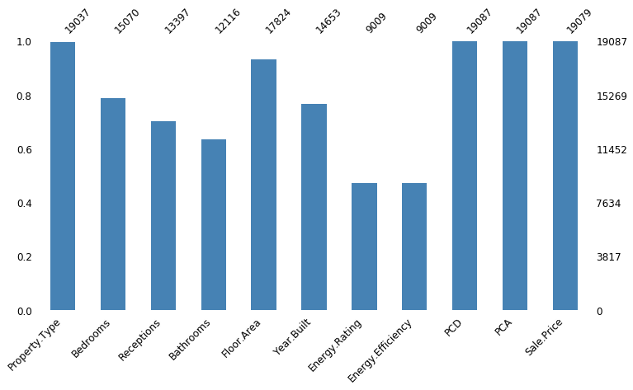

|  |  |
| --- | --- |
| **Correlation with Sale Price** |  |
| Sale.Price | 1.000000 |
| Bathrooms | 0.391792 |
| Floor.Area | 0.374298 |
| Bedrooms | 0.120519 |
| Energy.Efficiency | 0.098610 |
| Receptions | 0.041388 |
| Age_House | 0.026870 |

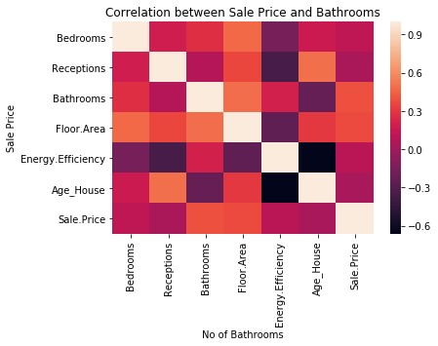

Below we can spot an outlier (>8 bathrooms with low price and floor area> 1400). We will exclude this observation.

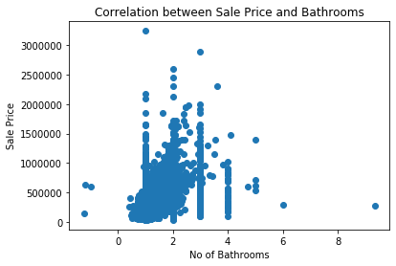

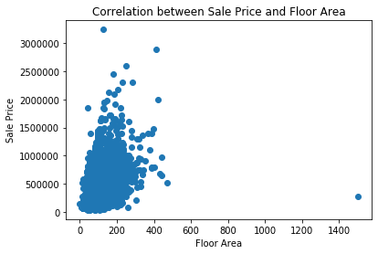

RandomForestRegressor  
score on training 0.9702467713315022

r2 score 0.8298114778770391

DecisionTreeRegressor  
score on training 0.8980497514751571

r2 score 0.7221319408792443

GradientBoostingRegressor  
score on training 0.995867519551433

r2 score 0.8045841836418807

