Block 1 Documentation: Apex Collections (List, Set, Map)
Title
Block 1: Apex Collections – List, Set, and Map
Objective
The objective of this block was to understand and practice the three collection types available in Apex: List, Set, and Map. Collections are used to store and manipulate multiple values efficiently in Salesforce applications. They are widely used in Apex programming, SOQL queries, triggers, and classes for handling groups of records.

Concepts Learned
1. List
A List is an ordered collection of elements. It allows duplicate values and maintains the order in which elements are inserted. Elements are accessed using their index, where indexing starts from 0. Lists are useful when the sequence of data is important.
2. Set
A Set is an unordered collection that stores only unique values. Duplicate values are automatically removed. Sets are commonly used to eliminate duplicates and to perform fast membership checks.
3. Map
A Map stores data in key-value pairs. Each key must be unique, while values may be duplicated. In Salesforce, a common practice is to use Map<Id, sObject> to retrieve records quickly using their record Id.

Practical Activities Performed
Task 1 – List Collection
Created a List<String> containing five city names. Used a for-each loop to iterate through the list and displayed each city name in uppercase using the toUpperCase() method.
Outcome:
- Successfully created and populated a List.
- Learned how to traverse a List using a loop.
- Practiced string manipulation methods.

Task 2 – Set Collection
Created a Set<Id> by retrieving record IDs from a custom object using a SOQL query. Displayed the size of the Set to verify that duplicate IDs were automatically removed.
Outcome:
- Understood that Sets store only unique values.
- Learned how to populate a Set using SOQL query results.
- Verified uniqueness using the size() method.

Task 3 – Map Collection
Created a Map<Id, Member__c> from records retrieved through SOQL. Retrieved a specific record using its Id as the key and displayed one of its field values.
Outcome:
- Learned how to create and populate a Map.
- Understood key-value storage.
- Retrieved records efficiently using record Ids.
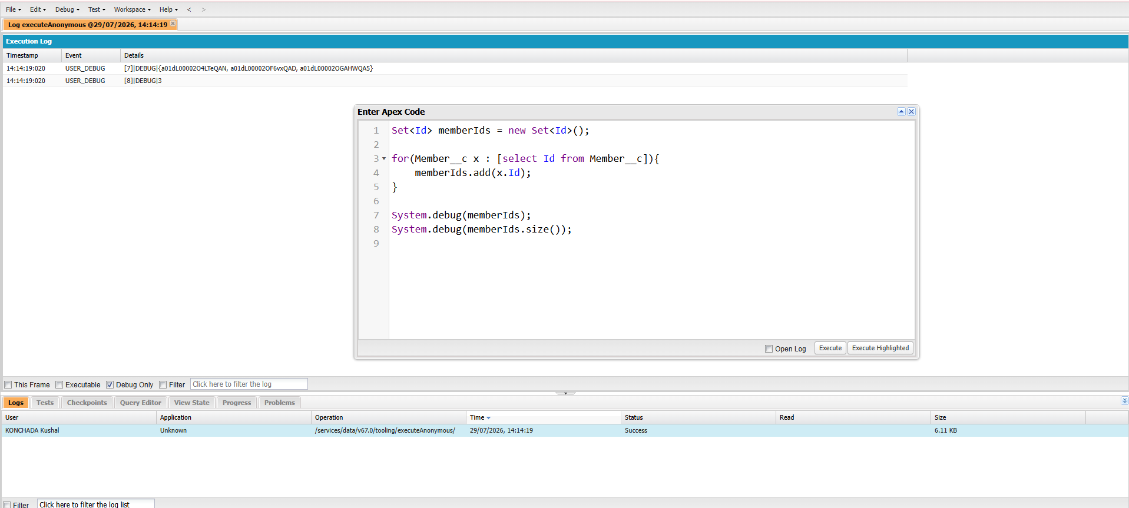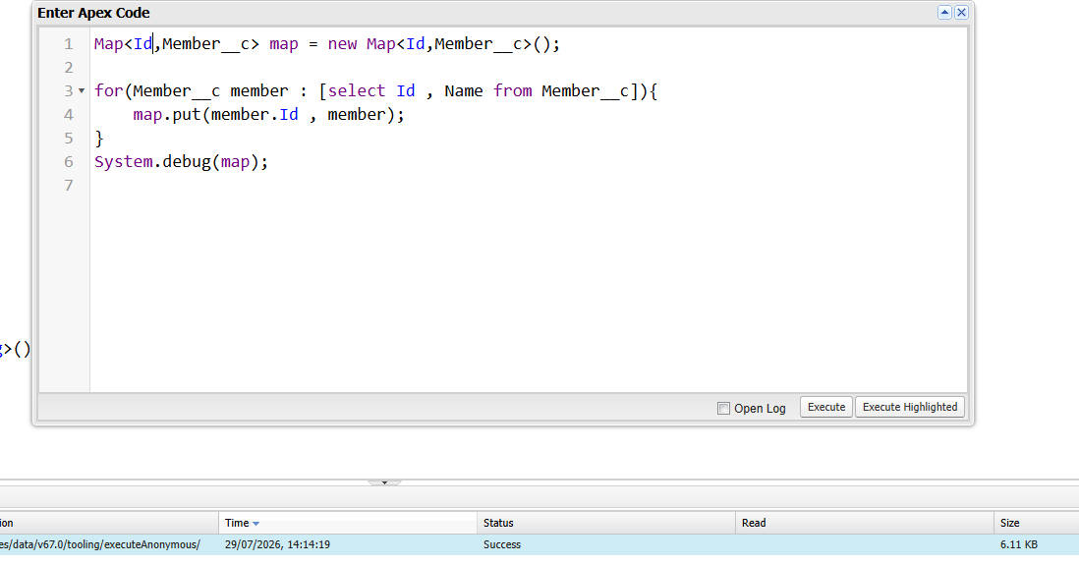
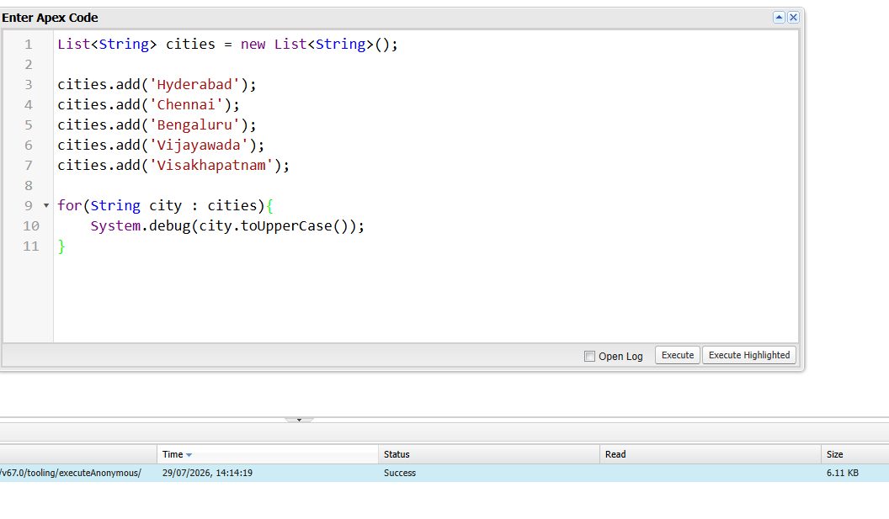
Block 2 Documentation: Governor Limits & Bulkification
Title
Block 2: Governor Limits and Bulkification in Apex Triggers
Objective
The objective of this block was to understand Salesforce Governor Limits and learn how to write bulkified Apex triggers that can efficiently process multiple records without exceeding platform limits. I also learned to identify common coding mistakes, such as placing SOQL queries or DML statements inside loops, and how to optimize them using collections like List, Set, and Map.

Introduction
Salesforce is a multi-tenant cloud platform, where multiple organizations share the same computing resources. To ensure that one organization's code does not consume excessive resources, Salesforce enforces Governor Limits. These limits restrict the number of database operations, SOQL queries, DML statements, CPU time, heap size, and other resources that Apex code can use in a single transaction.

Concepts Learned
1. Governor Limits
Governor Limits are runtime restrictions that prevent Apex code from monopolizing shared Salesforce resources.
Some important limits are:
- Maximum 100 SOQL queries in a synchronous transaction.
- Maximum 150 DML statements in a transaction.
- Triggers execute on batches of up to 200 records at a time.

2. Bulkification
Bulkification is the process of writing Apex code that can process multiple records efficiently in a single transaction.
Best practices include:
- Process records using Trigger.new.
- Use collections (List, Set, Map).
- Perform SOQL queries outside loops.
- Perform DML operations outside loops.
- Query all required records at once using the IN clause.

Practical Activities Performed
Task 1: Created a Non-Bulkified Trigger
A trigger was intentionally written with a SOQL query inside a for loop.
This implementation was designed to demonstrate how inefficient code can exceed Salesforce Governor Limits when processing a large number of records.
Observation
- The trigger worked correctly for a few records.
- When hundreds of records were processed, Salesforce executed a SOQL query during every loop iteration.
- This caused the transaction to exceed the maximum SOQL query limit.

Task 2: Trigger Failure Due to Governor Limits
A bulk data load containing more than 200 records was executed.
Expected Result
The transaction failed with an error similar to:
System.LimitException:
Too many SOQL queries: 101
This demonstrated why SOQL queries should never be placed inside loops.

Task 3: Bulkified the Trigger
The trigger was redesigned by:
- Moving the SOQL query outside the loop.
- Retrieving all required records using a single SOQL query.
- Using collections such as Set and Map to store and access records efficiently.
- Performing DML operations only once after processing all records.
Outcome
- Successfully processed 200+ records.
- No Governor Limit exceptions occurred.
- Trigger performance improved significantly.

Block 3 Documentation: Asynchronous Apex – Introduction
Title
Block 3: Introduction to Asynchronous Apex using Future Methods

Objective
The objective of this block was to understand the fundamentals of Asynchronous Apex and learn how to execute Apex code in the background using Future Methods. The practical task involved creating a simple @future method that accepted a record Id, queried the corresponding record, updated one of its fields, and verified its execution through Apex Jobs. Salesforce recommends asynchronous processing for operations that do not need to complete while the user waits, such as long-running processes, callouts, or background updates.

Introduction
By default, Apex code runs synchronously, meaning each statement executes immediately and the user waits until the entire transaction is complete.
Asynchronous Apex allows specific operations to run in the background, enabling users to continue working without waiting for long-running tasks to finish. This approach improves user experience and helps optimize resource utilization.

Concepts Learned
1. Synchronous Processing
In synchronous processing:
- Code executes immediately.
- The user waits until execution is complete.
- Suitable for simple and quick operations.

2. Asynchronous Processing
In asynchronous processing:
- Tasks are placed in a queue.
- Salesforce executes them when system resources become available.
- The user does not wait for completion.
- Ideal for long-running operations and external web service callouts.

3. Future Method
A Future Method is an Apex method annotated with @future that executes asynchronously.
Characteristics:
- Must be a static method.
- Must return void.
- Can accept only primitive data types or collections of primitive data types as parameters.
- Cannot accept sObjects directly as parameters.

Practical Activity Performed
Task: Update a Gym Member Record Asynchronously
A Future Method was created to:
- Accept a Member record Id.
- Retrieve the corresponding Member__c record.
- Update the Verified__c checkbox field.
- Save the changes using a DML update operation.
The method was executed through Execute Anonymous, passing the Member record Id as the parameter.

Verification
After execution:
- The Verified field was successfully updated.
- The execution was confirmed by navigating to:
Setup
↓

Apex Jobs
The job appeared with the status Completed, confirming that it executed asynchronously rather than synchronously.

Key Observations
- Future Methods execute in the background.
- They improve application responsiveness by preventing long-running operations from blocking users.
- Only primitive parameters (or collections of primitive parameters) are supported.
- Future Methods are commonly used for:
  - External web service callouts.
  - Background processing.
  - Resource-intensive operations.
  - Avoiding mixed DML scenarios.

Comparison of Asynchronous Techniques
Future Method | Queueable Apex
Uses @future annotation | Implements the Queueable interface
Accepts only primitive parameters | Supports non-primitive member variables such as sObjects
No job ID is returned to the caller | Returns an AsyncApexJob ID using System.enqueueJob()
Cannot chain jobs | Supports chaining of queueable jobs
Older asynchronous approach | Recommended for most new asynchronous implementations

Why Batch Apex?
Batch Apex is used when processing very large volumes of records that exceed the limits of a single transaction. Instead of processing everything at once, Salesforce divides the work into smaller batches, making large-scale data processing more efficient and reliable.

Applications
Asynchronous Apex is commonly used in:
- Background record updates.
- External API integrations.
- Email notifications.
- Large data processing.
- Scheduled system operations.
- Batch data maintenance.
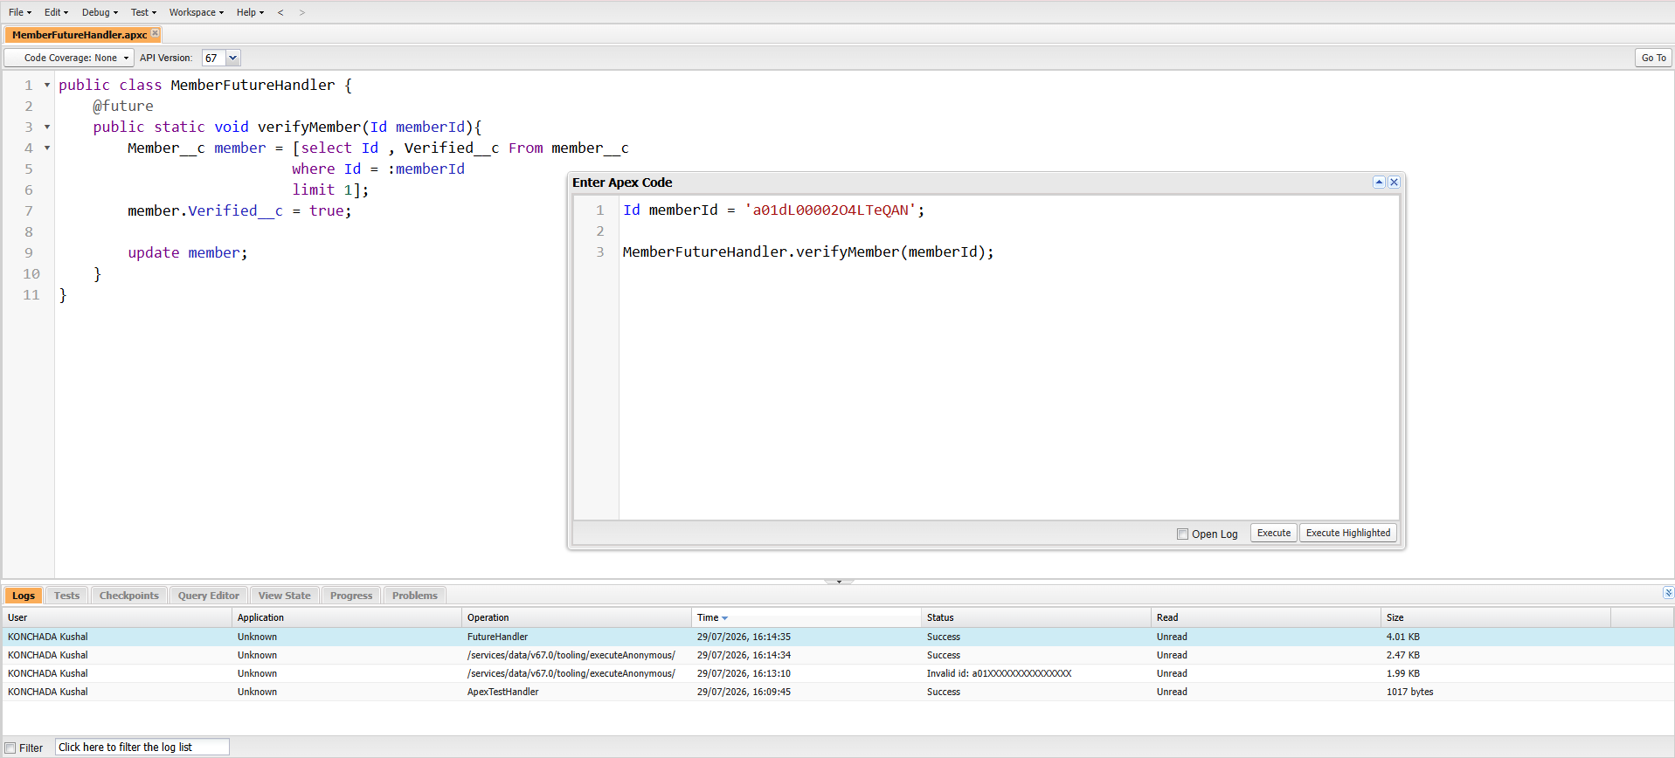

Block 4: Lightning Web Components – Component Communication
Objective
To understand how Lightning Web Components communicate using Parent-to-Child communication through the @api decorator and Child-to-Parent communication through custom events. The objective was to build two related components that exchanged information and responded to user interactions in real time.
Practical Activities
- Created a Parent LWC to pass a Member record Id to a Child component.
- Used a public @api property in the Child to receive and display Member information.
- Added a button in the Child component that dispatched a custom event.
- Configured the Parent component to listen for the event and update the displayed status message.
- Deployed the components to a Lightning App Builder page and verified communication in both directions.
