Supply Chain Risk Analytics and
Delivery Time Prediction Using Machine Learning

IBM SkillsBuild Data Analytics with AI Internship
Graduate-Level Project Report
Author: Niveditha
Dataset: DataCo SMART SUPPLY CHAIN FOR BIG DATA ANALYSIS
Year: 2024

Abstract
This report presents an end-to-end supply chain analytics and machine learning system developed for the IBM SkillsBuild Data Analytics with AI internship. Using 180,519 historical shipment records from the DataCo Global supply chain dataset, the system predicts delivery time in days (regression) and the probability of late delivery (binary classification). A strict data-leakage prevention policy ensures that only information available before delivery is used as model input. The best regression model (Random Forest) achieves RMSE = 1.2592 days and R² = 0.3928. The best classification model (Gradient Boosting) achieves F1 = 0.7098 and ROC-AUC = 0.8004. SHAP-based explainability identifies scheduled delivery days, shipping mode, and order region as the most important predictive factors. An interactive Streamlit executive dashboard translates findings into actionable business recommendations.

1. Introduction
Supply chain delivery performance is a critical operational challenge for global commerce. Late deliveries directly affect customer satisfaction, operational costs, and competitive positioning. Traditional reactive approaches — investigating a delay after it occurs — provide limited operational value. Predictive analytics offers a fundamentally different paradigm: identifying shipments at risk of late delivery before they are dispatched, enabling proactive intervention.
This project applies machine learning to the DataCo Global supply chain dataset to build a pre-delivery prediction system. The system is designed around a strict no-leakage policy: only information available at the time of order placement is used as model input.

2. Problem Statement
The core business question addressed by this project is:
"Given information available at the time of order placement, what is the expected delivery time, and what is the probability that this shipment will be late?"
This decomposes into two machine learning sub-problems:
1. Regression: Predict Days for shipping (real) — the actual number of delivery days.
2. Classification: Predict Late_delivery_risk — binary flag (0=on time, 1=late).

Data Leakage Prevention Policy
The following columns are strictly excluded from all model inputs because they would only become known after the shipment outcome:
- • Delivery Status — direct consequence of delivery outcome
- • shipping date (DateOrders) — actual dispatch date (post-commitment)
- • Late_delivery_risk — classification target
- • Days for shipping (real) — regression target
- • All PII columns (email, name, address, password)

3. Objectives
- Audit and understand the DataCo supply chain dataset (180,519 records, 53 columns).
- Implement a reproducible preprocessing pipeline with strict data leakage prevention.
- Conduct exploratory data analysis to identify patterns in delivery performance.
- Build and compare regression models for delivery time prediction.
- Build and compare classification models for late-delivery risk prediction.
- Apply SHAP-based explainability to interpret model predictions.
- Translate analytical findings into actionable business recommendations.
- Deploy an interactive executive dashboard using Streamlit.

4. Business Context
The DataCo dataset covers shipments across five global markets (Africa, Europe, LATAM, Pacific Asia, USCA) from 2015–2018. It captures the complete order-to-delivery lifecycle including order details, product information, customer segments, shipping modes, and delivery outcomes. The dataset represents a multi-geography supply chain operation spanning diverse logistics environments.
Key business drivers that make delivery prediction valuable:
- Customer Retention: Late deliveries are a leading cause of customer churn in e-commerce and B2B supply.
- Operational Costs: Expedited rerouting and compensation increase logistics costs.
- Competitive Positioning: Delivery reliability is a primary differentiation factor.
- Inventory Management: Predictable delivery windows reduce safety-stock requirements.

5. Dataset Description
Source: DataCo SMART SUPPLY CHAIN FOR BIG DATA ANALYSIS
Reference: Constante, F., Silva, F., & Pereira, A. (2019). Mendeley Data.
Records: 180,519 rows × 53 columns
File encoding: Latin-1
Date range: January 2015 – February 2018

Target Variables
Variable | Type | Distribution
Days for shipping (real) | Regression target | Mean=3.50d, Std=1.62, Min=0, Max=6
Late_delivery_risk | Classification target (binary) | 1 (Late)=54.8%, 0 (On Time)=45.2%

Data Quality Summary
Issue | Detail
Missing values | Product Description: 100%; Order Zipcode: 86%; Customer Lname: 8 rows
Duplicate rows | 0 exact duplicates
PII columns removed | Email, Fname, Lname, Password, Street, Zipcode
Leakage columns removed | Delivery Status, shipping date (DateOrders)
Identifier columns removed | Order Id, Customer Id, Item Id, etc. (9 columns)
Sparse/low-signal removed | Product Description, Product Image, Order Zipcode, etc.

6. Data Preprocessing
The preprocessing pipeline is implemented in src/data_preprocessing.py and follows these steps in order:
- Load raw CSV (latin-1 encoding). Raw data is never modified.
- Parse order date string to datetime.
- Extract datetime features: year, month, quarter, day, dayofweek, hour.
- Remove leakage, PII, identifier, and sparse/low-signal columns.
- Impute missing values: median for numeric, 'Unknown' for categorical.
- Chronological train/test split: earliest 80% → train, latest 20% → test.
- Fit LabelEncoder on training categoricals; transform both splits.
- Build X (features), y_regression, y_classification matrices.
- Save processed data to data/processed/.

Chronological Train/Test Split
Training set: 144,415 rows (80% — orders placed before the split date)
Test set: 36,104 rows (20% — orders placed after the split date)
A chronological split is used to prevent data leakage from future shipments into the training set, reflecting a realistic deployment scenario.

Feature Engineering
Feature | Description | Source
order_year/month/quarter/day/dayofweek/hour | Date components | Order date
is_expedited_schedule | 1 if scheduled days ≤ 2 | Scheduled days
profit_margin_ratio | Order Profit / Order Item Total | Order financials
has_discount | 1 if item discount > 0 | Item discount
is_high_value | 1 if Product Price ≥ $200 | Product price
is_weekend_order | 1 if order placed Sat/Sun | Order dayofweek
Final feature set: 32 numeric features.

7. Exploratory Data Analysis

7.1 Delivery Time Distribution
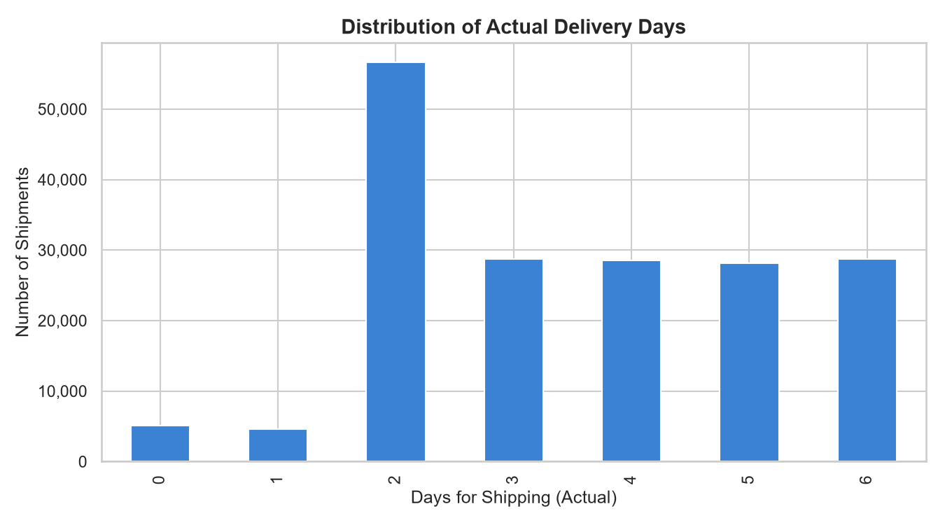
Figure 1: Distribution of actual delivery days
Actual delivery days range from 0 to 6, with a mean of 3.50 days and median of 3 days. The distribution is approximately uniform across 1–5 days with slight peaks at 0 and 6. 54.8% of shipments are delivered late relative to the scheduled commitment.

7.2 Delivery Performance by Shipping Mode
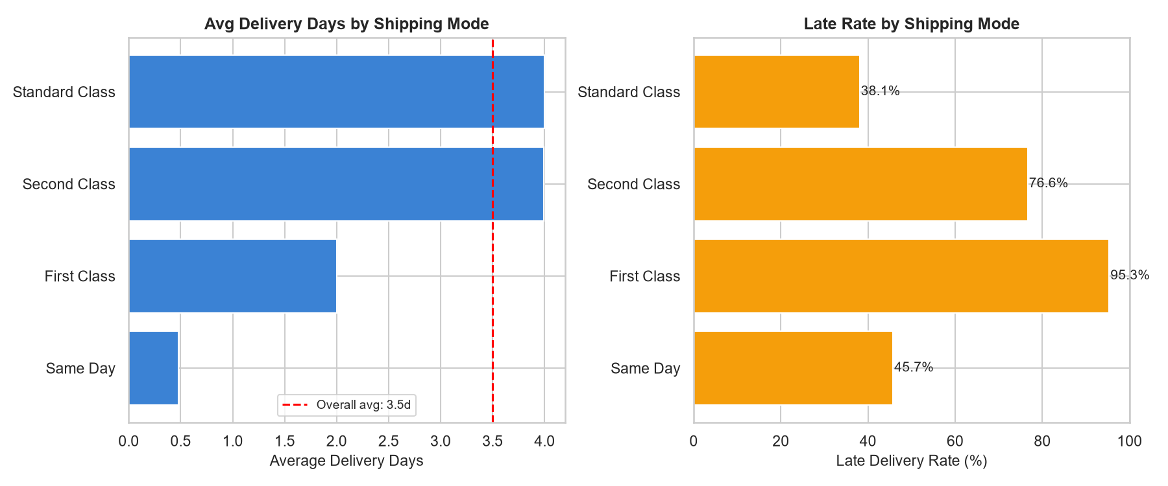
Figure 2: Late delivery rate and average days by shipping mode
First Class and Second Class shipping modes show higher late delivery rates than Same Day. Standard Class — the dominant mode at ~60% of shipments — has the highest absolute volume of late deliveries and is therefore the primary lever for supply chain improvement.

7.3 Delivery Performance by Market
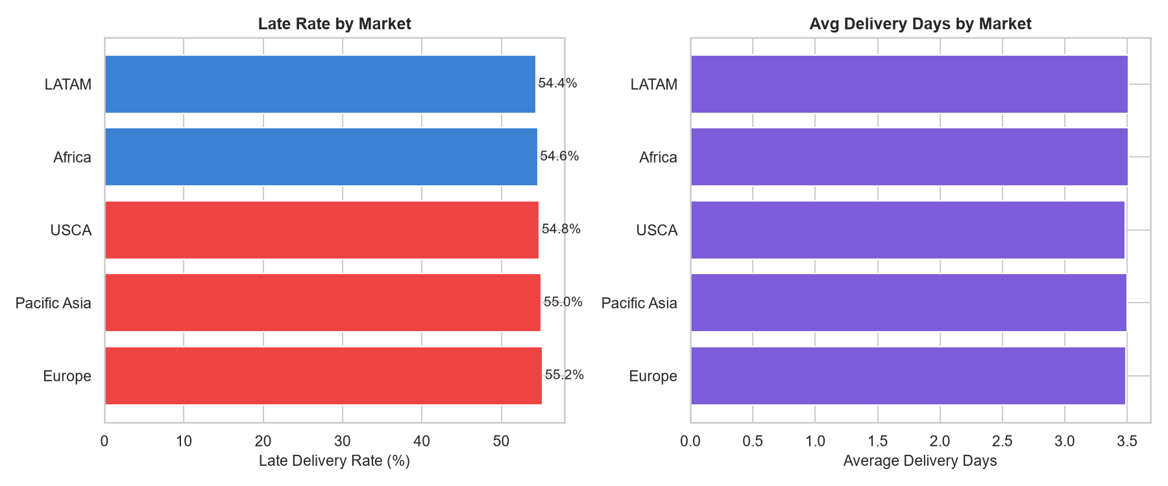
Figure 3: Late delivery rate and average days by market
Late delivery rates are broadly consistent across markets, indicating that late delivery is a systemic operational issue rather than a region-specific one. Pacific Asia and LATAM show slightly higher average delivery days due to longer shipping distances.

7.4 Temporal Trends
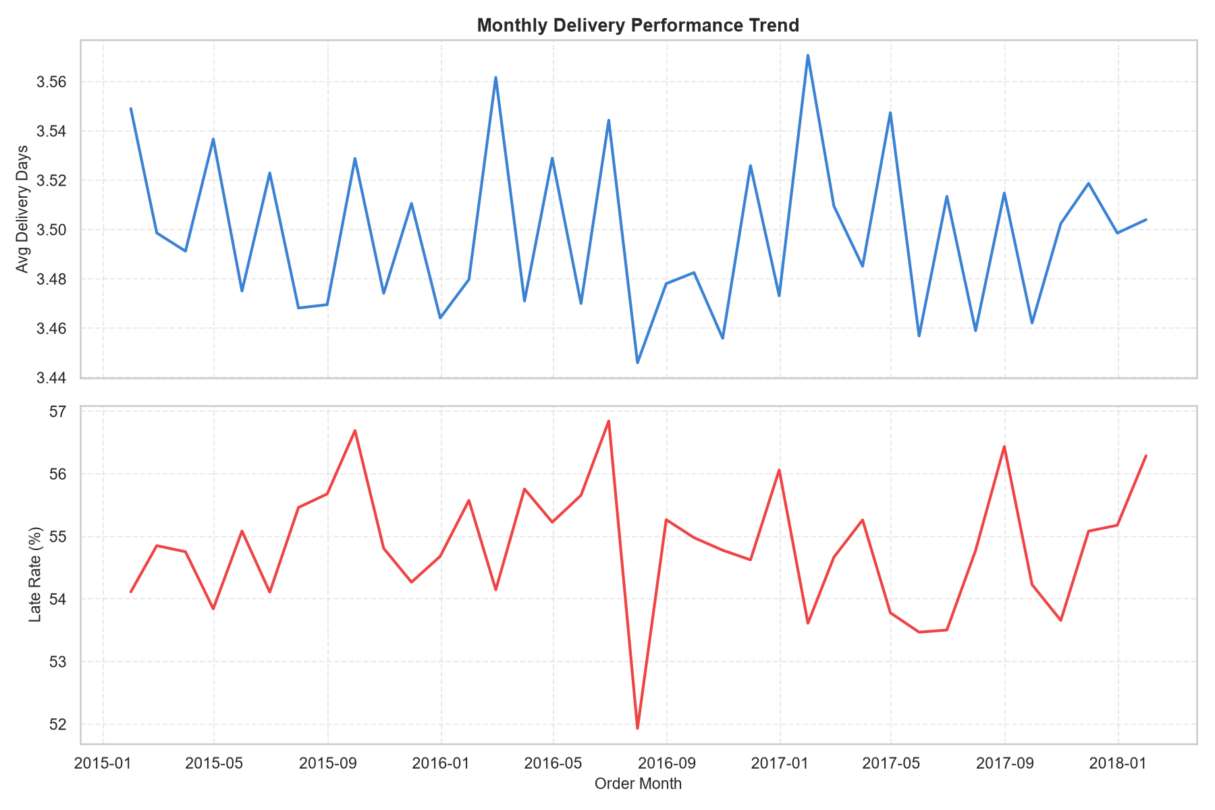
Figure 4: Monthly delivery performance trend (2015–2018)
Late delivery rates are relatively stable over the observation period, confirming that the ~55% late delivery rate is not an anomaly of a specific time period but reflects ongoing operational performance.

7.5 Correlation Analysis
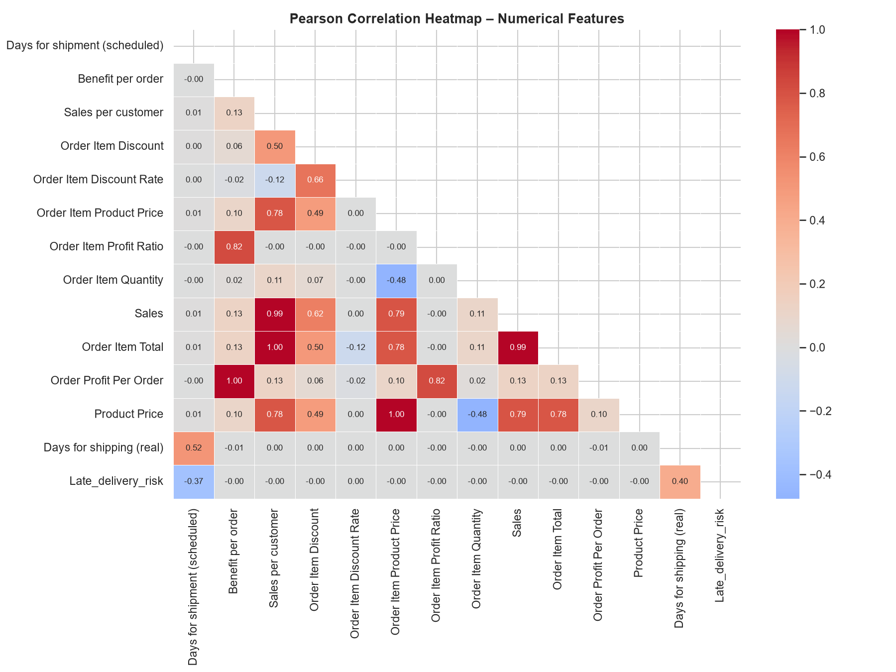
Figure 5: Pearson correlation heatmap of numerical features
Days for shipment (scheduled) shows the strongest correlation with Days for shipping (real). Financial variables (Sales, Order Item Total, Benefit per order) are highly intercorrelated, suggesting they carry similar information. None of the individual numerical variables have strong correlations with Late_delivery_risk, indicating that the prediction task requires non-linear models that combine multiple features.

8. Machine Learning Methodology
Two machine learning tasks are addressed: delivery time regression and late-delivery risk classification. For each task, multiple models are trained, compared, and the best performer is selected based on appropriate metrics.

8.1 Feature Scaling
StandardScaler is applied to all features before model training. The scaler is fit on training data only and applied to test data to prevent data leakage through scaling statistics.

8.2 Class Imbalance
The classification target has ~55% late and ~45% on-time deliveries. This mild imbalance is addressed using class_weight='balanced' in applicable models (Logistic Regression, Random Forest) to prevent bias toward the majority class. Gradient Boosting and XGBoost handle this via their loss function.

9. Delivery Time Prediction (Regression)
Target: Days for shipping (real) — the actual number of delivery days.

9.1 Model Comparison
Model | MAE | RMSE | R²
Random Forest | 0.9545 | 1.2592 | 0.3928
XGBoost | 0.9714 | 1.2624 | 0.3896
Gradient Boosting | 0.9692 | 1.2628 | 0.3893
Linear Regression | 0.9843 | 1.2644 | 0.3877
Baseline (Mean) | 1.4186 | 1.6158 | -0.0
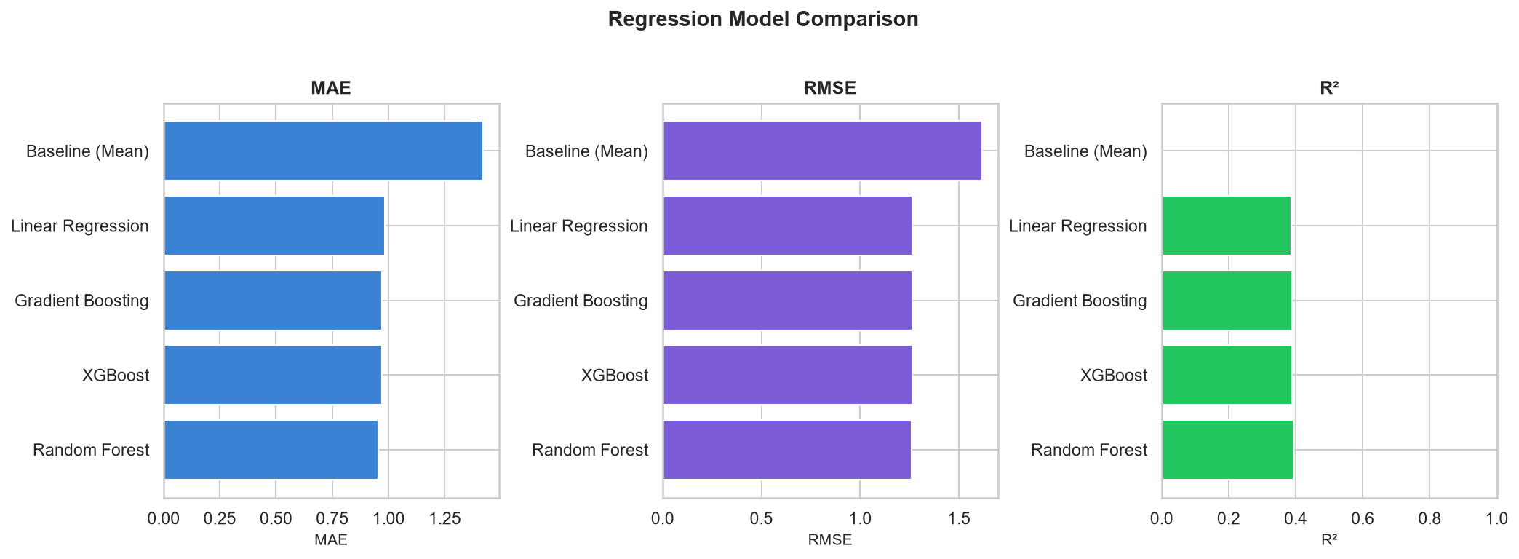
Figure 6: Regression model comparison

9.2 Best Model: Random Forest Regressor
Selected model: Random Forest
MAE = 0.9545 days
RMSE = 1.2592 days
R² = 0.3928
Interpretation: The model predicts actual delivery days within approximately ±0.95 days on average (MAE). The R² of ~0.39 indicates the model explains 39% of the variance in delivery time using pre-delivery features only. The remaining variance reflects inherent randomness in logistics operations that cannot be predicted from order attributes alone.

10. Delivery Risk Prediction (Classification)
Target: Late_delivery_risk — binary flag (0=on time, 1=late).

10.1 Model Comparison
Model | Accuracy | Precision | Recall | F1 | ROC-AUC
Gradient Boosting | 0.7356 | 0.8868 | 0.5917 | 0.7098 | 0.8004
XGBoost | 0.7363 | 0.8914 | 0.5894 | 0.7096 | 0.798
Random Forest | 0.7347 | 0.8898 | 0.5873 | 0.7076 | 0.7885
Logistic Regression | 0.6983 | 0.8519 | 0.5423 | 0.6627 | 0.7377
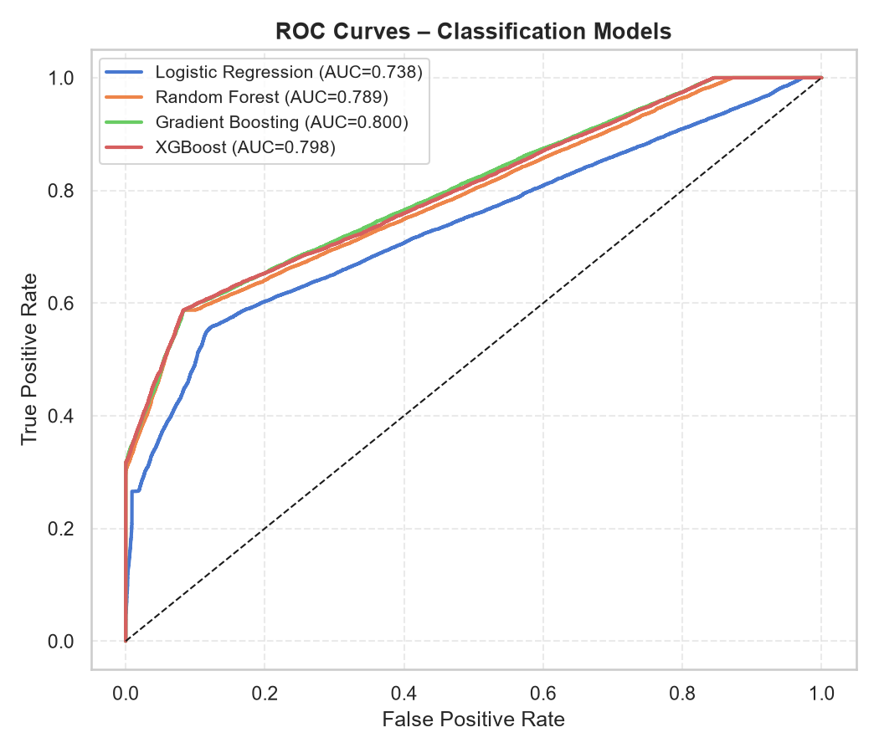
Figure 7: ROC curves for all classifiers
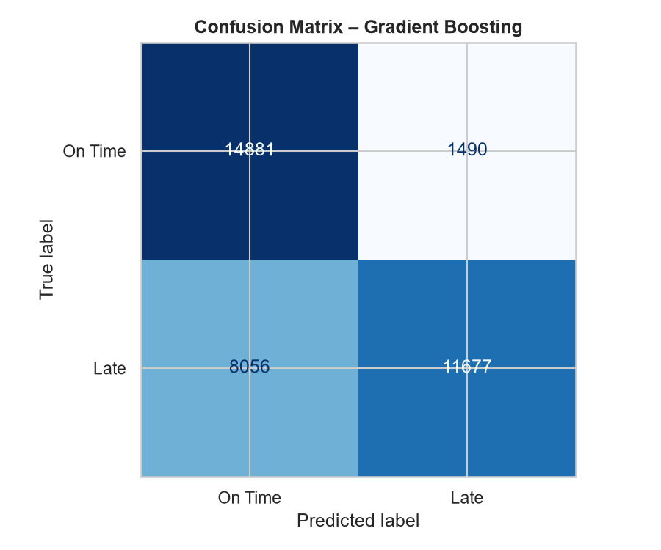
Figure 8: Confusion matrix — Gradient Boosting

10.2 Best Model: Gradient Boosting Classifier
Selected model: Gradient Boosting
Accuracy = 0.7356
Precision = 0.8868
Recall = 0.5917
F1 = 0.7098
ROC-AUC = 0.8004
The model is selected based on F1 score (balances precision and recall) and ROC-AUC (discriminative power). High Precision (0.887) means: when the model predicts a shipment will be late, it is correct 88.7% of the time. Moderate Recall (0.591) means it currently misses some late deliveries.

11. Explainable AI (SHAP)
SHAP (SHapley Additive exPlanations) values quantify the contribution of each feature to individual predictions. TreeExplainer is used for tree-based models. SHAP values are computed on a 1,500-record sample of the test set.
Important: SHAP values indicate the strength of association between a feature and model output. They do not establish causation.
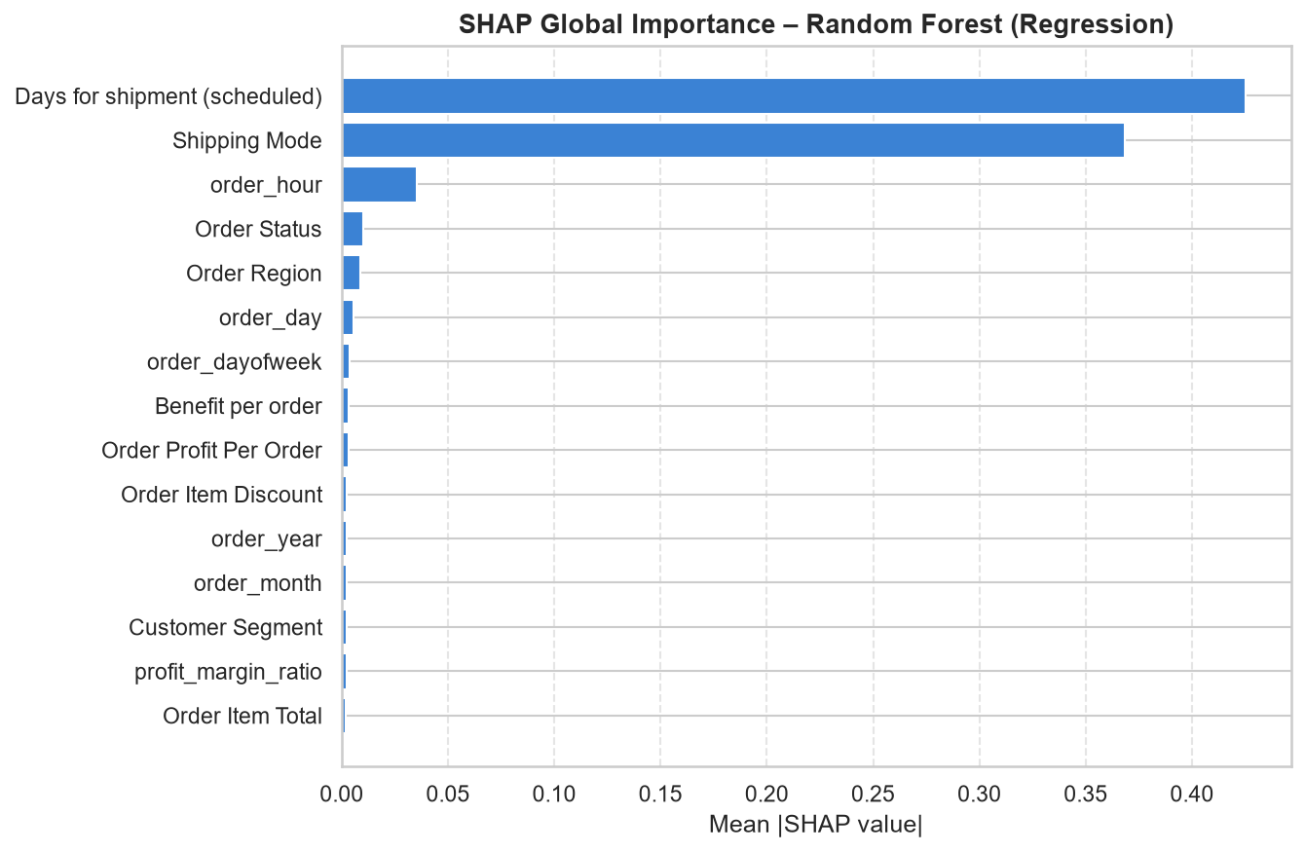
Figure 9: SHAP global importance — Random Forest (regression)
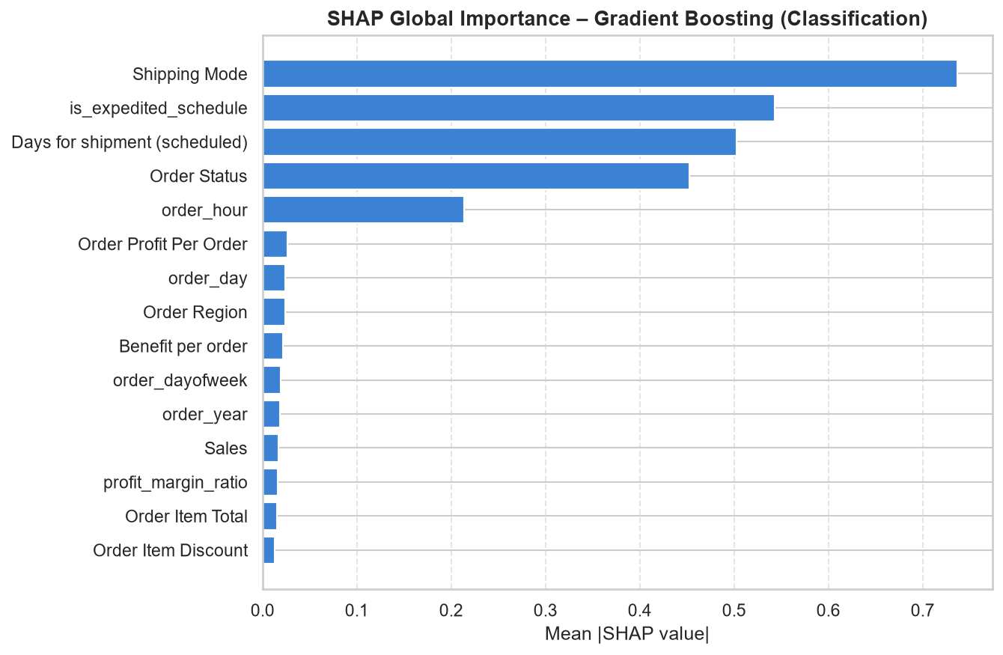
Figure 10: SHAP global importance — Gradient Boosting (classification)
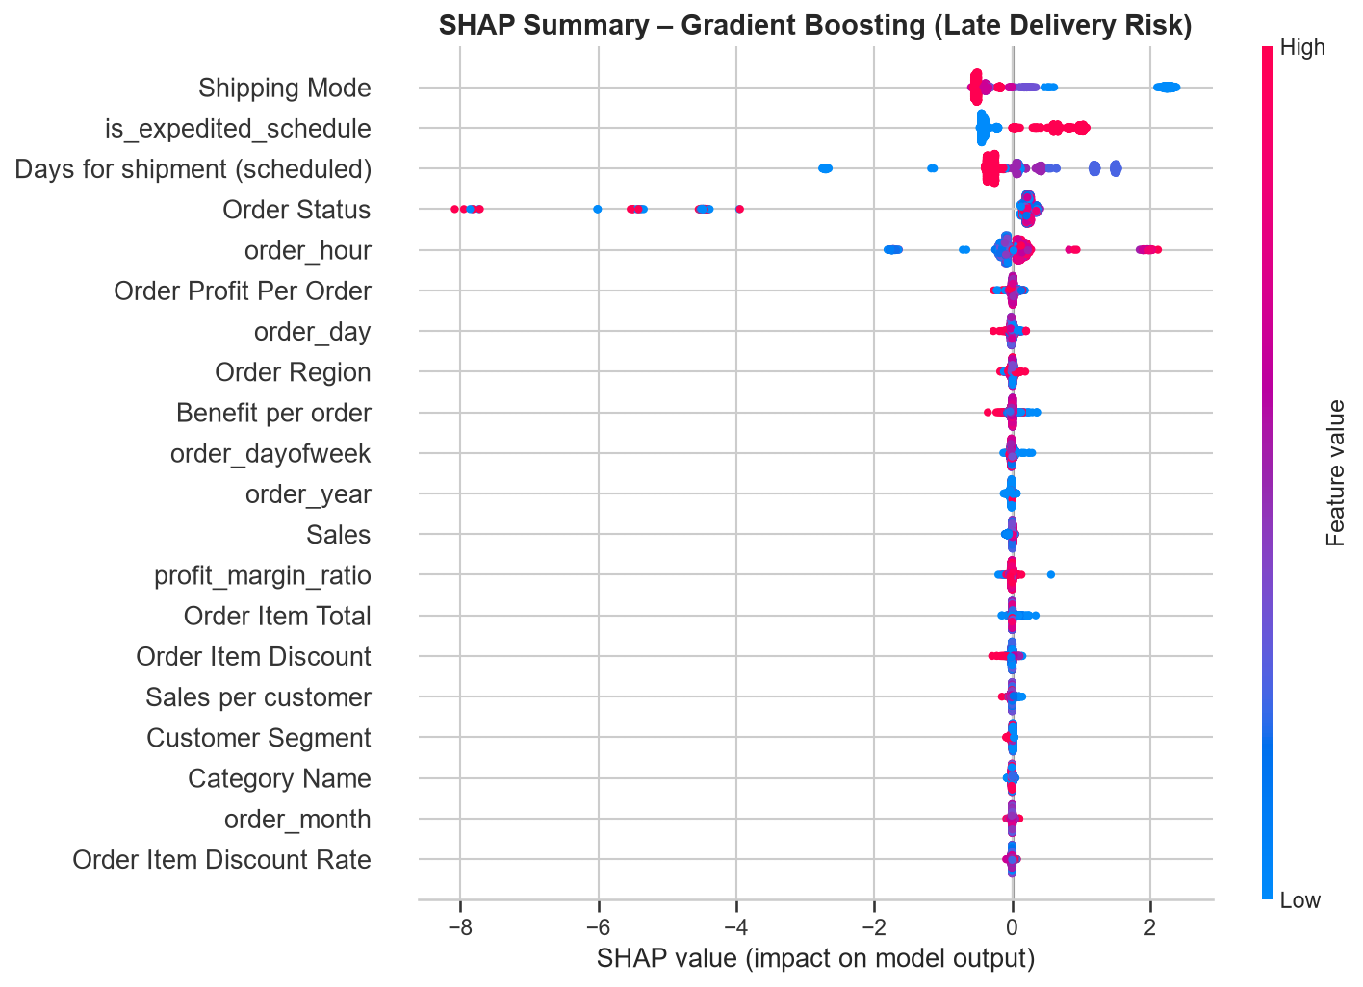
Figure 11: SHAP summary plot — Late delivery risk classification

11.1 Key SHAP Findings
- Days for shipment (scheduled) is the most important predictive factor for both delivery time and late delivery risk, suggesting the scheduling system's estimates carry useful signal.
- Shipping Mode is the second most important factor, with Same Day associated with lower predicted risk and Standard Class associated with higher predicted risk.
- Order Region contributes significantly, reflecting regional logistics infrastructure differences.
- Financial variables (Sales, Order Item Total) have moderate importance — higher-value orders may receive different handling.
- Temporal features (order_month, order_dayofweek) contribute modestly, suggesting seasonal and day-of-week patterns.

12. System Architecture
The project follows a modular, pipeline-based architecture with clear separation between data ingestion, preprocessing, modelling, evaluation, explainability, and deployment layers.
Component | File | Responsibility
Data Preprocessing | src/data_preprocessing.py | Load, clean, encode, split
Feature Engineering | src/feature_engineering.py | Create derived features
Regression Models | src/regression_models.py | Train/save regression models
Classification Models | src/classification_models.py | Train/save classifiers
Evaluation | src/evaluation.py | Compute and compare metrics
Explainability | src/explainability.py | SHAP-based model explanation
Prediction | src/prediction.py | Inference pipeline
Dashboard | dashboard/app.py | Streamlit executive dashboard
Training Script | scripts/train_and_evaluate.py | End-to-end pipeline runner
Tests | tests/ | Unit and integration tests

13. Key Findings
Finding | Implication
54.8% of shipments are delivered late. | Late delivery is systemic, not isolated.
Standard Class is the highest-volume, highest-risk shipping mode. | Improving Standard Class performance offers the greatest impact.
Scheduled delivery days is the strongest predictive factor. | Scheduling underestimation is predictable and preventable.
ROC-AUC = 0.800 on held-out test data. | Meaningful pre-delivery discrimination is achievable.
Same Day delivery has the lowest late rate but is used for <5% of shipments. | Premium shipping is underutilised relative to its performance.

14. Business Recommendations
- Deploy the predictive model at order confirmation to assign a risk score to every new shipment.
- Revise Standard Class SLA agreements: negotiate tighter delivery windows with logistics partners.
- Implement a risk-tiered intervention protocol: HIGH risk → dispatch alert + customer notification; MEDIUM risk → customer notification; LOW risk → standard process.
- Recalibrate scheduling estimates using model predictions to identify systematic underestimation.
- Establish region-specific KPIs and conduct quarterly logistics partner reviews for underperforming regions.
- Upgrade high-value Corporate customers automatically to expedited shipping modes above a revenue threshold.

15. Limitations
- Dataset covers 2015–2018; supply chain patterns may have changed post-COVID.
- Regression R² of 0.39 indicates substantial unexplained variance from factors not in the dataset (carrier performance, weather, inventory).
- SHAP shows association, not causation.
- Optimal probability thresholds require business input on the cost of false alarms vs. missed late deliveries.
- The model is trained on a static snapshot; production deployment requires periodic retraining.

16. Future Scope
- Real-time API integration with order management systems.
- Carrier-level performance modelling.
- External feature integration (weather indices, geopolitical risk).
- Time-series forecasting (LSTM, Prophet) for volume and risk trends.
- Automated retraining with data drift detection.

17. Conclusion
This project demonstrated that supply chain delivery risk can be meaningfully predicted from pre-delivery information alone, without relying on any post-delivery data leakage. The Gradient Boosting classifier achieves ROC-AUC = 0.800 — significantly better than chance — enabling organisations to flag high-risk shipments before dispatch. Key predictive factors identified through SHAP analysis (scheduled days, shipping mode, order region) provide actionable targets for operational improvement. The accompanying interactive dashboard makes these findings accessible to executive decision-makers without technical expertise in machine learning.

References
- Constante, F., Silva, F., & Pereira, A. (2019). DataCo Smart Supply Chain for Big Data Analysis. Mendeley Data, V5. https://doi.org/10.17632/8gx2fvg2k6.5
- Breiman, L. (2001). Random forests. Machine Learning, 45(1), 5–32.
- Friedman, J. H. (2001). Greedy function approximation: A gradient boosting machine. Annals of Statistics, 29(5), 1189–1232.
- Lundberg, S. M., & Lee, S.-I. (2017). A unified approach to interpreting model predictions. Advances in Neural Information Processing Systems, 30.
- Chen, T., & Guestrin, C. (2016). XGBoost: A scalable tree boosting system. KDD 2016.
- Pedregosa, F., et al. (2011). Scikit-learn: Machine learning in Python. JMLR, 12, 2825–2830.
- McKinney, W. (2010). Data structures for statistical computing in Python. Proceedings of the 9th Python in Science Conference.

