**NUMERICAL PREDICTION ANALYSIS USING LINEAR**

**REGRESSION THROUGH WEKA**

**AIM**:

To perform numerical prediction analysis using linear regression through weka

**DESCRIPTION :**

Consider a dataset of house.arff where it contains the attributes as house size, lot size, bedrooms, granite, bathroom and the selling price.

**Steps :**

* Load the dataset into the weka tool and check for the attributes.
* Classify the data using linear regression analysis method (or) technique.
* Check for the cross-validation folds where the value of the folds should be less than the value of the instances present in the dataset.
* Observe the cross validation summary after applying the linear regression technique for the price of the house.

**OUTPUT:**

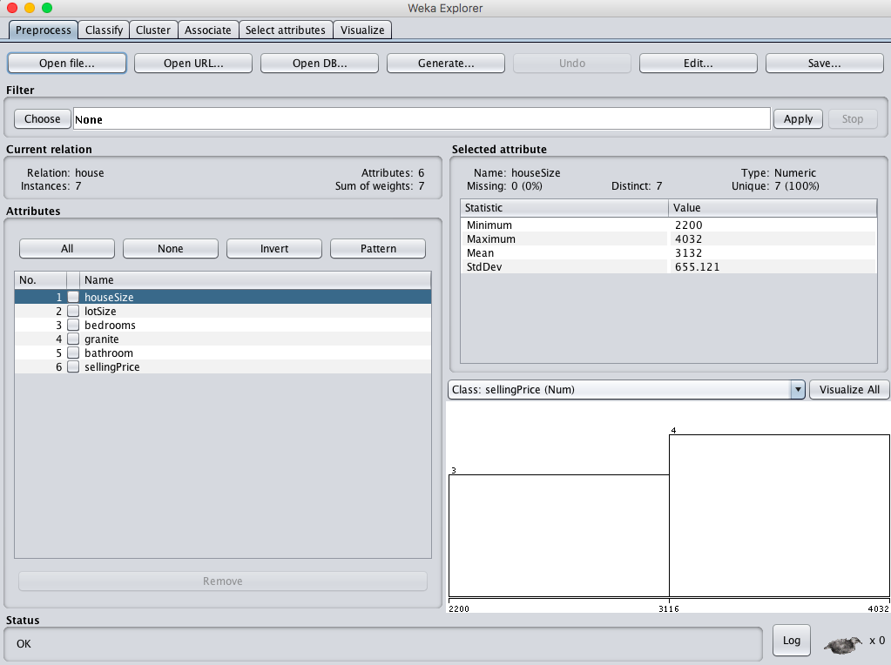

* **When cross validation folds = 05 :**

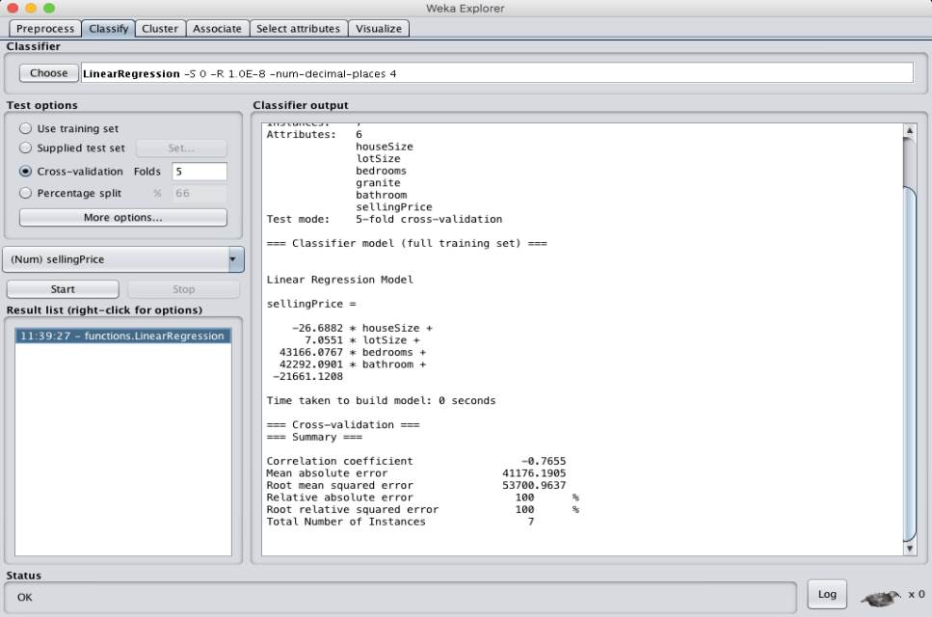

* **When cross validation folds = 10 :**

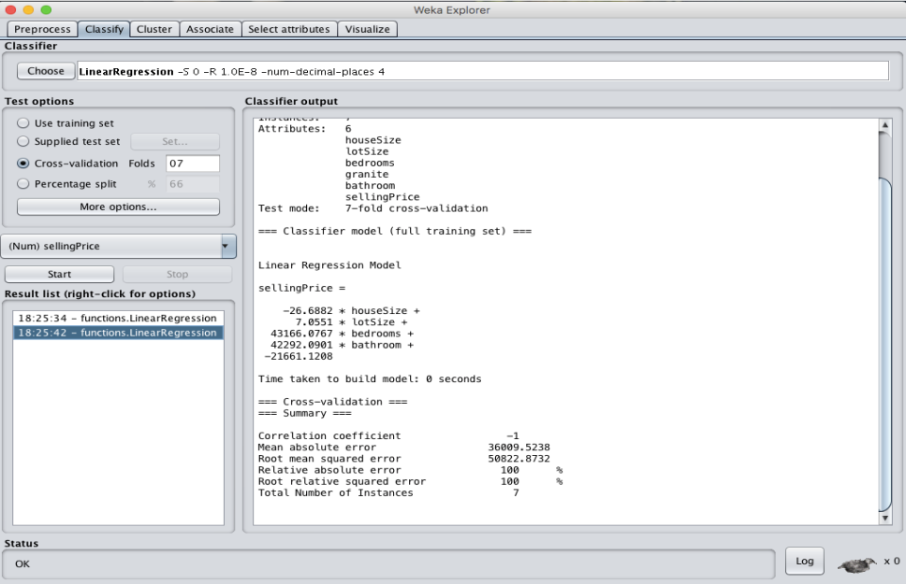

**RESULT :**

Thus, the house selling price has been observed using linear regression model. If the value of cross validation folds decreases time for creating model will be less than when folds value high, and the mean absolute error and Root mean square error values decreases with increase in the cross validation folds value.