**DATA SEGMENTATION BYK- MEANS CLUSTER**

**USING WEKA AND R-TOOL**

**DESCRIPTION :**

Consider a dataset of citycrimes.csv file of which it contains the attributes are City, Pop, WC, BP, Mur, Rap, Rob, Ass, Bus and car for the performance of the dataset by applying the K-means algorithm in weka and as well using R- tool.

* **USING WEKA TOOL :**

**STEPS INVOLVED :**

* Choose a set of attributes for clustering and for giving a motivation.
* Choose the dataset and import the dataset into Weka tool.
* Cluster the dataset and choose simple K-means algorithm and give the motivation.

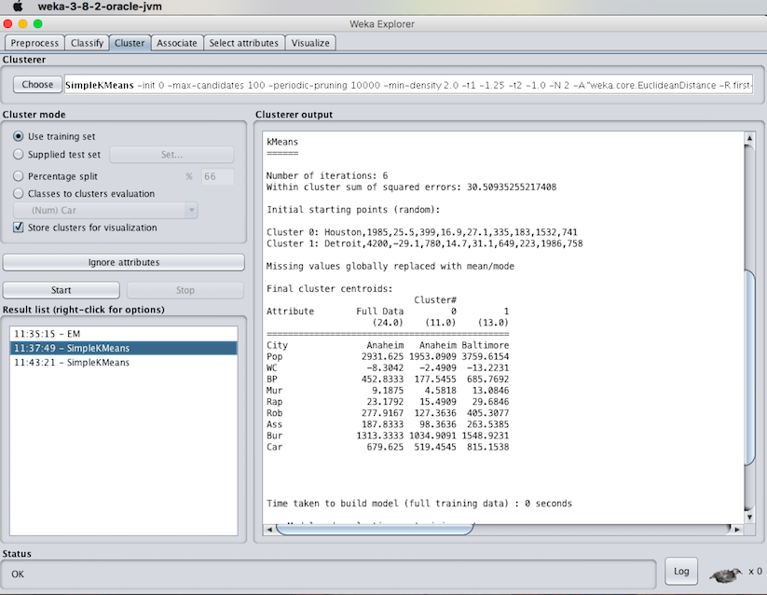

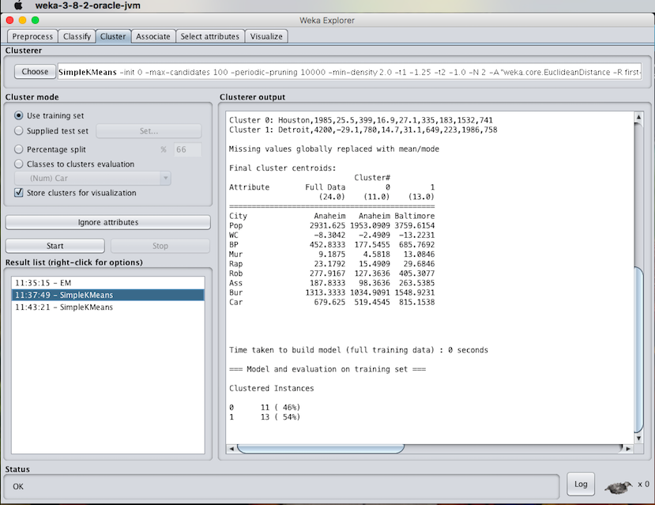

1. **Experiment with atleast 2 different number of clusters but with same seed values:**

**STEPS INVOLVED :**

* Compare the two different clusters but with the same seed values.
* Change the number of clusters value and need not to change the seed value.
* Apply the K-means algorithm and start executing the algorithm.

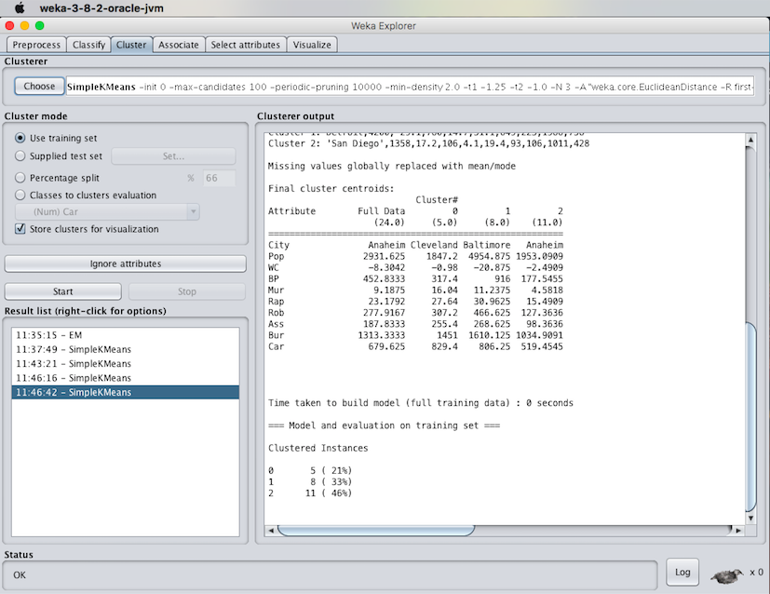

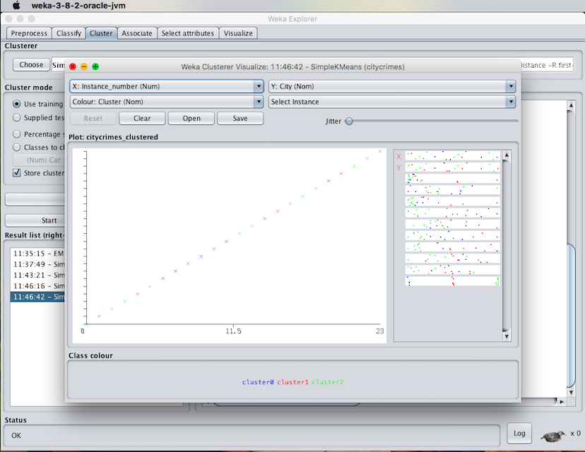

RESULT :

Thus, the K-means clustering analyzing using the weka tool has been successfully completed. In case of weka tool, the change in seed values lead to the decrease in the number of iterations.