**DATASEGMENTATION BY EXPECTATION**

**MAXIMISATION ALGORITHM**

**THROUGH WEKA**

**DESCRIPTION :**

Consider a dataset of citycrimes.csv file of which it contains the attributes are City, Pop, WC, BP, Mur, Rap, Rob, Ass, Bus and car for the performance of the dataset by applying the K-means algorithm in weka and as well using R- tool.

When the clustering is been made through the expectation maximization algorithm by setting minimum standard deviation values then the results will be of the following :

* **Steps Involved :**
* Initially, load the dataset into the weka tool and check for all the attributes present in the dataset.
* Then move to cluster panel and apply the EM algorithm technique for the datasheet.
* Finally, Observe the results that are obtained.

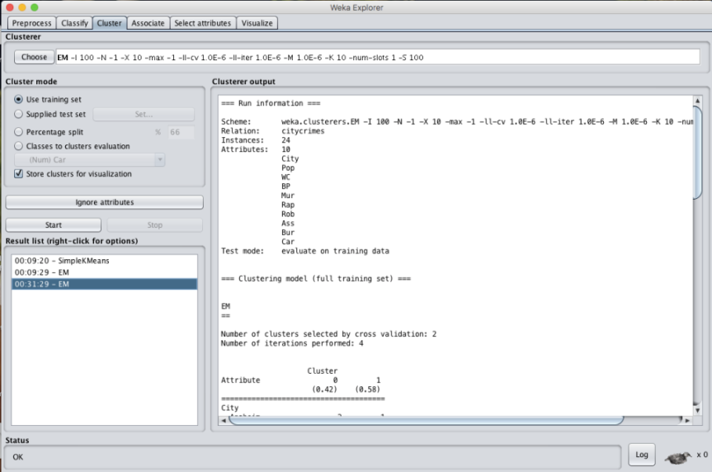

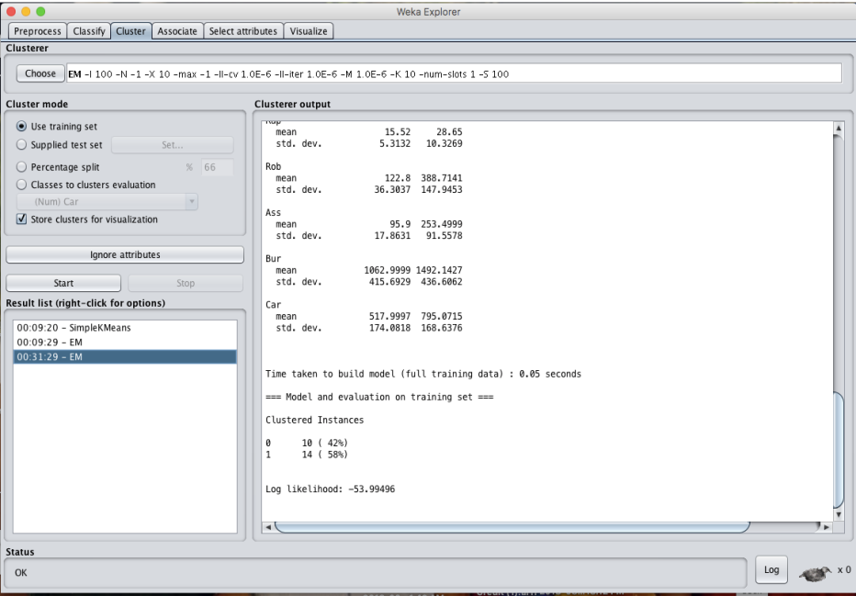

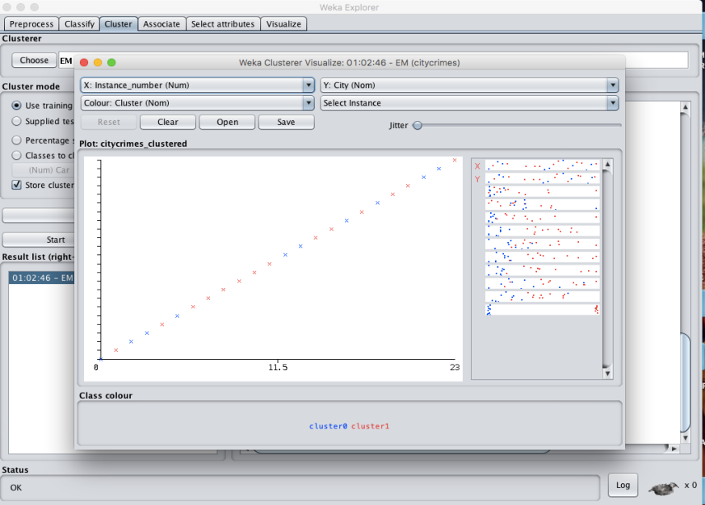

* **K- MEANS ALGORITHM:**

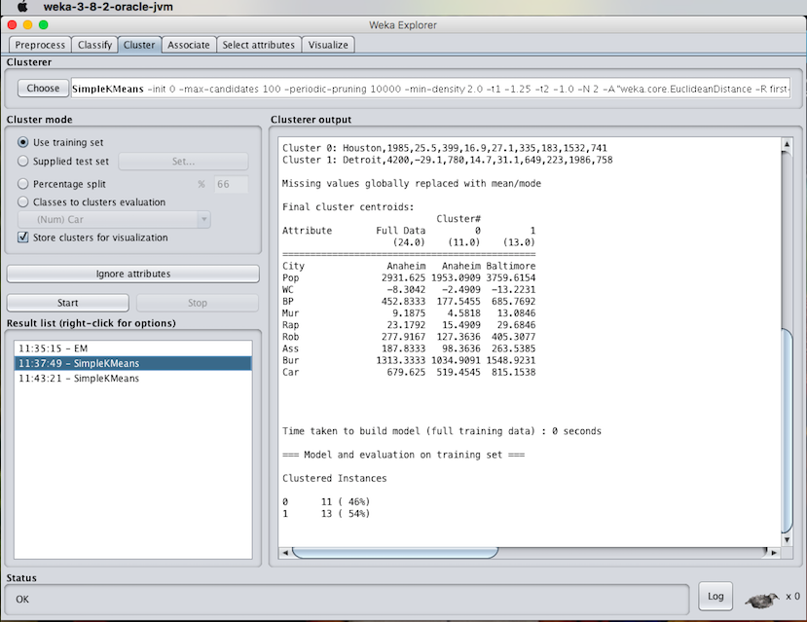

RESULT :

Thus, the data analysis by the expectation maximization algorithm using weka has been analyzed and observed properly.