**DATA SEGMENTATION BY COBWEB – HIERARCHIAL CLUSTERING**

**ALGORITHM USING WEKA TOOL**

.

**DESCRIPTION:**

Consider a dataset netscan.csv where it contains the attributes of Newsgroups, posts, posters, PPRatio, Returnees, Replies, Repliers, UnRMsgs, Avg.LineCT, Xports, XPTgs. Each attribute will have different types of the meanings.

**HIERARCHIIAL CLUSTERING:**

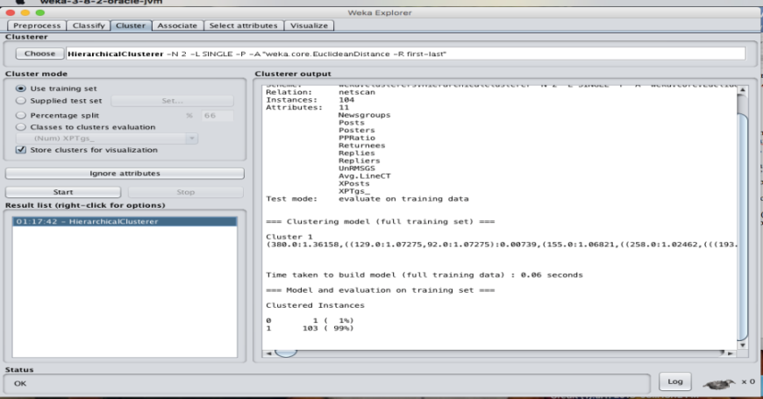

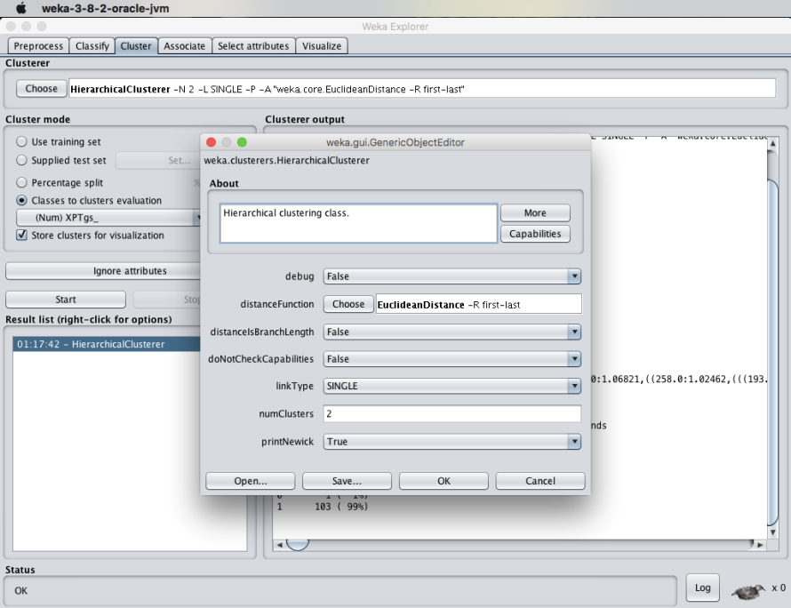

**RESULT :**  
 Thus, the data analysis of cobweb hierarchial clustering algorithm using weka tools has been analyzed and observed successfully.