**FREQUENT PATTERN MINING USING FP GROWTH**

**THROUGH WEKA TOOL**

**DESCRIPTION :**

Consider a dataset of 2015.csv file of which it contains the attributes are Reference Number, Grid ref: Easting, Grid Ref: Northing, Number of vehicles, Accident date, Time(24 hr), 1st Road class, Road Surface, Lighting conditions, Weather conditions, casuality class, Sex of casuality, Age of casuality, Type of casuality for the performance of the dataset by applying the FP algorithm in weka tool.

* **USING WEKA TOOL :**

**STEPS INVOLVED :**

* Choose a set of attributes for clustering and for giving a motivation.
* Choose the dataset and import the dataset into Weka tool.
* Discretize the attributes from all data types to nominal to perform the algorithm.
* Associate the attributes with the FP growth algorithm.
* Set the Upper bound min_sup and lower bound min_sup values.

**OBSERVATIONS :**

1. When the association rules are of values:
2. Upper bound min_sup = 1.0
3. Lower bound min_sup = 0.1
4. Metric type = confidence.

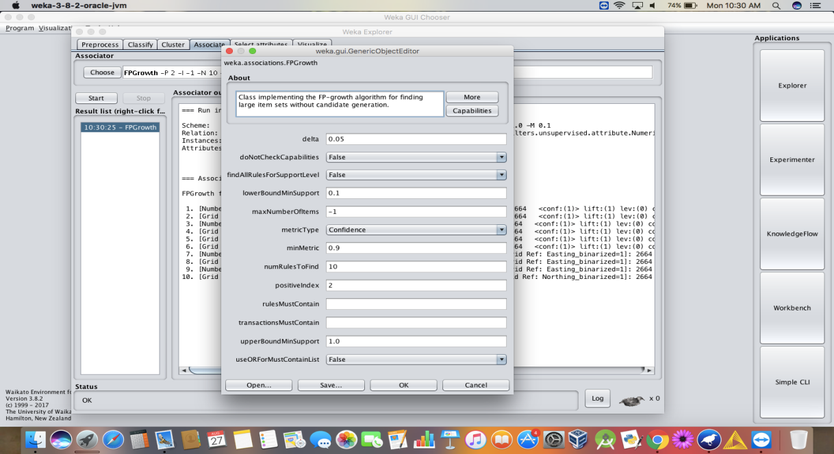

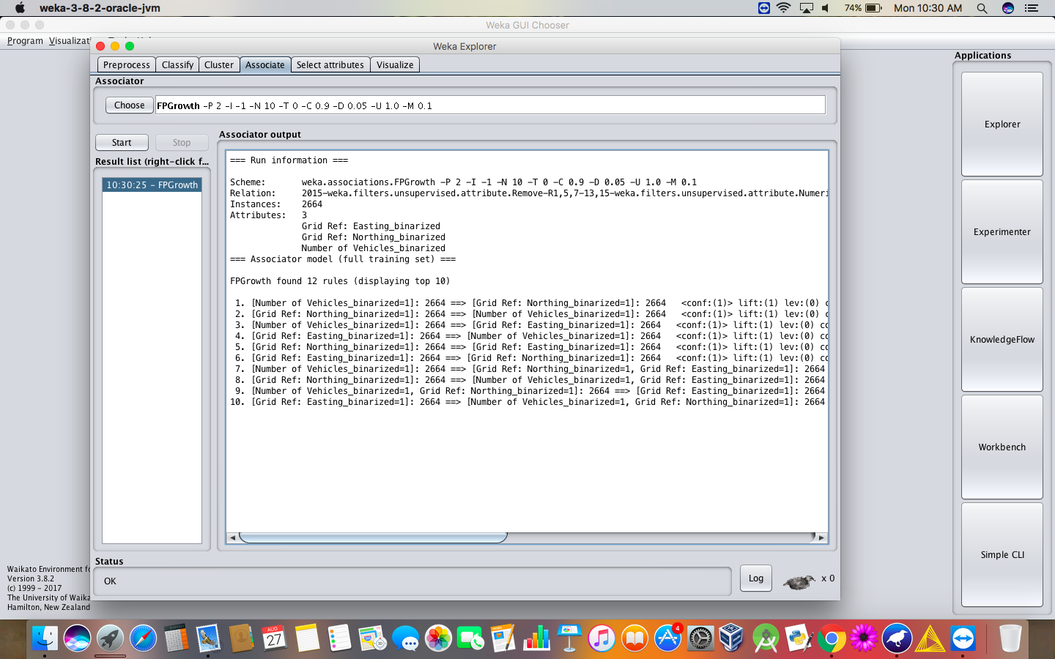

1. When the association rules are of values:
2. Upper bound min_sup = 2.0
3. Lower bound min_sup = 1.0
4. Metric type = confidence.

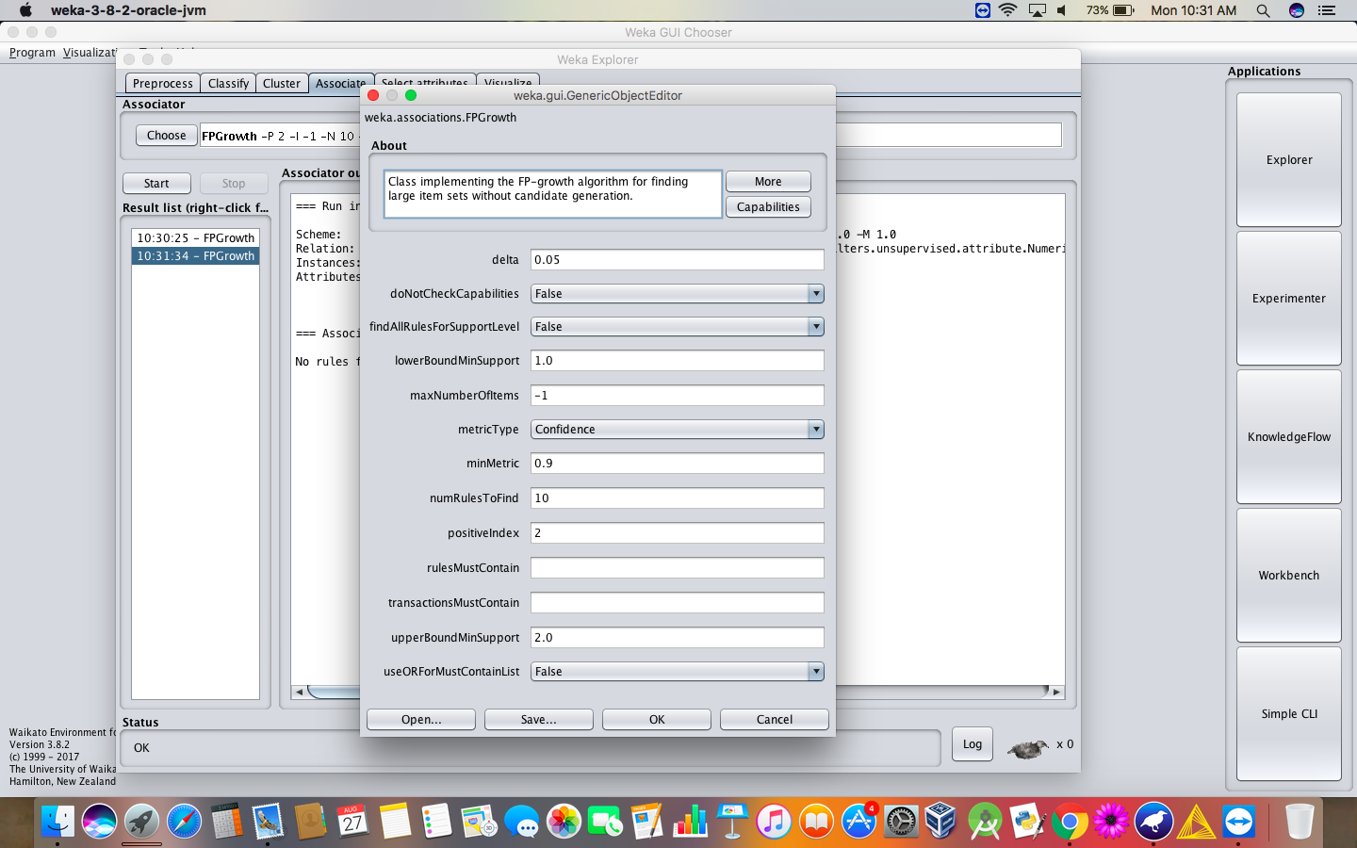

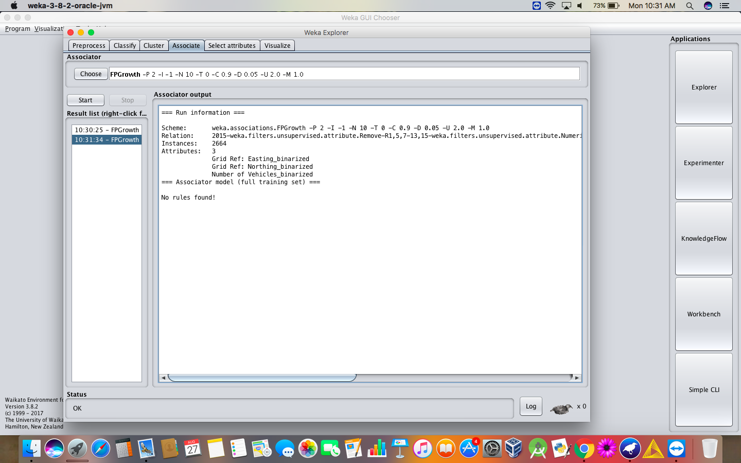

**RESULT :**

Thus, the analysis of FP growth algorithm using weka tool has been successfully completed. Incase of changing the upper bound and lower bound values there is a change in the number of rules that are found.