**PREDICTION OF CATEGORICAL DATA USING DECISION TREE**

**ALGORTIHM THROUGH WEKA**

* **Decision Tree :**

Visualize the decision tree for the given dataset.

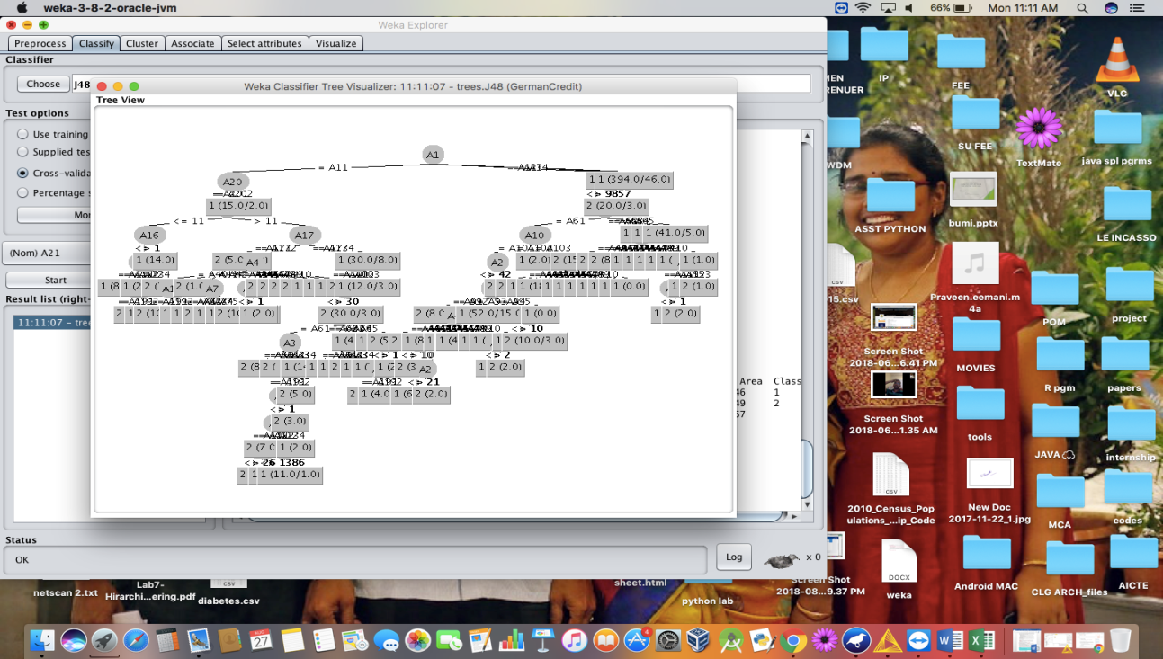

or.

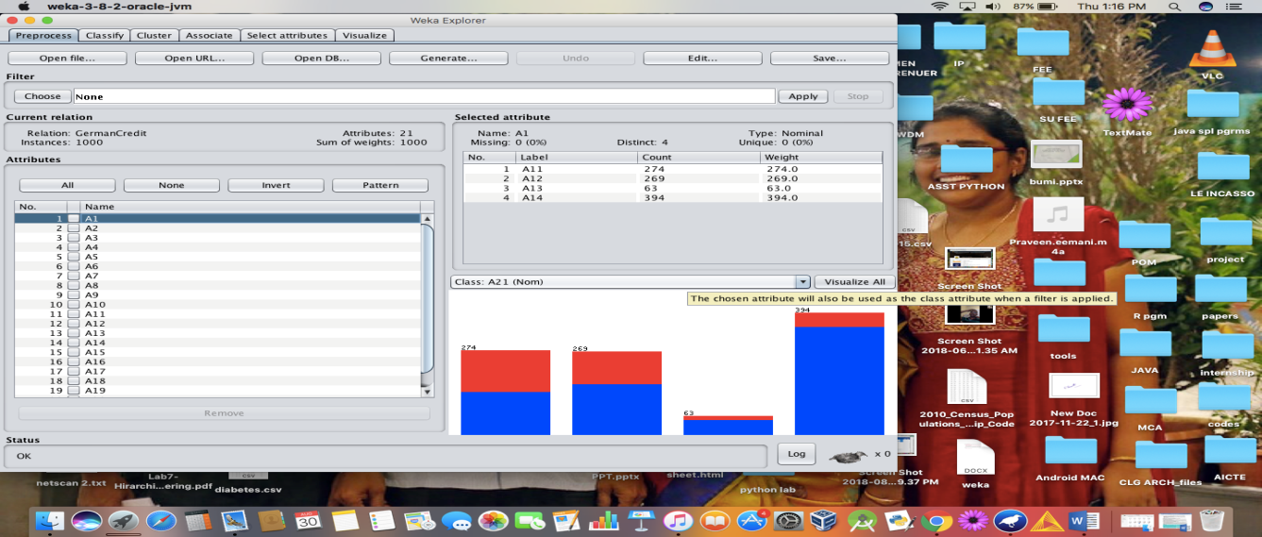

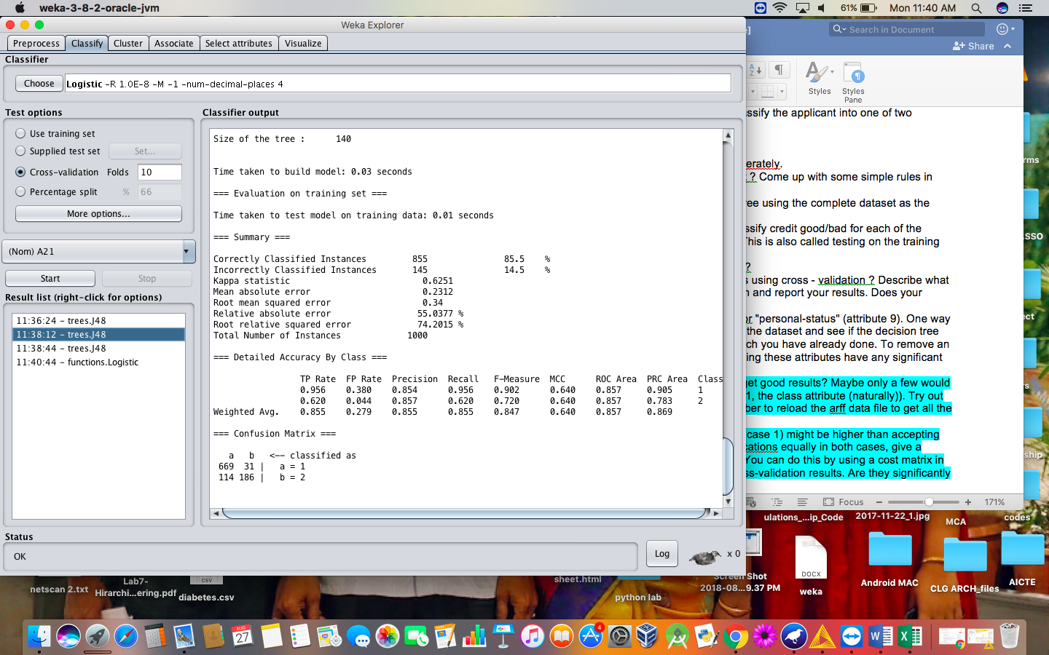

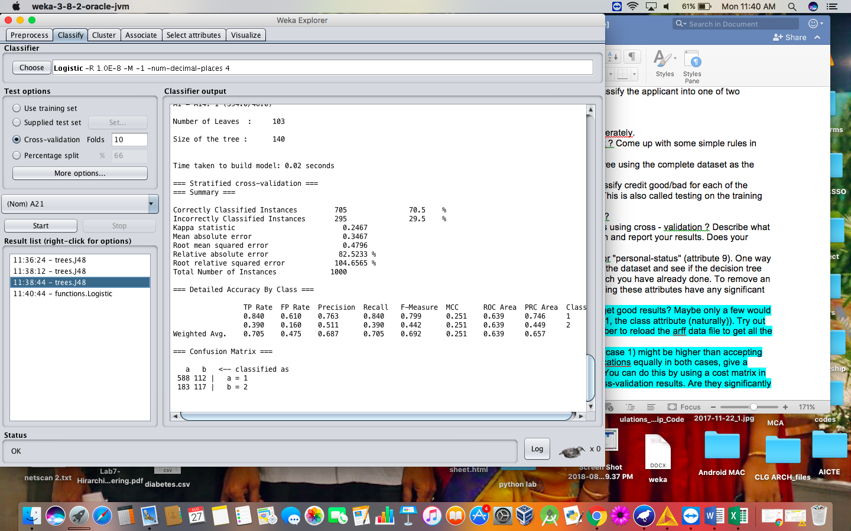

* **CROSS VALIDATION ANALYSIS :**
* **When cross validation folds are 10 :**

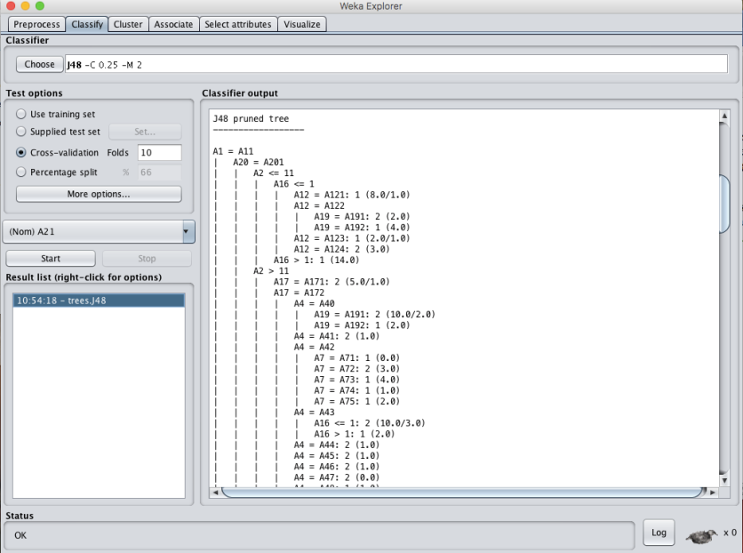

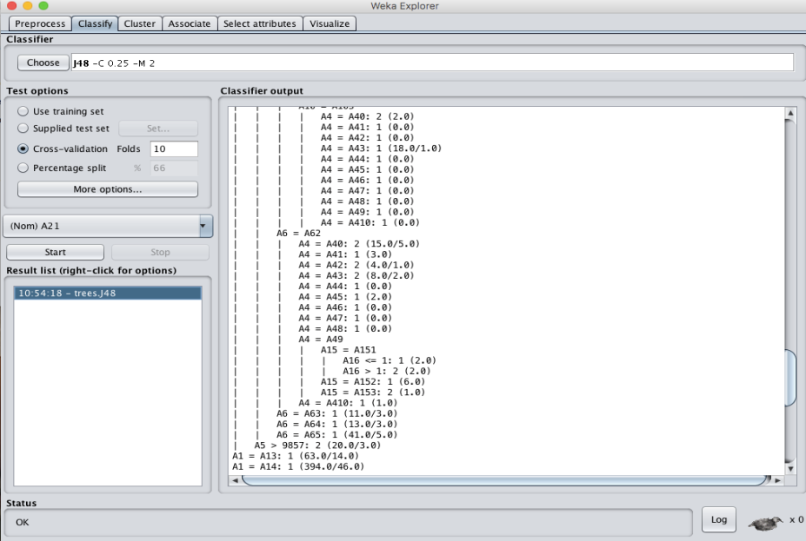

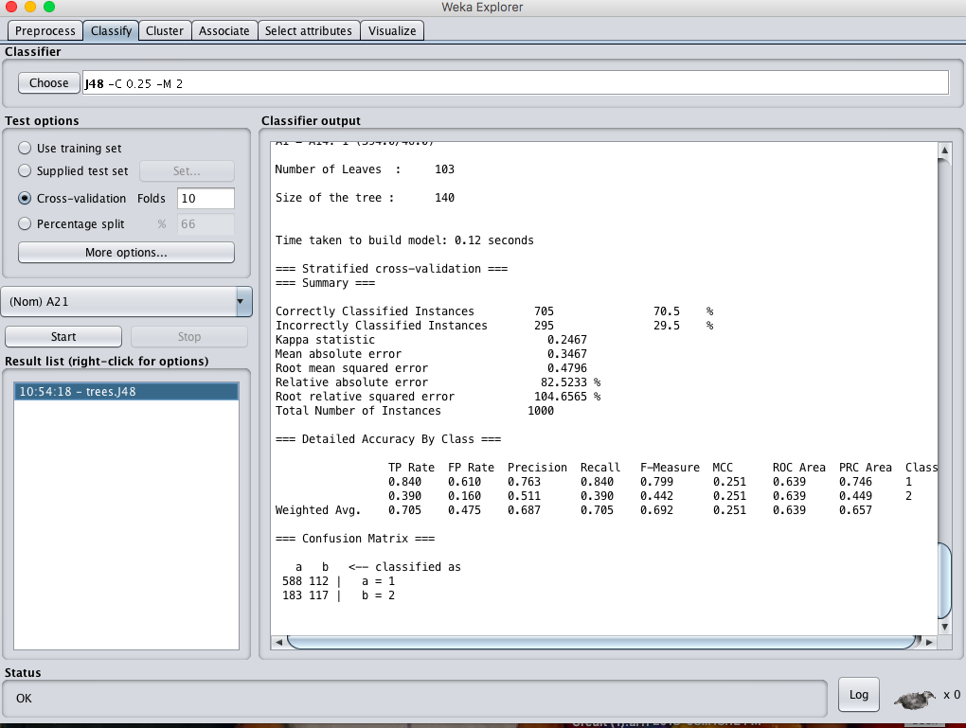

* **When cross validation folds are : 05 :-**

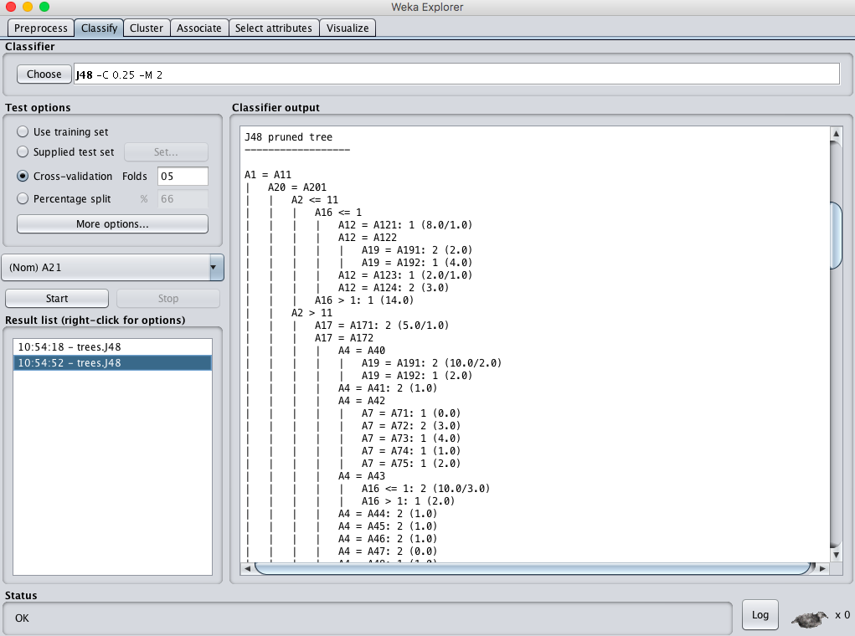

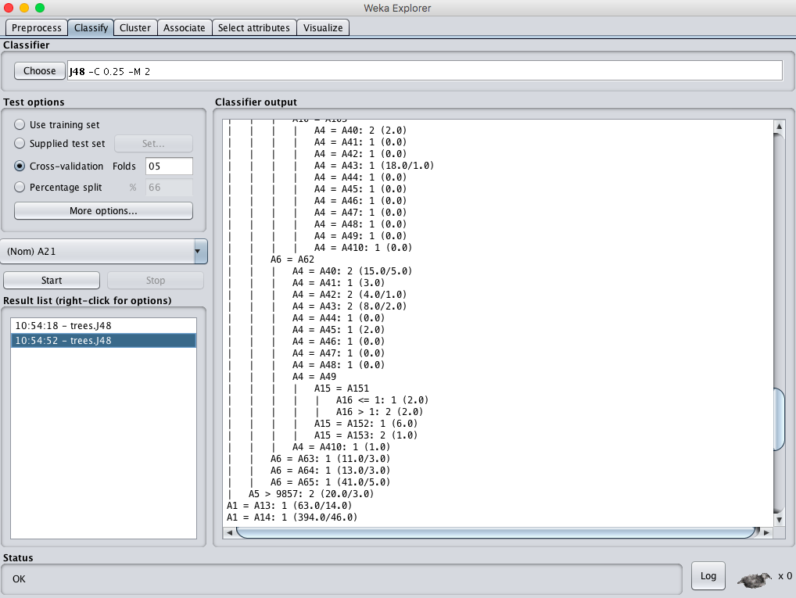

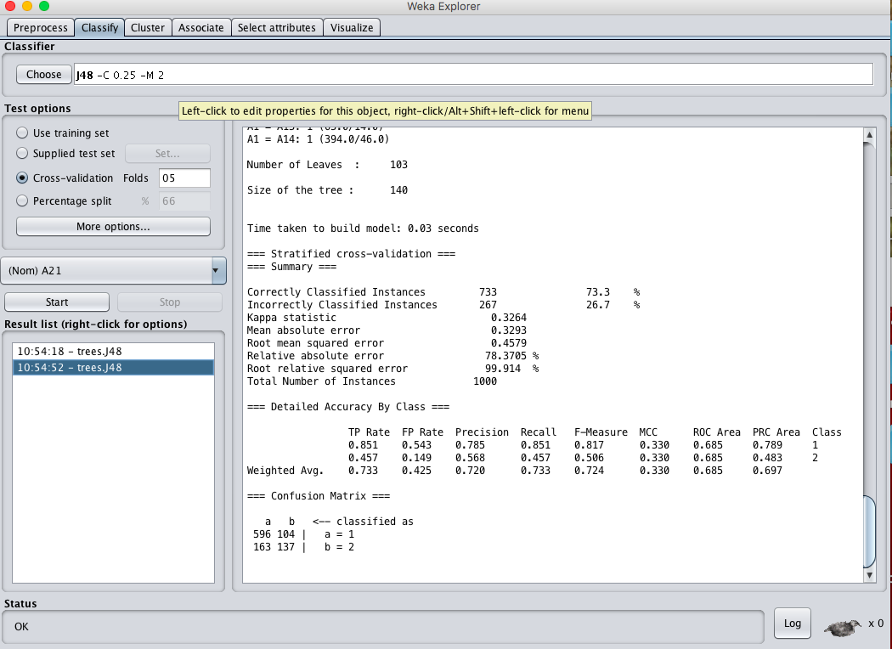

**RESULT :**

Thus, the observations and evaluations done on the german_credit dataset are analyzed. The decision tree has been successfully visualized. Various evaluations and comparisons done through the cross validation folds change. Which lead to the change of values in confusion matrix.