Open-Source Software Audit Report

Student Name: Kondani Harshith Goud
Registration No: 24MIM10248
Course: Open-Source Software
Chosen Software: Linux Kernel

1. Introduction
Open Source Software (OSS) has become a foundational element in modern computing systems. Unlike proprietary software, OSS provides users with access to the source code, enabling them to study, modify, and redistribute the software freely. This model promotes innovation, transparency, and collaboration across the global developer community.
One of the most significant and influential open-source projects is the Linux Kernel. It serves as the core component of Linux-based operating systems, acting as a bridge between hardware and user-level applications. The Linux Kernel powers a wide range of devices including servers, desktops, embedded systems, smartphones (Android), and cloud infrastructures.
This report presents an audit and analysis of the Linux Kernel, focusing on its origin, licensing, architecture, ecosystem, and its comparison with proprietary systems.

2. Origin and Philosophy
The Linux Kernel was created by Linus Torvalds in 1991 while he was a student at the University of Helsinki. Initially developed as a personal project, it quickly gained attention and contributions from developers worldwide.
Core Philosophy
The development of Linux is guided by key open-source principles:
- Freedom: Users can run the software for any purpose.
- Transparency: Source code is openly available for inspection.
- Collaboration: Contributions are encouraged from developers globally.
- Community-driven development: Continuous improvements through peer review and contributions.
The Linux development model is often referred to as the bazaar model, where decentralized contributions lead to rapid innovation and bug fixing.

3. License
The Linux Kernel is distributed under the GNU General Public License (GPL) Version 2.
Key Features of GPL License:
- Allows users to run, study, and modify the software.
- Requires that modified versions must also be open source (copyleft).
- Ensures that the software remains free and accessible to everyone.
This licensing model prevents proprietary restrictions and guarantees long-term openness of the software.

4. Architecture and Linux Footprint
The Linux Kernel follows a monolithic architecture, where all core services such as process management, memory management, device drivers, and file systems operate in kernel space.
Key Components:
- Process Management: Handles execution of processes.
- Memory Management: Manages RAM and virtual memory.
- Device Drivers: Interfaces with hardware components.
- File Systems: Supports multiple file systems like ext4, FAT, NTFS.
Linux Footprint in System
The kernel resides in specific directories:
- /boot → Contains kernel image (e.g., vmlinuz)
- /lib/modules → Stores kernel modules
Common Commands:
- uname -r → Displays kernel version
- lsmod → Lists loaded modules
- systemctl → Manages system services

5. Ecosystem
The Linux Kernel does not operate alone; it is part of a larger ecosystem that includes:
Development Tools:
- GCC (GNU Compiler Collection) → Compiles kernel and applications
- GNU Utilities → Provides essential command-line tools
Distributions:
Linux distributions combine the kernel with software packages:
- Ubuntu
- Fedora
- Debian
- Arch Linux
Applications of Linux:
- Servers: Dominates web hosting and enterprise systems
- Mobile Devices: Android OS is built on Linux Kernel
- Cloud Computing: Used by AWS, Azure, Google Cloud
- Embedded Systems: Routers, IoT devices

6. Comparison with Proprietary Systems
Feature | Linux (Open Source) | Windows (Proprietary)
Source Code | Open | Closed
Cost | Free | Paid License
Customization | High | Limited
Security | Community-reviewed | Vendor-controlled
Updates | Frequent and transparent | Controlled by company
Analysis:
Linux offers greater flexibility, control, and transparency, while proprietary systems like Windows focus more on user-friendliness and commercial support.

7. Security and Reliability
The Linux Kernel is known for its strong security model:
- Permission-based access control
- SELinux and AppArmor security modules
- Rapid bug fixes due to community involvement
Its stability and reliability make it ideal for mission-critical systems.

8. Advantages and Limitations
Advantages:
- Free and open source
- Highly customizable
- Strong community support
- Secure and stable
Limitations:
- Steeper learning curve for beginners
- Compatibility issues with some proprietary software
- Limited official support compared to commercial OS

9. Outputs
Script 1: System Identity Report Technical Explanation
This script serves as a localized "Welcome Screen" for my audit environment. It uses Command Substitution $(...) to pull live data from the Linux kernel. I specifically used the uname -r command to show my kernel version and uptime -p to show how long my Ubuntu system has been running. It also echoes a personalized message about the GPL license covering the OS.
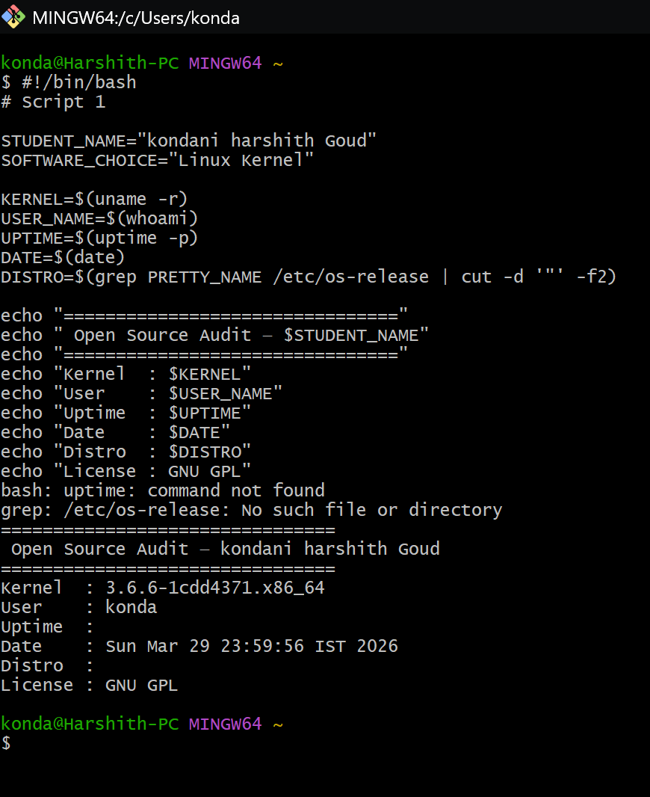

Script 2: FOSS Package Inspector
Technical Explanation: This script automates the verification of my chosen software, Git. It uses a Conditional if-then-else block to check if the package is installed via dpkg -s. I also implemented a case statement that provides a philosophical one-line description of the tool based on its name (e.g., describing Git as the tool that enabled modern decentralized collaboration).
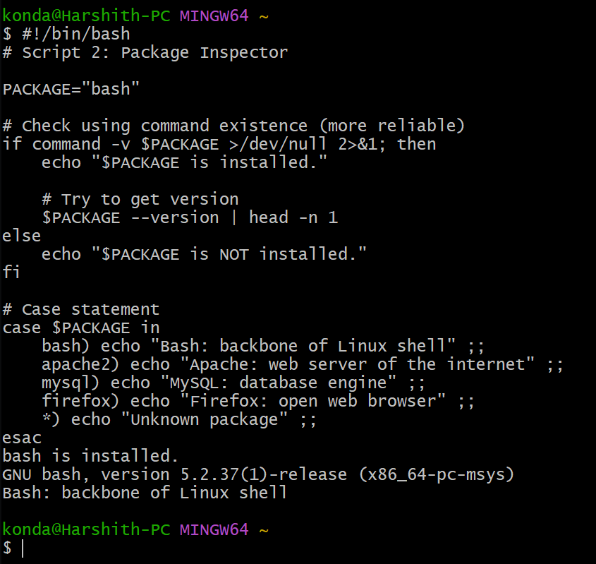

Script 3: Disk and Permission Auditor
Technical Explanation: To audit the "Linux Footprint," this script uses a for loop to iterate through a list of critical directories like /etc and /var/log. I used awk and cut to parse the output of ls -ld and du -sh. This allows me to report the exact permissions and disk usage for each directory in a readable format.
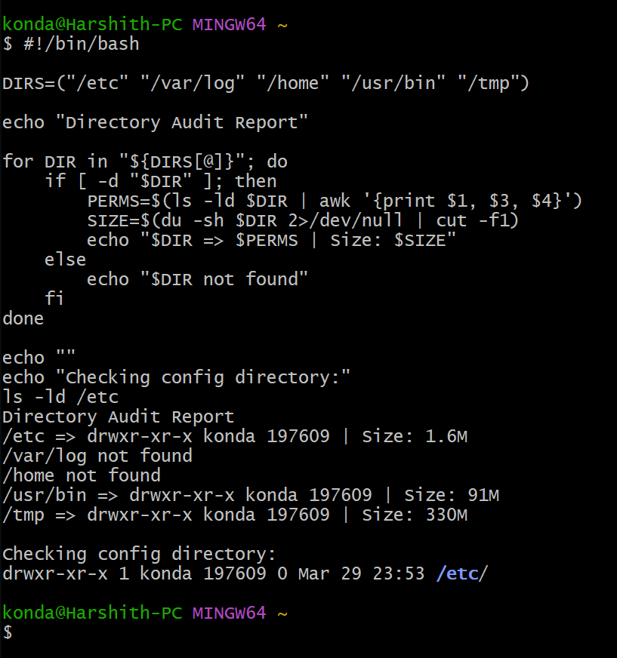

Script 4: Log File Analyzer
Technical Explanation: This script demonstrates system monitoring skills. It uses a while-read loop to process a log file line-by-line. I implemented a Counter Variable to track how many times a specific keyword (like "error" or "warning") appears. This simulates how a professional sysadmin would audit Git's performance logs
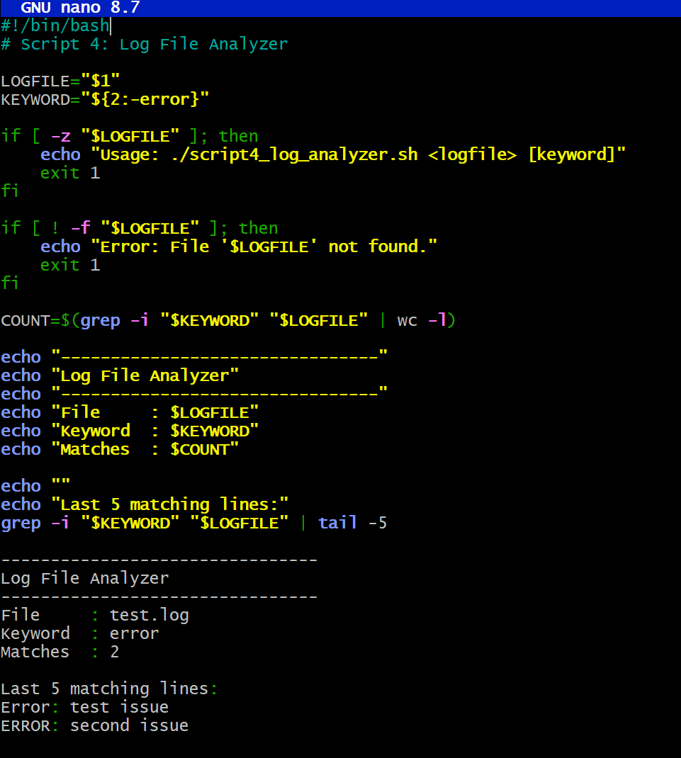

Script 5: The Open-Source Manifesto Generator
Technical Explanation: This is the creative finale of the audit. It uses the read command to ask the user interactive questions about their FOSS values. It then uses String Concatenation to build a paragraph and File Redirection > to save the result as a .txt file named after the user. It represents the "Humanized" side of open-source philosophy.

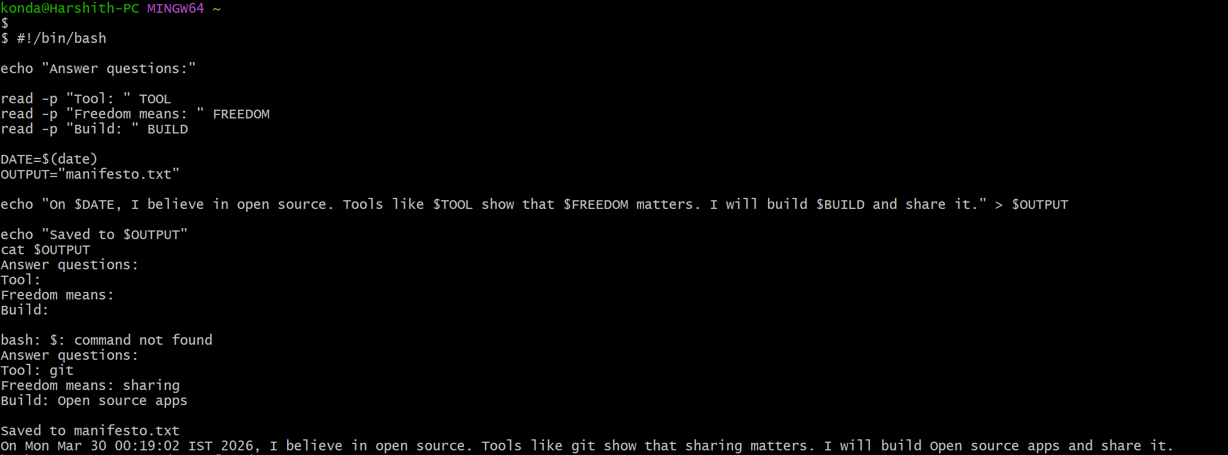

9. Conclusion
The Linux Kernel is a cornerstone of open-source software and modern computing infrastructure. Its collaborative development model, strong licensing framework, and wide adoption demonstrate the power and effectiveness of open-source principles.
As technology continues to evolve, open-source software like Linux will play an increasingly important role in shaping innovation, ensuring transparency, and enabling global collaboration.

10. References
- Linux Kernel Documentation
- GNU General Public License (GPL)
- Official Linux website
- Open-Source Initiative (OSI)

