🌱
OptiCrop
Smart Agricultural Production Optimization Engine
Full Stack Development — Project Documentation
Prepared: July 2026

1. Introduction

Project Title
OptiCrop — Smart Agricultural Production Optimization Engine

Team Members
Name | Role
Bhavani Sankar Kondapalli | [Add role]
Harshitha Baluguri | [Add role]
Goli Prasanthi | [Add role]
Hemasreekari Yalamanchili | [Add role]
K Siva Ganesh Kandregula | [Add role]

2. Project Overview

Purpose
OptiCrop is a data-driven web application that helps farmers, agronomists, and policy planners make informed crop-related decisions. Using a machine-learning classification model trained on soil nutrient levels (Nitrogen, Phosphorus, Potassium) and climate conditions (temperature, humidity, pH, rainfall), the system recommends the most suitable crop for a given plot of land, assesses how well current conditions suit a specific crop, and presents aggregate model-performance and crop-environment analytics for research and planning purposes.

Features
- Smart Crop Recommendation: farmers enter soil and climate readings and receive the top three recommended crops, each with a confidence score.
- Crop Suitability & Environmental Assessment: users select a specific crop and enter current field conditions to receive a 0–100 suitability score, a per-parameter breakdown (optimal / acceptable / unsuitable), and an overall verdict.
- Agricultural Research & Policy Planning Dashboard: a analytics dashboard presenting model comparison metrics, classification performance, exploratory data analysis (EDA) charts, and per-crop environmental profiles.
- Model auto-selection: five candidate classifiers are trained and cross-validated, and the best-performing model is automatically selected and persisted for use by the web application.
- Statistically grounded scoring: suitability scoring uses each crop's training-data mean/standard deviation with a Gaussian-based match score, and feature relevance is validated with a one-way ANOVA test on rainfall.

3. Architecture
Note: this reference documentation format was designed for a MERN (MongoDB, Express, React, Node.js) stack. OptiCrop is instead implemented as a Python data-science and web application, so the sections below describe the project's actual architecture (Flask + scikit-learn, server-rendered templates, and flat-file model artifacts) in place of MongoDB/Express/React equivalents.

Frontend
- Server-rendered HTML using Flask's Jinja2 templating engine (templates/ directory): base.html (shared layout and navigation), index.html (recommendation form), result.html (recommendation output), suitability.html / suitability_result.html (suitability check flow), and dashboard.html (research dashboard).
- Styling is handled through a single static stylesheet, static/css/style.css, applied across all pages via the shared base layout.
- Navigation links the three core scenarios: Recommend, Suitability Check, and Research Dashboard.

Backend
- Built with Flask (app.py), a lightweight Python web framework, rather than Node.js/Express.
- On startup, the backend loads the serialized model (crop_model.pkl), the fitted feature scaler (scaler.pkl), per-crop statistics (crop_stats.json), and model evaluation metrics (metrics.json) using joblib and json.
- Three route groups implement the three usage scenarios: '/' and '/predict' (recommendation), '/suitability' and '/suitability/check' (suitability assessment), and '/dashboard' (analytics).
- Business logic includes get_form_values() (form parsing), predict_top_crops() (top-3 ranked prediction using predict_proba), and suitability_score() (Gaussian-based per-feature and overall suitability scoring).
- Deployment is configured via a Procfile ('web: gunicorn app:app') for Gunicorn-based hosting on platforms such as Render or Heroku, and runtime.txt pins the Python version (3.11.9).

Database / Data Layer
OptiCrop does not use MongoDB or another database server. Instead, data persistence is handled through flat files generated by the machine-learning pipeline:
Artifact | Purpose
data/crop_data.csv | Synthetic agronomic dataset — 22 crops × ~120 samples (2,640 rows), columns: N, P, K, temperature, humidity, ph, rainfall, label
model/crop_model.pkl | Serialized best-performing classifier (selected automatically during training)
model/scaler.pkl | Fitted StandardScaler used to normalize input features before prediction
model/crop_stats.json | Per-crop mean/standard deviation for each feature, used for suitability scoring
model/metrics.json | Model comparison results and classification report used by the dashboard
model/anova_rainfall.json | One-way ANOVA (F-statistic, p-value) validating rainfall's predictive relevance
The dataset schema (N, P, K, temperature, humidity, ph, rainfall, label) is designed so that a real-world sensor or soil-survey dataset with the same column names can be substituted with no code changes.

4. Setup Instructions

Prerequisites
- Python 3.11 (see runtime.txt)
- pip (Python package manager)
- Dependencies listed in requirements.txt: Flask, numpy, pandas, scikit-learn, matplotlib, seaborn, scipy, joblib, gunicorn

Installation
1. Create and activate a virtual environment (recommended):
python3 -m venv venv
source venv/bin/activate # Windows: venv\Scripts\activate
2. Install dependencies:
pip install -r requirements.txt
3. (Re)generate the dataset — already included in the repository, but reproducible:
python3 data/generate_dataset.py
4. Train the model — this regenerates model/*.pkl and the static/images/*.png charts:
python3 model/train_model.py
5. Run the web application:
python3 app.py
Then open http://localhost:5000 in a web browser.

5. Folder Structure
As the project is a single Flask application rather than a client/server MERN split, the structure below is organized by module instead of client/server.
OptiCrop/
├── app.py # Flask application (routes for all 3 scenarios)
├── requirements.txt
├── Procfile / runtime.txt # Deployment configuration
├── data/
│ ├── generate_dataset.py # Synthetic agronomic dataset generator
│ └── crop_data.csv # Generated dataset (22 crops x ~120 samples)
├── model/
│ ├── train_model.py # Training pipeline: EDA, model selection, evaluation
│ ├── crop_model.pkl # Serialized best model (generated)
│ ├── scaler.pkl # StandardScaler (generated)
│ ├── crop_stats.json # Per-crop mean/std used for suitability scoring
│ ├── metrics.json # Model comparison & classification report
│ └── anova_rainfall.json # SciPy ANOVA result
├── static/
│ ├── css/style.css
│ └── images/ # Auto-generated EDA & evaluation charts
└── templates/
├── base.html, index.html, result.html
├── suitability.html, suitability_result.html
└── dashboard.html

Application Layer (equivalent to 'Client')
- templates/ — all user-facing Jinja2 HTML templates, extending a shared base.html layout with a persistent navigation bar.
- static/css/style.css — global styling; static/images/ — charts generated by the training pipeline and rendered on the dashboard.

Service Layer (equivalent to 'Server')
- app.py — single-file Flask application containing route handlers, prediction logic, and suitability-scoring logic.
- model/ and data/ — the machine-learning pipeline and its persisted artifacts, loaded by app.py at startup.

6. Running the Application
OptiCrop is a single Flask service (no separate frontend/backend processes).

Development server
python3 app.py
# Serves on http://localhost:5000 (debug mode enabled)

Production
gunicorn app:app
# As configured in the Procfile for platforms such as Render/Heroku

7. API Documentation
OptiCrop exposes server-rendered routes rather than a JSON REST API. Each route, its HTTP method, expected parameters, and response are documented below.
Route | Method | Description | Renders
/ | GET | Displays the crop recommendation input form | index.html
/predict | POST | Accepts N, P, K, temperature, humidity, ph, rainfall form fields; returns the top-3 predicted crops with confidence scores | result.html
/suitability | GET | Displays the suitability-check input form with a crop selector | suitability.html
/suitability/check | POST | Accepts the same 7 form fields plus a crop selection; returns an overall suitability score, verdict, and per-parameter breakdown | suitability_result.html
/dashboard | GET | Displays model comparison metrics, classification report, EDA charts, and per-crop statistics | dashboard.html

Request Parameters (shared by /predict and /suitability/check)
Field | Description
N | Nitrogen level (kg/ha)
P | Phosphorous level (kg/ha)
K | Potassium level (kg/ha)
temperature | Temperature (°C)
humidity | Humidity (%)
ph | Soil pH
rainfall | Rainfall (mm)
crop (suitability only) | The crop selected for suitability assessment

Example Response — /predict
The prediction endpoint ranks all classes by predicted probability and returns the top 3:
best_crop: "rice"
best_conf: 96.4
top_crops: [
("rice", 96.4),
("jute", 2.1),
("coconut", 1.5)
]

Example Response — /suitability/check
crop: "maize"
overall: 82.3
verdict: "Highly Suitable"
feature_scores: {
"N": { score: 88.1, value: 78, ideal_mean: 80, ideal_std: 15, status: "optimal" },
...
}

8. Authentication
The current version of OptiCrop does not implement user authentication or authorization. All routes are publicly accessible, and no login, session, or token-based access control is present in app.py. There is no user model, credential store, or protected route in the codebase.

Recommendation for Future Work
- Introduce session- or token-based authentication (e.g., Flask-Login or JWT) if the application needs to support saved histories, personalized dashboards, or role-based access (e.g., farmer vs. researcher/administrator views).

9. User Interface
The application uses a consistent green, agriculture-themed layout shared across all pages via base.html, with a top navigation bar linking the three core scenarios (Recommend, Suitability Check, Research Dashboard).

Research & Analytics Dashboard
The dashboard (Scenario 3) surfaces model performance and exploratory data analysis visuals generated by the training pipeline:
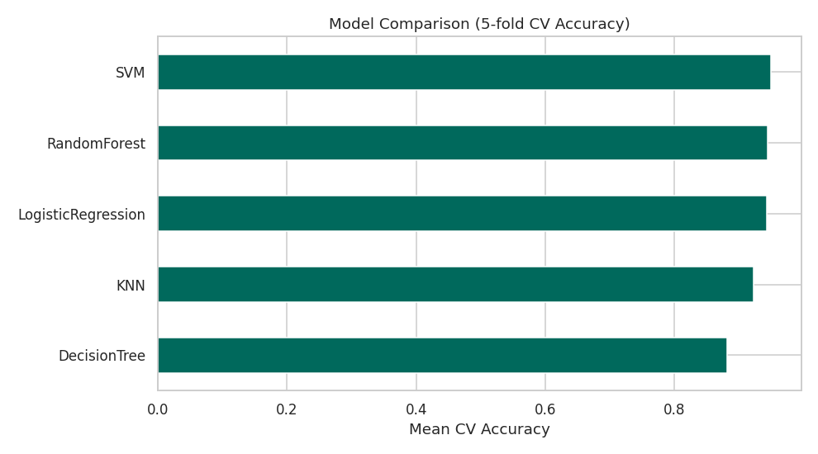
Figure 1 — Comparison of cross-validated accuracy across the five candidate classifiers.
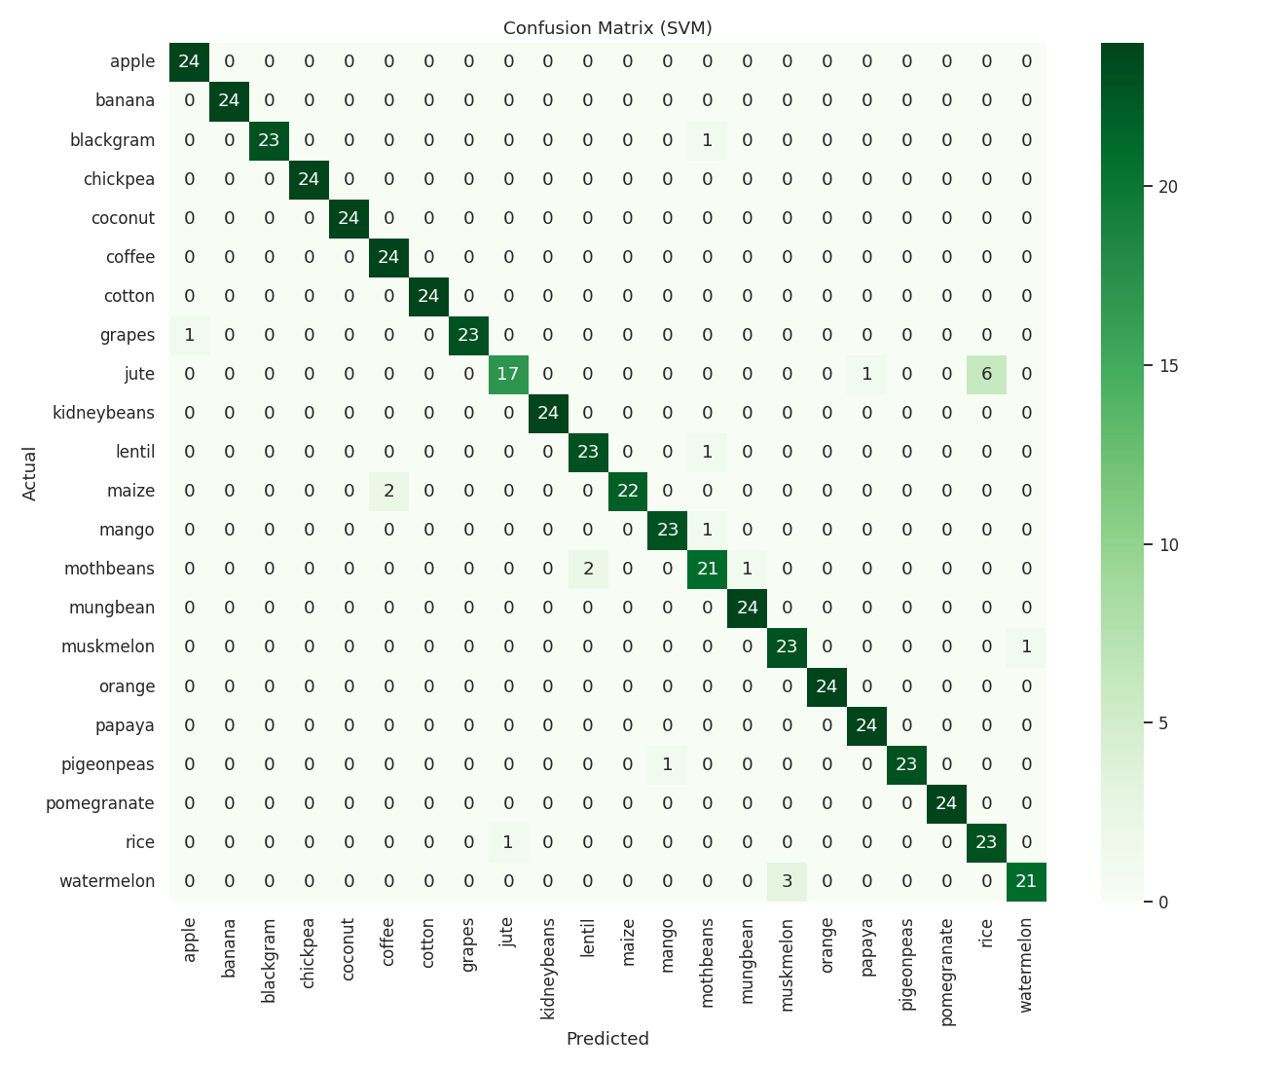
Figure 2 — Confusion matrix of the selected model (SVM) across all 22 crop classes.
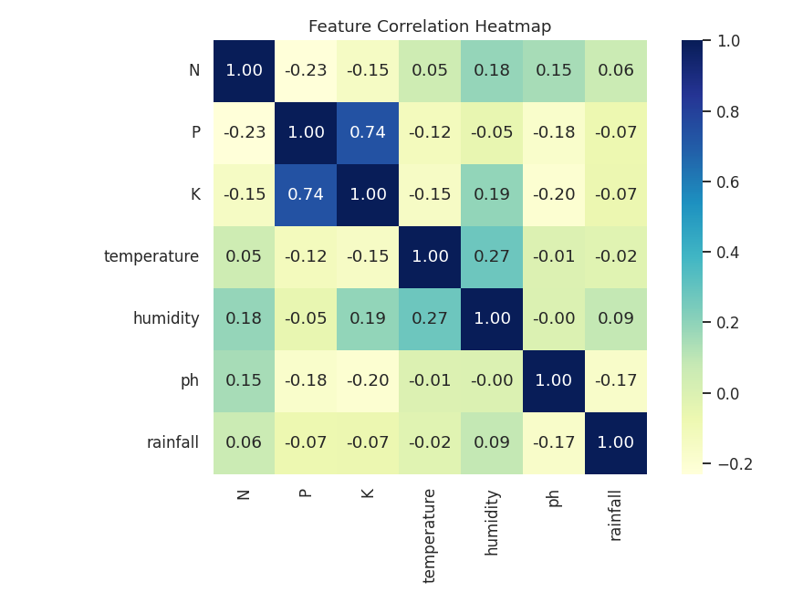
Figure 3 — Correlation heatmap of the seven input features.
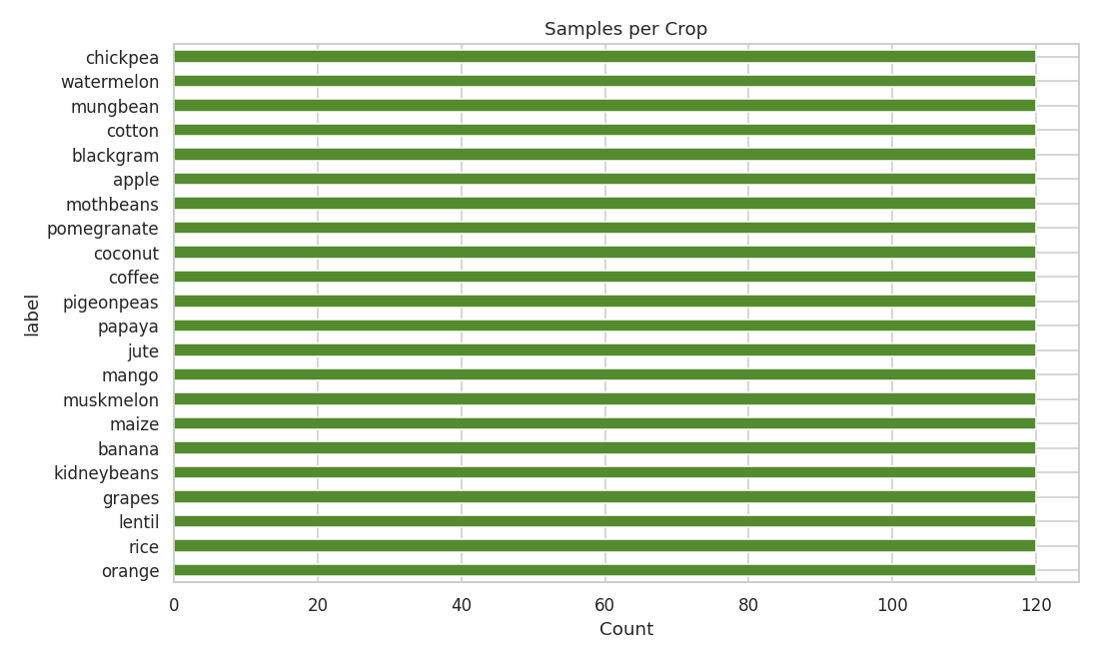
Figure 4 — Class distribution of the training dataset across 22 crops.
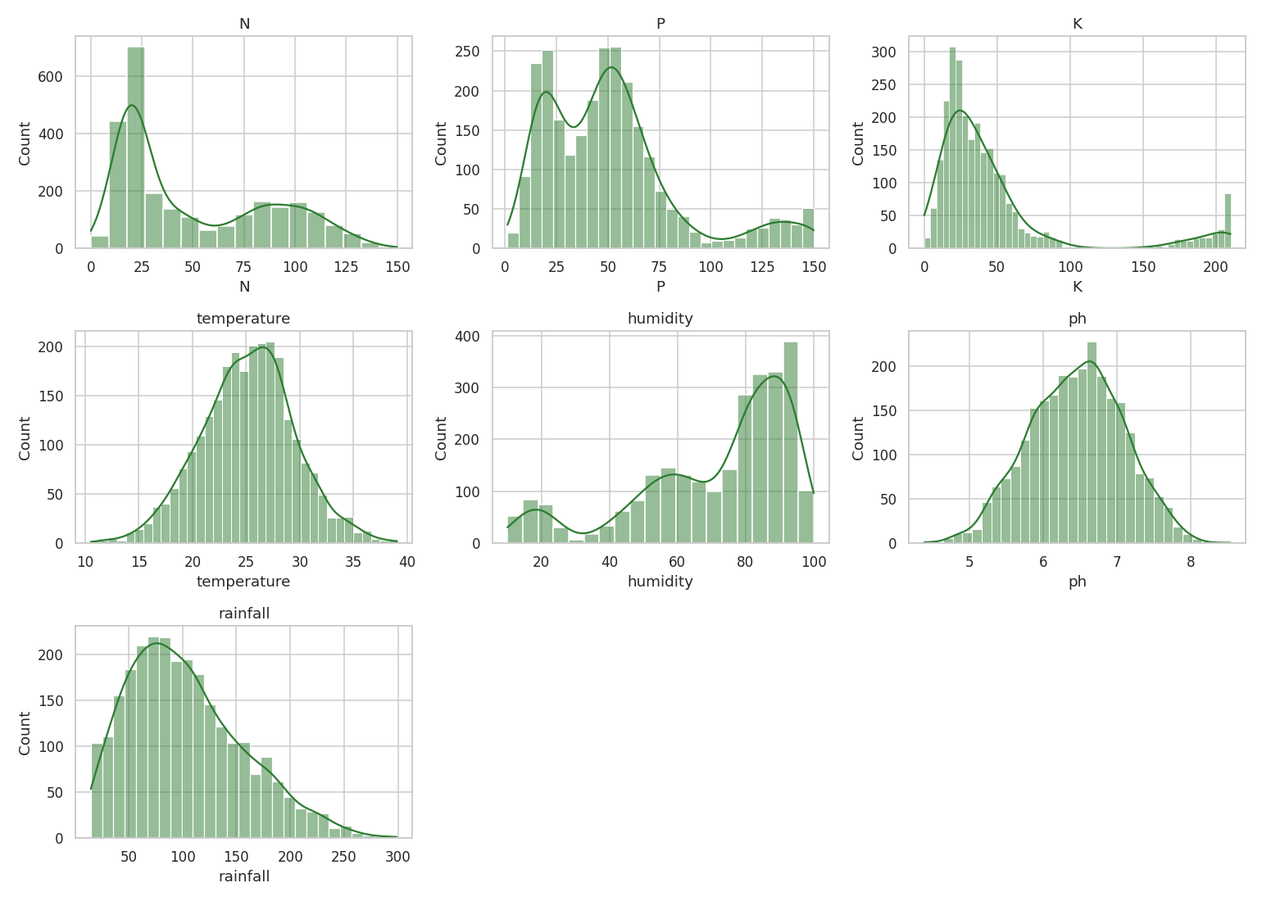
Figure 5 — Distribution of each input feature (N, P, K, temperature, humidity, pH, rainfall).

10. Testing
The repository does not include an automated unit or integration test suite (e.g., pytest files were not found). Model quality is instead validated through the machine-learning evaluation pipeline in model/train_model.py:
- 5-fold cross-validation is used to compare five classifiers (RandomForest, DecisionTree, KNN, SVM, LogisticRegression) on standardized features.
- Held-out test accuracy, weighted F1-score, and a full per-class classification report (precision, recall, F1, support) are computed for the best model.
- The best-performing model was SVM, selected automatically based on comparative accuracy and cross-validation score.
- A one-way ANOVA test (SciPy) statistically validates that rainfall differs significantly across crop labels, supporting its inclusion as a predictive feature.

Recommendation for Future Work
- Add automated tests (e.g., pytest) covering route responses, form validation, and the prediction/suitability-scoring functions.

11. Screenshots or Demo
- Live Demo: https://opticrop-m3kc.onrender.com/
- GitHub Repository: https://github.com/kondapallibhavanisankar03-source/OptiCrop
The application is deployed on Render. The screens below show all three scenarios in the live, running application.

Scenario 1 — Smart Crop Recommendation
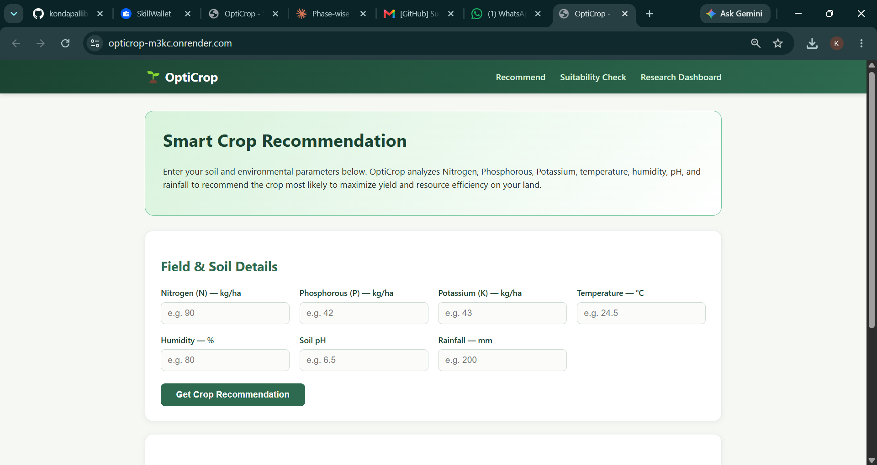
Figure 6 — Recommendation form: farmers enter soil (N, P, K) and climate (temperature, humidity, pH, rainfall) readings.
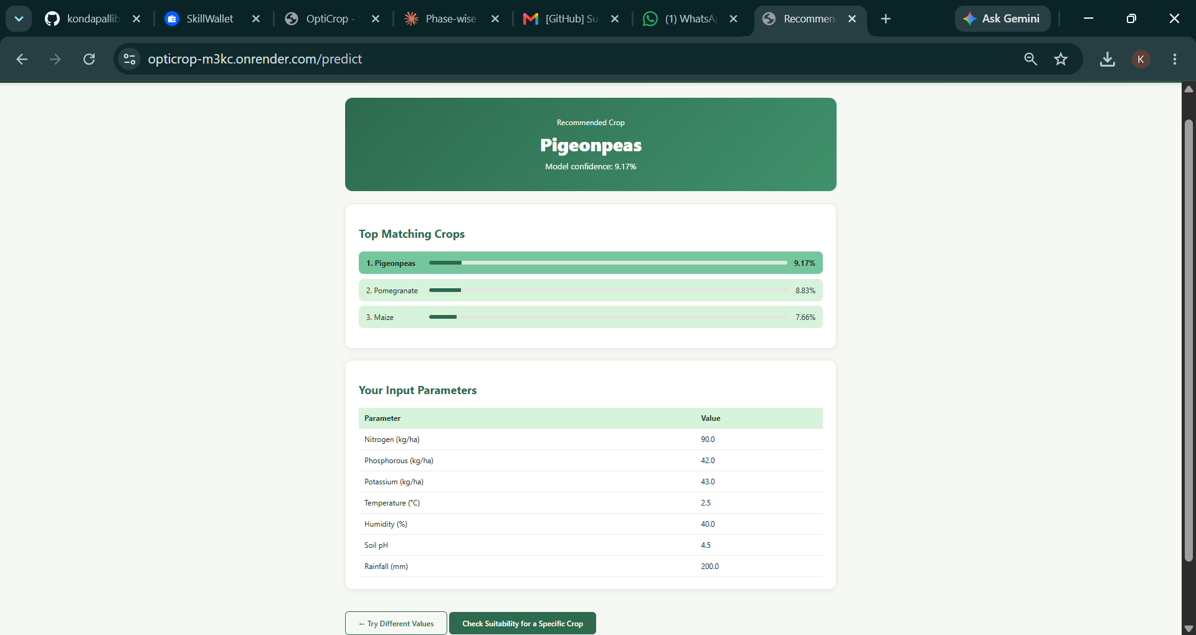
Figure 7 — Recommendation result: top matching crops ranked by model confidence, alongside the entered input parameters.

Scenario 2 — Crop Suitability & Environmental Assessment
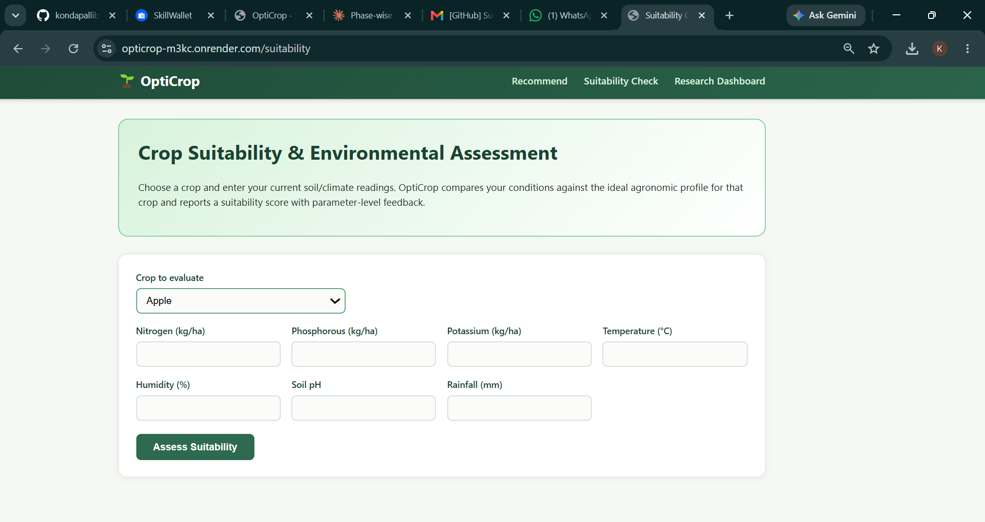
Figure 8 — Suitability check form: select a crop and enter current field conditions.
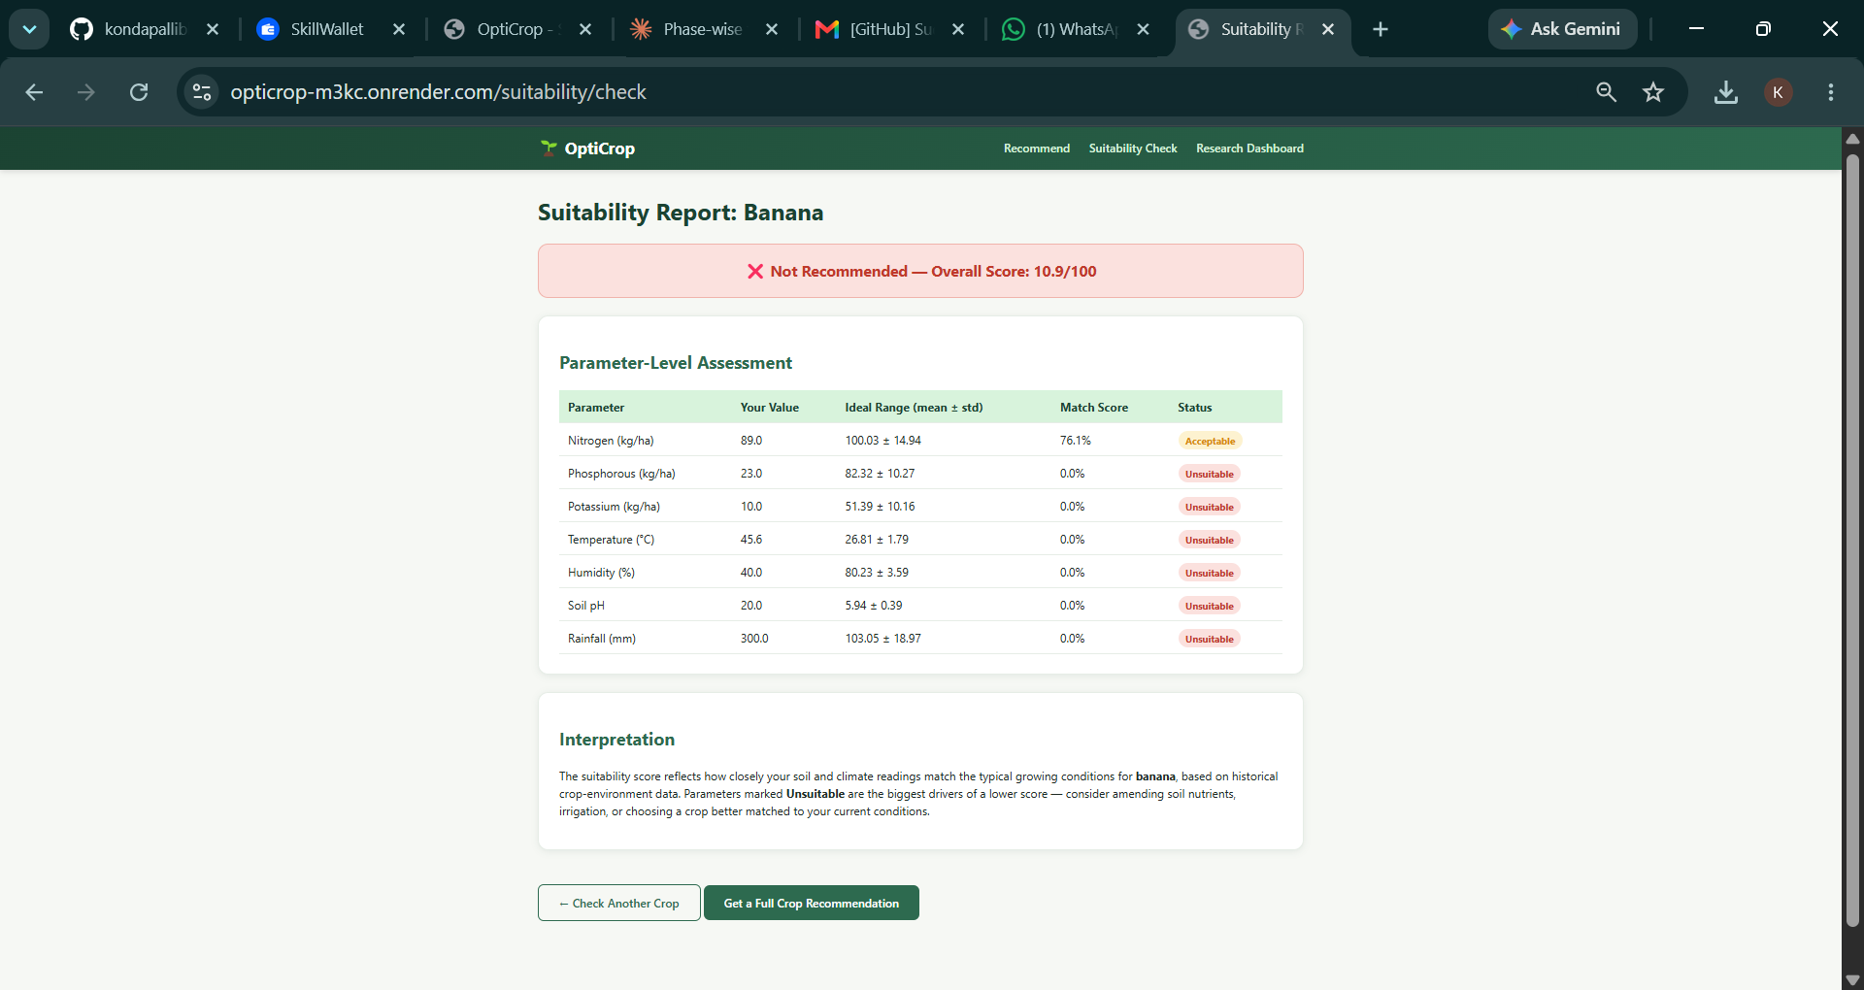
Figure 9 — Suitability report: overall score, verdict, and a parameter-level breakdown showing which readings drove the result.

Scenario 3 — Agricultural Research & Policy Dashboard
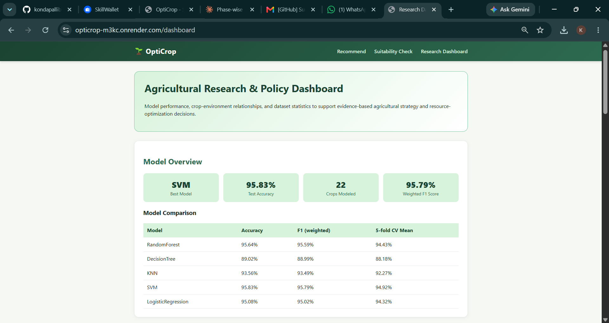
Figure 10 — Dashboard model overview: best model (SVM), test accuracy, crops modeled, and full model-comparison table.
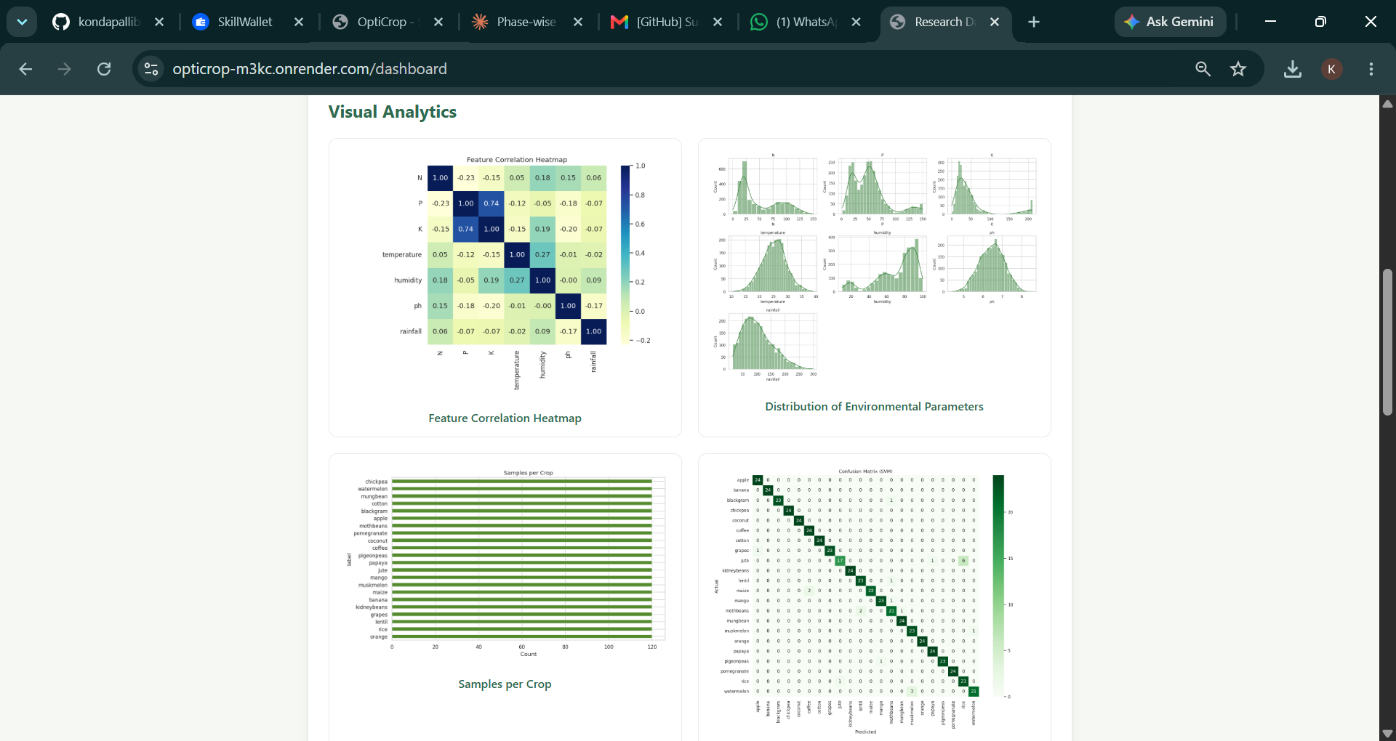
Figure 11 — Visual analytics: correlation heatmap, feature distributions, class balance, and confusion matrix.
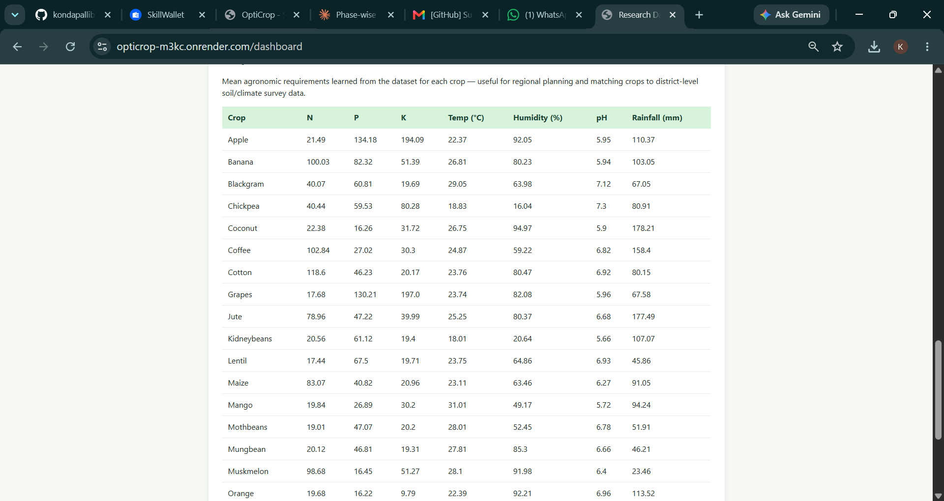
Figure 12 — Per-crop agronomic requirement table (mean N, P, K, temperature, humidity, pH, rainfall) for regional planning.

12. Known Issues
- The bundled dataset (data/crop_data.csv) is synthetically generated from published agronomic parameter ranges rather than real-world sensor or field data, since no internet access was available while building the project.
- No authentication or authorization is implemented; all routes and data are publicly accessible.
- No automated test suite is currently included in the repository.
- The Flask app is run with debug=True in app.py, which is not suitable for production and should be disabled (or controlled via environment variable) before deployment.
- Re-running model/train_model.py overwrites the saved model, scaler, statistics, and chart images with a fresh training run, which will change prediction results if the underlying data changes.

13. Future Enhancements
- Replace the synthetic dataset with real-world agronomic/sensor data (same column schema: N, P, K, temperature, humidity, ph, rainfall, label) to retrain on real observations.
- Add user accounts and authentication so farmers/researchers can save prediction history and revisit past suitability checks.
- Convert the recommendation and suitability endpoints into a JSON REST API (in addition to the current server-rendered pages) to support a mobile app or richer JavaScript frontend.
- Add automated testing (unit tests for scoring logic, integration tests for routes) and CI.
- Expand the dashboard with feature-importance visualizations (the app already checks for an optional feature_importance.png) and downloadable reports.
- Add geolocation or weather-API integration to auto-populate climate fields (temperature, humidity, rainfall) for a given location.

