**Predicting Customer Response to Marketing Campaigns**

**Executive Summary**

This project aims to predict customer responses to marketing campaigns using data from a superstore. By leveraging various machine learning models, we aim to identify key factors that influence customer responses and recommend strategies to improve campaign effectiveness. The data was cleaned and processed before being used in multiple models, including Logistic Regression, Random Forest, Support Vector Machine, Gradient Boosting, and K-Nearest Neighbors. The results indicate which model performs best in predicting customer responses, providing valuable insights for optimizing marketing strategies.

**Table of Contents**

1. Introduction

- The Problem

- Importance

2. The Data

- Source

- Summary Statistics

3. Methodology

- Data Collection

- Data Cleaning

- Model Development

- Estimation Methodology

-Data Visualization

4. Findings

- Model Results

- Analysis

5. Recommendations

- Marketing Strategy Suggestions

- Business Value

6. Discussion

- Limitations

- Future Development

7. Potential Questions and Answers

8. References

9. Appendices

**1. Introduction**

**The Problem**

Marketing campaigns are crucial for engaging customers and driving sales. However, not all customers respond positively to campaigns, leading to wasted resources and missed opportunities. The goal of this project is to predict customer responses to marketing campaigns, allowing for more targeted and effective marketing strategies.

Understanding and predicting customer responses can significantly enhance the efficiency of marketing campaigns, leading to better customer engagement and higher return on investment. It enables businesses to allocate resources more effectively and tailor their strategies to customer preferences and behaviors.

**2. The Data**

**Source**

The data for this project was obtained from a superstore's database(Kaggle), containing information about customer demographics, purchase behavior, and responses to marketing campaigns.

**Summary Statistics**

- Total Rows: 2240

- Numerical Variables:

- Income: Mean = $52,456, Median = $51,000

- Year_Birth: Mean = 1968, Median = 1970

- Recency: Mean = 49.3 days, Median = 50 days

- Categorical Variables: Education, Marital_Status

**3. Methodology**

**Data Collection**

The data was sourced from a superstore's database, containing records of customer demographics, purchase history, and responses to marketing campaigns.

**Data Cleaning**

1. Missing Values:

- Income: Replaced missing values with the median income.

2. Outliers:

- Removed records with Year_Birth <= 1900 and Income > $300,000.

- Removed extreme values for MntMeatProducts, MntSweetProducts, and MntGoldProds.

**Data Visualization**

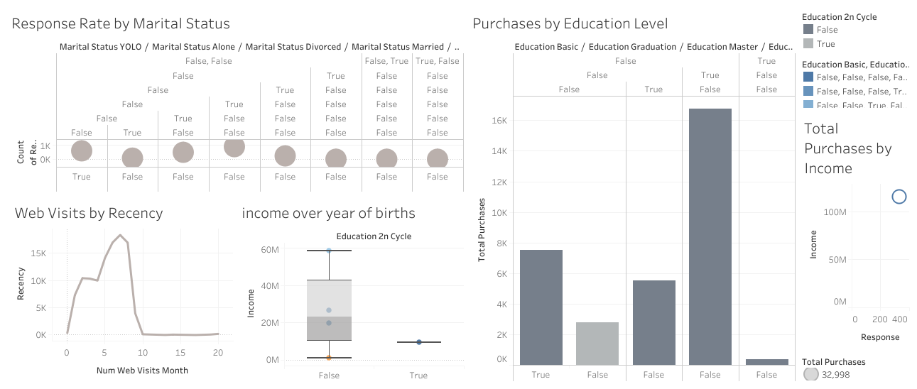

**Model Development**

1. Feature Engineering:

- Created `Total_MntProducts` and `Total_Purchases` as new features.

- Applied one-hot encoding to categorical variables.

2. Data Scaling:

- Standardized numerical features using `StandardScaler`.

3. Handling Imbalanced Data:

- Used `RandomOverSampler` to balance the target variable.

**Estimation Methodology**

Multiple machine learning models were developed and evaluated:

- Logistic Regression

- Random Forest Classifier

- Support Vector Machine (SVM)

- Gradient Boosting Classifier

- K-Nearest Neighbors (KNN)

Each model was trained and tested using an 80-20 train-test split, and performance metrics were calculated.

**4. Findings**

**Model Results**

- Logistic Regression:

- Accuracy: 87%

- Precision: 0.88

- Recall: 0.98

- F1-Score: 0.93

- Random Forest:

- Accuracy: 85%

- Precision: 0.86

- Recall: 0.97

- F1-Score: 0.91

- Support Vector Machine:

- Accuracy: 85%

- Precision: 0.85

- Recall: 0.99

- F1-Score: 0.91

- Gradient Boosting Classifier:

- Accuracy: 86%

- Precision: 0.88

- Recall: 0.96

- F1-Score: 0.92

- K-Nearest Neighbors:

- Accuracy: 83%

- Precision: 0.85

- Recall: 0.97

- F1-Score: 0.90

**Analysis**

The Logistic Regression model showed the best performance in terms of accuracy and F1-score, indicating its robustness in predicting customer responses to marketing campaigns. The results highlight the importance of customer demographics and purchase behavior in determining their likelihood to respond positively to campaigns.

**5. Recommendations**

**Marketing Strategy Suggestions**

- Targeted Campaigns: Focus on customers with high predicted response rates.

- Resource Allocation: Allocate more resources to segments with higher responsiveness.

- Personalized Messaging: Tailor messages based on key predictors identified by the models, such as purchase history and demographic factors.

**Business Value**

Implementing these strategies can lead to more efficient marketing efforts, increased customer engagement, and higher return on investment. By understanding customer preferences, the business can optimize its marketing spend and improve overall campaign effectiveness.

**6. Discussion**

**Limitations**

- Data Limitations: The dataset may not capture all relevant factors influencing customer responses.

- Model Generalizability: The models may not perform as well on different datasets or in different contexts.

- Imbalanced Data: Despite oversampling, the inherent imbalance in the dataset might still affect model performance.

**Future Development**

- Feature Expansion: Incorporate additional features such as social media activity and customer feedback.

- Model Refinement: Explore advanced modeling techniques and hyperparameter tuning to improve accuracy.

- Longitudinal Analysis: Conduct a longitudinal study to track changes in customer behavior over time.

**7. Potential Questions and Answers**

**Questions about the Prediction Model**

- What is the likelihood of a customer responding positively to a marketing campaign?

Given a set of customer characteristics, the model can predict the probability of a positive response.

- Which customer segments are most likely to respond positively to a marketing campaign?

By analyzing the feature importance or coefficients of the model, we can identify the customer segments that are most strongly associated with positive responses.

- How do different customer characteristics affect the likelihood of a positive response?

The model provides insights into how different customer characteristics, such as income, education, or purchase history, influence the likelihood of a positive response.

- What is the expected conversion rate for a new marketing campaign?

By applying the model to a new dataset of customers, we can estimate the expected conversion rate for a new marketing campaign.

- How can we optimize our marketing strategy to increase the conversion rate?

By analyzing the results of the model and identifying the most important features, we can refine our marketing strategy to target the most promising customer segments and increase the conversion rate.

- Can we identify high-value customers who are likely to respond positively to a marketing campaign?

By using the model to predict the likelihood of a positive response, we can identify high-value customers who are likely to respond positively and target them with personalized marketing efforts.

- How does the model perform on new, unseen data?

By evaluating the model on a holdout test set, we can assess its performance on new, unseen data and estimate its generalizability to future marketing campaigns.

**Questions about Model Performance**

- How accurate is the model in predicting positive responses?

The accuracy, precision, recall, and F1-score of the model provide a comprehensive view of its performance.

- Which features are most important for predicting positive responses?

The feature importance scores or coefficients for each feature in the model highlight the key predictors.

- How does the model handle class imbalance?

The model addresses class imbalance through techniques like oversampling and can be evaluated based on how well it predicts the minority class.

- How does the model generalize to new data?

The performance on new, unseen data provides insights into the model's robustness and applicability in real-world scenarios.

- What are the limitations of the model?

The assumptions and limitations of the model, such as potential biases and data limitations, impact its performance and generalizability.

- How can the model be improved?

Potential improvements include collecting additional data, enhancing feature engineering, and exploring different algorithms or techniques.

- How does the model compare to other models or benchmarks?

Comparing the model's performance to other models or benchmarks helps in selecting the best approach for a particular problem or application.

**8. References**

- Superstore database documentation

- Scikit-learn documentation

- Imbalanced-learn documentation

**9. Appendices**

Appendix A: Detailed Model Performance Metrics

- Logistic Regression:

- Confusion Matrix:

[[366 6]

[ 52 22]]

- Random Forest:

- Confusion Matrix:

[[362 10]

[ 58 16]]

- Support Vector Machine:

- Confusion Matrix:

[[368 4]

[ 65 9]]

- Gradient Boosting Classifier:

- Confusion Matrix:

[[357 15]

[ 49 25]]

- K-Nearest Neighbors:

- Confusion Matrix:

[[361 11]

[ 66 8]]

Appendix B: Data Cleaning and Feature Engineering Details

- Missing value imputation strategy

- Outlier detection and removal process

- Feature engineering steps

Appendix C: Additional Visualizations

- Distribution plots for numerical features

- Boxplots for categorical variables

Appendix D: Cost Analysis

- Cost implications of different marketing strategies based on model predictions.