Service: use below yaml's and create a nginx deployment and one service
nginx-deployment

apiVersion: apps/v1
kind: Deployment
metadata:
name: nginx-deployment
labels:
app: nginx
spec:
replicas: 1
selector:
matchLabels:
app: nginx
template:
metadata:
labels:
app: nginx
spec:
containers:
- name: nginx
image: nginx:1.7.9
ports:
- containerPort: 80
---------------
Service create yaml
apiVersion: apps/v1
kind: Service
metadata:
name: my-Service
labels:
app: nginx
spec:
selector:
app: nginx
type: NodePort
ports:
- nodePort: 31000
port: 80
TargetPort: 80

Note:- post creation of the service we need to enable the firewall if we are not able to access the nginix application using the above node ip address followed by node port(31000)
I did for GC cloud
veeresh_infra@cloudshell:~$ gcloud config set project decent-being-246011
Updated property [core/project].
veeresh_infra@cloudshell:~ (decent-being-246011)$ gcloud compute firewall-rules create test-node-port --allow tcp:31000
Creating firewall...⠧Created [https://www.googleapis.com/compute/v1/projects/decent-being-246011/global/firewalls/test-node-port].
Creating firewall...done.
NAME NETWORK DIRECTION PRIORITY ALLOW DENY DISABLED
test-node-port default INGRESS 1000 tcp:31000 False
veeresh_infra@cloudshell:~ (decent-being-246011)$
----------
below is the example screenshot for understanding port,nodeport,Target port.
Target port is the port of containger where the application is running
nodeport: it is a port for accessing our app from outside
port - 80 : its mandatory port for internal communication
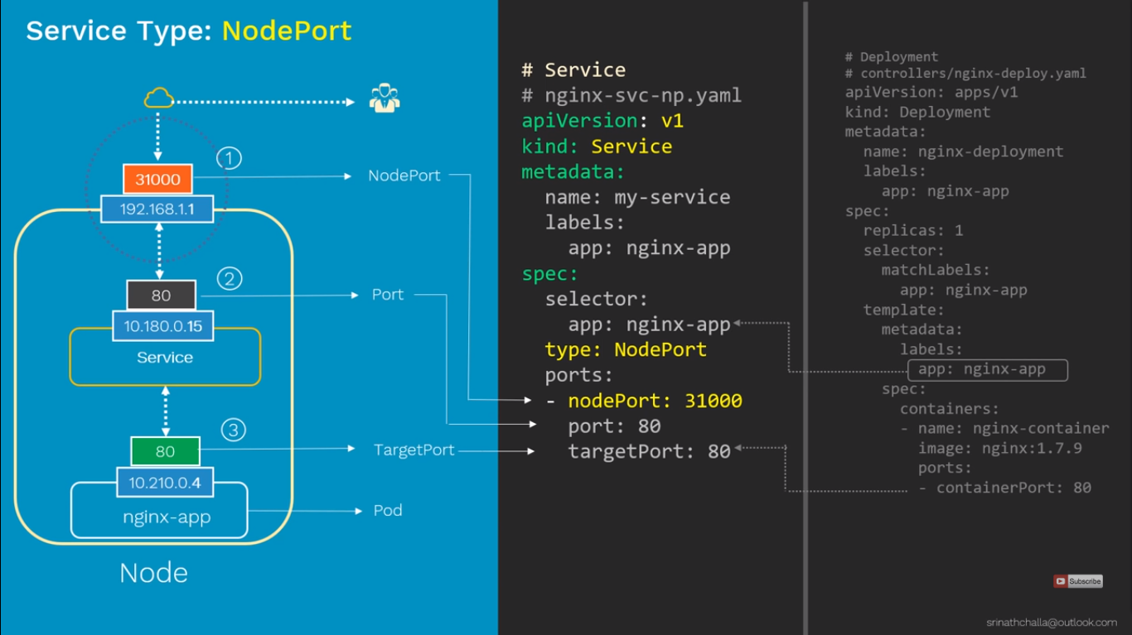

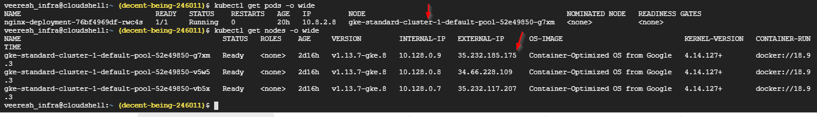
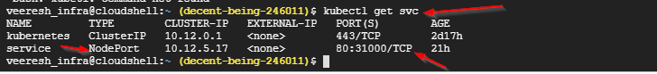
http://35.232.185.175:31000/
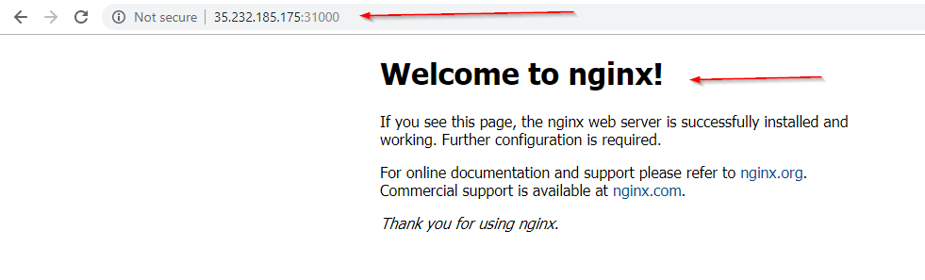
===========================================================================
taints and tolerations
▪ To check the taints on a node, type in the following command:
▪ Notice the line with ‘Taints’, says ‘Noschedule’, which ensures that no Pods schedule on the master

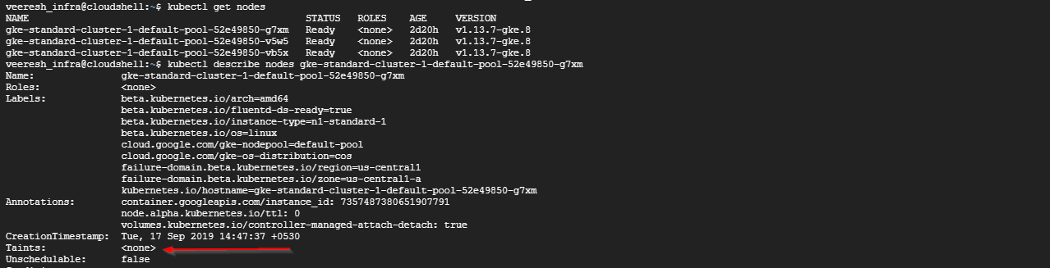
==========================
What are API Resources
veeresh_infra@kmaster:~/k8_apps/oreilly-kubernetes/manifests$ kubectl api-resources
NAME SHORTNAMES APIGROUP NAMESPACED KIND
bindings true Binding
componentstatuses cs false ComponentStatus
configmaps cm true ConfigMap
endpoints ep true Endpoints
events ev true Event
limitranges limits true LimitRange
namespaces ns false Namespace
nodes no false Node
persistentvolumeclaims pvc true PersistentVolumeClaim
persistentvolumes pv false PersistentVolume
pods po true Pod
podtemplates true PodTemplate
replicationcontrollers rc true ReplicationController
resourcequotas quota true ResourceQuota
secrets true Secret
serviceaccounts sa true ServiceAccount
services svc true Service
mutatingwebhookconfigurations admissionregistration.k8s.io false MutatingWebhookConfiguration
validatingwebhookconfigurations admissionregistration.k8s.io false ValidatingWebhookConfiguration
customresourcedefinitions crd,crds apiextensions.k8s.io false CustomResourceDefinition
apiservices apiregistration.k8s.io false APIService
controllerrevisions apps true ControllerRevision
daemonsets ds apps true DaemonSet
deployments deploy apps true Deployment
replicasets rs apps true ReplicaSet
statefulsets sts apps true StatefulSet
tokenreviews authentication.k8s.io false TokenReview
localsubjectaccessreviews authorization.k8s.io true LocalSubjectAccessReview
selfsubjectaccessreviews authorization.k8s.io false SelfSubjectAccessReview
selfsubjectrulesreviews authorization.k8s.io false SelfSubjectRulesReview
subjectaccessreviews authorization.k8s.io false SubjectAccessReview
horizontalpodautoscalers hpa autoscaling true HorizontalPodAutoscaler
cronjobs cj batch true CronJob
jobs batch true Job
certificatesigningrequests csr certificates.k8s.io false CertificateSigningRequest
leases coordination.k8s.io true Lease
events ev events.k8s.io true Event
ingresses ing extensions true Ingress
ingresses ing networking.k8s.io true Ingress
networkpolicies netpol networking.k8s.io true NetworkPolicy
runtimeclasses node.k8s.io false RuntimeClass
poddisruptionbudgets pdb policy true PodDisruptionBudget
podsecuritypolicies psp policy false PodSecurityPolicy
clusterrolebindings rbac.authorization.k8s.io false ClusterRoleBinding
clusterroles rbac.authorization.k8s.io false ClusterRole
rolebindings rbac.authorization.k8s.io true RoleBinding
roles rbac.authorization.k8s.io true Role
priorityclasses pc scheduling.k8s.io false PriorityClass
csidrivers storage.k8s.io false CSIDriver
csinodes storage.k8s.io false CSINode
storageclasses sc storage.k8s.io false StorageClass
volumeattachments storage.k8s.io false VolumeAttachment
veeresh_infra@kmaster:~/k8_apps/oreilly-kubernetes/manifests$
=============================
To see what and all API Versions are there you can execute below command
veeresh_infra@kmaster:~/k8_apps/oreilly-kubernetes/manifests$ curl localhost:8001
{
"paths": [
"/api",
"/api/v1",
"/apis",

"/apis/",
"/apis/admissionregistration.k8s.io",
"/apis/admissionregistration.k8s.io/v1",
"/apis/admissionregistration.k8s.io/v1beta1",
"/apis/apiextensions.k8s.io",
"/apis/apiextensions.k8s.io/v1",
=============================
To Get what are there in each API you can grep like below
veeresh_infra@kmaster:~/k8_apps/oreilly-kubernetes/manifests$ curl localhost:8001/api/v1
{
"kind": "APIResourceList",
"groupVersion": "v1",
"resources": [
{
"name": "bindings",
"singularName": "",
"namespaced": true,
"kind": "Binding",
"verbs": [
"create"
]
},
{
"name": "componentstatuses",
"singularName": "",
"namespaced": false,
"kind": "ComponentStatus",
"verbs": [
"get",
"list"
],
"shortNames": [
"cs"
]
},
{
"name": "configmaps",
"singularName": "",
"namespaced": true,
"kind": "ConfigMap",
"verbs": [
"create",
"delete",
"deletecollection"
=====================================
To see what and all there in one API version we can use below jquery command
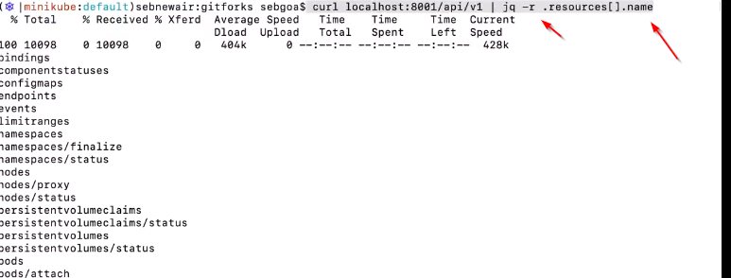
=========
what is the difference between kubectl create and apply?

apply is for changing the objects and create is for new objects. apply also can be used if your object is not created to create an object

you can do using the kubectl edit

alsokubectl -f
Explain command is used for getting the kubernetes documentation in the cmd promt
veeresh_infra@kmaster:~/ckad/ckad$ kubectl explain pod.spec.containers
KIND: Pod
VERSION: v1

RESOURCE: containers <[]Object>

DESCRIPTION:
List of containers belonging to the pod. Containers cannot currently be
added or removed. There must be at least one container in a Pod. Cannot be
updated.

A single application container that you want to run within a pod.

FIELDS:
args<[]string>
Arguments to the entrypoint. The docker image's CMD is used if this is not
provided. Variable references $(VAR_NAME) are expanded using the
container's environment. If a variable cannot be resolved, the reference in
the input string will be unchanged. The $(VAR_NAME) syntax can be escaped
with a double $$, ie: $$(VAR_NAME). Escaped references will never be
expanded, regardless of whether the variable exists or not. Cannot be
updated. More info:
https://kubernetes.io/docs/tasks/inject-data-application/define-command-argument-container/#running-a-command-in-a-shell

command <[]string>
Entrypoint array. Not executed within a shell. The docker image's
ENTRYPOINT is used if this is not provided. Variable references $(VAR_NAME)
are expanded using the container's environment. If a variable cannot be
resolved, the reference in the input string will be unchanged. The
$(VAR_NAME) syntax can be escaped with a double $$, ie: $$(VAR_NAME).
Escaped references will never be expanded, regardless of whether the
variable exists or not. Cannot be updated. More info:
https://kubernetes.io/docs/tasks/inject-data-application/define-command-argument-container/#running-a-command-in-a-shell

env <[]Object>
List of environment variables to set in the container. Cannot be updated.

envFrom<[]Object>
List of sources to populate environment variables in the container. The
keys defined within a source must be a C_IDENTIFIER. All invalid keys will
be reported as an event when the container is starting. When a key exists
in multiple sources, the value associated with the last source will take
precedence. Values defined by an Env with a duplicate key will take
precedence. Cannot be updated.

image <string>
Docker image name. More info:
https://kubernetes.io/docs/concepts/containers/images This field is
optional to allow higher level config management to default or override
container images in workload controllers like Deployments and StatefulSets.

imagePullPolicy<string>
Image pull policy. One of Always, Never, IfNotPresent. Defaults to Always
if :latest tag is specified, or IfNotPresent otherwise. Cannot be updated.
More info:
https://kubernetes.io/docs/concepts/containers/images#updating-images

lifecycle <Object>
Actions that the management system should take in response to container
lifecycle events. Cannot be updated.

livenessProbe<Object>
Periodic probe of container liveness. Container will be restarted if the
probe fails. Cannot be updated. More info:
https://kubernetes.io/docs/concepts/workloads/pods/pod-lifecycle#container-probes

name <string> -required-
Name of the container specified as a DNS_LABEL. Each container in a pod
must have a unique name (DNS_LABEL). Cannot be updated.

ports <[]Object>
List of ports to expose from the container. Exposing a port here gives the
system additional information about the network connections a container
uses, but is primarily informational. Not specifying a port here DOES NOT
prevent that port from being exposed. Any port which is listening on the
default "0.0.0.0" address inside a container will be accessible from the
network. Cannot be updated.

readinessProbe<Object>
Periodic probe of container service readiness. Container will be removed
from service endpoints if the probe fails. Cannot be updated. More info:
https://kubernetes.io/docs/concepts/workloads/pods/pod-lifecycle#container-probes

resources <Object>
Compute Resources required by this container. Cannot be updated. More info:
https://kubernetes.io/docs/concepts/configuration/manage-compute-resources-container/

securityContext<Object>
Security options the pod should run with. More info:
https://kubernetes.io/docs/concepts/policy/security-context/ More info:
https://kubernetes.io/docs/tasks/configure-pod-container/security-context/

startupProbe<Object>
StartupProbe indicates that the Pod has successfully initialized. If
specified, no other probes are executed until this completes successfully.
If this probe fails, the Pod will be restarted, just as if the
livenessProbe failed. This can be used to provide different probe
parameters at the beginning of a Pod's lifecycle, when it might take a long
time to load data or warm a cache, than during steady-state operation. This
cannot be updated. This is an alpha feature enabled by the StartupProbe
feature flag. More info:
https://kubernetes.io/docs/concepts/workloads/pods/pod-lifecycle#container-probes

stdin <boolean>
Whether this container should allocate a buffer for stdin in the container
runtime. If this is not set, reads from stdin in the container will always
result in EOF. Default is false.

stdinOnce<boolean>
Whether the container runtime should close the stdin channel after it has
been opened by a single attach. When stdin is true the stdin stream will
remain open across multiple attach sessions. If stdinOnce is set to true,
stdin is opened on container start, is empty until the first client
attaches to stdin, and then remains open and accepts data until the client
disconnects, at which time stdin is closed and remains closed until the
container is restarted. If this flag is false, a container processes that
reads from stdin will never receive an EOF. Default is false

terminationMessagePath<string>
Optional: Path at which the file to which the container's termination
message will be written is mounted into the container's filesystem. Message
written is intended to be brief final status, such as an assertion failure
message. Will be truncated by the node if greater than 4096 bytes. The
total message length across all containers will be limited to 12kb.
Defaults to /dev/termination-log. Cannot be updated.

terminationMessagePolicy<string>
Indicate how the termination message should be populated. File will use the
contents of terminationMessagePath to populate the container status message
on both success and failure. FallbackToLogsOnError will use the last chunk
of container log output if the termination message file is empty and the
container exited with an error. The log output is limited to 2048 bytes or
80 lines, whichever is smaller. Defaults to File. Cannot be updated.

tty<boolean>
Whether this container should allocate a TTY for itself, also requires
'stdin' to be true. Default is false.

volumeDevices<[]Object>
volumeDevices is the list of block devices to be used by the container.
This is a beta feature.

volumeMounts<[]Object>
Pod volumes to mount into the container's filesystem. Cannot be updated.

workingDir<string>
Container's working directory. If not specified, the container runtime's
default will be used, which might be configured in the container image.
Cannot be updated.

veeresh_infra@kmaster:~/ckad/csskad$
===========================================
Jobs

what is the difference between jobs and pods?

Pods runs all the time. jobs/cronjobs run for specific period of time as per the schedule mention in the cron entry.

apiVersion: batch/v1
kind: Job
metadata:
name: simple-job
spec:
template:
spec:
containers:
- name: sleepy
image: alpine
command: [ "/bin/sleep" ]
args: [ "5" ]
restartPolicy: Never
=========

AME COMPLETIONS DURATION AGE
simple-job 1/1 9s 10s
veeresh_infra@kmaster:~/ckad/ckad$ kubectl get pods
NAME READY STATUS RESTARTS AGE
busybox 1/1 Running 18 18h
ghost-86795b6bb-tzmwr 1/1 Running 0 3h19m
nginx-friday20-549945c99c-9zvtk 1/1 Running 0 76m
nginx-friday20-549945c99c-khn68 1/1 Running 0 76m
nginx-friday20-549945c99c-lfsfv 1/1 Running 0 36m
nginx-friday20-549945c99c-rwscl 1/1 Running 0 36m
simple-job-fnzrd 0/1 Completed 0 21s
veeresh_infra@kmaster:~/ckad/ckad$

veeresh_infra@kmaster:~/ckad/ckad$ cat cron-example.yaml
apiVersion: batch/v1beta1
kind: CronJob
metadata:
name: hello
spec:
schedule: "*/1 * * * *"
jobTemplate:
spec:
template:
spec:
containers:
- name: hello
image: busybox
args:
- /bin/sh
- -c
- date; echo hello from the K8s cluster
restartPolicy: OnFailure
------------
Cveeresh_infra@kmaster:~/ckad/ckad$ kubectl get cronjob hello
NAME SCHEDULE SUSPEND ACTIVE LAST SCHEDULE AGE
hello */1 * * * * False 1 9s 6m30s
veeresh_infra@kmaster:~/ckad/ckad$

veeresh_infra@kmaster:~/ckad/ckad$ kubectl get job --watch
NAME COMPLETIONS DURATION AGE
hello-1570886580 1/1 2s 119s
hello-1570886640 1/1 2s 59s
simple-job 1/1 9s 22m
hello-1570886700 0/1 0s
hello-1570886700 0/1 0s 0s
hello-1570886700 1/1 3s 3s
hello-1570886760 0/1 0s
hello-1570886760 0/1 0s 0s
hello-1570886760 1/1 3s 3s
hello-1570886580 1/1 2s 3m10s
hello-1570886820 0/1 0s
hello-1570886820 0/1 0s 0s
hello-1570886820 1/1 2s 2s
hello-1570886640 1/1 2s 3m10s
--
^Cveeresh_infra@kmaster:~/ckad/ckad$ kubectl delete cronjob hello
cronjob.batch "hello" deleted
veeresh_infra@kmaster:~/ckad/ckad$ kubectl get cronjob hello
Error from server (NotFound): cronjobs.batch "hello" not found
veeresh_infra@kmaster:~/ckad/ckad$
------------------
============
veeresh_infra@kmaster:~/ckad/ckad$ kubectl get pods
NAME READY STATUS RESTARTS AGE
busybox 1/1 Running 19 19h
frontend 1/2 CrashLoopBackOff 2 85s
ghost-86795b6bb-tzmwr 1/1 Running 0 4h7m
nginx-friday20-549945c99c-9zvtk 1/1 Running 0 124m
nginx-friday20-549945c99c-khn68 1/1 Running 0 124m
nginx-friday20-549945c99c-lfsfv 1/1 Running 0 85m
nginx-friday20-549945c99c-rwscl 1/1 Running 0 85m
simple-job-fnzrd 0/1 Completed 0 48m
veeresh_infra@kmaster:~/ckad/ckad$ kubectl logs frontend
Error from server (BadRequest): a container name must be specified for pod frontend, choose one of: [dbwp]
veeresh_infra@kmaster:~/ckad/ckad$
======================

Resource limits

veeresh_infra@kmaster:~/ckad/ckad$ view frontend-resources.yaml
apiVersion: v1
kind: Pod
metadata:
name: frontend
spec:
containers:
- name: db
image: mysql
env:
- name: MYSQL_ROOT_PASSWORD
value: "password"
resources:
requests:
memory: "64Mi"
cpu: "250m"
limits:
memory: "128Mi"
cpu: "500m"
- name: wp
image: wordpress
resources:
requests:
memory: "64Mi"
cpu: "250m"
limits:
memory: "128Mi"
cpu: "500m"

veeresh_infra@kmaster:~/ckad/ckad$ kubectl edit deployment nginx-friday20
deployment.apps/nginx-friday20 edited
veeresh_infra@kmaster:~/ckad/ckad$ kubectl rollout history deployment/nginx-friday20
deployment.apps/nginx-friday20
REVISION CHANGE-CAUSE
1 <none>
2 <none>
eresh_infra@kmaster:~/ckad/ckad$ kubectl rollout status -w deployment/nginx-friday20
deployment "nginx-friday20" successfully rolled out
veeresh_infra@kmaster:~/ckad/ckad$

veeresh_infra@kmaster:~/ckad/ckad$ kubectl rollout undo deployment/nginx-friday20
deployment.apps/nginx-friday20 rolled back
here you can put te version also –to-revision=2
veeresh_infra@kmaster:~/ckad/ckad$ kubectl rollout undo deployment/nginx-friday20 --to-revision=2
deployment.apps/nginx-friday20 rolled back
veeresh_infra@kmaster:~/ckad/ckad$
Note:- Rollout history REVISION version will not change if you scall up and scall down(it ill increase the replicas after u put the scallop and down only rollout version will not change) the replicas also when you update its pod template revision will not change.

NOTE: Clarify that rollout revision is only created when pod template is changed
Post rollback/undo you can check the code changes back or not.
https://stackoverflow.com/questions/40009831/cant-find-kubeadm-token-after-initializing-master

Generallykubeadm join token which was generated as part of Kubernetes installation will expire in 24 hours.
root@kmaster:/etc/kubernetes/pki# kubeadm token list
TOKEN TTL EXPIRES USAGES DESCRIPTION EXTRA GROUPS
rzo5yk.qntyg96xkxdipfgq23h2019-10-14T05:59:05Zauthentication,signing<none>system:bootstrappers:kubeadm:default-node-token
root@kmaster:/etc/kubernetes/pki#

Suppose if you want to generate a never expire token you can generate as below tty=0

root@kmaster:/etc/kubernetes/pki# kubeadm token create --ttl=0
ybkok9.55wftt73jhw4e5af
to see the list of available tokens validity and tokens you can run below command.
root@kmaster:/etc/kubernetes/pki# kubeadm token list
TOKEN TTL EXPIRES USAGES DESCRIPTION EXTRA GROUPS
rzo5yk.qntyg96xkxdipfgq 23h 2019-10-14T05:59:05Z authentication,signing<none>system:bootstrappers:kubeadm:default-node-token
ybkok9.55wftt73jhw4e5af <forever><never>authentication,signing<none>system:bootstrappers:kubeadm:default-node-token
root@kmaster:/etc/kubernetes/pki#

Below is the format of the token
Format
kubeadm join <Master ip address>:6443 --token ybkok9.55wftt73jhw4e5af--discovery-token-unsafe-skip-ca-verification
Red colour one is the token you generated. Yellow colour one is the default one.

kubeadm join 10.128.0.15:6443 --token ybkok9.55wftt73jhw4e5af --discovery-token-unsafe-skip-ca-verification
root@knode2:~# kubeadm join 10.128.0.15:6443 --token ybkok9.55wftt73jhw4e5af --discovery-token-unsafe-skip-ca-verification
[preflight] Running pre-flight checks
[WARNING IsDockerSystemdCheck]: detected "cgroupfs" as the Docker cgroup driver. The recommended driver is "systemd". Please follow the guide at https://kubernetes.io/docs/setup/cri/
[preflight] Reading configuration from the cluster...
[preflight] FYI: You can look at this config file with 'kubectl -n kube-system get cm kubeadm-config -oyaml'
[kubelet-start] Downloading configuration for the kubelet from the "kubelet-config-1.16" ConfigMap in the kube-system namespace
[kubelet-start] Writing kubelet configuration to file "/var/lib/kubelet/config.yaml"
[kubelet-start] Writing kubelet environment file with flags to file "/var/lib/kubelet/kubeadm-flags.env"
[kubelet-start] Activating the kubelet service
[kubelet-start] Waiting for the kubelet to perform the TLS Bootstrap...

This node has joined the cluster:
* Certificate signing request was sent to apiserver and a response was received.
* The Kubelet was informed of the new secure connection details.

Run 'kubectl get nodes' on the control-plane to see this node join the cluster.

root@knode2:~#
After you install the installation of K8’s if you don’t get the docker containers after put docker ps command.
Execute the below command to add the current user(which u use for kubectl commands) to the docker group.
See below your k8s user Veeresh_infra is not part of the docker group hence it is giving the error
veeresh_infra@kmaster:~$ id
uid=1001(veeresh_infra) gid=1002(veeresh_infra) groups=1002(veeresh_infra),4(adm),20(dialout),24(cdrom),25(floppy),27(sudo),29(audio),30(dip),44(video),46(plugdev),106(lxd),110(netdev),1000(ubuntu)
veeresh_infra@kmaster:~$ docker ps
Got permission denied while trying to connect to the Docker daemon socket at unix:///var/run/docker.sock: Get http://%2Fvar%2Frun%2Fdocker.sock/v1.39/containers/json: dial unix /var/run/docker.sock: connect: permission denied
veeresh_infra@kmaster:~$
now add Veeresh_infra to the docker group and start new session. It will not work in existing session after command success also.
veeresh_infra@kmaster:~$ echo $USER
veeresh_infra
veeresh_infra@kmaster:~$ sudousermod -a -G docker $USER
veeresh_infra@kmaster:~$ id
uid=1001(veeresh_infra) gid=1002(veeresh_infra) groups=1002(veeresh_infra),4(adm),20(dialout),24(cdrom),25(floppy),27(sudo),29(audio),30(dip),44(video),46(plugdev),106(lxd),110(netdev),115(docker),1000(ubuntu)
here docker ps command will work
https://techoverflow.net/2017/03/01/solving-docker-permission-denied-while-trying-to-connect-to-the-docker-daemon-socket/

=========================
Daemon set
apiVersion: apps/v1 # For Kubernetes version 1.9 and later, use apps/v1
kind: DaemonSet
metadata:
name: fluentd
spec:
selector:
matchLabels:
name: fluentd # Label selector that determines which Pods belong to the DaemonSet
template:
metadata:
labels:
name: fluentd # Pod template's label selector
spec:
nodeSelector:
type: prod # Node label selector that determines on which nodes Pod should be scheduled
# In this case, Pods are only scheduled to nodes bearing the label "type: prod"
containers:
- name: fluentd
image: gcr.io/google-containers/fluentd-elasticsearch:1.20
resources:
limits:
memory: 200Mi
requests:
cpu: 100m
memory: 200Mi

veeresh_infra@kmaster:~/ckad/ckad$ kubectl create -f d.yaml
daemonset.apps/fluentd created
veeresh_infra@kmaster:~/ckad/ckad$ kubectl get ds
NAME DESIRED CURRENT READY UP-TO-DATE AVAILABLE NODE SELECTOR AGE
daemonset-pods 2 2 0 2 0 <none> 9s
veeresh_infra@kmaster:~/ckad/ckad$ kubectl get pods -o wide
NAME READY STATUS RESTARTS AGE IP NODE NOMINATED NODE READINESS GATES
busybox 1/1 Running 42 42h 10.32.0.5 knode<none><none>
daemonset-pods-4lns2 0/1 InvalidImageName 0 73s 10.32.0.7 knode<none><none>
daemonset-pods-cctjm 0/1 InvalidImageName 0 73s 10.38.0.2 knode2 <none><none>
simple-job-fnzrd 0/1 Completed 0 23h 10.32.0.12 knode<none><none>
Updating DaemonSets

You can update DaemonSets by changing its Pod specification, resource requests and limits, labels, and annotations.

To decide how to handle updates, DaemonSet use a update strategy defined in spec: updateStrategy. There are two strategies, OnDelete and RollingUpdate:

OnDelete does not automatically delete and recreate DaemonSet Pods when the object's configuration is changed. Instead, Pods must be manually deleted to cause the controller to create new Pods that reflect your changes.
RollingUpdate automatically deletes and recreates DaemonSet Pods. With this strategy, valid changes automatically triggers a rollout. This is the default update strategy for DaemonSets.
Simple terms:
OnDelete: when we delete a daemon set pod manually the controler will take an action and recreate it this is called ondelete

Rolling updatte:- it works when node gets added/deleted pod will be deleted and created automatically by the controller.
Update rollouts can be monitored by running the following command:

kubectl rollout status ds [DAEMONSET_NAME]
https://kubernetes.io/docs/tasks/manage-daemon/update-daemon-set/
https://medium.com/google-cloud/kubernetes-run-a-pod-per-node-with-daemon-sets-f77ce3f36bf1

PV and PVC’s
https://kubernetes.io/docs/concepts/storage/persistent-volumes/#persistentvolumeclaims
https://kubernetes.io/docs/concepts/storage/persistent-volumes/
Notes: Storageclass mence which volume you are using EBS/GCP azuredisk etc

Persistent Volumes
Persistent Volumes are simply a piece of storage in your cluster. Similar to how you have a disk resource in a server, a persistent volume provides storage resources for objects in the cluster. At the most simple terms you can think of a PV as a disk drive. It should be noted that this storage resource exists independently from any pods that may consume it. Meaning, that if the pod dies, the storage should remain intact assuming the claim policies are correct. Persistent Volumes are provisioned in two ways, Statically or Dynamically.
Static Volumes – A static PV simply means that some k8s administrator provisioned a persistent volume in the cluster and it’s ready to be consumed by other resources.
Dynamic Volumes – In some circumstances a pod could require a persistent volume that doesn’t exist. In those cases it is possible to have k8s provision the volume as needed if storage classes were configured to demonstrate where the dynamic PVs should be built. This post will focus on static volumes for now.

Persistent Volume Claims
Pods that need access to persistent storage, obtain that access through the use of a Persistent Volume Claim. A PVC, binds a persistent volume to a pod that requested it.
When a pod wants access to a persistent disk, it will request access to the claim which will specify the size , access mode and/or storage classes that it will need from a Persistent Volume. Indirectly the pods get access to the PV, but only through the use of a PVC.

Claim Policies
We also reference claim policies earlier. A Persistent Volume can have several different claim policies associated with it including:
Retain – When the claim is deleted, the volume remains.
Recycle – When the claim is deleted the volume remains but in a state where the data can be manually recovered.
Delete – The persistent volume is deleted when the claim is deleted.
The claim policy (associated at the PV and not the PVC) is responsible for what happens to the data on when the claim has been deleted.

Secrets
you can encript all user names and pwd and keep in one FS which you can mount that fs to the YAMl there your pod can read..
you can directly encript the values and pass them in the YAML
you can create a variable and store the username and pwd in variables and call them.
for example. $username='veeresh'
$password="encript this valuewih below command
type: Opaque means that from kubernetes's point of view the contents of this Secret is unstructured, it can contain arbitrary key-value pairs.
In contrast, there is the Secret storing ServiceAccount credentials, or the ones used as ImagePullSecret. These have a constrained contents

https://kubernetes.io/docs/concepts/configuration/secret/#decoding-a-secret
using below command we can encript the username/pwd into base64 string/algorithm
master $ echo -n 'veeresh' | base64
dmVlcmVzaA==
Decode the password field:

master $ echo 'dmVlcmVzaA==' | base64 --decode

veeresh

What’s Kompose?

https://kompose.io/
Kompose is a tool to help users familiar with docker-compose move to Kubernetes. It takes a Docker Compose file and translates it into Kubernetes resources. More details can be found at http://kompose.io/
Kompose is a conversion tool for Docker Compose to container orchestrators such as Kubernetes (or OpenShift).
Why do developers love it?
- Simplify your development process with Docker Compose and then deploy your containers to a production cluster
- Convert your docker-compose.yaml with one simple command kompose convert
- Immediately bring up your cluster with kompose up
- Bring it back down with kompose down
=========================
Kubernetes have advanced networking capabilities that allow Pods and Services to communicate inside the cluster's network. An Ingress enables inbound connections to the cluster, allowing external traffic to reach the correct Pod.
Ingress enables externally-reachable urls, load balance traffic, terminate SSL, offer name based virtual hosting for a Kubernetes cluster.
In this scenario you will learn how to deploy and configure Ingress rules to manage incoming HTTP requests.

