PYTHON CASE STUDIES 71–80
Complete Activity Documentation with Embedded Flowcharts
EXPERIMENT 71: Integrated University Fee and Eligibility Audit
1. Problem Statement
University administration requires an automated system to audit student eligibility for end-semester examinations based on fee settlement, classroom attendance percentage, and internal examination marks.
2. Objectives
- Audit individual student records systematically.
- Verify fee payment status, classroom attendance (>= 75%), and internal marks (>= 20).
- Generate specific, descriptive reason codes for student disqualification.
3. Assumptions
- Input data is provided as a structured nested list containing [ID, Name, Fee Due, Fee Paid, Attendance %, Internal Marks].
- A student is considered 'Fee Pending' if Fee Due > Fee Paid.
- Thresholds are fixed: Attendance >= 75%, Internal Marks >= 20.
4. Algorithm
Step 1: Initialize the list of student records.
Step 2: Iterate over each student record in the dataset.
Step 3: Create an empty list 'reasons' to collect eligibility failure logs.
Step 4: Check if Fee Due > Fee Paid; if true, append 'Fee Pending' to 'reasons'.
Step 5: Check if Attendance < 75; if true, append 'Low Attendance' to 'reasons'.
Step 6: Check if Internal Marks < 20; if true, append 'Low Internal Marks' to 'reasons'.
Step 7: If 'reasons' is non-empty, display 'Not Eligible' with reasons; otherwise, display 'Eligible for Examination'.
5. Flowchart
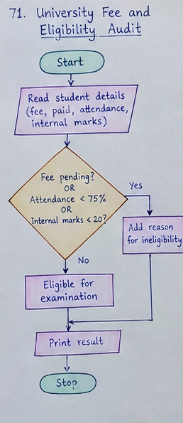
6. Pseudocode
FOR EACH student IN students DO
INITIALIZE reasons as empty list
IF student.fee_due > student.fee_paid THEN
APPEND "Fee Pending" TO reasons
END IF
IF student.attendance < 75 THEN
APPEND "Low Attendance" TO reasons
END IF
IF student.internal_marks < 20 THEN
APPEND "Low Internal Marks" TO reasons
END IF
IF reasons IS NOT EMPTY THEN
PRINT student.name, "Not Eligible:", JOIN(reasons)
ELSE
PRINT student.name, "Eligible for Examination"
END IF
END FOR
7. Python Source Code
students = [
[101, "Ravi", 20000, 18000, 85, 32],
[102, "Sita", 20000, 20000, 65, 25],
[103, "Arun", 20000, 15000, 90, 18],
[104, "Priya", 20000, 20000, 80, 35]
]
for s in students:
reasons = []
if s[2] > s[3]:
reasons.append("Fee Pending")
if s[4] < 75:
reasons.append("Low Attendance")
if s[5] < 20:
reasons.append("Low Internal Marks")
print("\nStudent:", s[1])
if reasons:
print("Not Eligible:", ", ".join(reasons))
else:
print("Eligible for Examination")
8. Test Cases
Test Case | Input Scenario | Expected Output
TC1 | Student: Ravi (Due: 20000, Paid: 18000, Att: 85%, Marks: 32) | Not Eligible: Fee Pending
TC2 | Student: Sita (Due: 20000, Paid: 20000, Att: 65%, Marks: 25) | Not Eligible: Low Attendance
TC3 | Student: Arun (Due: 20000, Paid: 15000, Att: 90%, Marks: 18) | Not Eligible: Fee Pending, Low Internal Marks
TC4 | Student: Priya (Due: 20000, Paid: 20000, Att: 80%, Marks: 35) | Eligible for Examination
9. Output Screenshots
Student: Ravi
Not Eligible: Fee Pending
Student: Sita
Not Eligible: Low Attendance
Student: Arun
Not Eligible: Fee Pending, Low Internal Marks
Student: Priya
Eligible for Examination
10. Conclusion
The integrated audit script successfully evaluates multi-condition examination eligibility and accurately pinpoints disqualification reasons for administrative compliance.
EXPERIMENT 72: Smart Hostel Resource Monitoring
1. Problem Statement
Hostel administration needs to calculate individual room resource utility bills (electricity and water) while simultaneously flagging excessive consumption that exceeds predefined environmental threshold limits.
2. Objectives
- Compute monthly utility billing charges per hostel room based on standard tariffs.
- Evaluate consumption metrics against safe operational limits.
- Trigger automated consumption warnings when limits are breached.
3. Assumptions
- Electricity tariff = Rs. 8 per unit; Water tariff = Rs. 2 per unit.
- Maximum permissible limits: Electricity = 150 units, Water = 700 units.
- Room metrics provided as [Room Name, Electricity Units, Water Units].
4. Algorithm
Step 1: Define utility rates and maximum safe consumption limits.
Step 2: Iterate over each room's consumption record.
Step 3: Calculate Electricity Bill = units * electricity_rate.
Step 4: Calculate Water Bill = units * water_rate.
Step 5: Calculate Total Bill = Electricity Bill + Water Bill.
Step 6: Check if electricity > max_electricity OR water > max_water.
Step 7: Print billing details and display 'Warning: Consumption Limit Exceeded' if limit breached, else 'Consumption Normal'.
5. Flowchart
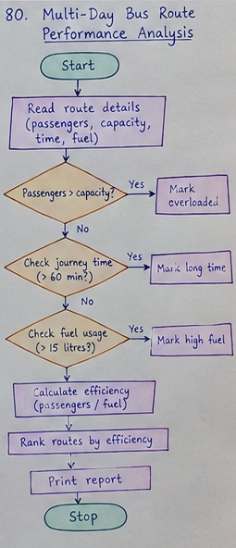
6. Pseudocode
SET electricity_rate = 8, water_rate = 2
SET max_electricity = 150, max_water = 700
FOR EACH room IN rooms DO
electricity_bill = room.electricity * electricity_rate
water_bill = room.water * water_rate
total = electricity_bill + water_bill
PRINT room.name, electricity_bill, water_bill, total
IF room.electricity > max_electricity OR room.water > max_water THEN
PRINT "Warning: Consumption Limit Exceeded"
ELSE
PRINT "Consumption Normal"
END IF
END FOR
7. Python Source Code
rooms = [
["Room 101", 120, 500],
["Room 102", 180, 800],
["Room 103", 90, 400],
["Room 104", 220, 1000]
]
electricity_rate = 8
water_rate = 2
max_electricity = 150
max_water = 700
for room in rooms:
name, electricity, water = room
electricity_bill = electricity * electricity_rate
water_bill = water * water_rate
total = electricity_bill + water_bill
print("\nRoom:", name)
print("Electricity Bill: Rs.", electricity_bill)
print("Water Bill: Rs.", water_bill)
print("Total Bill: Rs.", total)
if electricity > max_electricity or water > max_water:
print("Warning: Consumption Limit Exceeded")
else:
print("Consumption Normal")
8. Test Cases
Test Case | Input Scenario | Expected Output
TC1 | Room 101 (Elec: 120, Water: 500) | Total: Rs. 1960, Status: Consumption Normal
TC2 | Room 102 (Elec: 180, Water: 800) | Total: Rs. 3040, Status: Warning: Consumption Limit Exceeded
TC3 | Room 103 (Elec: 90, Water: 400) | Total: Rs. 1520, Status: Consumption Normal
9. Output Screenshots
Room: Room 101
Electricity Bill: Rs. 960
Water Bill: Rs. 1000
Total Bill: Rs. 1960
Consumption Normal
Room: Room 102
Electricity Bill: Rs. 1440
Water Bill: Rs. 1600
Total Bill: Rs. 3040
Warning: Consumption Limit Exceeded
Room: Room 103
Electricity Bill: Rs. 720
Water Bill: Rs. 800
Total Bill: Rs. 1520
Consumption Normal
Room: Room 104
Electricity Bill: Rs. 1760
Water Bill: Rs. 2000
Total Bill: Rs. 3760
Warning: Consumption Limit Exceeded
10. Conclusion
The smart monitoring program efficiently calculates utility overheads and highlights rooms exceeding resource limits to promote sustainability.
EXPERIMENT 73: Multi-Route Courier Dispatch Planning
1. Problem Statement
A logistics dispatcher must allocate courier packages to delivery vehicles based on priority levels while strictly respecting vehicle payload weight capacities.
2. Objectives
- Sort packages according to priority hierarchy (High > Medium > Low).
- Fit high-priority packages into available vehicle capacities first.
- Monitor vehicle capacity utilization and flag undispatched packages.
3. Assumptions
- Priority weight mapping: High = 1, Medium = 2, Low = 3.
- Packages are assigned to the first vehicle that has sufficient remaining capacity.
- Vehicle capacity cannot be exceeded.
4. Algorithm
Step 1: Define package list [ID, Weight, Priority] and vehicle list [ID, Capacity, Current Load].
Step 2: Sort packages in ascending order of priority rank.
Step 3: Iterate through each sorted package.
Step 4: Check available vehicles sequentially; if current load + package weight <= capacity, assign package and update load.
Step 5: If no vehicle can accommodate the package, mark as undispatched.
Step 6: Output assignment results and final vehicle capacity utilization.
5. Flowchart
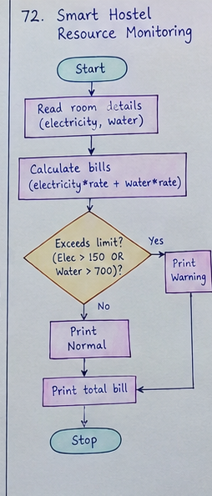
6. Pseudocode
SORT packages BY priority_order (High -> Medium -> Low)
FOR EACH package IN packages DO
SET dispatched = False
FOR EACH vehicle IN vehicles DO
IF vehicle.current_load + package.weight <= vehicle.capacity THEN
vehicle.current_load += package.weight
PRINT package.id, "assigned to", vehicle.id
SET dispatched = True
BREAK
END IF
END FOR
IF NOT dispatched THEN
PRINT package.id, "cannot be dispatched"
END IF
END FOR
PRINT vehicle utilization report
7. Python Source Code
packages = [
["P101", 20, "High"],
["P102", 35, "Low"],
["P103", 25, "High"],
["P104", 40, "Medium"],
["P105", 15, "Low"]
]
vehicles = [
["Vehicle 1", 60, 0],
["Vehicle 2", 50, 0]
]
priority_order = {"High": 1, "Medium": 2, "Low": 3}
packages.sort(key=lambda p: priority_order[p[2]])
for package in packages:
dispatched = False
for vehicle in vehicles:
if vehicle[2] + package[1] <= vehicle[1]:
vehicle[2] += package[1]
print(package[0], "assigned to", vehicle[0])
dispatched = True
break
if not dispatched:
print(package[0], "cannot be dispatched")
print("\nVehicle Utilization:")
for vehicle in vehicles:
print(vehicle[0], ":", vehicle[2], "/", vehicle[1], "kg")
8. Test Cases
Test Case | Input Scenario | Expected Output
TC1 | High priority: P101(20kg), P103(25kg) | Assigned to Vehicle 1 (Total load: 45kg)
TC2 | Medium priority: P104(40kg) | Assigned to Vehicle 2 (Total load: 40kg)
TC3 | Low priority: P102(35kg), P105(15kg) | P105 assigned to Vehicle 1; P102 cannot be dispatched
9. Output Screenshots
P101 assigned to Vehicle 1
P103 assigned to Vehicle 1
P104 assigned to Vehicle 2
P102 cannot be dispatched
P105 assigned to Vehicle 1
Vehicle Utilization:
Vehicle 1 : 60 / 60 kg
Vehicle 2 : 40 / 50 kg
10. Conclusion
The greedy dispatch algorithm optimizes load allocation according to package priority constraints and vehicle capacity limits.
EXPERIMENT 74: Campus Festival Registration and Financial Audit
1. Problem Statement
Organizers of a campus festival need an automated tool to audit event registrations for duplicate entries while auditing financial inflows and outflows.
2. Objectives
- Identify and log duplicate student registration entries.
- Compute total collected valid registration fees, sponsorships, and expenses.
- Determine final net financial balance for the event.
3. Assumptions
- A registration is duplicate if the Student ID has already been processed.
- Only unique registrations contribute to total registration fee collection.
- Net Balance = (Total Valid Registration Fees + Total Sponsorships) - Total Expenses.
4. Algorithm
Step 1: Store registration list, sponsorship list, and expense list.
Step 2: Initialize empty set 'seen' and total fee counter to 0.
Step 3: Iterate through registration records.
Step 4: If Student ID in 'seen', print duplicate warning; otherwise add ID to 'seen' and accumulate fee.
Step 5: Sum total sponsorships and expenses.
Step 6: Compute total income and net balance.
Step 7: Print full registration and financial audit report.
5. Flowchart
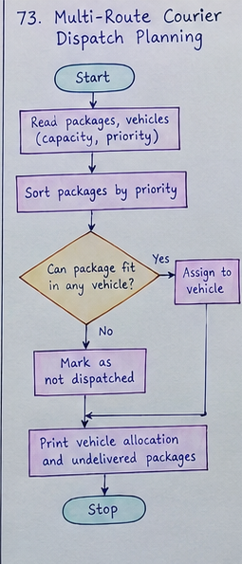
6. Pseudocode
INITIALIZE seen set, total_fees = 0
FOR EACH reg IN registrations DO
IF reg.id IN seen THEN
PRINT "Duplicate Registration:", reg.id
ELSE
ADD reg.id TO seen
total_fees += reg.fee
END IF
END FOR
total_sponsorship = SUM(sponsorships)
total_expenses = SUM(expenses)
total_income = total_fees + total_sponsorship
balance = total_income - total_expenses
PRINT summary metrics and balance
7. Python Source Code
registrations = [
[101, "Ravi", 500],
[102, "Sita", 500],
[101, "Ravi", 500],
[103, "Arun", 500],
[104, "Priya", 500]
]
sponsorships = [5000, 3000, 2000]
expenses = [4000, 2500, 1500]
seen = set()
total_fees = 0
print("Registration Audit:")
for r in registrations:
if r[0] in seen:
print("Duplicate Registration:", r[0], r[1])
else:
seen.add(r[0])
total_fees += r[2]
total_sponsorship = sum(sponsorships)
total_expenses = sum(expenses)
total_income = total_fees + total_sponsorship
balance = total_income - total_expenses
print("\nValid Participants:", len(seen))
print("Registration Fees: Rs.", total_fees)
print("Sponsorships: Rs.", total_sponsorship)
print("Total Income: Rs.", total_income)
print("Total Expenses: Rs.", total_expenses)
print("Final Balance: Rs.", balance)
8. Test Cases
Test Case | Input Scenario | Expected Output
TC1 | Registrations with duplicate ID 101 | Duplicate Registration detected for ID 101
TC2 | 4 unique students @ 500 each | Total Registration Fees: Rs. 2000
TC3 | Fees (2000) + Sponsorship (10000) - Expenses (8000) | Final Balance: Rs. 4000
9. Output Screenshots
Registration Audit:
Duplicate Registration: 101 Ravi
Valid Participants: 4
Registration Fees: Rs. 2000
Sponsorships: Rs. 10000
Total Income: Rs. 12000
Total Expenses: Rs. 8000
Final Balance: Rs. 4000
10. Conclusion
The audit script accurately filters duplicate entries using set data structures and provides a clear financial audit summary.
EXPERIMENT 75: Integrated Student Record Consistency Checker
1. Problem Statement
An academic department requires a validation engine to check student database integrity against multiple integrity rules such as duplicates, missing values, range bounds, and relational cross-checks.
2. Objectives
- Detect duplicate student IDs within the primary registry.
- Validate presence and score boundary constraints (0–100) for marks and attendance.
- Cross-validate student IDs against attendance database tables.
3. Assumptions
- Marks and attendance values must strictly lie between 0 and 100.
- Names cannot be empty string or None.
- Attendance table maps Student ID to attendance percentage.
4. Algorithm
Step 1: Initialize student dataset tuple list and attendance dictionary.
Step 2: Track encountered IDs using a 'seen' set.
Step 3: Loop through student records and evaluate validation rules.
Step 4: Check ID duplication, missing name, missing/invalid marks, and missing/invalid attendance.
Step 5: Collect error descriptions into an errors list for each record.
Step 6: Display 'Record Valid' if error list is empty; otherwise output concatenated error flags.
5. Flowchart
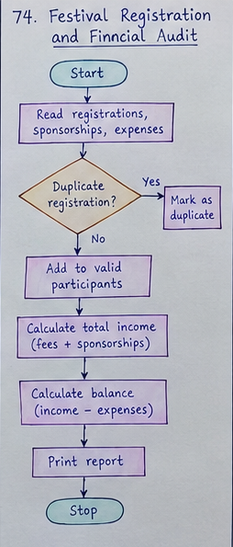
6. Pseudocode
FOR EACH student IN students DO
INITIALIZE errors as empty list
IF student.id IN seen THEN
APPEND "Duplicate ID" TO errors
ELSE
ADD student.id TO seen
END IF
IF student.name IS EMPTY THEN APPEND "Missing Name" TO errors
IF marks IS NONE OR OUT_OF_BOUNDS(0,100) THEN APPEND "Invalid/Missing Marks"
IF student.id NOT IN attendance THEN APPEND "Missing Attendance"
PRINT student.id, errors IF errors ELSE "Record Valid"
END FOR
7. Python Source Code
students = [
(101, "Ravi", 85, 90),
(102, "Sita", 78, 80),
(101, "Arun", 65, 70),
(103, "", 110, 75),
(104, "Priya", 88, None)
]
attendance = {101: 85, 102: 60, 103: 90, 104: 80}
seen = set()
for s in students:
sid, name, marks, course_marks = s
errors = []
if sid in seen:
errors.append("Duplicate ID")
else:
seen.add(sid)
if not name:
errors.append("Missing Name")
if marks is None or course_marks is None:
errors.append("Missing Marks")
elif not (0 <= marks <= 100 and 0 <= course_marks <= 100):
errors.append("Invalid Marks")
if sid not in attendance:
errors.append("Missing Attendance")
elif not (0 <= attendance[sid] <= 100):
errors.append("Invalid Attendance")
print("\nStudent ID:", sid)
if errors:
print("Errors:", ", ".join(errors))
else:
print("Record Valid")
8. Test Cases
Test Case | Input Scenario | Expected Output
TC1 | ID 101 second instance | Errors: Duplicate ID
TC2 | ID 103 with empty name & marks=110 | Errors: Missing Name, Invalid Marks
TC3 | ID 104 with course_marks=None | Errors: Missing Marks
9. Output Screenshots
Student ID: 101
Record Valid
Student ID: 102
Record Valid
Student ID: 101
Errors: Duplicate ID
Student ID: 103
Errors: Missing Name, Invalid Marks
Student ID: 104
Errors: Missing Marks
10. Conclusion
The integrity checker effectively isolates bad records, enabling clean data pipeline processing before database commitment.
EXPERIMENT 76: University Examination Result Moderation
1. Problem Statement
An examination board requires a moderation script to apply grace marks to subject scores near pass thresholds and compute updated overall pass/fail status.
2. Objectives
- Apply moderation rule: add 5 grace marks to scores below passing mark (35).
- Cap moderated marks at maximum limit of 100.
- Re-evaluate student final pass/fail result post-moderation.
3. Assumptions
- Pass mark threshold = 35 for each individual subject.
- Grace addition = min(original_mark + 5, 100) if original_mark < 35.
- Overall Result = Pass if all moderated subject marks >= 35, else Fail.
4. Algorithm
Step 1: Iterate over student list containing subject mark tuples.
Step 2: For each subject score, evaluate if mark < 35.
Step 3: If mark < 35, update score to min(mark + 5, 100); otherwise keep unchanged.
Step 4: Compute original total and moderated total.
Step 5: Check if all moderated subject marks >= 35.
Step 6: Display original marks, moderated marks, totals, and final Pass/Fail status.
5. Flowchart
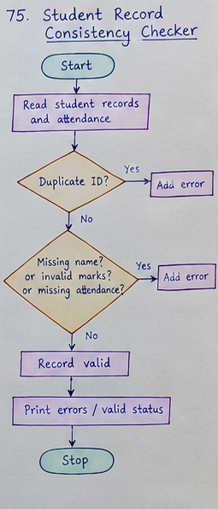
6. Pseudocode
FOR EACH student IN students DO
SET moderated = []
FOR EACH mark IN student.original_marks DO
IF mark < 35 THEN
new_mark = MIN(mark + 5, 100)
ELSE
new_mark = mark
END IF
APPEND new_mark TO moderated
END FOR
IF ALL marks IN moderated >= 35 THEN
status = "Pass"
ELSE
status = "Fail"
END IF
PRINT student details, totals, and status
END FOR
7. Python Source Code
students = [
["Ravi", [30, 45, 60]],
["Sita", [32, 28, 75]],
["Arun", [50, 65, 80]],
["Priya", [20, 35, 40]]
]
for student in students:
name = student[0]
original = student[1]
moderated = []
for mark in original:
if mark < 35:
new_mark = min(mark + 5, 100)
else:
new_mark = mark
moderated.append(new_mark)
print("\nStudent:", name)
print("Original Marks:", original)
print("Moderated Marks:", moderated)
print("Original Total:", sum(original))
print("Moderated Total:", sum(moderated))
if all(mark >= 35 for mark in moderated):
print("Result: Pass")
else:
print("Result: Fail")
8. Test Cases
Test Case | Input Scenario | Expected Output
TC1 | Ravi [30, 45, 60] | Moderated: [35, 45, 60], Result: Pass
TC2 | Sita [32, 28, 75] | Moderated: [37, 33, 75], Result: Fail
TC3 | Priya [20, 35, 40] | Moderated: [25, 35, 40], Result: Fail
9. Output Screenshots
Student: Ravi
Original Marks: [30, 45, 60]
Moderated Marks: [35, 45, 60]
Original Total: 135
Moderated Total: 140
Result: Pass
Student: Sita
Original Marks: [32, 28, 75]
Moderated Marks: [37, 33, 75]
Original Total: 135
Moderated Total: 145
Result: Fail
Student: Arun
Original Marks: [50, 65, 80]
Moderated Marks: [50, 65, 80]
Original Total: 195
Moderated Total: 195
Result: Pass
Student: Priya
Original Marks: [20, 35, 40]
Moderated Marks: [25, 35, 40]
Original Total: 95
Moderated Total: 100
Result: Fail
10. Conclusion
The result moderation module accurately applies grace mark logic and re-evaluates student eligibility criteria based on updated marks.
EXPERIMENT 77: Smart Electricity Billing for Multiple Apartments
1. Problem Statement
A housing society needs an automated billing engine that calculates electricity charges using slab-based progressive rates, applies rebate rules, and detects payment discrepancies.
2. Objectives
- Compute energy charges using progressive slab rates.
- Apply a 10% energy charge rebate for eco-friendly usage (< 100 units) and add fixed charges.
- Detect billing discrepancies by comparing calculated bill against paid amounts.
- Rank apartments based on power consumption.
3. Assumptions
- Slab 1: <=100 units @ Rs. 2/unit.
- Slab 2: 101–200 units @ Rs. 3/unit for excess over 100.
- Slab 3: >200 units @ Rs. 5/unit for excess over 200.
- Fixed monthly service charge = Rs. 100.
- Rebate = 10% of energy charge if units < 100.
4. Algorithm
Step 1: Loop through each apartment record [Name, Units, Paid Amount].
Step 2: Calculate energy charge using tiered slab conditions.
Step 3: Calculate rebate = 10% of energy charge if units < 100, else 0.
Step 4: Final Calculated Bill = Energy Charge + 100 (Fixed Charge) - Rebate.
Step 5: Check if Paid Amount == Calculated Bill; flag discrepancy if unequal.
Step 6: Sort apartments in descending order based on unit consumption and print ranking report.
5. Flowchart
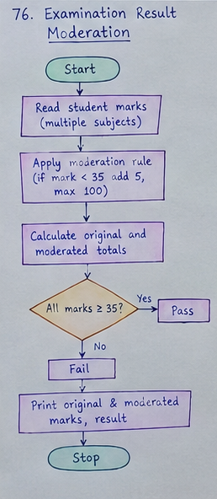
6. Pseudocode
FOR EACH apt IN apartments DO
IF units <= 100 THEN
energy_charge = units * 2
ELSE IF units <= 200 THEN
energy_charge = 100 * 2 + (units - 100) * 3
ELSE
energy_charge = 100 * 2 + 100 * 3 + (units - 200) * 5
END IF
rebate = (units < 100) ? (energy_charge * 0.10) : 0
bill = energy_charge + 100 - rebate
IF paid != bill THEN PRINT "Billing Discrepancy Detected"
APPEND bill TO apt
END FOR
SORT apartments BY units DESCENDING
PRINT ranking report
7. Python Source Code
apartments = [
["A101", 80, 260],
["A102", 150, 550],
["A103", 250, 1400],
["A104", 120, 400]
]
for apartment in apartments:
name, units, paid = apartment
if units <= 100:
energy_charge = units * 2
elif units <= 200:
energy_charge = 100 * 2 + (units - 100) * 3
else:
energy_charge = 100 * 2 + 100 * 3 + (units - 200) * 5
rebate = energy_charge * 0.10 if units < 100 else 0
bill = energy_charge + 100 - rebate
print("\nApartment:", name)
print("Units:", units)
print("Calculated Bill: Rs.", bill)
print("Amount Paid: Rs.", paid)
print("Billing Discrepancy Detected" if paid != bill else "Billing Correct")
apartment.append(bill)
apartments.sort(key=lambda a: a[1], reverse=True)
print("\nApartments Ranked by Consumption:")
for apartment in apartments:
print(apartment[0], "-", apartment[1], "units")
8. Test Cases
Test Case | Input Scenario | Expected Output
TC1 | A101 (80 units, Paid: 260) | Calculated Bill: Rs. 244.0, Discrepancy Detected
TC2 | A102 (150 units, Paid: 550) | Calculated Bill: Rs. 450.0, Discrepancy Detected
TC3 | Ranking Order | A103 (250) > A102 (150) > A104 (120) > A101 (80)
9. Output Screenshots
Apartment: A101
Units: 80
Calculated Bill: Rs. 244.0
Amount Paid: Rs. 260
Billing Discrepancy Detected
Apartment: A102
Units: 150
Calculated Bill: Rs. 450.0
Amount Paid: Rs. 550
Billing Discrepancy Detected
Apartment: A103
Units: 250
Calculated Bill: Rs. 850.0
Amount Paid: Rs. 1400
Billing Discrepancy Detected
Apartment: A104
Units: 120
Calculated Bill: Rs. 360.0
Amount Paid: Rs. 400
Billing Discrepancy Detected
Apartments Ranked by Consumption:
A103 - 250 units
A102 - 150 units
A104 - 120 units
A101 - 80 units
10. Conclusion
The progressive tariff billing algorithm accurately audits tenant electricity bills, detects discrepancies, and ranks energy usage.
EXPERIMENT 78: Hospital Resource Allocation and Capacity Monitoring
1. Problem Statement
A hospital operational dashboard requires a real-time monitor for ward capacity, bed availability, staffing levels, and critical equipment shortages.
2. Objectives
- Compute available beds per ward.
- Detect shortages in staffing and specialized medical equipment.
- Determine primary triage operational priority status for resource allocation.
3. Assumptions
- Available Beds = Total Beds - Occupied Beds.
- Staff Shortage = Required Staff - Available Staff (if > 0).
- Equipment Shortage = Required Equipment - Available Equipment (if > 0).
- Priority assigned in order: No Beds > Staff Required > Equipment Required > Normal.
4. Algorithm
Step 1: Iterate through ward tuples containing bed, staff, and equipment metrics.
Step 2: Calculate available beds = Total Beds - Occupied Beds.
Step 3: Evaluate staff shortage (available < required) and equipment shortage.
Step 4: Assess bed capacity overload error if occupied > total.
Step 5: Determine operational priority flag based on highest severity shortage.
Step 6: Print resource breakdown and priority status for each ward.
5. Flowchart
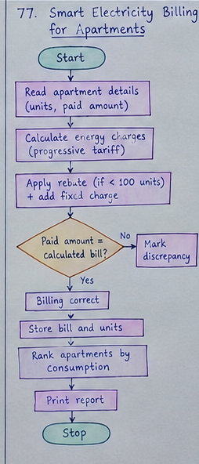
6. Pseudocode
FOR EACH ward IN wards DO
available_beds = ward.total_beds - ward.occupied_beds
PRINT ward.name, available_beds
IF ward.occupied_beds > ward.total_beds THEN PRINT "Error: Bed Capacity Exceeded"
IF available_staff < required_staff THEN PRINT "Staff Shortage:", diff
IF available_equipment < required_equipment THEN PRINT "Equipment Shortage:", diff
IF available_beds == 0 THEN
PRINT "Priority: No Beds Available"
ELSE IF staff_shortage THEN
PRINT "Priority: Staff Required"
ELSE IF equipment_shortage THEN
PRINT "Priority: Equipment Required"
ELSE
PRINT "Status: Resources Sufficient"
END IF
END FOR
7. Python Source Code
wards = [
["General Ward", 40, 35, 8, 10, 6, 8],
["ICU", 20, 20, 3, 6, 2, 4],
["Emergency", 30, 25, 4, 8, 3, 6],
["Pediatric Ward", 25, 15, 5, 4, 5, 5]
]
for ward in wards:
name, total_beds, occupied_beds, available_staff, required_staff, available_equipment, required_equipment = ward
available_beds = total_beds - occupied_beds
print("\nWard:", name)
print("Available Beds:", available_beds)
if occupied_beds > total_beds:
print("Error: Bed Capacity Exceeded")
if available_staff < required_staff:
print("Staff Shortage:", required_staff - available_staff)
else:
print("Staff Sufficient")
if available_equipment < required_equipment:
print("Equipment Shortage:", required_equipment - available_equipment)
else:
print("Equipment Sufficient")
if available_beds == 0:
print("Priority: No Beds Available")
elif available_staff < required_staff:
print("Priority: Staff Required")
elif available_equipment < required_equipment:
print("Priority: Equipment Required")
else:
print("Status: Resources Sufficient")
8. Test Cases
Test Case | Input Scenario | Expected Output
TC1 | General Ward (40 total, 35 occupied) | Beds: 5, Staff Shortage: 2, Equip Shortage: 2, Priority: Staff Required
TC2 | ICU (20 total, 20 occupied) | Beds: 0, Priority: No Beds Available
TC3 | Pediatric Ward (25 total, 15 occupied, sufficient staff/equip) | Status: Resources Sufficient
9. Output Screenshots
Ward: General Ward
Available Beds: 5
Staff Shortage: 2
Equipment Shortage: 2
Priority: Staff Required
Ward: ICU
Available Beds: 0
Staff Shortage: 3
Equipment Shortage: 2
Priority: No Beds Available
Ward: Emergency
Available Beds: 5
Staff Shortage: 4
Equipment Shortage: 3
Priority: Staff Required
Ward: Pediatric Ward
Available Beds: 10
Staff Sufficient
Equipment Sufficient
Status: Resources Sufficient
10. Conclusion
The monitoring script provides critical visibility into hospital operational constraints, facilitating prompt resource allocation.
EXPERIMENT 79: Integrated Warehouse Order Prioritization
1. Problem Statement
An automated warehouse fulfillment system needs to process pending orders based on commercial priority levels and current stock availability.
2. Objectives
- Sort order fulfillment queue by priority level (High > Medium > Low).
- Calculate fulfilled quantity based on available stock limits.
- Determine outstanding unfulfilled quantities and label order status.
3. Assumptions
- Fulfilled Quantity = min(Requested Quantity, Available Stock).
- Outstanding Quantity = Requested Quantity - Fulfilled Quantity.
- Status is 'Order Fulfilled' if outstanding is 0, else 'Partially Fulfilled'.
4. Algorithm
Step 1: Read order list [Order ID, Item Name, Quantity, Stock, Priority].
Step 2: Map priority levels: High = 1, Medium = 2, Low = 3.
Step 3: Sort orders based on mapped priority index.
Step 4: Iterate through sorted orders.
Step 5: Compute fulfilled = min(quantity, stock) and outstanding = quantity - fulfilled.
Step 6: Determine order fulfillment status flag and print complete summary.
5. Flowchart
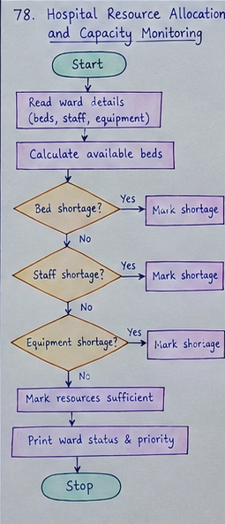
6. Pseudocode
SORT orders BY priority_order (High -> Medium -> Low)
FOR EACH order IN orders DO
fulfilled = MIN(order.quantity, order.stock)
outstanding = order.quantity - fulfilled
IF outstanding == 0 THEN
status = "Order Fulfilled"
ELSE
status = "Partially Fulfilled"
END IF
PRINT order details, fulfilled, outstanding, status
END FOR
7. Python Source Code
orders = [
["O101", "Laptop", 20, 15, "High"],
["O102", "Mouse", 50, 60, "Low"],
["O103", "Keyboard", 30, 20, "Medium"],
["O104", "Monitor", 15, 10, "High"]
]
priority_order = {"High": 1, "Medium": 2, "Low": 3}
orders.sort(key=lambda o: priority_order[o[4]])
for order in orders:
order_id, product, quantity, stock, priority = order
fulfilled = min(quantity, stock)
outstanding = quantity - fulfilled
print("\nOrder ID:", order_id)
print("Product:", product)
print("Priority:", priority)
print("Requested Quantity:", quantity)
print("Available Stock:", stock)
print("Fulfilled Quantity:", fulfilled)
print("Outstanding Quantity:", outstanding)
if outstanding == 0:
print("Status: Order Fulfilled")
else:
print("Status: Partially Fulfilled")
8. Test Cases
Test Case | Input Scenario | Expected Output
TC1 | O101 Laptop (Qty: 20, Stock: 15, High) | Fulfilled: 15, Outstanding: 5, Partially Fulfilled
TC2 | O104 Monitor (Qty: 15, Stock: 10, High) | Fulfilled: 10, Outstanding: 5, Partially Fulfilled
TC3 | O102 Mouse (Qty: 50, Stock: 60, Low) | Fulfilled: 50, Outstanding: 0, Order Fulfilled
9. Output Screenshots
Order ID: O101
Product: Laptop
Priority: High
Requested Quantity: 20
Available Stock: 15
Fulfilled Quantity: 15
Outstanding Quantity: 5
Status: Partially Fulfilled
Order ID: O104
Product: Monitor
Priority: High
Requested Quantity: 15
Available Stock: 10
Fulfilled Quantity: 10
Outstanding Quantity: 5
Status: Partially Fulfilled
Order ID: O103
Product: Keyboard
Priority: Medium
Requested Quantity: 30
Available Stock: 20
Fulfilled Quantity: 20
Outstanding Quantity: 10
Status: Partially Fulfilled
Order ID: O102
Product: Mouse
Priority: Low
Requested Quantity: 50
Available Stock: 60
Fulfilled Quantity: 50
Outstanding Quantity: 0
Status: Order Fulfilled
10. Conclusion
The prioritization script manages warehouse stock dispatch effectively, prioritizing critical orders under stock deficit constraints.
EXPERIMENT 80: Multi-Day Bus Route Performance Analysis
1. Problem Statement
A public transit department requires an analytics program to evaluate bus route performance, detect operational inefficiencies, and rank routes by fuel efficiency.
2. Objectives
- Check for passenger overloading against bus seating capacity.
- Identify route delay risks (journey time > 60 min) and high fuel consumption (> 15 litres).
- Calculate passenger efficiency per litre of fuel and rank routes.
3. Assumptions
- Overloaded condition: Passengers > Seating Capacity.
- Long Journey Warning: Time > 60 minutes.
- High Fuel Warning: Fuel > 15 litres.
- Efficiency = Passengers / Fuel Used.
4. Algorithm
Step 1: Loop through bus route list [Name, Passengers, Capacity, Time, Fuel].
Step 2: Check overloading condition (Passengers > Capacity).
Step 3: Check journey time threshold (> 60 mins) and fuel threshold (> 15 L).
Step 4: Compute fuel efficiency metric = Passengers / Fuel.
Step 5: Sort routes in descending order of passenger efficiency.
Step 6: Output individual route alerts and overall route efficiency rankings.
5. Flowchart
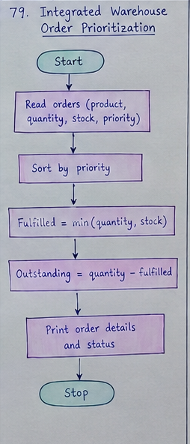
6. Pseudocode
FOR EACH route IN routes DO
PRINT route details
IF route.passengers > route.capacity THEN PRINT "Warning: Overloaded Route"
IF route.time > 60 THEN PRINT "Warning: Long Journey Time"
IF route.fuel > 15 THEN PRINT "Warning: High Fuel Consumption"
IF route.fuel > 0 THEN PRINT "Passengers per Litre:", ROUND(passengers/fuel, 2)
END FOR
SORT routes BY (passengers / fuel) DESCENDING
PRINT route performance ranking list
7. Python Source Code
routes = [
["Route A", 55, 50, 60, 12],
["Route B", 40, 45, 50, 10],
["Route C", 70, 55, 80, 20],
["Route D", 30, 40, 45, 8]
]
for route in routes:
name, passengers, capacity, time, fuel = route
print("\nRoute:", name)
print("Passengers:", passengers)
print("Bus Capacity:", capacity)
print("Journey Time:", time, "minutes")
print("Fuel Used:", fuel, "litres")
if passengers > capacity:
print("Warning: Overloaded Route")
else:
print("Passenger Capacity Normal")
if time > 60:
print("Warning: Long Journey Time")
if fuel > 15:
print("Warning: High Fuel Consumption")
if fuel > 0:
print("Passengers per Litre:", round(passengers / fuel, 2))
routes.sort(key=lambda r: r[1] / r[4], reverse=True)
print("\nRoutes Ranked by Passenger-Fuel Efficiency:")
for route in routes:
print(route[0], "-", round(route[1] / route[4], 2), "passengers/litre")
8. Test Cases
Test Case | Input Scenario | Expected Output
TC1 | Route A (55 pass, 50 cap, 60 min, 12L) | Warning: Overloaded Route, Efficiency: 4.58 pass/L
TC2 | Route C (70 pass, 55 cap, 80 min, 20L) | Warnings: Overloaded, Long Journey, High Fuel. Eff: 3.5 pass/L
TC3 | Route B (40 pass, 45 cap, 50 min, 10L) | Normal, Efficiency: 4.0 pass/L
9. Output Screenshots
Route: Route A
Passengers: 55
Bus Capacity: 50
Journey Time: 60 minutes
Fuel Used: 12 litres
Warning: Overloaded Route
Passengers per Litre: 4.58
Route: Route B
Passengers: 40
Bus Capacity: 45
Journey Time: 50 minutes
Fuel Used: 10 litres
Passenger Capacity Normal
Passengers per Litre: 4.0
Route: Route C
Passengers: 70
Bus Capacity: 55
Journey Time: 80 minutes
Fuel Used: 20 litres
Warning: Overloaded Route
Warning: Long Journey Time
Warning: High Fuel Consumption
Passengers per Litre: 3.5
Route: Route D
Passengers: 30
Bus Capacity: 40
Journey Time: 45 minutes
Fuel Used: 8 litres
Passenger Capacity Normal
Passengers per Litre: 3.75
Routes Ranked by Passenger-Fuel Efficiency:
Route A - 4.58 passengers/litre
Route B - 4.0 passengers/litre
Route D - 3.75 passengers/litre
Route C - 3.5 passengers/litre
10. Conclusion
The performance analysis program effectively identifies bottlenecks and ranks fleet routes based on operational and fuel efficiency metrics.

