LINKEDLIST:

A linked list is a collection which contains many objects of same type,similar to an arraylist.

The linkedlist stores the items in containers,there is a link to first container and each container .

To add an element in linked list,the element is placed into new container and it is linked to one of the other containers.

addFirst()---adds an element to beginning of the list.

addLast()—add an element at end of the list

removeFirst()---remove an element from beginning of the list

removeLast()---remove an element from end of the lst

getFirst()—access first item

getLast()---get the item at end of lists

**HASHMAP:**

**HASHMAP is used to store the items in key-value pairs.**

**Keys and values may be of different types .**

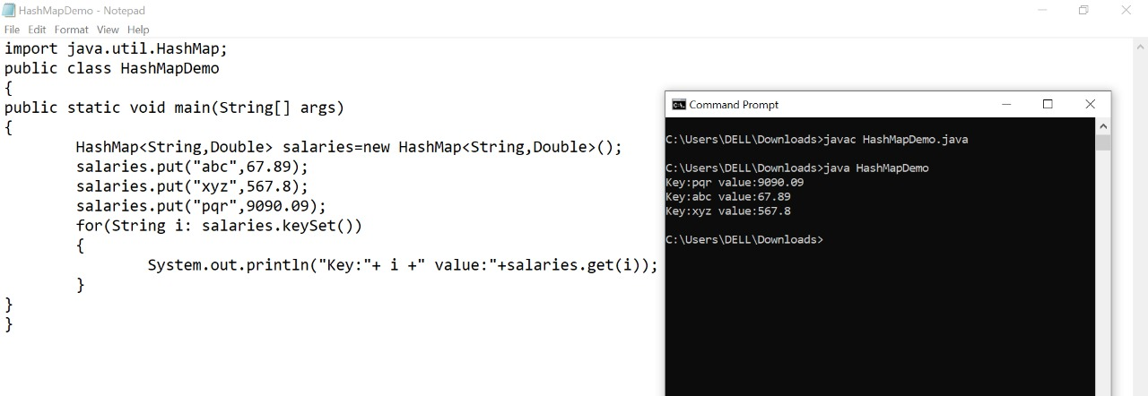

**HASHSET:**

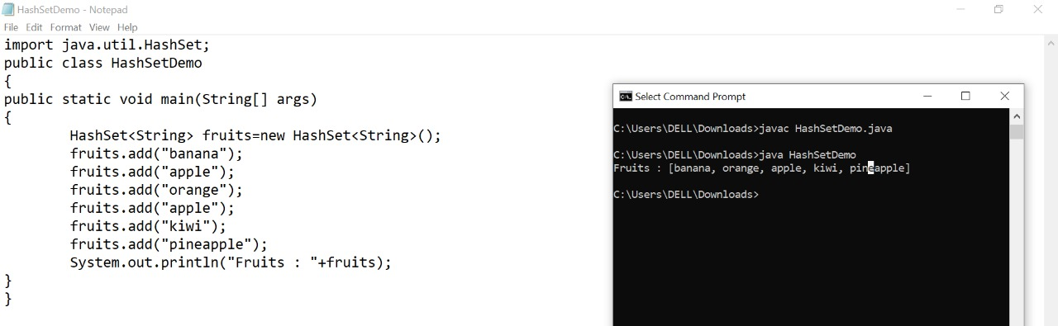

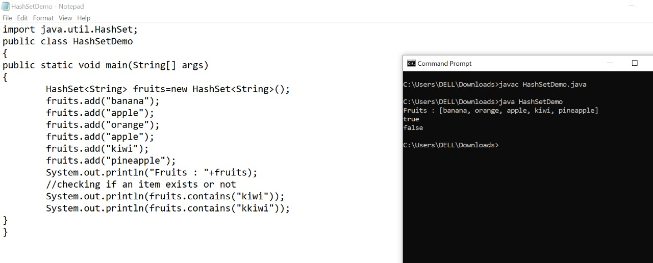

A HashSet is a collection of items where every item is unique, and it is found in the java.util package:

Syntax:

HashSet <datatype> hashset_name=new HashSet<datatype>();

**🡪use the add() method to add the items.**

**🡪to check if an item exists or not use the contains() method**

**🡪use the remove() method to remove an item**

**🡪to remove all items use the clear() method**

**🡪size() method return size of hashset**