EXPERIMENT NO: 4 DATE: 04/07/2026

AIM:
To demonstrate Windows Firewall blocking outbound Telnet port 23 and verify traffic after rule removal.

REQUIREMENTS:
1. Windows 10/11 PC
2. Command Prompt
3. Windows Firewall with Advanced Security - wf.msc

PROCEDURE:
1. Open Windows Firewall with Advanced Security using 'wf.msc'
2. Create Outbound Rule named 'Block_Telnet_Port23_Out'
- Rule Type: Port → TCP → Specific remote port: 23
- Action: Block the connection
- Profile: Domain, Private, Public all ticked
3. Test with rule ON: Run 'telnet google.com 23' in CMD
4. Delete the outbound rule from Windows Firewall
5. Test with rule OFF: Run 'telnet google.com 23' again
6. Test outbound traffic: Run 'telnet google.com 80'

OBSERVATION:
1. With firewall rule Enabled=Yes: telnet google.com 23 failed instantly with 'Connect failed'
2. After deleting rule: telnet google.com

SCREENSHOTS :
- 1_inbound_rules.png - Inbound Rules list with Block_Telnet_Port23

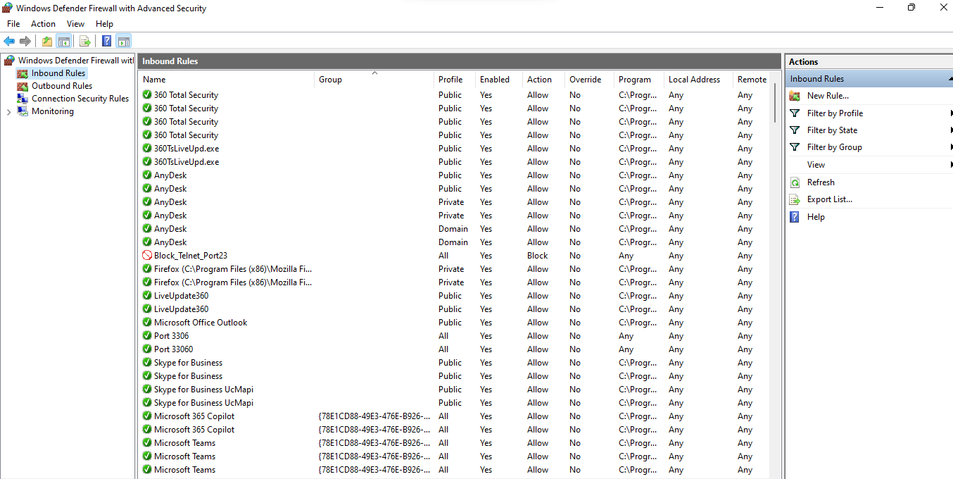

2. 2_outbound_rules.png- Outbound Rules list with Block_Telnet_Port23_Out + red Block icon

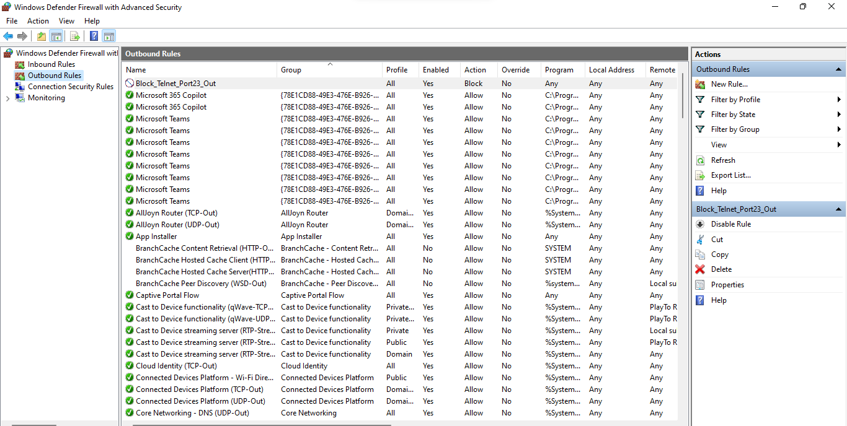

3. 3_inbound_enabled.png - CMD showing telnet google.com 23 → Connect failed with rule enabled

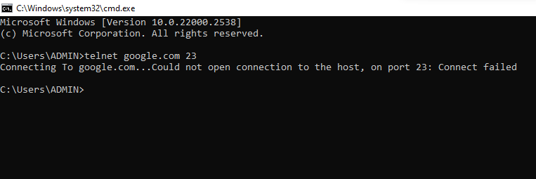

4. 4_outbound_enabled.png - Properties → Protocols and Ports tab: TCP + Remote port: 23


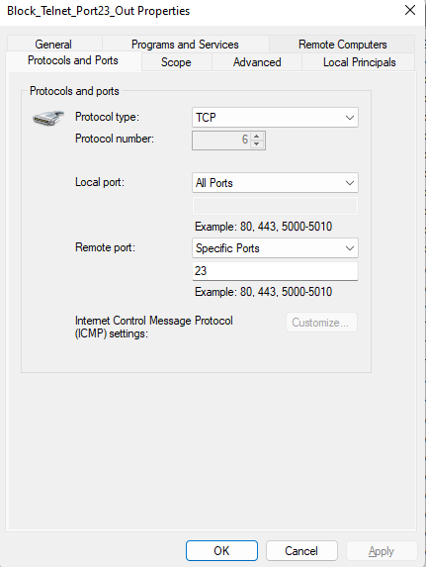

5. 4_inbound_rules_disabled.png - Outbound Rules list AFTER deleting the rule

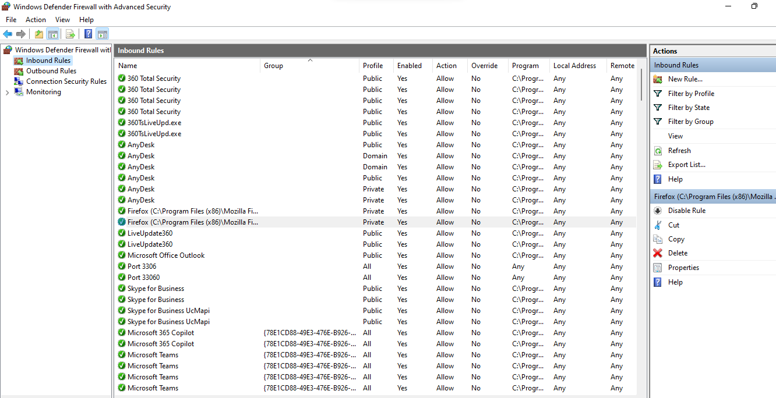

6. 8_outbound_disabled.png- CMD telnet google.com 23 after deleting rule

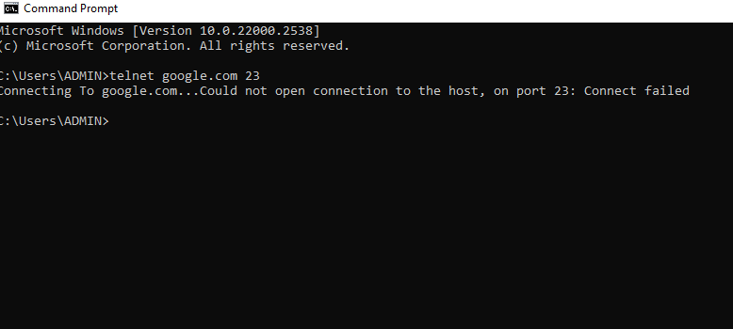

7. 9_port80_works.png - CMD telnet google.com 80 blank screen
