Credit Risk Default Prediction System

Machine Learning Project

Name: Kondreddy Vikhila

📄 Abstract

A machine learning-based credit risk assessment system was developed to predict whether a customer is likely to default on a loan. The project involved data preprocessing, feature engineering, and handling class imbalance using SMOTE to improve model performance.
Multiple machine learning algorithms such as Logistic Regression, Random Forest, and XGBoost were implemented and evaluated. Hyperparameter tuning was performed to optimize model performance, and cross-validation was used to ensure model stability.
The final tuned XGBoost model achieved the best performance with an accuracy of 94.7% and a ROC-AUC score of 98.54%, indicating strong predictive capability.
The model was further deployed using a Streamlit web application to enable real-time prediction of credit risk. The system provides default probability, risk categorization, and insights into important features influencing predictions.

📄 Problem Statement

The objective of this project is to develop a machine learning-based system that can predict the likelihood of a customer defaulting on a loan. Financial institutions require accurate risk assessment tools to make informed lending decisions, minimize credit losses, and improve portfolio quality.
Traditional credit evaluation methods rely heavily on manual analysis and limited historical indicators, which may not effectively capture complex patterns in customer behavior. This project aims to address this limitation by building an automated predictive model using machine learning techniques.

📊 Dataset Description

The dataset used in this project consists of historical credit and loan information used to predict customer default risk. It contains both numerical and categorical features that describe customer financial behavior and repayment history.
- Total Records: 5000
- Total Attributes: 42
- Model Features Used: 40
- Target Variable: Default Status
Key features include income level, debt-to-income ratio, bureau score, delinquency history, and other behavioral credit indicators that influence loan repayment capability.

⚙️ Methodology
The project follows a structured machine learning pipeline to develop an accurate credit risk prediction system.
1. Data Understanding
The dataset was analyzed to understand feature types, missing values, and target distribution.
2. Exploratory Data Analysis (EDA)
Visual analysis was performed using histograms, count plots, and correlation heatmaps to understand data patterns and relationships between features.
3. Feature Engineering
Important features such as debt-to-income ratio and delinquency metrics were created or refined to improve model performance.
4. Data Preprocessing
Data cleaning, encoding of categorical variables, and normalization were performed to prepare the dataset for modeling.
5. Train-Test Split
The dataset was divided into training and testing sets to evaluate model performance on unseen data.
6. Class Imbalance Handling (SMOTE)
SMOTE technique was applied to balance the dataset and improve model learning for minority class (default cases).
7. Model Building
Multiple machine learning algorithms were implemented, including Logistic Regression, Random Forest, and XGBoost.
8. Hyperparameter Tuning
Grid search / manual tuning was applied to optimize XGBoost parameters for better accuracy and performance.
9. Cross Validation
Cross-validation was used to ensure model stability and reduce overfitting.

📊 Models Developed
Multiple machine learning models were trained and evaluated to identify the best-performing algorithm for credit risk prediction.
The performance of each model was compared using accuracy metrics.

Model | Accuracy
Logistic Regression | 75.8%
Random Forest | 91.1%
XGBoost | 93.6%
Tuned XGBoost | 94.7%

The Tuned XGBoost model performed the best among all models and was selected as the final model for deployment due to its superior accuracy and ROC-AUC score.

🧠 SHAP Explainability
SHAP (SHapley Additive Explanations) was used to interpret the machine learning model and understand the contribution of each feature in predicting credit default risk.
It helps in explaining how individual features such as debt-to-income ratio, bureau score, and delinquent accounts influence the final prediction output.
SHAP values provide both global and local interpretability, making the model transparent and easier to trust in real-world financial decision-making systems.
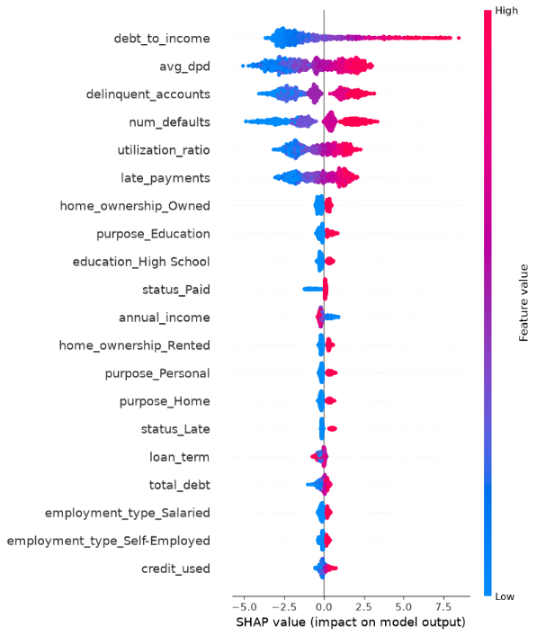
1️⃣ SHAP Summary Plot

2️⃣ SHAP Bar Plot (Feature Importance)
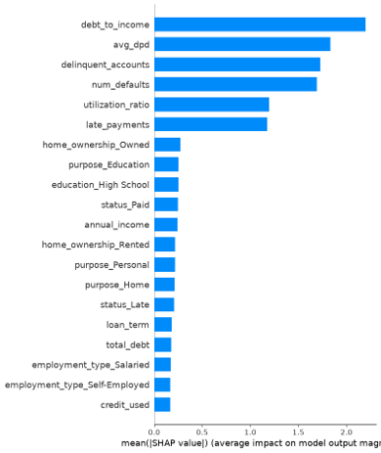
Model Evaluation
Model performance was evaluated using a confusion matrix and correlation analysis. These help in understanding prediction accuracy and relationships between important features.
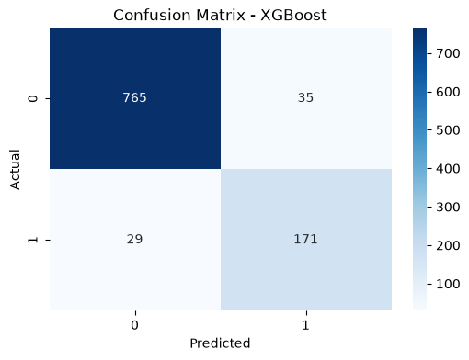
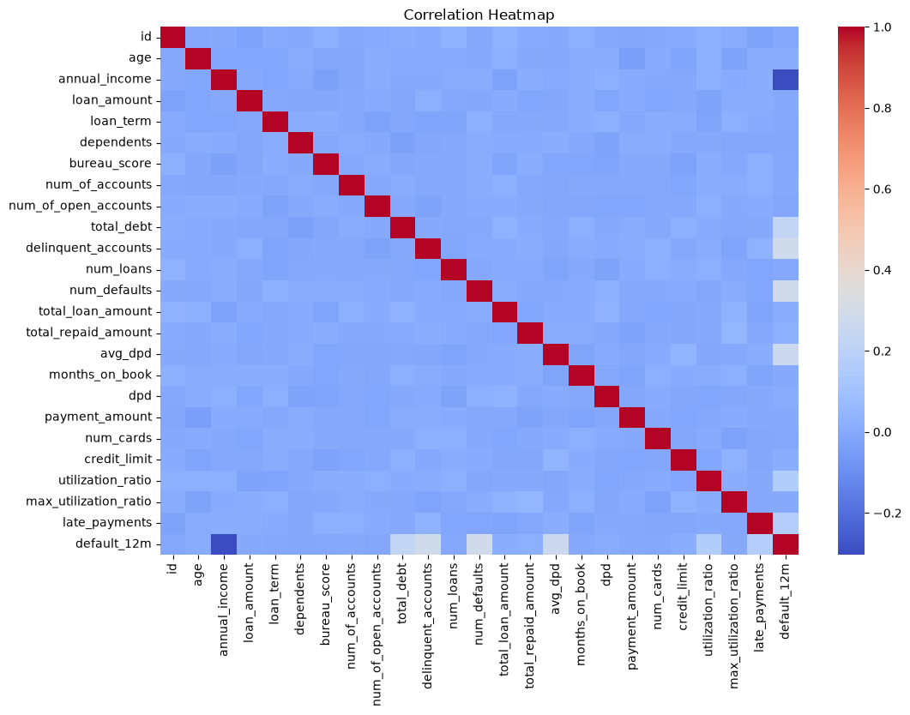
The confusion matrix shows the model’s ability to correctly classify default and non-default cases. The high number of correct predictions indicates strong model performance.
The correlation heatmap helps identify relationships between features, showing how variables such as debt-to-income ratio, income, and delinquency are interrelated.
🌐 Streamlit Deployment
The developed credit risk prediction model was deployed using a Streamlit web application to provide an interactive and user-friendly interface. The application enables real-time prediction of loan default risk based on user input features.
The system accepts customer financial details and outputs the probability of default along with a risk category (Low, Medium, High). It also provides model insights such as feature importance and explanation of predictions.
This deployment makes the machine learning model practical for real-world financial decision-making.
✔ Features of Streamlit Application
- Real-time credit risk prediction
- Default probability output
- Risk categorization (Low / Medium / High)
- Interactive user input form
- Feature importance visualization
- Model explainability support ✔ Streamlit Home Dashboard
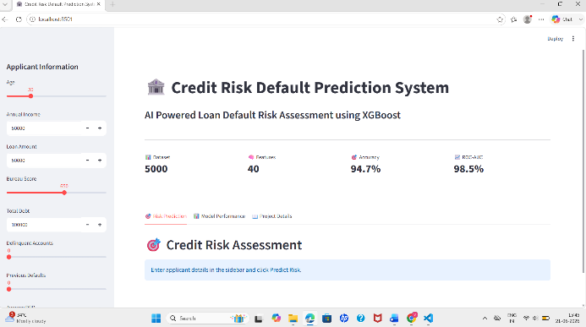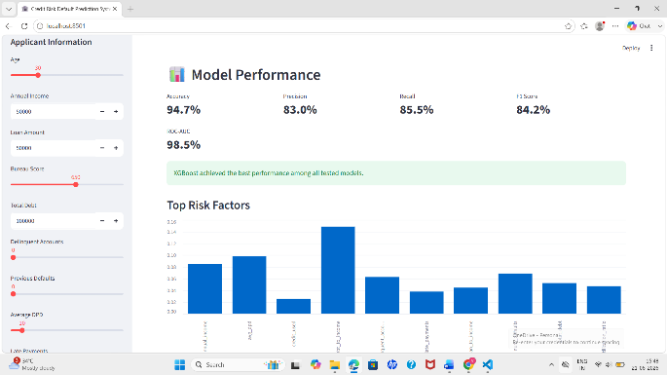
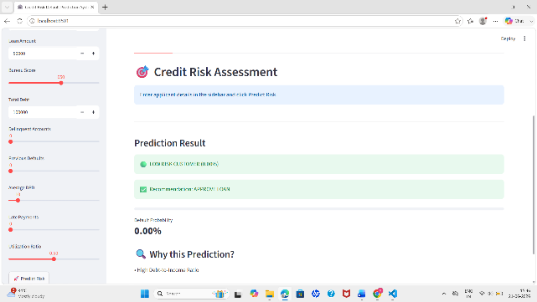✔Prediction Output Screen
📌 Conclusion
The project successfully developed a machine learning-based credit risk prediction system to assess the likelihood of loan default. Various machine learning models were evaluated, and the tuned XGBoost model achieved the best performance with 94.7% accuracy and 98.54% ROC-AUC score.
The integration of data preprocessing, feature engineering, SMOTE for class balancing, and hyperparameter tuning significantly improved model performance. The final system was deployed using Streamlit, enabling real-time predictions and user-friendly interaction.
This solution demonstrates how machine learning can effectively support financial institutions in making data-driven lending decisions.

📊 Business Insights
- Customers with high debt-to-income ratios are more likely to default
- Previous loan defaults strongly indicate future risk
- High delinquency (DPD) is a key predictor of credit risk
- Credit bureau scores significantly influence repayment behavior
- Income stability plays an important role in loan approval decisions

📌 Recommendations
- Reject high-risk loan applicants automatically
- Manually review medium-risk applicants before approval
- Approve low-risk customers with confidence
- Continuously monitor customers with increasing debt levels
- Improve credit scoring using behavioral and transaction-based features

The system can be further enhanced by integrating real-time banking data and advanced deep learning models for improved prediction accuracy.

