SMART TRAFFIC DEMAND PREDICTION SYSTEM
Machine Learning Internship Project Report
Submitted by: Kondreddy Vikhila

1.INTRODUCTION
Traffic congestion is a major problem in urban areas. This project predicts traffic volume using machine learning techniques based on historical traffic, weather, and road-related features.

2. PROBLEM STATEMENT
To develop a machine learning model that accurately predicts traffic volume using historical traffic, weather, temporal, and road-related features.

3.DATASET DESCRIPTION
The dataset contains historical traffic and weather-related information collected at regular intervals. It includes temporal, environmental, and traffic-related features such as Hour, Day, Month, Temperature, Humidity, Rainfall, Snowfall, Cloud Cover, Weather Condition, and Weekend Indicator. These features are used to predict traffic demand levels.

4.DATASET INFORMATION
Dataset Name: Metro Interstate Traffic Volume Dataset
Total Records: 481,204
Total Features: 23
Target Variable: Traffic Volume
Description:
The dataset contains historical traffic and weather information collected over several years. It includes temporal, environmental, and traffic-related attribute that are used to predict traffic demand levels. The target variable, Traffic Volume, classifies traffic into Low, Medium, and High categories

5.DATASET PREVIEW
The following figure shows a preview of the traffic dataset used for model development. 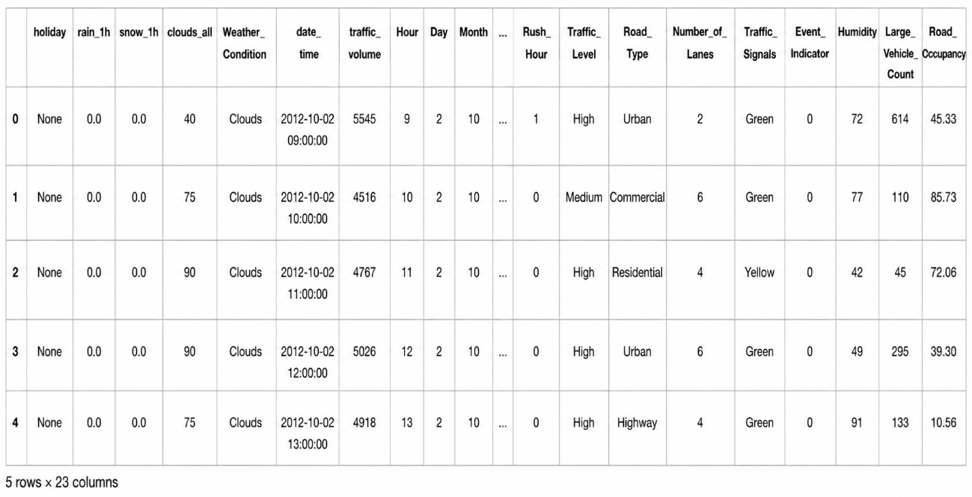
Figure 5.1. Preview of the Traffic Demand Prediction Dataset (First Five Records)

6.DATA PREPROCESSING
Before training the machine learning models, the dataset was preprocessed to improve data quality and model performance. Data preprocessing is an essential step that prepares the raw dataset for effective machine learning by handling inconsistencies, transforming features, and selecting relevant information.
Preprocessing Steps:
- Handled missing values in the dataset.
- Extracted Hour, Day, and Month from the date_time feature.
- Encoded categorical features such as Weather Condition.
- Created the target variable Traffic_Level (Low, Medium, High).
- Selected the required input features for model training.
- Split the dataset into training and testing sets.
- Saved the processed dataset for machine learning model development.

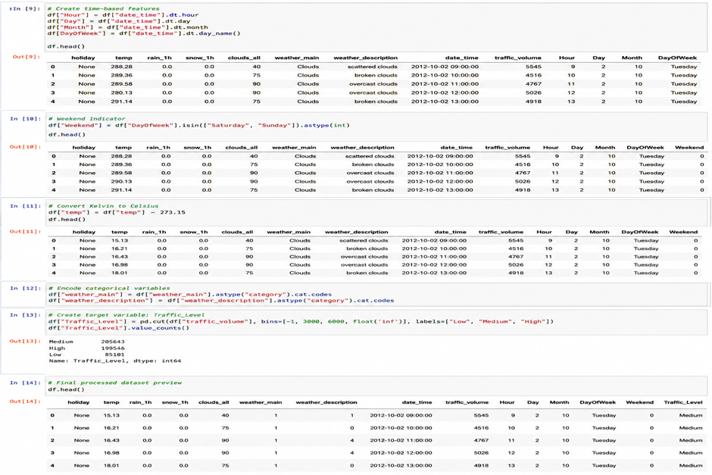
Figure 6.1. Data Preprocessing and Feature Engineering

7. EXPLORATORY DATA ANALYSIS (EDA)
Exploratory Data Analysis (EDA) was performed to understand the characteristics of the traffic dataset before developing the machine learning models. Different visualizations were used to analyze traffic patterns, weather conditions, road types, temporal trends, and relationships among features. The insights obtained from EDA helped in selecting relevant features for traffic volume prediction.

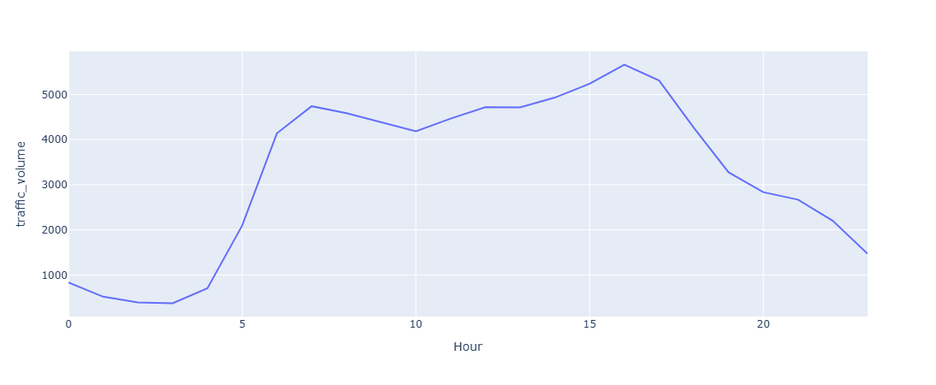Figure 7.1. Hourly Traffic Pattern

Observation:
- Traffic volume changes throughout the day.
- Peak traffic is observed during busy commuting hours.
- Traffic volume is lowest during late-night and early morning hours.

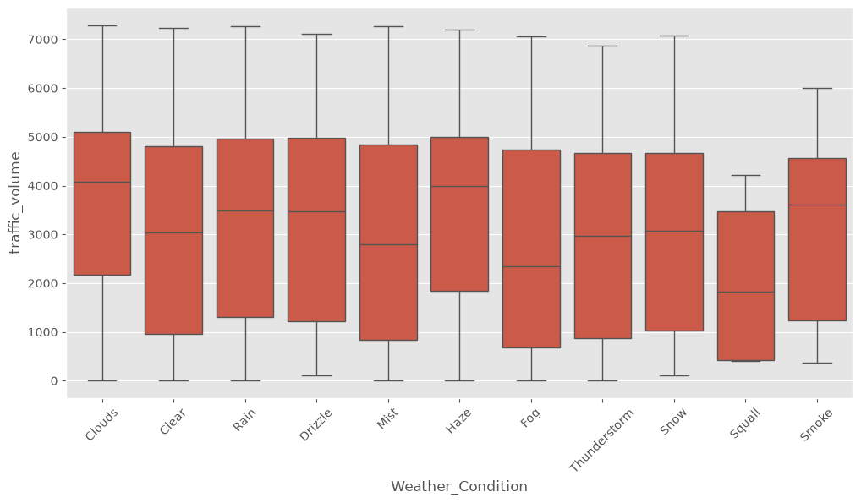
Figure 7.2. Weather Impact on Traffic
Observation:
- Traffic volume varies under different weather conditions.
- Rain, fog, and cloudy conditions influence traffic movement.
- Weather information is an important feature for prediction.
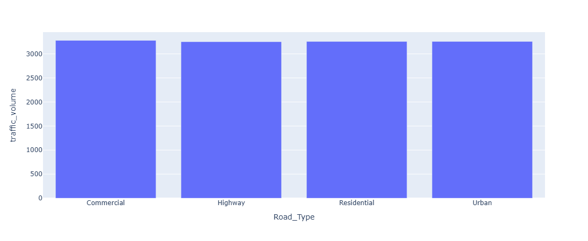Figure 7.3. Traffic by Road Type
Observation:
- Highway roads experience higher traffic volumes compared to urban and residential roads. Road type significantly affects traffic demand.
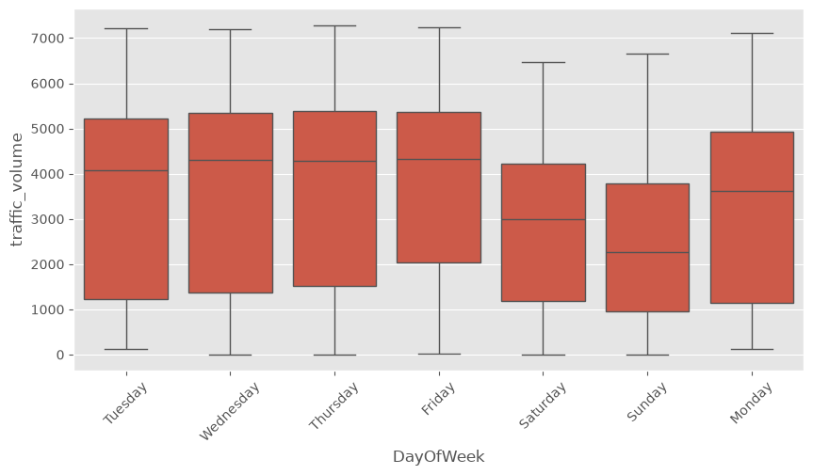
Figure 7.4.Traffic Volume by Day of the Week
Observation
- Weekdays generally experience higher traffic due to office, school, and business activities.
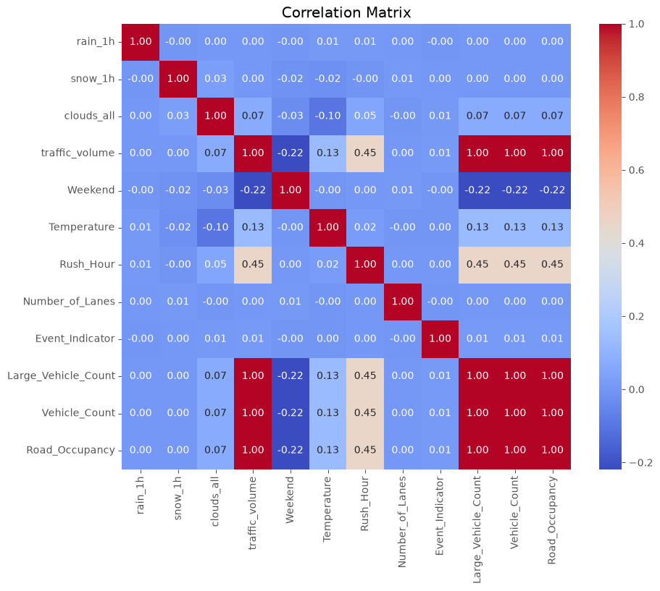
Figure 7.5: Feature Correlation Matrix
Observation:
- The correlation matrix shows the relationships among numerical features.
- Features such as Hour, Temperature, and Humidity exhibit varying degrees of correlation with traffic volume.
- Correlation analysis helped identify useful input variables for the prediction model.
The exploratory data analysis revealed that traffic volume is influenced by temporal, environmental, and road-related factors. Hourly traffic trends, weather conditions, and road types showed noticeable variations in traffic volume. These observations supported the feature engineering process and contributed to building an accurate machine learning model for traffic volume prediction.
7.FEATURE ENGINEERING
Feature engineering was performed to improve model performance by creating meaningful input variables from the raw dataset.
Feature engineering included:
- Extracting Hour, Day, and Month from the Date-Time feature.
- Creating the Weekend feature.
- Creating the Rush Hour indicator.
- Including environmental features such as Temperature, Humidity, Rainfall, Snowfall, and Cloud Cover.
- Including road-related features such as Number of Lanes, Road Type, Traffic Signals, and Vehicle Count.
- Encoding categorical variables using One-Hot Encoding.
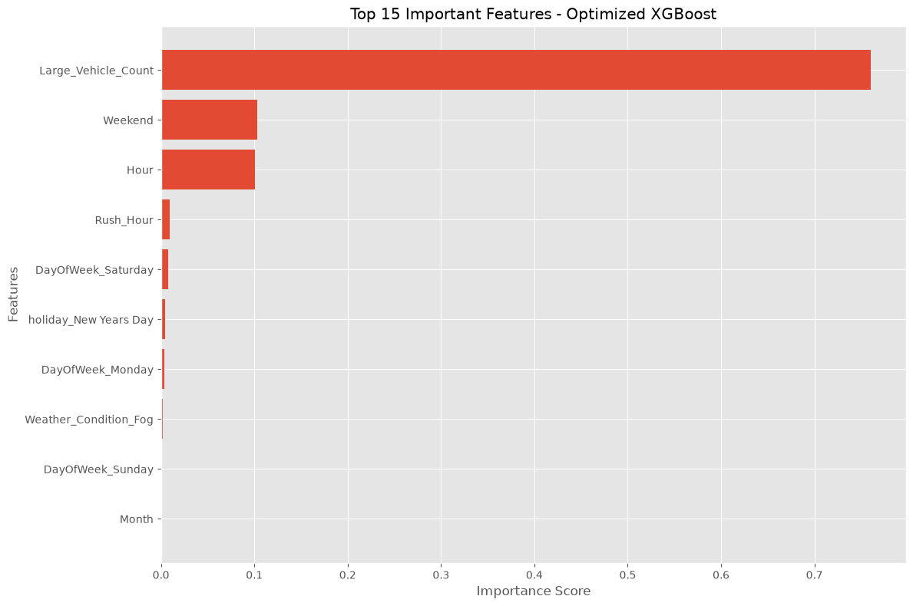
9. MACHINE LEARNING MODEL DEVELOPMENT
Introduction
Three machine learning regression models were developed to predict traffic volume using the engineered features. Each model was initially trained using its default parameters and evaluated using standard regression metrics. The models were then optimized through hyperparameter tuning to improve prediction performance.
Models Used
Model | Purpose
Random Forest Regressor | Baseline ensemble regression model
XGBoost Regressor | Gradient boosting model for accurate prediction
LightGBM Regressor | Fast gradient boosting model for large datasets

Train-Test Split
The dataset was divided into training and testing sets using an 80:20 ratio. The training dataset was used to train the regression models, while the testing dataset was used to evaluate their predictive performance.
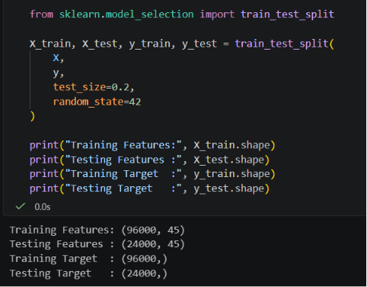 Figure 9.1. Train-Test Split

10. MODEL EVALUATION
The performance of each regression model was evaluated using the following regression metrics.
Mean Absolute Error (MAE)
Measures the average absolute difference between predicted and actual traffic volume. Lower values indicate better performance.
Mean Squared Error (MSE)
Measures the average squared prediction error. It penalizes larger errors more heavily.
Root Mean Squared Error (RMSE)
Represents the standard deviation of prediction errors and is expressed in the same unit as the target variable.
R² Score
Indicates how well the model explains the variance in traffic volume. Values closer to 1 indicate better prediction accuracy.
11. INITIAL MODEL PERFORMANCE
Three regression models were initially trained using their default parameters. Their performance was evaluated using MAE, MSE, RMSE, and R² Score to establish a baseline before hyperparameter tuning.
Model | MAE | MSE | RMSE | R² Score
Random Forest Regressor | 22.2454 | 1328.4272 | 36.4476 | 0.9997
XGBoost Regressor | 62.2980 | 5569.3618 | 74.6282 | 0.9986
LightGBM Regressor | 63.2419 | 5713.1578 | 75.5854 | 0.9985

Observation: Among the initial models, the Random Forest Regressor achieved the best baseline performance with the lowest prediction error and the highest R² score. However, further improvements were explored through hyperparameter tuning.
12. HYPERPARAMETER TUNING
Introduction
Hyperparameter tuning was performed to improve the prediction performance of the machine learning models. The objective was to identify the optimal combination of parameters that minimizes prediction error while improving the model's generalization capability.
Method Used
GridSearchCV was used to search for the best hyperparameter combinations using cross-validation. The optimized parameters obtained from GridSearchCV were then used to retrain each regression model.
Hyperparameter Tuning Results
Model | MAE | MSE | RMSE | R² Score
Optimized Random Forest | 39.7972 | 4727.4483 | 68.7564 | 0.9988
Optimized XGBoost | 32.7880 | 2126.9619 | 46.1190 | 0.9995
Optimized LightGBM | 45.1786 | 3294.4244 | 57.3971 | 0.9992

OBSERVATION: Hyperparameter tuning improved the performance of the XGBoost and LightGBM models. Among the optimized models, XGBoost achieved the lowest prediction errors and the highest R² score, making it the best-performing model after optimization.

13. ENSEMBLE LEARNING
Introduction
To further improve prediction stability and reduce model variance, an ensemble learning approach was implemented by combining the predictions of the optimized regression
Ensemble Method
A weighted ensemble technique was used by assigning different weights to the predictions generated by the optimized Random Forest, XGBoost, and LightGBM models. The final prediction was calculated as the weighted average of the individual model predictions.
You can include your ensemble equation if you used weighted averaging:
$$\text{Prediction}=w_{1}(RF)+w_{2}(XGB)+w_{3}(LGBM)$$

Ensemble Results
Model | MAE | MSE | RMSE | R² Score
Random Forest (Optimized) | 39.7972 | 4727.4483 | 68.7564 | 0.9988
XGBoost (Optimized) | 32.7880 | 2126.9619 | 46.1190 | 0.9995
LightGBM (Optimized) | 45.1786 | 3294.4244 | 57.3971 | 0.9992
Weighted Ensemble | 38.4130 | 2524.8739 | 50.2481 | 0.9994
Observation: The weighted ensemble model achieved highly accurate predictions by combining multiple optimized models. However, the optimized XGBoost model still produced the lowest prediction error and the highest R² score. Therefore, XGBoost was selected as the final deployment model.

14. Final Model Selection
Final Model
Based on the evaluation results obtained from the baseline models, hyperparameter tuning, and ensemble learning, the Optimized XGBoost Regressor was selected as the final model for deployment.
Reasons for Selecting XGBoost
- Highest R² Score (0.9995)
- Lowest MAE
- Lowest RMSE
- Better generalization performance
- Faster prediction time
- Suitable for real-time traffic volume prediction
Final Performance
Metric | Value
MAE | 32.7880
MSE | 2126.9619
RMSE | 46.1190
R² Score | 0.9995

15. STREAMLIT WEB APPLICATION
Introduction
A user-friendly web application was developed using Streamlit to demonstrate the traffic prediction system. The application allows users to analyze traffic patterns, predict traffic volume, and visualize important traffic insights through an interactive interface.

Application Modules
a. Dashboard
The Dashboard provides an overview of the Smart Traffic AI System. It displays key project information, application capabilities, and an interactive visualization of average hourly traffic volume.
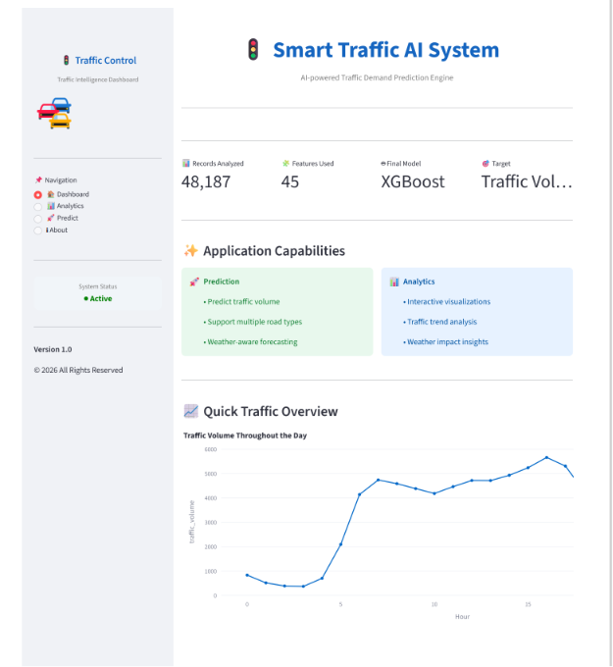
Figure 15.1: Dashboard of Smart Traffic AI System
b. Analytics
The Analytics module enables users to explore different traffic patterns through interactive visualizations. Users can analyze hourly traffic trends, weather impact, road type analysis, day-wise traffic patterns, and feature correlation.
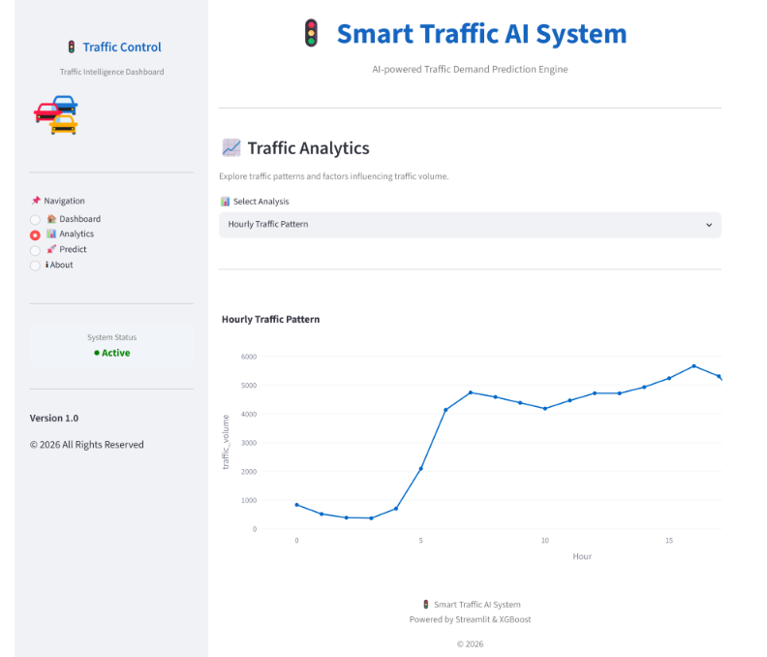
Figure 15.2: Analytics Dashboard
c. Traffic Prediction
The Prediction module allows users to enter traffic-related, weather-related, and road-related parameters. Based on the provided inputs, the optimized XGBoost model predicts the expected traffic volume and displays the estimated traffic condition.
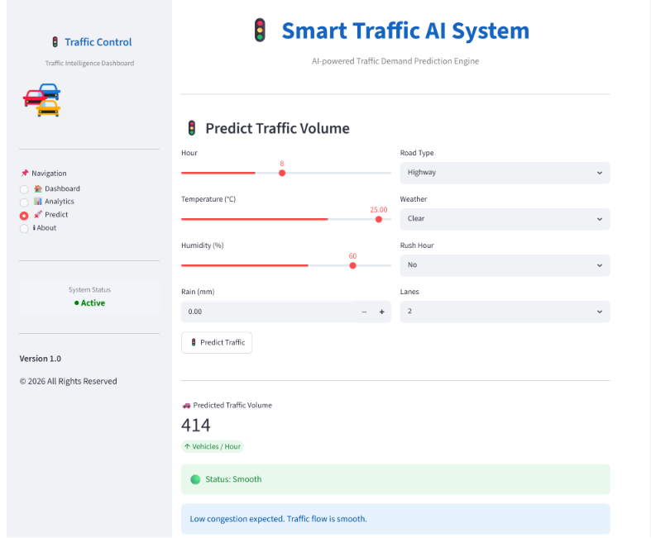
Figure 15.3: Traffic Volume Prediction
d. About
The About page provides information about the project, machine learning model, evaluation metrics, and the technologies used to develop the application.
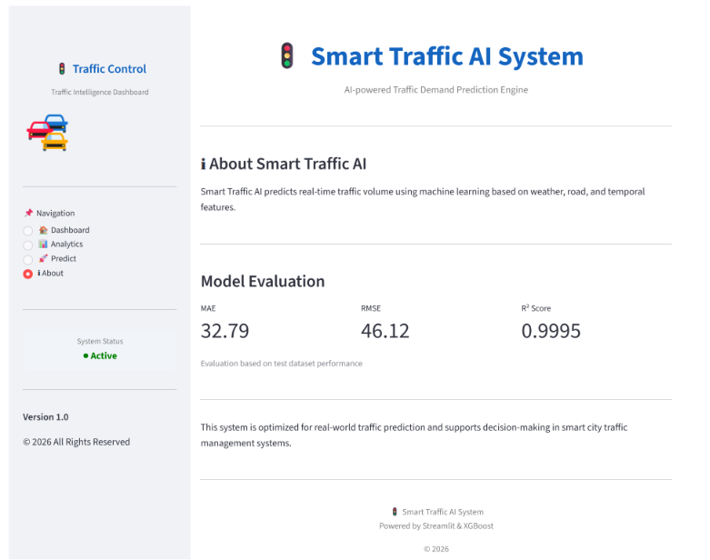
Figure 15.4: About Page
Technologies Used
Technology | Purpose
Python | Programming Language
Pandas | Data Processing
NumPy | Numerical Computation
Scikit-learn | Machine Learning
XGBoost | Final Prediction Model
LightGBM | Model Comparison
Streamlit | Web Application
Plotly | Interactive Visualization
Joblib | Model Serialization

16. CONCLUSION
The Smart Traffic Demand Prediction System was successfully developed using machine learning techniques to predict traffic volume based on weather, temporal, and road-related features. After evaluating multiple regression models and applying hyperparameter tuning and ensemble learning, the optimized XGBoost Regressor was selected as the final model due to its superior predictive performance. The Streamlit-based web application provides an interactive platform for traffic analysis and real-time traffic volume prediction, demonstrating the practical application of machine learning in intelligent transportation systems.

17. FUTURE SCOPE
Future Scope
- Integrate live traffic data from IoT sensors and GPS devices.
- Deploy the model as a cloud-based API for real-time predictions.
- Extend the system to predict traffic congestion several hours in advance.
- Integrate map services for route optimization and congestion alerts.
- Explore deep learning models such as LSTM or Transformer networks for time-series traffic forecasting.

