WEEK-3 SRS Document

Roll No:25BD5A6620
SRDC SHIELD
SEMANTICS-BASED RANSOMWARE DETECTION AND CLASSIFICATION
WITH LLM-ASSISTED PRE-TRAINING

1. AELUGU RANITH KUMAR - 25BD5A6615
2. CHINTALA RISHITH - 25BD5A6617
3. G SAMPATH - 25BD5A6618
4. KONDURI ABHIRAM - 25BD5A6620
5. MAINENI SREENILAY - 25BD5A6621

Problem Statement:

Ransomware remains one of the most financially destructive categories of malware, encrypting a victim's files and demanding payment for the decryption key. Traditional antivirus solutions rely on static signature matching, comparing files against databases of known malware hashes and byte patterns. This method fails completely against zero-day ransomware variants that have no existing signature, leaving organizations exposed during the critical early window of a new attack.
Statistical machine learning classifiers built directly on raw behavioral feature counts improve on signature matching but still lack semantic reasoning: they can count how often a suspicious API is called, but they cannot infer intent from the pattern of calls. The core problem this project addresses is how a system can reliably flag ransomware it has never encountered before, using only the behavioral semantics of what a program is attempting to do, without relying on prior knowledge of its binary fingerprint.
SRDC Shield solves this by translating raw behavioral observations, such as API calls, registry modifications, dropped files, and directory access, into natural language sentences through an Internal Semantic Processing pipeline, and then reasoning over those sentences using a cybersecurity domain fine-tuned GPT-2 model. The research pipeline is productized into a two-tier client-server system: a Chrome Manifest V3 extension that intercepts high-risk browser downloads before they reach disk, and a local Flask backend that performs a dual-layer scan combining VirusTotal hash lookups with the fine-tuned semantic AI model, returning an allow/block verdict in real time.

Software Requirement Specification
For
SRDC Shield: AI-Powered Ransomware Detection
and Browser Protection System
Version 1.0 approved
Prepared by:
1. Aelugu Ranith Kumar - 25BD5A6615
2. Chintala Rishith - 25BD5A6617
3. G Sampath - 25BD5A6618
4. Konduri Abhiram - 25BD5A6620
5. Maineni Sreenilay - 25BD5A6621

Keshav Memorial Institute of Technology
15-08-2026

Table of Contents
Table of Contents 3
Revision History 5
1. Introduction 6
1.1 Purpose 6
1.2 Document Conventions 6
1.3 Intended Audience and Reading Suggestions 6
1.4 Product Scope 7
1.5 References 7
2. Overall Description 7
2.1 Product Perspective 7
2.2 Product Functions 8
2.3 User Classes and Characteristics 8
2.4 Operating Environment 8
2.5 Design and Implementation Constraints 9
2.6 User Documentation 9
2.7 Assumptions and Dependencies 9
3. External Interface Requirements 10
3.1 User Interfaces 10
3.2 Hardware Interfaces 10
3.3 Software Interfaces 10
3.4 Communications Interfaces 10
4. System Features 10
4.1 Layer 1 - VirusTotal Hash-Based Scanning 11
4.2 Layer 2 - Semantic AI Behavioral Scanning 11
4.3 Browser Download Interception 12
4.4 Dataset Ingestion and Internal Semantic Processing 12
4.5 Model Training and Zero-Day Evaluation 13
4.6 Safe Simulation and Demonstration Mode 13
5. Other Nonfunctional Requirements 14
5.1 Performance Requirements 14
5.2 Safety Requirements 14
5.3 Security Requirements 15
5.4 Software Quality Attributes 15
5.5 Business Rules 15
6. Other Requirements 15
Appendix A: Glossary 16
Appendix B: Analysis Models 16
B.1 Use Case Diagram 16
B.2 Use Case Template 17
B.3 Sequence Diagram 18
B.4 Class Diagram 18
B.5 Component Diagram 19
Appendix C: To Be Determined List 20

Revision History

Name | Date | Reason for changes | Version
SRDC Shield Team | AY 2025-26 | SRS creation (Introduction, Overall Description) | 1.0
SRDC Shield Team | AY 2025-26 | External Interfaces, System Features added | 2.0
SRDC Shield Team | AY 2025-26 | Nonfunctional requirements, UML analysis models | 3.0

1. Introduction
The Software Requirement Specification is designed to document and describe the agreement between the project team and the evaluating faculty regarding the specification of the software product requested. This documentation provides a clear idea of the project's requirements and can be used as a reference in further development of the software system.

1.1 Purpose
This is the Software Requirement Specification for SRDC Shield, an AI-powered ransomware detection and browser-download protection system. Our project is about reproducing the SRDC research pipeline (AAAI 2025) and productizing it into a real-time endpoint protection tool. It will facilitate the detection of zero-day ransomware purely from behavioral semantics and will intercept and block malicious file downloads in the browser before they reach disk, without relying on known malware signatures alone.

1.2 Document Conventions
Heading:
Font-Size: 16
Font-Style: Bold
Font: Times New Roman
Subheading:
Font-Size: 14
Font-Style: Bold
Font: Times New Roman
Content:
Font-Size: 12
Font: Times New Roman.

1.3 Intended Audience and Reading Suggestions
This document is useful for different audiences in various ways. For the developers, it is a reference to design and implement the SRDC Shield backend and Chrome extension. For the project mentors and evaluators, it documents the scope and acceptance criteria of the reproduced research. For security analysts, it explains what the dual-layer scanning engine does and does not cover. Testers can validate the system against the functional and non-functional requirements listed here, and future contributors can use this document as the reference for extending the system, as outlined in Appendix C.

1.4 Product Scope
The scope of this project encompasses two distinct deliverables. The first is the reproduction of the SRDC research pipeline: preprocessing of the EldeRan dynamic behavioral dataset (1,524 samples across 11 ransomware families and goodware), Internal Semantic Processing to convert binary feature vectors into natural language descriptions, a zero-day experimental split with 4 ransomware families held out entirely from training, fine-tuning of a GPT-2 (zhouce/RDC-GPT) model for both binary detection and family classification, and an interactive CLI sandbox demo.
The second deliverable is SRDC Shield, a production-ready Manifest V3 Chrome extension that intercepts browser downloads pre-disk, paired with a local Python Flask backend that performs dual-layer threat evaluation: Layer 1 uses the VirusTotal API for known-threat hash checking, and Layer 2 uses statically extracted PE file semantics fed through the fine-tuned GPT-2 models for zero-day detection. The scope explicitly excludes live malware execution environments, OS-level kernel driver integration, and cloud API deployment, which are identified as future enhancements in Appendix C.

1.5 References
- Ce Zhou et al., "SRDC: Semantics-based Ransomware Detection and Classification with LLM-assisted Pre-training", AAAI 2025, AISI Track.
- Sgandurra, D., Munoz-Gonzalez, L., Mohsen, R., & Lupu, E.C. (2016), "Automated Dynamic Analysis of Ransomware", arXiv:1609.03020 (source of the EldeRan dataset).
- Radford, A. et al. (2019), "Language Models are Unsupervised Multitask Learners" (GPT-2 architecture).
- HuggingFace Transformers Library Documentation - https://huggingface.co/docs/transformers
- Google Chrome Extensions Manifest V3 Documentation - https://developer.chrome.com/docs/extensions/mv3/
- VirusTotal API v3 Documentation - https://developers.virustotal.com/reference

2. Overall Description

2.1 Product Perspective
SRDC Shield is organized as a dual-layer client-server architecture comprising three tiers. Tier 1 is the Chrome Extension frontend, which hooks into the browser's download event stream and pauses high-risk downloads before any bytes reach the host filesystem. Tier 2 is the Flask backend engine, which preloads both fine-tuned model checkpoints into CPU RAM at startup and orchestrates a two-layer evaluation combining hash-based and semantic AI-based scanning. Tier 3 is the research and training pipeline that produced the fine-tuned models, including the dataset processing scripts, the Internal Semantic Processing module, and the Google Colab training notebook. It is a self-contained, locally deployed system with a lightweight, security-focused browser UI.

2.2 Product Functions

2.2.1 System (Automated Engine)
- The system shall preload the fine-tuned GPT-2 checkpoints into RAM and expose scanning endpoints.
- The system shall compute file hashes and query VirusTotal for known-threat lookups.
- The system shall extract PE behavioral features and run semantic AI inference for zero-day detection.
- The system shall classify detected ransomware into one of 12 known families.

2.2.2 End User / Browser User
- Users are automatically protected from malicious downloads without needing to take manual action.
- Users can view scan results, verdicts, and plain-English behavioral explanations in the extension popup.
- Users can configure a VirusTotal API key and toggle Strict Mode.

2.2.3 Security Analyst
- Analysts can run the interactive CLI sandbox demo to inspect model predictions on sample data.
- Analysts can trigger the safe simulate_zero_day mode to demonstrate detection without live malware.
- Analysts can review scan history, family classification results, and confidence scores.

2.3 User Classes and Characteristics
The primary user classes of SRDC Shield span multiple cybersecurity roles. Endpoint Detection and Response (EDR) vendors require accurate zero-day detection with sub-second inference latency. Security Operations Center (SOC) analysts need automated tools to analyze suspicious samples in sandboxed environments before deployment on corporate networks. Enterprise IT security teams must protect infrastructure in sectors such as healthcare, finance, and government. Malware research labs require systematic tools for family identification and behavioral characterization. End users installing the Chrome extension are assumed to have only basic computer literacy, while security analysts and developers are assumed to have working knowledge of machine learning pipelines, REST APIs, and browser extension internals.

2.4 Operating Environment
- Chrome extension: Google Chrome version 109 or above, required for Manifest V3 support.
- Flask backend: Python 3.12+, runs on Windows 10/11 (validated), and is OS-independent in principle.
- Runtime hardware: Intel i5 (6th Gen) or equivalent CPU, minimum 8 GB RAM (16 GB recommended), 2 GB free disk space for model checkpoints.
- Model training environment: Google Colab with an NVIDIA T4 GPU (16 GB VRAM) or equivalent, with an internet connection to download the zhouce/RDC-GPT base weights.

2.5 Design and Implementation Constraints
- All file scanning operations are performed within an isolated sandbox_temp/ workspace; files are deleted immediately after inference.
- The Chrome extension communicates exclusively with localhost (127.0.0.1:5000) and never transmits file contents to any external server; only SHA-256 hashes are sent to VirusTotal.
- If the Flask backend is unavailable, the extension fails open (allows the download) rather than blocking indefinitely, prioritizing usability in degraded mode.
- The system is designed for local, single-user endpoint deployment; it is not designed for concurrent multi-user scaling without additional load-balancing infrastructure.
- No live malware execution is permitted anywhere in the deployed product; all behavioral features are obtained through static PE analysis or the pre-recorded EldeRan dataset.

2.6 User Documentation
The project README documents installation of the Flask backend, loading of the Chrome extension in developer mode, and configuration of the VirusTotal API key. The /health endpoint exposes live engine status for verification. In-product documentation is limited to the extension popup's inline explanations of scan verdicts; a full user manual is not in scope for the current version.

2.7 Assumptions and Dependencies
- The zhouce/RDC-GPT base weights are assumed to remain publicly available on HuggingFace Model Hub.
- A valid VirusTotal API key is assumed to be available for Layer 1 scanning; the system does not function fully without one, though Layer 2 semantic scanning can still run independently.
- Model training assumes access to a GPU (Google Colab T4 or equivalent); CPU-only training is not practical within the project timeline.
- The EldeRan dataset's 11 ransomware families and behavioral feature set are assumed to remain representative enough for demonstration and evaluation purposes.

3. External Interface Requirements

3.1 User Interfaces
The primary user interface is the SRDC Shield Chrome extension popup (popup.html/popup.js/popup.css), presenting a dark-mode glassmorphic UI that shows the current scan status, file name, SHA-256 hash, VirusTotal positive count, SRDC AI family identification, confidence scores, and a plain-English behavioral explanation. A secondary interface is the interactive CLI sandbox demo (srdc_demo_fixed.py), which prints behavioral previews, predictions, and correctness flags to the terminal for analyst review.

3.2 Hardware Interfaces
The system does not interface with specialized hardware. It runs on standard commodity PC/laptop hardware for inference (CPU-only) and depends on cloud GPU hardware (NVIDIA T4 via Google Colab) only during the offline model training phase, not at runtime.

3.3 Software Interfaces
- Flask REST API: exposes GET /health and POST /analyze on http://127.0.0.1:5000, consumed by the Chrome extension's background service worker.
- VirusTotal API v3: queried via GET /files/{sha256} with an x-apikey header for known-threat hash lookups.
- HuggingFace Transformers: GPT2Tokenizer and GPT2Model APIs used to load the zhouce/RDC-GPT pre-trained weights.
- PyTorch: torch.load() with map_location='cpu' used to load the fine-tuned .pth checkpoint files for inference.
- Chrome Extension APIs: chrome.downloads.onCreated, chrome.downloads.pause(), chrome.downloads.resume(), chrome.downloads.cancel(), and chrome.storage.local.

3.4 Communications Interfaces
- Local REST communication over HTTP between the Chrome extension and the Flask backend on localhost:5000, enabled via Flask-CORS.
- Outbound HTTPS requests from the Flask backend to the VirusTotal API v3 endpoint, transmitting only file hashes.
- Local browser storage communication via chrome.storage.local for persisting scan history and settings between the background service worker and the popup UI.

4. System Features
These requirements describe the functional behavior of the SRDC research pipeline and the SRDC Shield production application, grouped into the six system features below. Each requirement is identified with a unique ID, title, description, and priority, following the convention Priority 1 (highest) to Priority 4 (lowest).

4.1 Layer 1 - VirusTotal Hash-Based Scanning
Requirement ID: FR-07
Title: Layer 1 VirusTotal Scan
Description: The Flask /analyze endpoint shall compute the SHA-256 hash of each intercepted file and query the VirusTotal v3 API. A file shall be blocked if 3 or more antivirus engines flag it as malicious or suspicious.
Priority: 1

Requirement ID: FR-11
Title: Verdict Communication
Description: The Flask /analyze endpoint shall return a JSON response containing the verdict (allowed/blocked), file hash, filename, Layer 1 VirusTotal results, Layer 2 SRDC AI results, plain-English behavioral explanations, and elapsed scan time.
Priority: 1

4.2 Layer 2 - Semantic AI Behavioral Scanning
Requirement ID: FR-05
Title: Binary Detection Inference
Description: The Flask backend shall load the srdc_zero_day_BEST.pth checkpoint into CPU RAM at startup and classify behavior text as Ransomware or Goodware using the fine-tuned GPT-2 Classifier model. A confidence threshold of at least 70% is required to flag a file as ransomware.
Priority: 1

Requirement ID: FR-06
Title: Family Classification Inference
Description: When the binary detector flags a file as Ransomware, the system shall run the srdc_family_BEST.pth classifier to identify the ransomware family from 12 classes, including Goodware, Citroni, CryptLocker, CryptoWall, Kollah, Kovter, Locker, Matsnu, PGPCODER, Reveton, TeslaCrypt, and Trojan-Ransom.
Priority: 2

Requirement ID: FR-08
Title: Layer 2 Static PE Analysis
Description: The system shall extract behavioral features from Portable Executable binaries using the pefile library (imports table) and raw string extraction limited to the first 256 KB. Features shall be assembled into a combined behavioral text string matching the Internal Semantic Processing output format and passed to the GPT-2 models for inference.
Priority: 2

4.3 Browser Download Interception
Requirement ID: FR-10
Title: Chrome Extension Download Interception
Description: The Manifest V3 background service worker shall intercept browser download events for dangerous file extensions (.exe, .dll, .scr, .sys, .msi, .bat, .cmd, .vbs, .js, .jar, .zip, .rar) and immediately pause the download, freezing it in a .crdownload pre-disk state pending scanning results.
Priority: 1

Requirement ID: FR-09
Title: ZIP Archive Handling
Description: When an intercepted file has a .zip extension, the system shall extract its contents to an isolated sandbox_temp/ workspace, recursively scan all nested executables, and securely delete the extracted directory after inference.
Priority: 2

4.4 Dataset Ingestion and Internal Semantic Processing
Requirement ID: FR-01
Title: Dataset Ingestion
Description: The system shall load the EldeRan behavioral dataset (RansomwareData.csv, 1,524 samples, 30,000+ binary feature dimensions) and parse the VariableNames.txt feature mapping file using UTF-8/latin1 encoding fallback.
Priority: 2

Requirement ID: FR-02
Title: Internal Semantic Processing
Description: The system shall convert binary feature vectors into natural language sentences by decomposing CamelCase API names, removing encoding and extended API suffixes, replacing 'Nt' prefixes with 'kernel', and constructing seven semantic feature columns (apiFeatures, dropFeatures, regFeatures, filesFeatures, filesEXTFeatures, dirFeatures, strFeatures).
Priority: 2

4.5 Model Training and Zero-Day Evaluation
Requirement ID: FR-03
Title: Zero-Day Data Splitting
Description: The system shall create a zero-day experimental split by holding out four ransomware families (PGPCODER, Reveton, TeslaCrypt, Trojan-Ransom) entirely from the training set, producing zero_day_train.csv (1,388 rows) and zero_day_test.csv (268 rows).
Priority: 3

Requirement ID: FR-04
Title: Family Classification Data Splitting
Description: The system shall create a stratified 80/20 split for family classification across all 12 classes, producing train.csv (1,219 rows) and test.csv (305 rows).
Priority: 3

4.6 Safe Simulation and Demonstration Mode
Requirement ID: FR-12
Title: Safe Simulation Mode
Description: The system shall handle a simulate_zero_day URL pattern by bypassing actual file download and instead injecting predefined ransomware behavioral features into the model pipeline, enabling safe demonstration of the red-alert UI without executing live malware.
Priority: 2

Requirement ID: FR-13
Title: Interactive CLI Demo
Description: The system shall provide a standalone CLI sandbox simulation that loads both model checkpoints, randomly selects test samples, displays behavioral previews, runs model inference, and outputs predictions with confidence scores and correctness flags.
Priority: 3

Requirement ID: FR-14
Title: Health Endpoint
Description: The Flask server shall expose a /health GET endpoint returning engine status, model type, and the number of active CPU threads.
Priority: 4

5. Other Nonfunctional Requirements

5.1 Performance Requirements
- Binary zero-day detection accuracy shall be at least 97.01% on the zero_day_test.csv split (4 ransomware families held out from training).
- Family classification balanced accuracy shall be at least 60.00% across 12 imbalanced ransomware families.
- Local inference latency shall not exceed 200ms per sample once models are preloaded into CPU RAM.
- PE string extraction latency shall not exceed 0.05s per file after applying the 256 KB read optimization.

5.2 Safety Requirements
- The system shall never execute intercepted or sandboxed files; all behavioral analysis shall be static (PE import table and string extraction) or drawn from the pre-recorded EldeRan dataset.
- The simulate_zero_day demonstration mode shall not download, store, or execute any live malware sample.
- All extracted/quarantined files in sandbox_temp/ shall be permanently deleted immediately after inference completes.

5.3 Security Requirements
- The Chrome extension shall communicate exclusively with localhost (127.0.0.1:5000) and shall not transmit file contents to any external server.
- Only SHA-256 hashes, never raw file contents, shall be transmitted to the VirusTotal API.
- VirusTotal API keys shall be injectable via environment variable or extension storage, and shall never be hardcoded in source code.

5.4 Software Quality Attributes
Reliability:
- If the Flask backend is unavailable or returns an HTTP error, the Chrome extension shall fail open, allowing the download rather than blocking indefinitely.
- All scan operations shall include try/except error handling to prevent unhandled exceptions from crashing the service.
Maintainability:
- Model paths shall be configurable via a BASE_DIR variable without code changes.
- FAMILY_NAMES and API_EXPLANATIONS mappings shall be modifiable without touching inference logic.
Scalability:
- The system is designed for local single-user endpoint deployment; both checkpoints (~498 MB each) are preloaded into CPU RAM at startup to eliminate cold-start latency.

5.5 Business Rules
- A file shall be blocked if either Layer 1 (VirusTotal, 3+ engines flagged) or Layer 2 (semantic AI, confidence >= 70%) returns a positive threat verdict.
- The zero-day test families shall remain entirely absent from the training split at all times, verified by the check_leakage.py integrity script, to preserve experimental validity per the AAAI 2025 paper's methodology.

6. Other Requirements
Legal/Compliance: The system shall not execute live malware under any deployment configuration; all zero-day demonstrations shall use the safe simulate_zero_day pathway.
Data Privacy: No file content is transmitted off the local machine; only SHA-256 hashes are shared with the external VirusTotal service.
Reproducibility: All dataset splits, model checkpoints, and training hyperparameters shall be documented to allow the reported accuracy figures to be independently reproduced.
Database Requirements: Not applicable in the current version - scan history is persisted client-side via chrome.storage.local rather than a server-side database.

Appendix A: Glossary
Zero-day ransomware: A ransomware family or variant that has never been seen before and has no existing signature in antivirus databases.
Internal Semantic Processing (ISP): The pipeline step that converts raw binary behavioral feature vectors into natural-language sentences an LLM can reason over.
EldeRan dataset: The dynamic behavioral dataset (1,524 samples, 11 ransomware families + goodware) used as the empirical basis for training and evaluation.
GPT-2 / RDC-GPT: A 12-layer Transformer decoder language model; RDC-GPT (zhouce/RDC-GPT) is a cybersecurity-domain pre-trained variant used as the semantic encoder.
PE (Portable Executable): The standard file format for executables, DLLs, and drivers on Windows; statically parsed via the pefile library to extract imported API calls.
Balanced accuracy: The average of per-class recall, used to fairly evaluate classification performance across severely imbalanced ransomware family classes.
VirusTotal: A third-party threat-intelligence service that aggregates results from multiple antivirus engines, queried here via SHA-256 hash lookups.
Manifest V3 (MV3): The current Chrome extension platform standard, used to build the SRDC Shield browser extension.
Sandbox (sandbox_temp/): An isolated, temporary workspace where intercepted files are analyzed and from which they are permanently deleted after inference.
Fail-open: A reliability design choice where the system defaults to allowing an action (rather than blocking) when a dependent service is unavailable.

Appendix B: Analysis Models

B.1 Use Case Diagram
Actors: End User (browser user), Security Analyst, SRDC Shield System (automated), VirusTotal API (external).
- UC-1: Initiate Browser Download - End User triggers a download of a high-risk file format.
- UC-2: Intercept Download Pre-Disk - Chrome Extension pauses the download before it reaches disk.
- UC-3: Submit File for Analysis - Extension forwards the download URL to the Flask backend.
- UC-4: Layer 1 Hash Scan - Backend queries VirusTotal for known-malware identification.
- UC-5: Layer 2 Semantic AI Scan - Backend runs GPT-2 inference for zero-day detection and family classification.
- UC-6: Receive Verdict - Extension resumes or cancels the download based on the verdict.
- UC-7: Run Interactive CLI Demo - Security Analyst runs the sandbox simulation script.
- UC-8: Simulate Zero-Day Demo - Security Analyst triggers a safe demonstration without live malware.
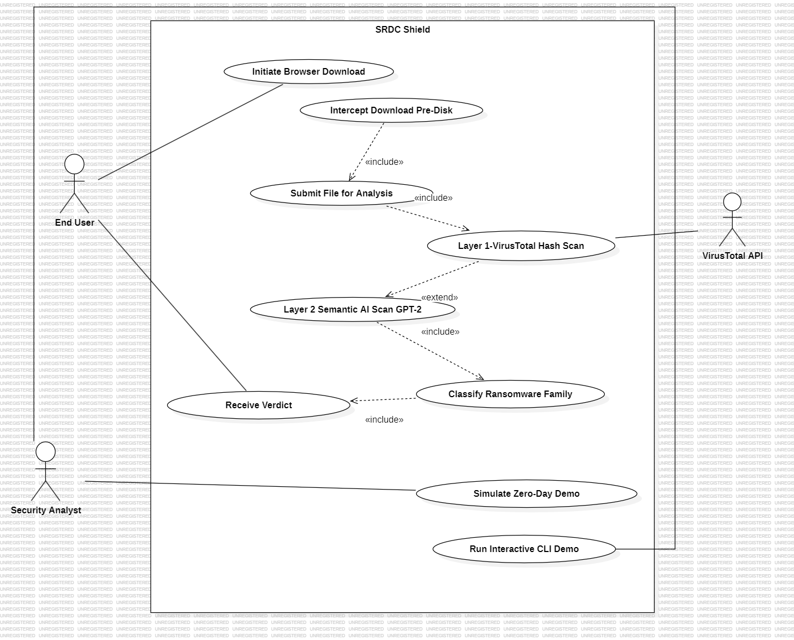

B.2 Use Case Template
Basic/Normal Flow
Exception Flow

B.3 Sequence Diagram
The sequence below traces the complete download-interception flow from the Chrome extension's background service worker through the Flask backend to VirusTotal and the GPT-2 models.
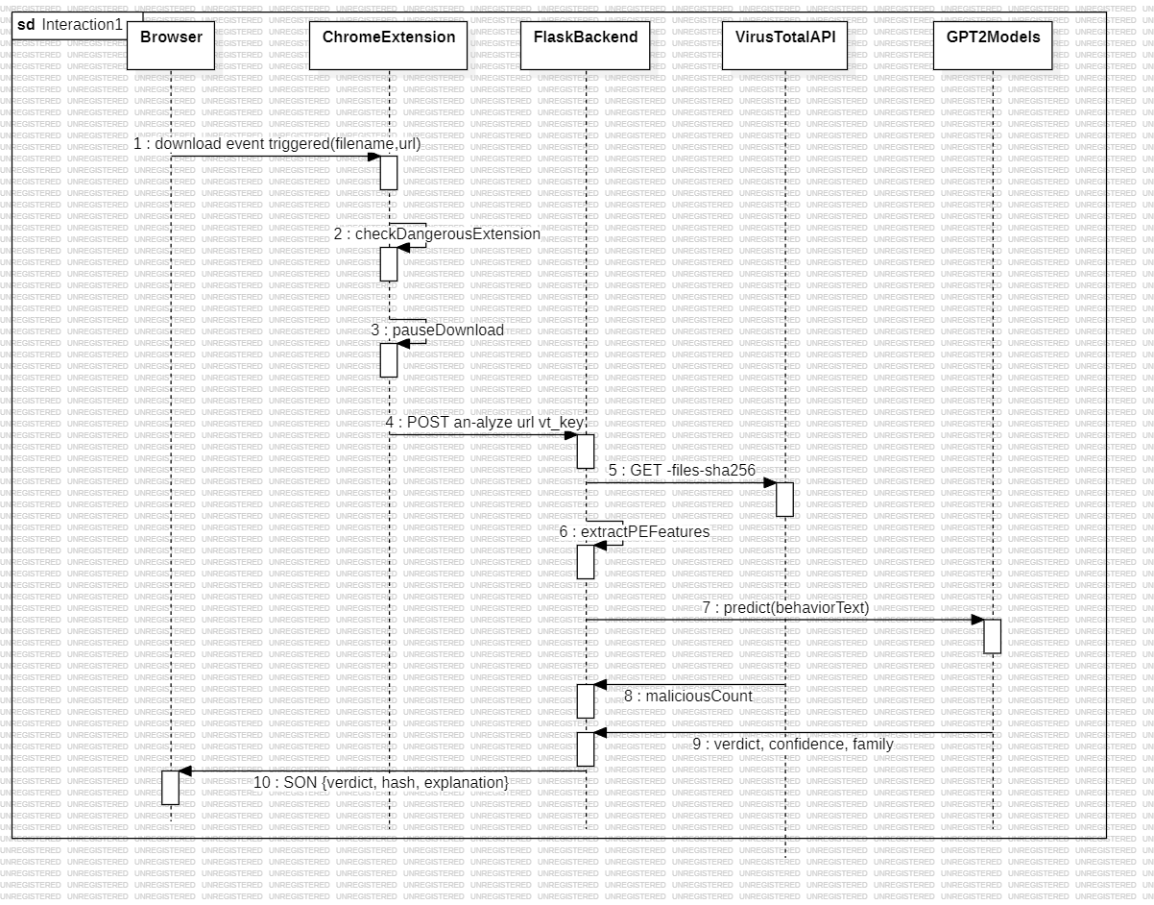
Sequence Steps

B.4 Class Diagram
The class diagram models the core object structure of the Flask backend: the ChromeExtension client, the FlaskBackendServer orchestrator, its VirusTotalClient and PEFeatureExtractor collaborators, the InternalSemanticProcessor, the shared GPT2Classifier base with its FamilyClassifier and ZeroDayClassifier subtypes, and the ScanResult/PredictionResult value objects returned to the caller.
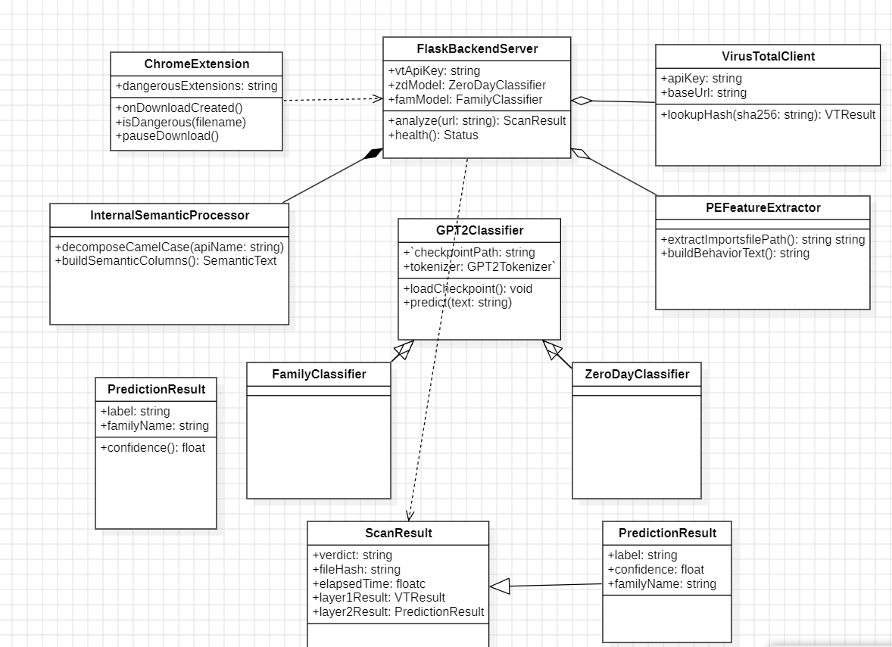

B.5 Component Diagram
The component diagram shows the six major components of SRDC Shield and the interfaces that connect them across the three architectural tiers. The Chrome Extension (Tier 1) requires IAnalyzeAPI, provided by the Flask Backend Server (Tier 2). The Flask Backend Server in turn requires IVirusTotalAPI (provided by the external VirusTotal Service), IModelInference (provided by the Model Inference Engine), and ISandboxAccess (provided by the Sandbox Workspace). The Model Inference Engine has a «use» dependency on the Dataset & Training Pipeline (Tier 3), which supplies the trained .pth checkpoints it loads at startup.
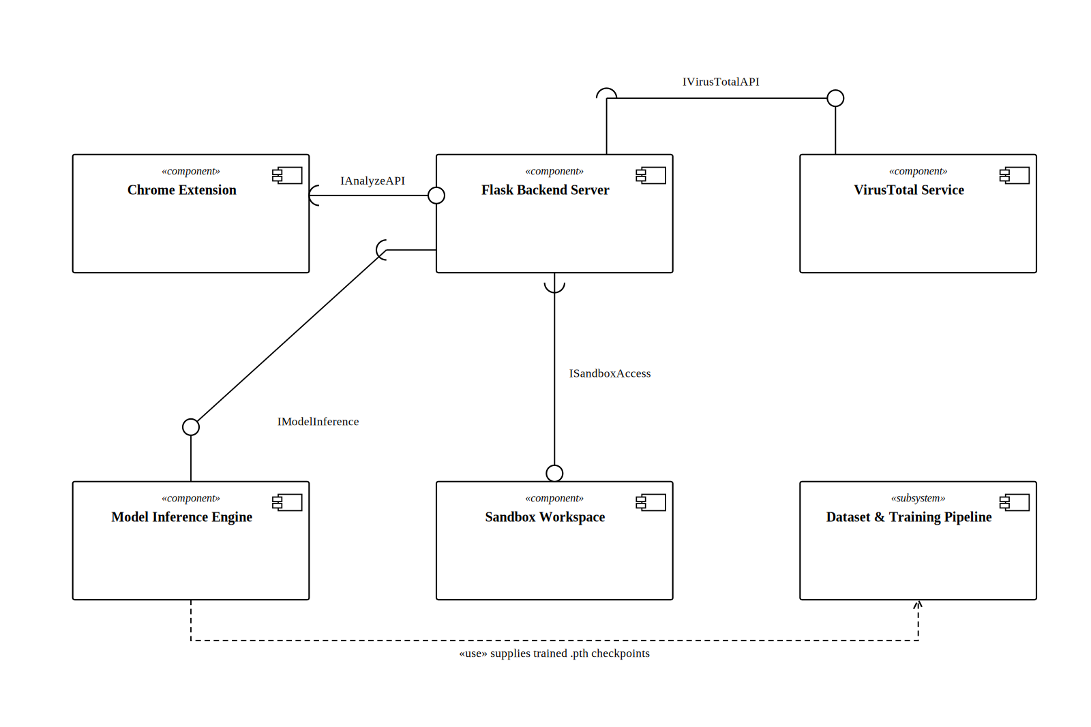

Appendix C: To Be Determined List
- Live Sandbox Integration: Connect the model to a live dynamic sandbox (e.g., Cuckoo Sandbox or a lightweight KVM VM) to capture live API call sequences rather than static import analysis alone.
- Multi-Model Ensemble Voting: Combine the GPT-2 classifier with additional lightweight models to improve family classification accuracy on underrepresented classes.
- OS-Level Kernel Driver Integration: Expand the local engine into a background Windows service using file-system mini-filter drivers for system-wide protection beyond browser downloads.
- Automated Threat Mitigation: Implement automatic network isolation of an infected endpoint when ransomware is detected with confidence >= 95%.
- Extended Dataset and New Ransomware Families: Incorporate post-2016 ransomware families (e.g., WannaCry, LockBit) to improve relevance to the current threat landscape.
- Baseline Model Comparison: Implement the comparative baseline models cited in the original SRDC paper (LSTM, KNN, VarLenPSO, BERT, DCAE-ZSLHVE) for a complete empirical comparison.
- Cloud Deployment API: Deploy the scanning engine as a cloud-hosted microservice to serve mobile apps, IoT agents, and enterprise SIEM platforms.
- Few-Shot Evaluation Protocol: Characterize how detection performance degrades as the model is exposed to fewer training families.

