The details of the user interface such as options displaying the user interaction information:

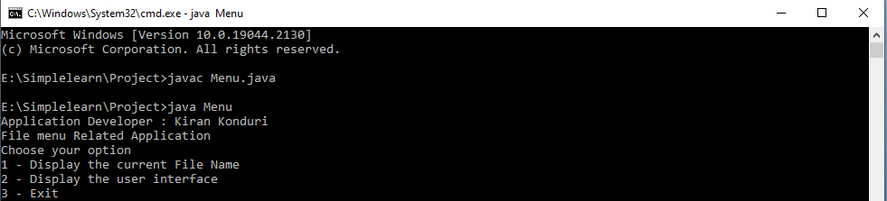

first option:

-------------

The first option should return the current file names in ascending order. The root directory can be either empty or contain few files or folders in it

It should display all the files in the specified directory

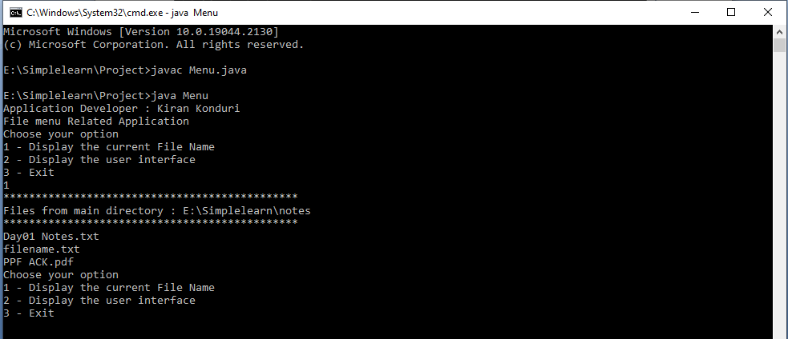

second option:

--------------

On second option selection

Should display below Options:

-----------------------------

4.Add a file to the existing directory list

5.Delete a user specified file from the existing directory list

6.Search a user specified file from the main directory

7.Option to navigate back to the main context

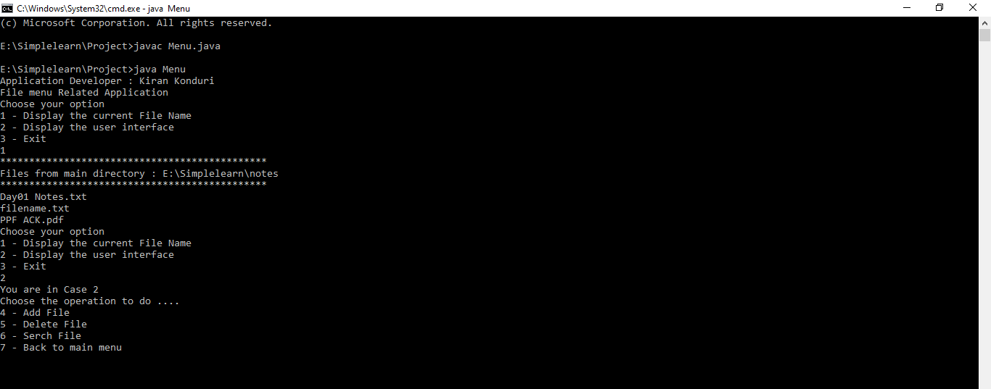

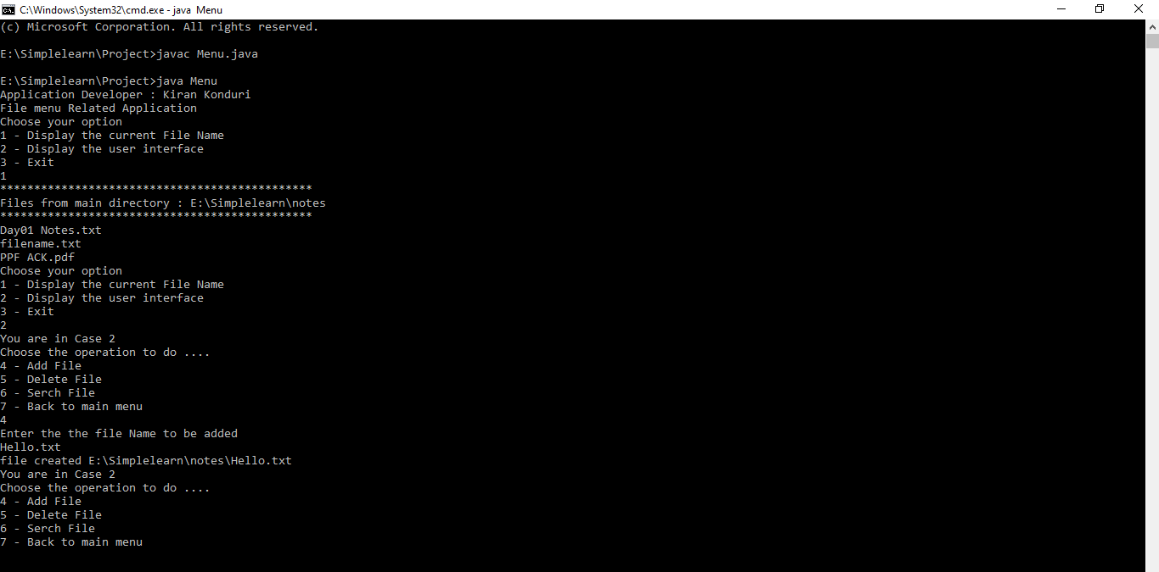

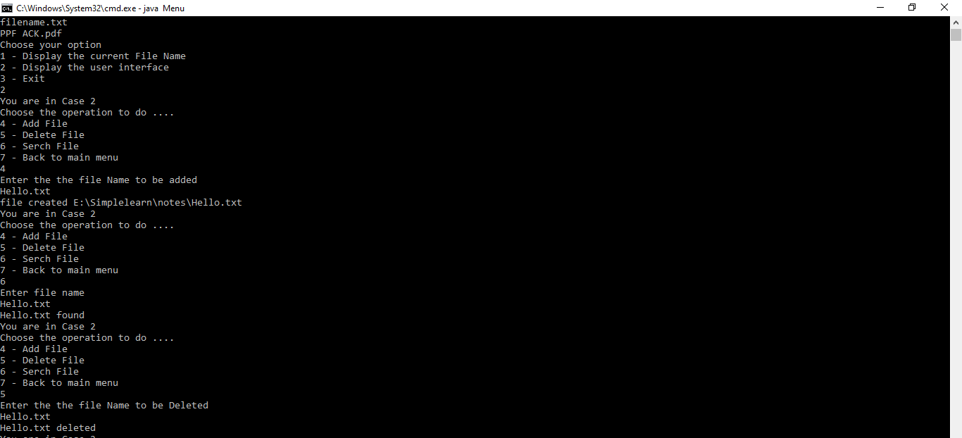

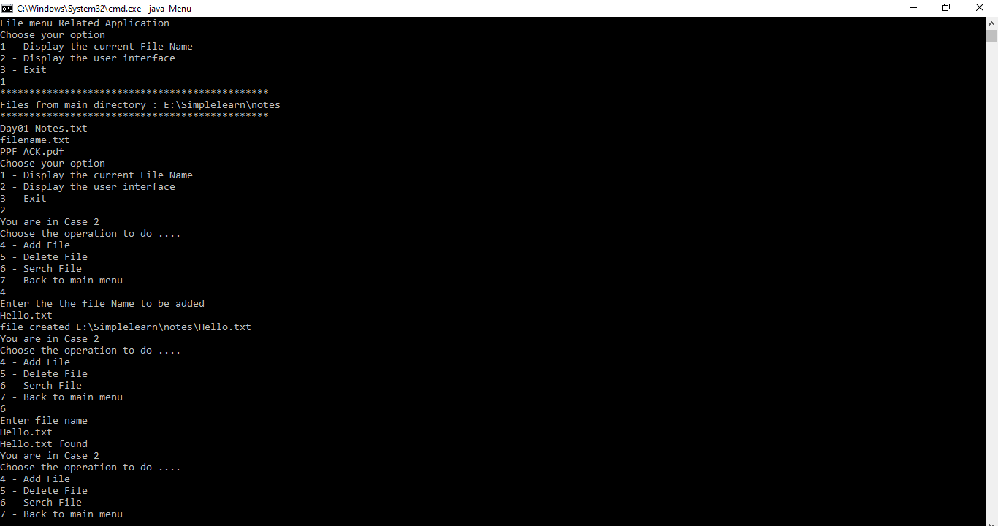

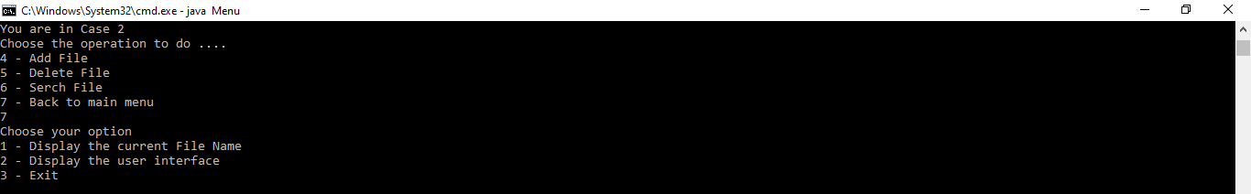

third option:

-------------

There should be a third option to close the application

