Module 9 Assignment 2

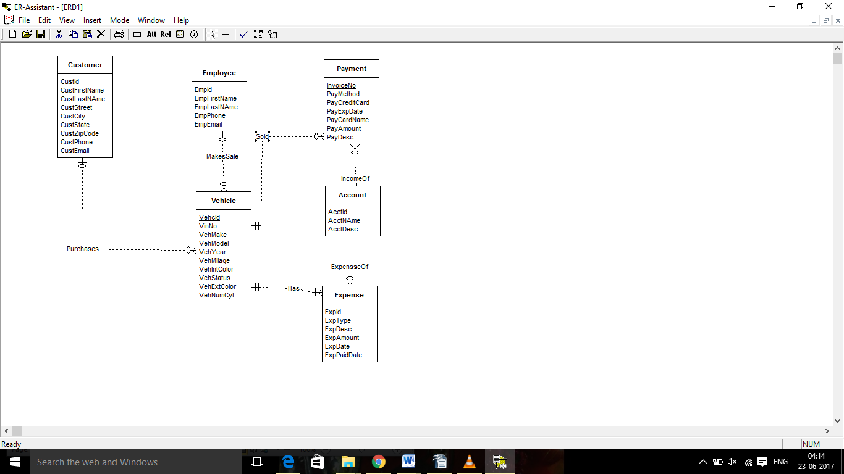

1Typically, vehicles remain on the lot for a period of time before sales occur. Hence minimum cardinality of vehicle for make sale relationship should be zero.(Design error)

2) due to same reason min cardinality of ‘employee’ for ‘MakesSale’ relationship should be zero. (Design error)

3) due to same reason min cardinality of ‘Payment’ for ‘Sold’ relationship should be zero(Design error)

4)Account should be strong entity. (Design error)

5)’Expense’ and ‘Payment’ should be related to one account so reverse cardinality of ‘IncomeOf’ and ‘ExpenseOf’ relationship. (Design error)

6) Min cardinality of ‘Account’ for ‘Income_of’ relationship should be one as payment must be associated with account.(Diagram error)