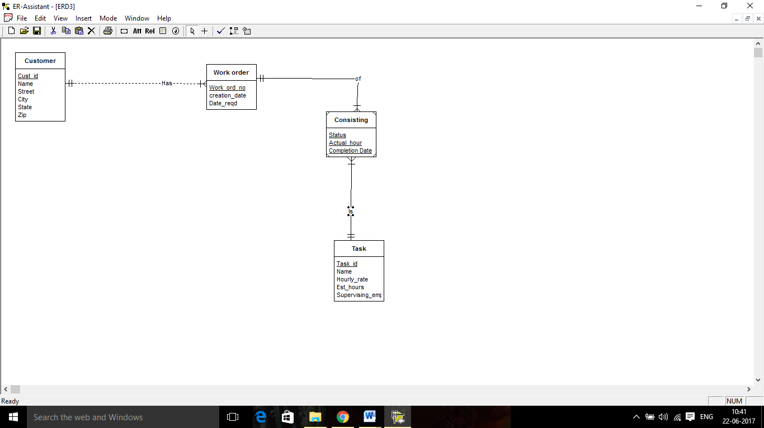Module 9 Pb1

Design decision

1.Customer can have many work order but each order related to one customer minimum cardinality is not specified.

2.Consisting is weak entity type used to connect work order and task and it’s primary key is combination of local attributes and attributes from work order and task.

3. A work order can have many task and each task has one order minimum cardinality is not specified.

After review

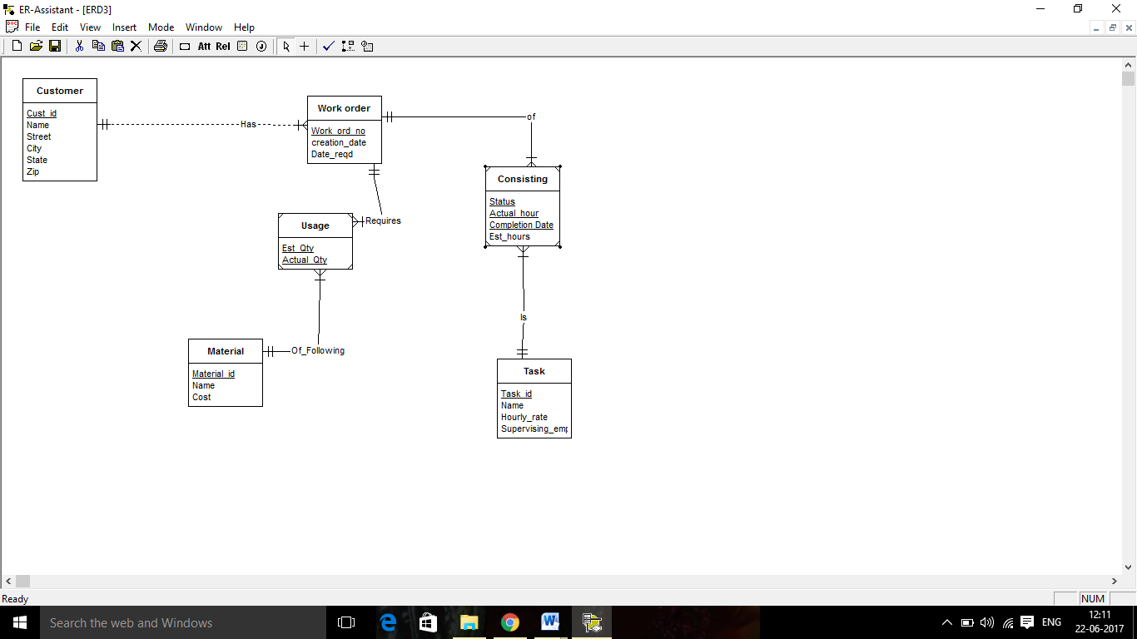

1>shifting est_hours to consisting makes it dependent on both work order and task.

2>Usage is used as weak entity to join material and work order