ASSIGNMENT

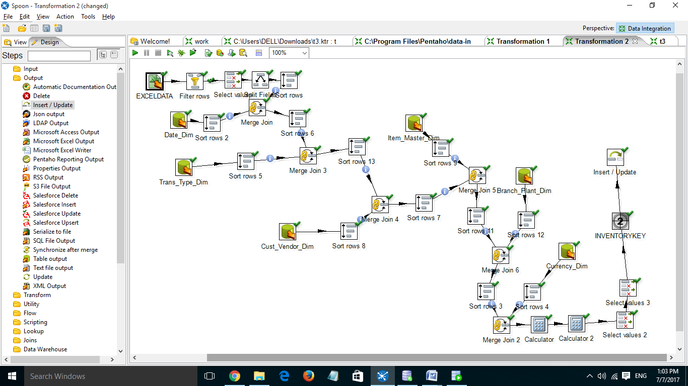

The data from excel data source is added after access data source so total no of rows include rows from access table

