**Answer 1**

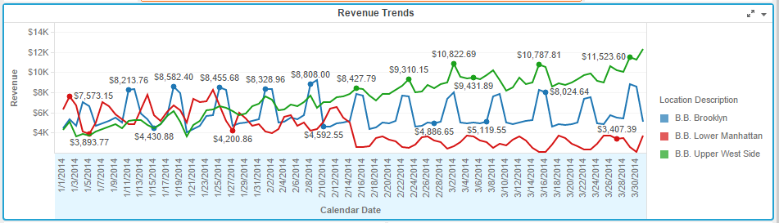

Lower manhattan which was top performer in 01-01-2014 became worst performer since 12-02-14. Brooklyn’s performance is relatively stable over the period of time. Upper west side performance has improved significantly over the period of time.

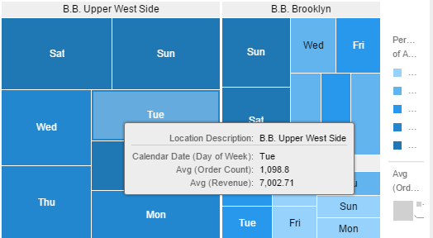

A large chunk of revenue almost one third of Upper west side is generated on weekends.

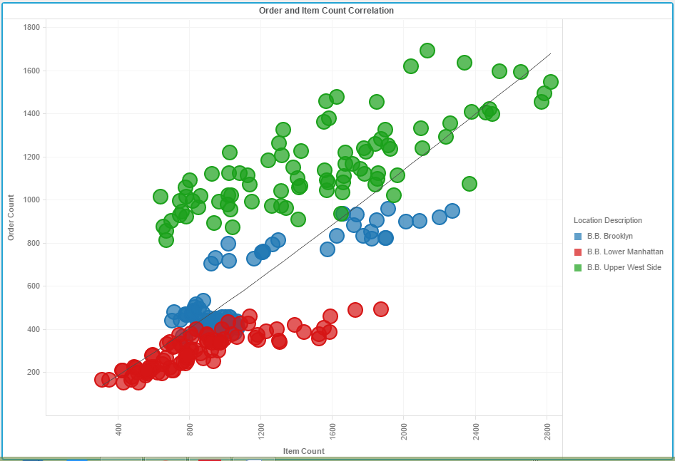

This shows order count and items association expressed over days of week.

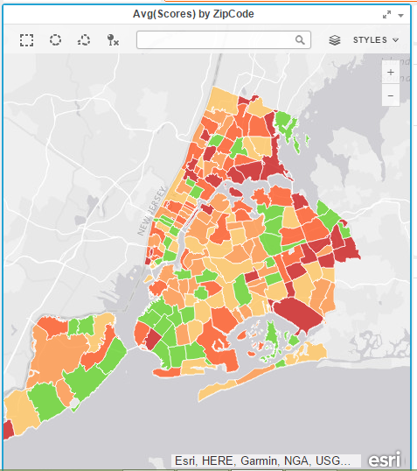

This uses esri map shows zip codes in new york and is coloured by avg of scores

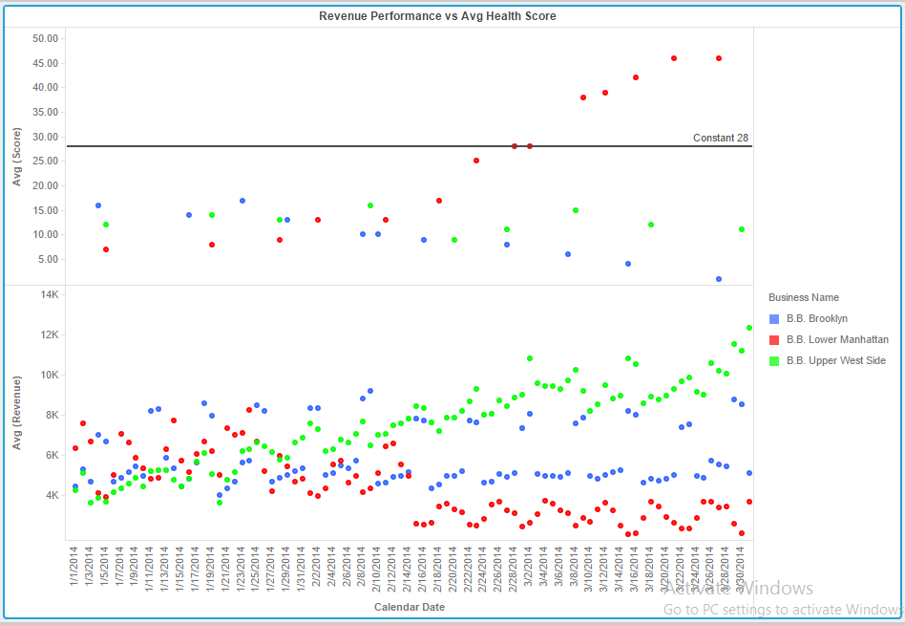

This graph depicts how revenue is affected by health score.

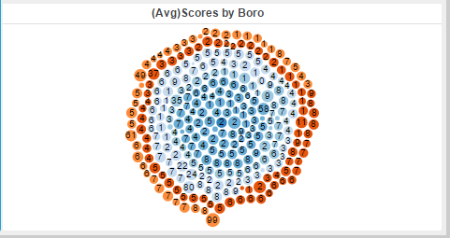

This is a bubble chart depicting relationship between score and boro.

**Answer 2**

Would have established more relationship between various attributes and metrics and examined info in detail.