1.

SELECT

Location_Name, Time_Year, Time_Month

, SUM ( QUANTITY_ORDERED * Unit_Price ) AS SumJobAmt,

SUM ( SUM ( QUANTITY_ORDERED * Unit_Price ) ) OVER ( PARTITION BY Location_Name, Time_Year

ORDER BY Time_Month ROWS UNBOUNDED PRECEDING ) AS CumSumAmt FROM W_JOB_F, W_Location_D, W_TIME_D

WHERE W_Location_D.Location_ID = W_Job_F.Location_Id AND W_JOB_F.CONTRACT_DATE = W_TIME_D.Time_ID

GROUP BY Location_Name, Time_Year, Time_Month;

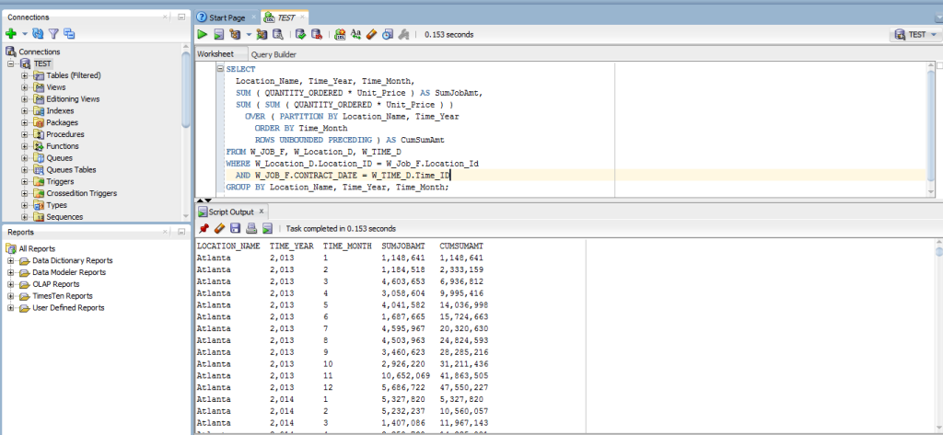

2.

SELECT Location_Name, Time_Year, Time_Month, AVG( QUANTITY_ORDERED * Unit_Price ) AS AvgJobAmount , AVG( AVG( QUANTITY_ORDERED * Unit_Price ) ) OVER ( PARTITION BY Location_Name

ORDER BY Time_Year, Time_Month ROWS BETWEEN 11 PRECEDING AND CURRENT ROW ) AS MovAvgAmtOrdered FROM W_JOB_F, W_Location_D, W_TIME_D

WHERE W_Location_D.Location_ID = W_Job_F.Location_Id AND W_JOB_F.CONTRACT_DATE = W_TIME_D.Time_ID

GROUP BY Location_Name, Time_Year, Time_Month;

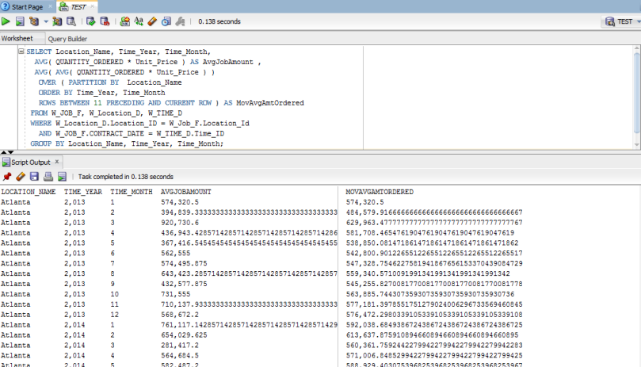

3.

SELECT X1.Location_Name, X1.Time_Year, SUM(SumInvoiceAmt - TotalCosts) AS SumLocProfit, RANK() OVER ( PARTITION BY X1.Time_Year ORDER BY ( SUM(SumInvoiceAmt - TotalCosts) ) DESC ) AS RankProfitSum

FROM LocCostSummary X1, LocRevenueSummary X2 WHERE X1.Job_Id = X2.Job_Id

GROUP BY X1.Location_Name, X1.Time_Year;

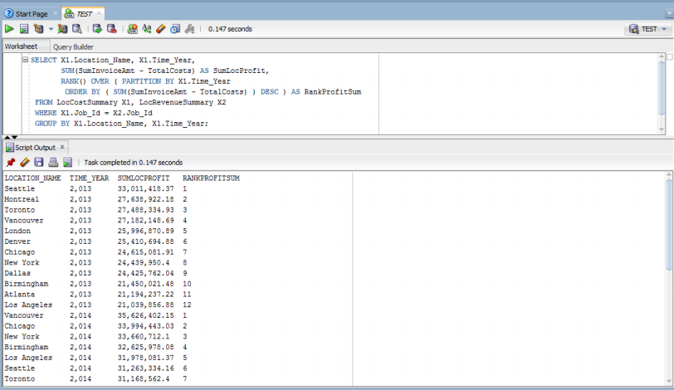

4.

SELECT X1.Location_Name, X1.Time_Year, SUM (SumInvoiceAmt - TotalCosts) / SUM(SumInvoiceAmt) AS ProfitMargin, RANK() OVER ( PARTITION BY X1.Time_Year

ORDER BY ( SUM (SumInvoiceAmt - TotalCosts) / SUM(SumInvoiceAmt) ) DESC ) AS RankProfitMargin

FROM LocCostSummary X1, LocRevenueSummary X2 WHERE X1.Job_Id = X2.Job_Id

GROUP BY X1.Location_Name, X1.Time_Year;

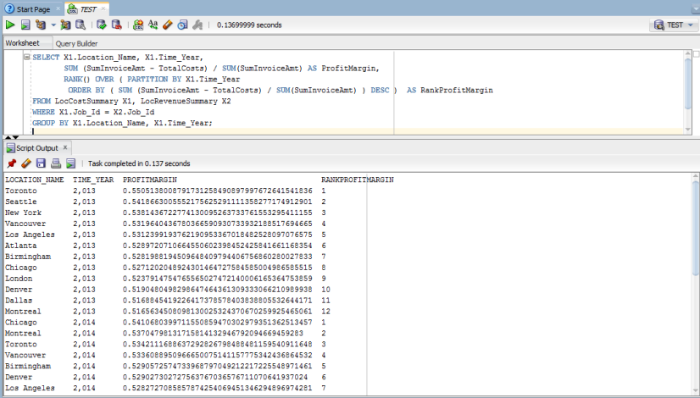

5.

SELECT X1.Job_Id, X1.Location_Name, X1.Time_Year, X1.Time_Year,

(SumInvoiceAmt - TotalCosts) / SumInvoiceAmt AS ProfitMargin, PERCENT_RANK() OVER ( ORDER BY ( (SumInvoiceAmt - TotalCosts) / SumInvoiceAmt ) ) AS PercentRankProfitMargin

FROM LocCostSummary X1, LocRevenueSummary X2

WHERE X1.Job_Id = X2.Job_Id;

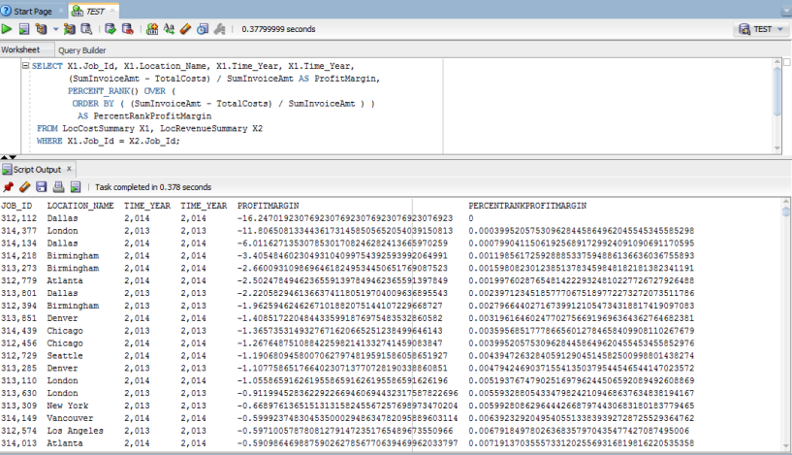

6.

SELECT Job_Id, Location_Name, Time_Year, Time_Month,

ProfitMargin, PercentRankProfitMargin

FROM ( SELECT X1.Job_Id, X1.Location_Name, X1.Time_Year, X1.Time_Month, (SumInvoiceAmt - TotalCosts) / SumInvoiceAmt AS ProfitMargin, PERCENT_RANK() OVER ( ORDER BY ( (SumInvoiceAmt - TotalCosts) / SumInvoiceAmt ) ) AS PercentRankProfitMargin

FROM LocCostSummary X1, LocRevenueSummary X2 WHERE X1.Job_Id = X2.Job_Id )

WHERE PercentRankProfitMargin > 0.95;

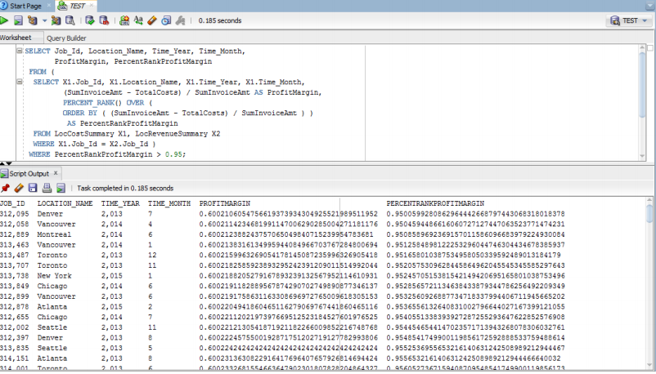

7.

SELECT Sales_Class_Desc, Time_Year, SUM ( quantity_shipped - invoice_quantity ) as ReturnSum , RANK() over ( PARTITION BY Time_Year ORDER BY SUM ( quantity_shipped - invoice_quantity ) DESC ) AS RankReturnSum

FROM W_INVOICELINE_F INNER JOIN W_TIME_D ON W_INVOICELINE_F.INVOICE_SENT_DATE = W_TIME_D.TIME_ID INNER JOIN W_Sales_Class_D ON W_INVOICELINE_F.Sales_Class_Id = W_Sales_Class_D.Sales_Class_Id

WHERE quantity_shipped > invoice_quantity GROUP BY Sales_Class_Desc, Time_Year;

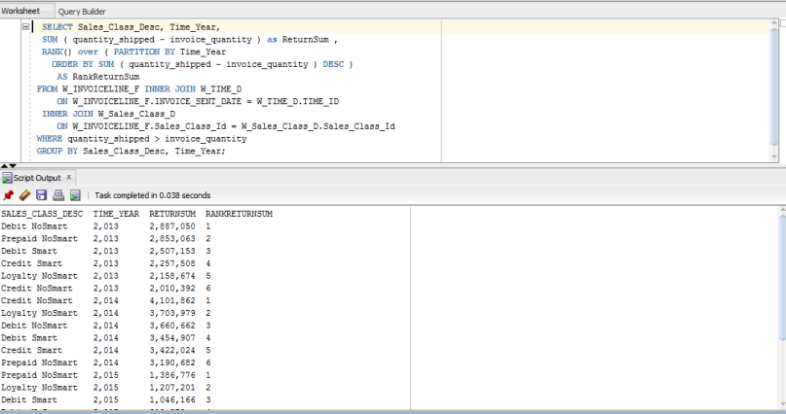

8.

SELECT Time_Year, Sales_Class_Desc, SUM ( quantity_shipped - invoice_quantity ) as SumReturnQty, Ratio_To_Report(SUM ( quantity_shipped - invoice_quantity )) OVER ( PARTITION BY Time_Year ) AS RatioReturnSum

FROM W_INVOICELINE_F INNER JOIN W_TIME_D ON W_INVOICELINE_F.INVOICE_SENT_DATE = W_TIME_D.TIME_ID INNER JOIN W_Sales_Class_D ON W_INVOICELINE_F.Sales_Class_Id = W_Sales_Class_D.Sales_Class_Id

WHERE quantity_shipped > invoice_quantity GROUP BY Sales_Class_Desc, Time_Year

ORDER BY Time_Year, SUM( quantity_shipped - invoice_quantity );

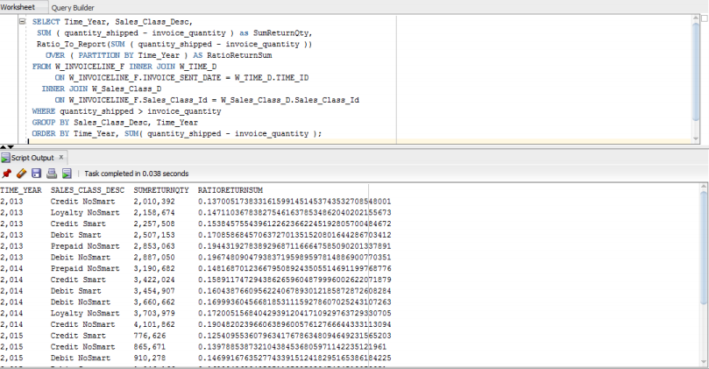

9.

SELECT Location_Name, W_Time_D.Time_Year, SUM(BusDaysDiff) as SumDelayDays, RANK() OVER ( PARTITION BY W_Time_D.Time_Year

ORDER BY SUM(BusDaysDiff) DESC) AS RankSumDelayDays, DENSE_RANK() OVER ( PARTITION BY W_Time_D.Time_Year

ORDER BY SUM(BusDaysDiff) DESC) AS RankSumDelayDays FROM FirstShipmentDelays, W_Time_D WHERE W_Time_D.Time_Id = FirstShipmentDelays.Date_Ship_By

GROUP BY Location_Name, W_Time_D.Time_Year;

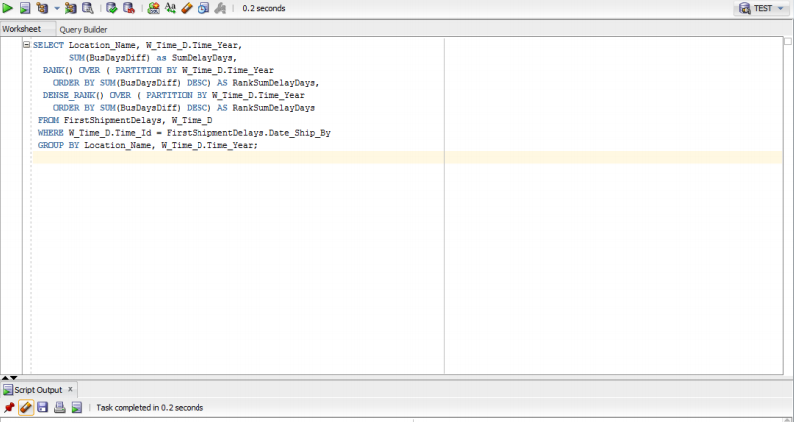

10.

SELECT Location_Name, W_Time_D.Time_Year, COUNT(*) AS NumJobs, SUM(BusDaysDiff) as SumDelayDays, SUM(Quantity_Ordered - SumDelayShipQty) / SUM(Quantity_Ordered) AS PromisedDelayRate, RANK() OVER ( PARTITION BY W_Time_D.Time_Year

ORDER BY SUM(Quantity_Ordered - SumDelayShipQty) / SUM(Quantity_Ordered) DESC) AS RankDelayRate

FROM LastShipmentDelays, W_Time_D

WHERE W_Time_D.Time_Id = LastShipmentDelays.Date_Promised

GROUP BY Location_Name, W_Time_D.Time_Year;

