1.

SELECT

W_Location_D.Location_Id, Location_Name, W_Sales_Class_D.Sales_Class_Id, Sales_Class_Desc, Base_Price, Time_Year, Time_Month, SUM ( QUANTITY_ORDERED ) AS Sum_Job_Qty, SUM ( QUANTITY_ORDERED * Unit_Price ) AS Sum_Job_Amount FROM W_JOB_F, W_Location_D, W_TIME_D, W_Sales_Class_D

WHERE W_Location_D.Location_ID = W_Job_F.Location_Id AND W_JOB_F.CONTRACT_DATE = W_TIME_D.Time_ID AND W_Job_F.Sales_Class_Id = W_Sales_Class_D.Sales_Class_Id

GROUP BY W_Location_D.Location_Id, Location_Name, W_Sales_Class_D.Sales_Class_Id, Sales_Class_Desc, Base_Price, Time_Year, Time_Month;

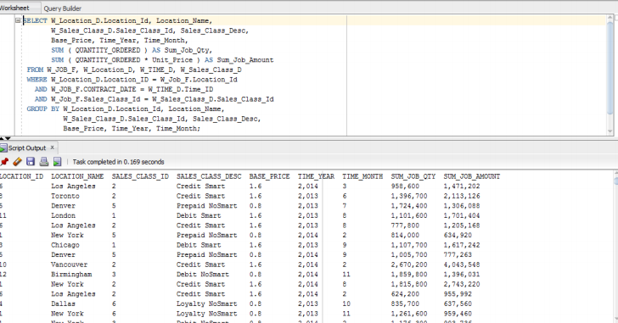

2.

CREATE VIEW LocRevenueSummary AS

SELECT W_Sub_Job_F.Job_Id, W_Location_D.LOCATION_ID, W_LOCATION_D.LOCATION_NAME, Quantity_Ordered, Unit_Price, W_TIME_D.TIME_YEAR, W_TIME_D.TIME_MONTH, SUM (Invoice_Quantity) AS SumInvoiceQty, SUM (Invoice_Amount) AS SumInvoiceAmt

FROM W_Job_Shipment_F, W_Sub_Job_F, W_Location_D, W_Time_D, W_InvoiceLine_F, W_Job_F WHERE W_Sub_Job_F.Sub_Job_Id = W_Job_Shipment_F.Sub_Job_Id AND W_Job_Shipment_F.Invoice_Id = W_InvoiceLine_F.Invoice_Id AND W_Time_D.Time_Id = Contract_Date AND W_Location_D.Location_Id = W_InvoiceLine_F.Location_Id AND W_Job_F.Job_Id = W_Sub_Job_F.Job_Id GROUP BY W_Sub_Job_F.Job_Id, W_Location_D.Location_Id, W_LOCATION_D.LOCATION_NAME, Quantity_Ordered, Unit_Price, W_Time_D.Time_Year, W_Time_D.Time_Month;

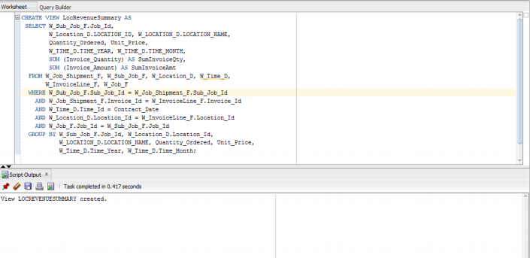

3.

CREATE VIEW LocCostSummary AS

SELECT W_Sub_Job_F.Job_Id, W_Location_D.LOCATION_ID ,W_LOCATION_D.LOCATION_NAME, W_TIME_D.TIME_YEAR, W_TIME_D.TIME_MONTH, SUM(Cost_Labor) AS SumLaborCosts, SUM(Cost_Material) AS SumMaterialCosts, SUM(Cost_Overhead) AS SumOvrhdCosts, SUM(Machine_Hours * Rate_Per_Hour) AS SumMachineCosts, SUM(Quantity_Produced) AS SumQtyProduced, SUM(Cost_Labor + Cost_Material + Cost_Overhead + (Machine_Hours * Rate_Per_Hour) ) AS TotalCosts, SUM( Cost_Labor + Cost_Material + Cost_Overhead + (Machine_Hours * Rate_Per_Hour) ) / SUM(Quantity_Produced) AS UnitCosts FROM W_Job_F, W_Sub_Job_F, W_Location_D, W_Time_D, W_Machine_Type_D

WHERE W_Job_F.Location_Id = W_Location_D.Location_Id AND W_Sub_Job_F.Machine_Type_Id = W_Machine_Type_D.Machine_Type_Id AND W_Time_D.Time_Id = Contract_Date AND W_Job_F.Job_Id = W_Sub_Job_F.Job_Id

GROUP BY W_Sub_Job_F.Job_Id, W_Location_D.LOCATION_ID, W_LOCATION_D.LOCATION_NAME, W_TIME_D.TIME_YEAR, W_TIME_D.TIME_MONTH;

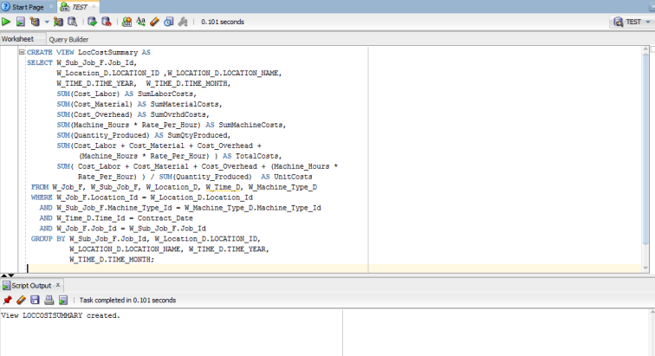

4.

SELECT W_Location_D.Location_Id, Location_Name, W_Sales_Class_D.Sales_Class_Id, Sales_Class_Desc, Time_Year, Time_Month, SUM ( quantity_shipped - invoice_quantity ) as SumReturnQty, SUM ( (quantity_shipped - invoice_quantity) * (invoice_amount/invoice_quantity) ) AS SumReturnAmt FROM W_INVOICELINE_F INNER JOIN W_TIME_D ON W_INVOICELINE_F.INVOICE_SENT_DATE = W_TIME_D.TIME_ID INNER JOIN W_Location_D ON W_INVOICELINE_F.Location_Id = W_Location_D.Location_Id INNER JOIN W_Sales_Class_D ON W_INVOICELINE_F.Sales_Class_Id = W_Sales_Class_D.Sales_Class_Id

WHERE quantity_shipped > invoice_quantity

GROUP BY W_Location_D.Location_Id, Location_Name, W_Sales_Class_D.Sales_Class_Id, Sales_Class_Desc, Time_Year, Time_Month;

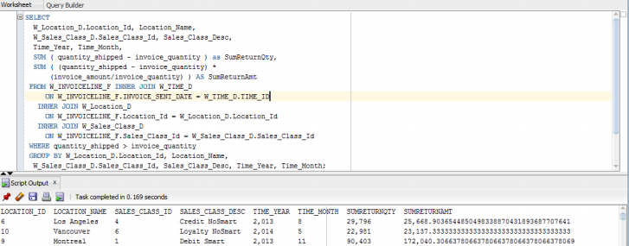

5.

CREATE VIEW LastShipmentDelays AS SELECT W_JOB_F.job_ID , W_JOB_F.SALES_CLASS_ID, Sales_Class_Desc, W_JOB_F.LOCATION_ID, Location_Name, Date_Promised, Last_Shipment_Date, QUANTITY_ORDERED, SumDelayShipQty, GetBusDaysDiff ( date_promised, Last_Shipment_Date ) AS BusDaysDiff FROM W_JOB_F , W_Location_D, W_Sales_Class_D, (SELECT W_SUB_JOB_F.JOB_ID, MAX(actual_ship_Date) AS Last_Shipment_Date, SUM ( actual_Quantity ) AS SumDelayShipQty FROM W_JOB_SHIPMENT_F, W_SUB_JOB_F, W_Job_F

WHERE W_SUB_JOB_F.SUB_JOB_ID = W_JOB_SHIPMENT_F.SUB_JOB_ID AND W_Job_F.Job_Id = W_SUB_JOB_F.JOB_ID AND Actual_Ship_Date > Date_Promised

GROUP BY W_SUB_JOB_F.JOB_ID ) X1 WHERE date_promised < X1.Last_Shipment_Date AND W_JOB_F.JOB_ID = X1.Job_Id AND W_Job_F.Location_Id = W_Location_D.Location_Id AND W_Job_F.Sales_Class_Id = W_Sales_Class_D.Sales_Class_Id;

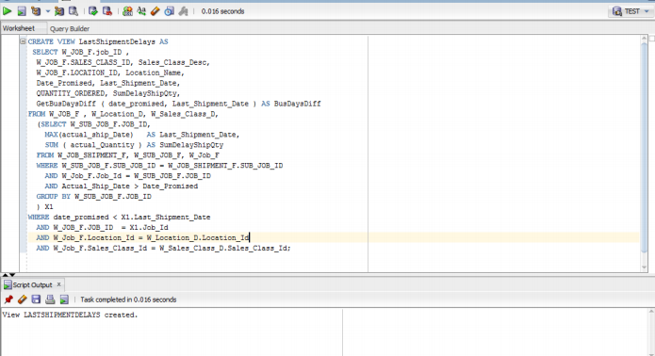

6.

CREATE VIEW FirstShipmentDelays AS

SELECT W_JOB_F.job_ID, W_JOB_F.SALES_CLASS_ID, Sales_Class_Desc, W_JOB_F.LOCATION_ID, Location_Name, Date_Ship_By, FirstShipDate, GetBusDaysDiff ( date_ship_By, FirstShipDate ) AS BusDaysDiff

FROM W_JOB_F , W_Location_D, W_Sales_Class_D, (SELECT W_SUB_JOB_F.JOB_ID, MIN(actual_ship_Date) as FirstShipDate FROM W_JOB_SHIPMENT_F, W_SUB_JOB_F

WHERE W_SUB_JOB_F.SUB_JOB_ID = W_JOB_SHIPMENT_F.SUB_JOB_ID GROUP BY W_SUB_JOB_F.JOB_ID ) X1 WHERE date_ship_By < X1.FirstShipDate AND W_JOB_F.JOB_ID = X1.Job_Id AND W_Job_F.Location_Id = W_Location_D.Location_Id AND W_Job_F.Sales_Class_Id = W_Sales_Class_D.Sales_Class_Id;

