**Job and Shipment Trends**

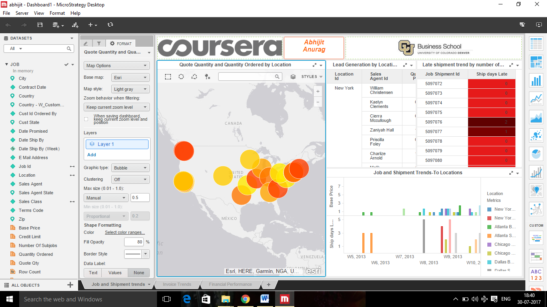

In the Quote Quantity and Quantity Ordered by Location shows us the quantity ordered and no of sub jobs listed for particular zip codes.

In the Lead Generation by Location and Agent visualization, information about the quote price and the Quantity by Sales agent ID for various cities is shown

In the Job and Shipment Trends-To-Location, bar chart shows Ship dates by week for locations on basis of their Base Price. For Shipment days late, information is displayed about the days the shipment was delayed by for a particular Job Shipment id.

**Invoice Trends**

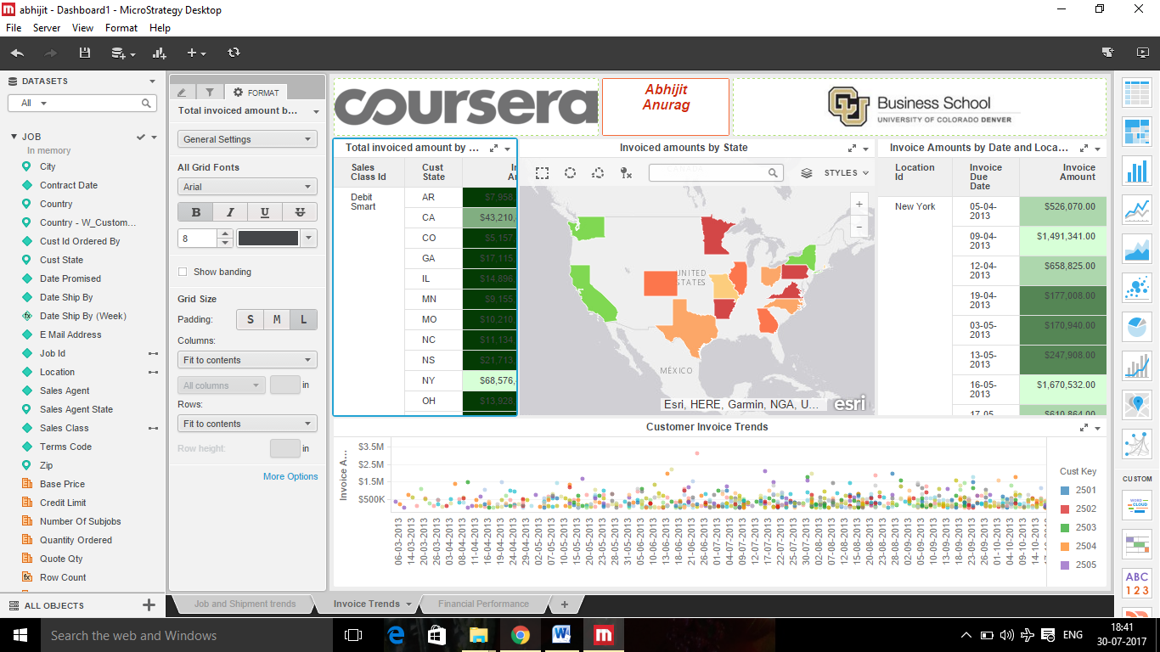

This visualization reflects shows the invoice amount for sales class id for diff types of cards generated by company. The green colour reflects highest invoice amount and red reflects lowest amount.

Customer invoice trends shows the invoice amount by the invoice due dates with respect to customer keys and reflects how the Invoice amount changes over the period of time for each customer.

**Financial Summary**

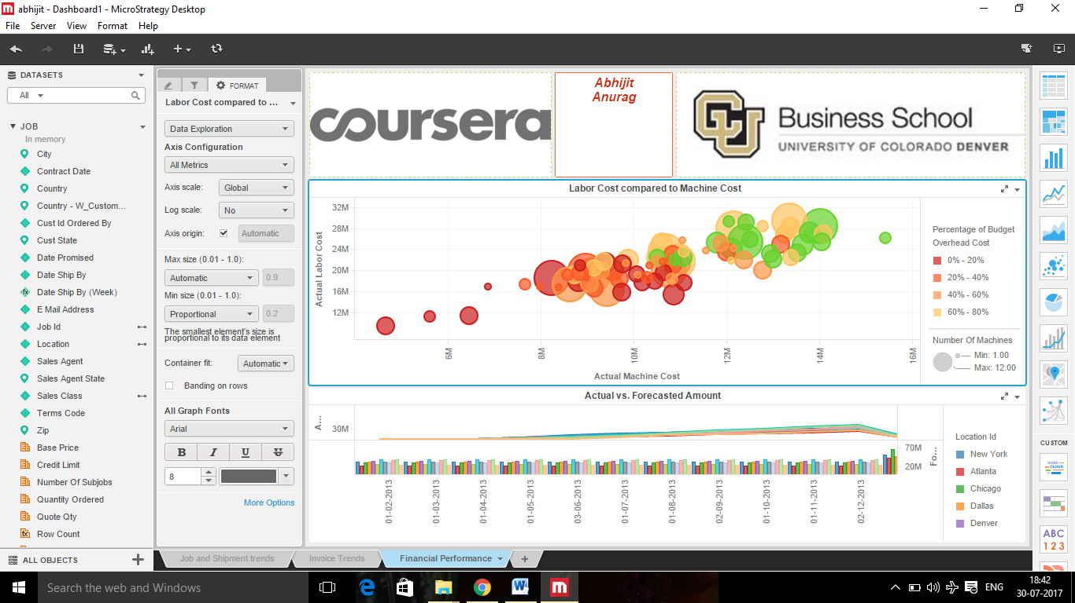

Bubble chart visualization reflects how the budget overhead cost varies with Actual Machine Cost and Actual Labor Cost. Red shows the lowest budget overhead cost and green show higher overhead budget cost.

**Conclusion :**

This analysis give us the overall trends in the production by the company as well as variation in production and presence in different states.