TABLE OF CONTENTS
1.Introduction 1
1.2 PROBLEM STATEMENT 1
1.3 RESEARCH OBJECTIVES 2
1.4 PROJECT SCOPE 2
1.6 ORGANIZATION OF PROJECT 3
2.LITERATURE REVIEW 4
2.1Introduction. 4
2.2The Importance of Tourism. [1] 4
2.3 Related works. 6
2.4 Discussion. 10
2.5 Conclusion. 11
3. REQUIREMENTS SPECIFICATION 12
3.1Introduction 12
3.2Functional Requirement. 13
3.3Non-Functional Requirements 14
3.4 Assumptions and constraints. 14
3.5 Conclusion 14
4.SYSTEM DESIGN 16
4.1 Introduction. 16
4.2 Use Cases. 16
4.3 Use Case Diagram. 20
4.4 Entity Relationship Diagram. 21
4.5 Context Diagram. 22
4.6 Client Server Achitectural Design 23
4.7 Conclusion. 24
5.IMPLEMENTATION 25
5.1Introduction 25
5.2 System implementation 25
7.CONCLUSION AND RECOMMENDATIONS 31
7.1 Introduction 31
7.2 Conclusion 31
7.2.1 Objectives 31
7.2.1.1 Main Objective 31
7.2.1.2 Secondary Objectives 31
7.2.2 Strengths 31
7.2.3 Weaknesses 32
7.3 Recommendations 32
8.REFERENCES. 33

1.Introduction
Tourist attractions in Zambia are numerous - from National parks such as Kafue and Nyiku national parks to Traditional ceremonies such as N’cwala and Kuomboka ceremonies. Accessing information about these places of interest can be challenging. In response to this issue, we’re proposing a system that provides the necessary information and resources to truly experience Zambia. The system aims to tackle the lack of a comprehensive platform in Zambia, with which tourists can obtain easy access to information and resources regarding local attractions and points of interest. Encompassing both well-known hotspots and lesser-known attractions, the system is to act as an informative resource for exploration and adventure.
In Zambia, destinations are often chosen based on word of mouth. This causes tourists to flow towards the popular hotspots as they can’t visit attractions they do not know about. Unfortunately, this leaves many attractions overlooked. The lack of information about recreational destinations is shared among tourists and locals, hindering the potential benefits such as increased revenue that could arise from the increased traffic to these places.
Statistics indicate a decline in tourist visits to Zambia [5], allowing opportunity for improvement and innovation. This system has the potential to revitalize tourist traffic by offering the opportunity for new experiences.

1.2 PROBLEM STATEMENT
There is a significant challenge in the tourism sector, where both tourists and locals in Zambia struggle to find comprehensive information about local tourist attractions and enjoyable places to visit. Existing sources of information, such as travel guides and online platforms (e.g Facebook groups, online forums), often lack compiled, up-to-date data, and user-friendly features leading to missed opportunities for tourists to explore the country's diverse attractions and for locals to discover hidden gems in their own communities. If left unaddressed, this issue could hinder the growth of the local tourism platform that caters to the needs of both tourists and locals.

1.3 RESEARCH OBJECTIVES
The primary goal of this project is to develop a web application aimed at providing both residents and tourists with thorough information for planning their travels. The subsidiary objectives include:
1.Systematically gathering and categorizing data on local tourist attractions, landmarks, events, and amenities to facilitate a user-friendly experience.
2.Designing an interactive and intuitive interface to enhance user engagement.
Soliciting feedback and insights from tourists and locals to refine the platform's functionalities and services.
3.Establishing collaborations with local businesses, tour operators, and cultural organizations to leverage the platform for promoting their offerings and products.

1.4 PROJECT SCOPE
The scope of this project is to develop a Web Application that will gather information about the Zambia Tourism Sector.

1.6 ORGANIZATION OF PROJECT
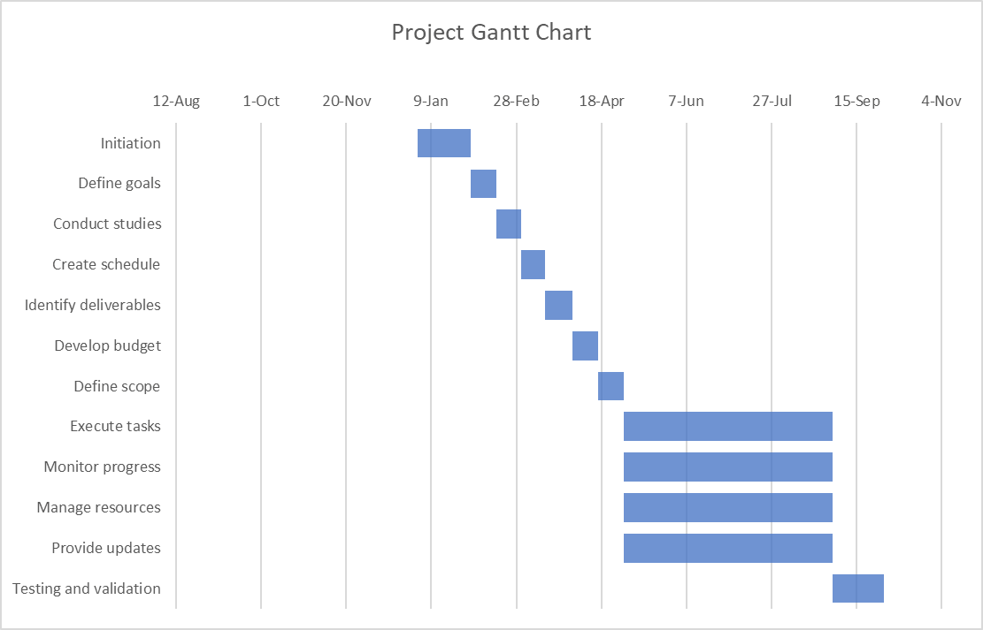

2.LITERATURE REVIEW

2.1Introduction.
The tourism landscape in Zambia presents a challenge due to the lack of an all-encompassing platform integrating information on attractions, accommodations, and activities. While existing methodologies such as guidebooks, online forums, and mobile applications attempt to address this need, they often fall short in providing comprehensive and real-time updates. Guidebooks, for instance, may become outdated quickly and lack the dynamic content required to keep up with evolving tourism trends. Similarly, online forums may offer valuable insights from fellow travelers, but the information provided may not always be reliable or up-to-date. Mobile applications, though convenient, may focus only on specific aspects of travel, leaving travelers to navigate multiple platforms to plan their trips effectively.
This literature review aims to explore how information on Zambian tourism is disseminated and identify areas for innovation. Through extensive research, it has become evident that there is a significant need for a platform that not only showcases popular tourist destinations but also includes the lesser-known local treasures. Existing platforms often overlook these hidden gems, focusing primarily on mainstream attractions. Moreover, there is a lack of emphasis on providing authentic cultural experiences and promoting sustainable tourism practices, which are essential for preserving Zambia's rich heritage and natural beauty.
Using insights gathered from the literature review, our goal is to develop a dynamic, user-friendly platform that serves as a comprehensive guide to Zambia's tourism offerings while promoting sustainable and authentic travel experiences. By incorporating local perspectives and highlighting lesser known destinations, our platform aims to encourage travelers to explore beyond typical tourist routes, fostering a deeper connection with Zambia and its people. Through addressing the gaps identified in existing methodologies and incorporating insights from the literature review, we aim to create a valuable resource that enriches the travel experience for visitors to Zambia while contributing to the country's tourism development goals.

2.2The Importance of Tourism. [1]
Tourism as an industry contributes significantly to the country's foreign exchange reserves and provides direct and indirect job possibilities to a broad segment of the population (Thommandru et al., 2023). It generates new revenue streams by attracting visitors and increasing the amount of money spent in the area (Erkin & Odilov, 2023). It is also a globalization promoter and a significant constituent of sustainable development with its contribution to the GDP being proportional to the development level of each country (Bunghez, 2016). Furthermore, supporting a nation's handicrafts and fine arts aids in the preservation of nature's beauty, cultural legacy of the country as well as strengthening the process of national integration and global brotherhood (Thommandru et al., 2023). Beyond their economic benefits, international tourism enhances understanding between nations and people (Bacsia, 2017).

2.3 Related works.
1. Zambia Tourism. [2]
This website is managed and maintained by Zambia Tourism. It offers a range of services aimed at assisting travelers in planning their trips, including recommending accommodation options, suggesting activities, and offering practical travel advice to do with visa information, travel agents and self-drive. Additionally, the website features a blog section with the latest news and articles related to tourism, along with a YouTube video showcasing the tourist attractions Zambia has to offer.
The website employs several technologies for its operations. It utilizes WordPress for content management, Microsoft 365 for webmail services, and MySQL for managing its database. Video content is integrated using YouTube and Vimeo players, while the user interface is developed using the Bootstrap framework for responsiveness. SEO optimization is managed by the Yoast SEO plugin, and various analytics tools, such as Google Analytics, are used to track user interactions. Cloudflare is employed for content delivery to ensure fast performance, and Send in Blue facilitates marketing automation.
Information on the Zambia Tourism website is regularly managed and updated to keep it relevant and informative. The WordPress CMS enables administrators to easily create, edit, and publish content such as articles, blog posts, images, and videos. Efficient communication among team members for collaboration is facilitated by Microsoft 365 webmail services, while the MySQL database organizes information effectively. Additionally, RSS feeds keep users informed about updates.
The design of the Zambia Tourism website is characterized by its simplicity and functionality, featuring a clean layout and intuitive navigation. Vibrant imagery and clear typography create an inviting atmosphere for users, while the website's responsive design ensures accessibility across various devices, enhancing the user experience.
However, user management on the Zambia Tourism website faces a significant hurdle as it lacks a registration and login process to easily help in navigating the website in a personalized manner especially with so much information. Unlike other aspects of the website, such as content presentation and navigation, which may function adequately, the absence of an efficient registration and login system limits user interaction. Without the ability for users to create accounts or log in, they are unable to access personalized features or save preferences. This limitation significantly reduces the website's functionality and convenience for users, hindering their ability to engage fully with the site's content and services. As a result, the overall user experience is compromised, as travelers interested in exploring Zambia's tourism offerings are unable to take full advantage of the website's resources.
2. People and Places.[15]
People and Places is a website that focuses on providing tourism information about Malawi, Zambia and Zimbabwe. It is built with PHP as its backend programming language. JavaScript libraries such as jQuery and Axios are used in its creation, along with the Apache HTTP server acting as the webserver.
Upon visiting the homepage, users encounter divisions with headers such as Explore Africa and Featured Destinations, each accompanied by a short and concise paragraph of information. The website features such as Destinations, offering a list of three countries: Malawi, Zambia, and Zimbabwe. Selecting any of these countries opens a page with detailed information about the selected country and its destinations. Choosing one of the available destinations leads to a page with facts about the destination and a list of links. These links allow users to download documents providing information about the country's overview, travel information, and tips, among other things.
Itineraries are another feature of the website, presenting users with different itineraries indicated by the number of nights. Selecting an itinerary opens a page with details such as pricing and terms and conditions. Additionally, the website includes an Agents feature, which, when selected, displays a login and registration page.
The website is responsive, with its information well presented. However, it has some drawbacks. It provides limited local information about Zambia, focusing only on major attractions, thus neglecting local tourists interested in exploring unpopular sites. Furthermore, the requirement to download documents for more information may limit user engagement, as some users may be uncomfortable downloading documents from unknown sources. Additionally, difficulty was encountered when logging in despite successfully creating an account, which further limits user interaction.
- Ministry of Tourism.[16]
The website is designed to provide information to various members of society needed to make informed decisions related to tourism in Zambia. It utilizes PHP as the backend programming language with the use of JavaScript libraries such as jQuery, jQuery Migrate, Core JS, Swiper, and jQuery UI. MySQL serves as the database, with Apache HTTP server as the web server. The UI framework used is Bootstrap.
Upon visiting the homepage, users encounter sections providing brief information about National Parks, culture, heritage, and travel information. There is also a section providing the latest news about tourism. Additionally, there are images which, when clicked, lead to a new webpage displaying information about the selected subject. The website has features such as Services feature, which, when selected, presents a menu containing options such as E-services, wildlife services, and tourism licensing. Choosing E-services displays a webpage with departments under the ministry, each linking to further information about a selected subject. Selecting wildlife service’s leads to a webpage for the Department of Wildlife and National Parks. The website also includes a News feature, displaying news articles related to tourism when selected. Another feature is Explore, which, when selected, presents a menu containing options such as heritage sites, national parks, wildlife safaris and adventure activities. If national parks or wildlife safari is chosen under Explore, it redirects to another website. The Operators feature presents a menu consisting of accommodation, tour operators, and tour agents. Selecting accommodation displays a table containing hotels and their contact details. Choosing tour operators redirects to another website
The website is responsive and regularly updated. While the information provided is extensive and well-presented, it lacks in-depth catering to local tourists. It only offers a general overview of travel information, which may not be satisfactory for comprehensive travel planning. Some of the links were not working.
- Lonely Planet.[17]
Lonely Planet is a website that offers information and resources for travelers looking to explore destinations around the world. The website, located at www.lonelyplanet.com, is a hub for travel guides, advice, and inspiration.
The website employs a variety of technologies to operate effectively. It utilizes HTML, CSS, and JavaScript for the frontend, providing a responsive and interactive user experience. For its online shop, Lonely Planet utilizes Shopify, a popular e-commerce platform known for its user-friendly interface and robust features. Additionally, Zendesk provides hosted customer service software, enhancing the website's customer support capabilities. For server-side programming, Lonely Planet employs JavaScript and Ruby. In terms of JavaScript libraries, Lonely Planet utilizes jQuery and Bootstrap.
Lonely Planet provides a range of features and one of them is account creation. To create an account, users can navigate to the website's registration page and fill out the required information, such as name, email address, and password. Once registered, users can log in to their account using their credentials. While users can create an account and access information and resources on the website, they are not able to post content.
It also provides other features such as trip planning, and the sale of guidebooks. For the planning of trips, the website offers tools that allow users to research destinations and create travel plans. Users can search for specific destinations or browse through categories such as "Top Destinations" or "Travel Themes" to find inspiration.
5. Travel Guide.[18]
The Zambia Travel Guide is built using HTML, JavaScript, ASP.NET frameworks, and IIS servers. It is maintained by Expert Africa and features a section of Zambia:
The Bradt Travel Guide (ed. 3)
The homepage includes an introduction to the guide, a link to the map, and an overview of the content available on the website, such as Facts and figures and
History and Economy. Furthermore, the homepage has a search that links to the
Expert Africa website to provide details on safaris and a menu for navigation. The Menu sections include Facts and Figures, History, Livingstone and the Victoria Falls, lake Kariba and the lower Zambezi, and a few other attractions. Upon clicking a menu option, the user is taken to the overview of that section and the selected option is expanded into a submenu with listings such as History, Geology, Shopping, and many more. Each option has a brief paragraph detailing what it's about.
Zambia Travel guide provides comprehensive information about Zambia, covering its rich history, diverse economy, fascinating tribes, and languages. It catalogs the provinces of Zambia, what makes them unique, and what they offer, but it lacks in detailing the attractions and is outdated. It lacks provisions for users to create accounts, log in, or upload information, leaving little room for community engagement. Furthermore, it has a range of information but has a limited number of attractions listed, which include the already popular ones. The magnitude of information offered can be overwhelming and unnecessary for users only looking to plan visits and not learn about History, for example. Learning from this, we aim to narrow the information to help tourists learn about places and points of interest and prioritize updating our database regularly so that users can easily find the information they need and have access to the latest information. We further hope to allow for the creation of user accounts and user-generated content to improve user engagement.

2.4 Discussion.
Analysis of the previous works discussed revealed several strengths and weaknesses to be considered for the project. Our proposed system aims to harness these strengths and learn from the weaknesses to create a good user experience. The existing websites, while informative, prioritize popular attractions and lack details on the lesser-known attractions that hold immense potential for adventurous travelers looking for fresh experiences. Additionally, the lack of user-friendly navigation tools hinders the users’ ability to plan and explore destinations with confidence. Our proposed tourism web application aims to address these limitations by including information about both popular and unpopular destinations, as well as providing maps and navigation to enhance user experience, all while ensuring responsiveness based on our analysis of existing systems. Furthermore, our system will allow users to create accounts for user-generated content and community engagement. This integration of comprehensive coverage of destination information and improved navigation features will set our system apart, offering users an enriched and personalized tourism experience in Zambia.

2.5 Conclusion.
In this document, we reviewed different systems that display information about tourism sites in Zambia as well as the importance of tourism toward social and economic development. We have discussed the various strengths and weaknesses of the reviewed systems. In light of that, our system is going to incorporate those various strengths enhancing the overall travel experience for visitors to Zambia.

3. REQUIREMENTS SPECIFICATION

3.1Introduction
The tourism landscape in Zambia faces challenges due to the lack of an all-encompassing platform that integrates information on attractions, accommodations, and activities. Existing resources such as guidebooks, online forums, and mobile applications are often outdated or fragmented, failing to provide travellers with real-time, reliable, and comprehensive insights into Zambia's tourism[19].
Individuals seeking to explore Zambia struggle to find a single, reliable source that offers up-to-date, comprehensive information on various tourism elements. This fragmentation leads to inefficiencies in trip planning, as users must navigate multiple platforms to gather necessary information. Additionally, mainstream platforms often overlook local treasures and sustainable tourism practices, essential for preserving Zambia's cultural and natural heritage[20].
To address these challenges, we propose developing a dynamic, user-friendly tourism platform. This platform aims to serve as an all-in-one guide to Zambia's tourism offerings, encompassing both popular destinations and lesser-known local treasures. It will promote sustainable and authentic travel experiences by incorporating local perspectives and emphasizing cultural and environmental preservation.
This document outlines the requirements specifications for the proposed tourism system. It details the functional and non-functional requirements necessary for developing an effective platform that meets the needs of tourists. The specifications will guide the development process to ensure the platform is robust, user-friendly, and capable of providing real-time, reliable information, thus enriching the travel experience and supporting Zambia's tourism development goals.

3.2Functional Requirement.
Functional requirements describe what the software has to do [21] . The My Zambia web application must have the following functional requirements:
- User Registration: The web application should allow the two different sets of users, namely contributors and system users, to create accounts by providing relevant information to the system such as date of birth, email address, password, username and phone number for both system users and contributors. For contributors’ specific details such as organization details, usage purpose and organization background will be required. As for system users, details such as user preferences and location will be required.
- Authentication: The web application should be able to authenticate users by comparing the information provided at login with the information provided during user registration.
- Search and Filter: The web application should be able to allow users to search for tourist attractions by location or by supplying words that match a selected criterion.
- Attraction Details: The web application should have a dedicated page for each attraction providing comprehensive information, including descriptions, photos, opening hours, admission fees, contact details, and directions.
- Interactive Map: The web application should include an interactive map that displays the locations of tourist attractions, allowing users to explore and plan their journey visually.
- User Reviews and Ratings: The web application should allow users to leave reviews and ratings for attractions, helping others make informed decisions and providing feedback to attraction owners.

3.3Non-Functional Requirements
Non-Functional requirements are mostly quality requirements. That stipulate how well the software does, what it has to do[21]. The My Zambia web application must have the following non-functional requirements:
- Performance: The web application should load quickly and handle simultaneous user requests efficiently.
- Reliability: The web application should be stable and available, with minimal downtime.
- Security: The web application should have security measures to protect user data and prevent unauthorized access.
- Usability: The web application should be easy to use and navigate.
- Scalability: The web application should be able to accommodate an increasing number of users.

3.4 Assumptions and constraints.
The My Zambia web application will operate under the following assumptions and constraints:
- Internet connectivity: The web application requires users have an internet connection to access and interact with it.
- Regulatory Compliance: The web application must comply with local regulations and guidelines related to tourism.
- Content Accuracy: The web application is assumed to provide accurate and up-to-date information about tourist attractions and activities.
- Cultural Sensitivity: The web application is assumed to have content and recommendations that are culturally sensitive.

3.5 Conclusion
The web application aims to create a comprehensive platform that encompasses both popular and lesser-known attractions, providing reliable insights and information about the various destinations. By integrating all the necessary information about destinations, the application aims to solve the problem of inadequate and inaccessible information covering destinations.
This document presented functional and non-functional requirements that are required for the system. The key functional requirements include User registration and Authentication, which allow personalized experiences and security. The application also includes search and filter facilities, dedicated pages for attraction details and a Map for visual exploration. Furthermore, users can leave reviews and share their experiences thereby giving a sense of community. The non-functional requirements emphasize performance, requiring the system to load quickly and handle simultaneous user requests efficiently even during peak traffic. Reliability is also crucial, requiring the system to be stable and consistently available. Additionally, the non-functional requirements specify Usability, Security and Scalability, ensuring the system is easy to use and navigate, has security measures to protect user data and can allow for growth.
Together these functional and non-functional requirements ensure that My Zambia offers an informative and engaging platform that enhances user experiences.

4.SYSTEM DESIGN

4.1 Introduction.
Zambia's tourism sector faces significant challenges due to the absence of a comprehensive platform that consolidates information on attractions, accommodations, and activities. Current resources such as guidebooks, online forums, and mobile applications are frequently outdated or fragmented, failing to offer traveller’s reliable, real-time, and holistic insights into Zambia's diverse tourism offerings.[19]
Travelers looking to explore Zambia encounter difficulties in finding a single, dependable source that provides current, comprehensive information about various tourism elements. This fragmentation causes inefficiencies in trip planning, as users must sift through multiple platforms to collect necessary information. Additionally, mainstream platforms often neglect local gems and sustainable tourism practices, which are crucial for preserving Zambia's cultural and natural heritage. [2]
To overcome these challenges, we propose the development of a dynamic, user-friendly tourism platform. This platform is designed to be an all-inclusive guide to Zambia's tourism offerings, highlighting both popular destinations and hidden local treasures. It will promote sustainable and authentic travel experiences by integrating local insights and emphasizing cultural and environmental conservation.
This document presents the logical design of the proposed tourism system along with the identified features to be integrated. Specifically, we employed the use of Use Case diagrams, Context Diagrams, and Entity Relationship Diagrams to depict the implementation of the design. This approach ensures a clear understanding of the system's architecture and functionality, facilitating efficient development and effective communication among stakeholders.

4.2 Use Cases.
Use cases are a way of describing interactions between user and a system using a graphical model and structured text.[22]
Use case diagrams give a simple overview of an interaction.[22]
- Login
- Actors: User
- Description: User logs in to the system.
- Precondition: The user must have a valid account.
- Main Flow:
- The user enters their username and password.
- The system verifies the credentials.
- If the credentials are valid, the user is logged into the system.
- Postcondition: The user is successfully logged in.
- Explore Attractions (includes View Attraction Details).
● Actors: User.
- Description: Allows user to explore various tourist attractions.
- Main Flow:
- The user navigates to the "Explore Attractions" section.
- The system displays a list of attractions.
- The user selects an attraction to view its details (View Attraction Details).
- Postcondition: User can view details of a selected attraction.

- Search Attractions (includes View Attraction Details).
● Actors: User.
- Description: Allows user to search for specific tourist attractions.
- Main Flow:
  - The user enters search criteria, such as location or attraction type, into the search bar.
  - The system displays a list of attractions matching the search criteria.
  - The user selects an attraction to view its details (View Attraction Details).
- Postcondition: User can view details of a selected attraction.
- Share Experience/Review (extends share to social media).
- Actors: User.
- Description: User can share their experience or leave a review for a chill spot.
- Main Flow:
- The user selects a chill spot.
- User write a review or share their experience with a star rating.
- Post condition: User review should be taken note of and displayed.

- View Attraction Map.
- Actors: User
- Description: Displays a map showing the locations of attractions.
- Main Flow:
- The user navigates to the "Attraction Map" section.
- The system displays a map with markers for attractions.
- Postcondition: User can view attractions on the map.

4.3 Use Case Diagram.
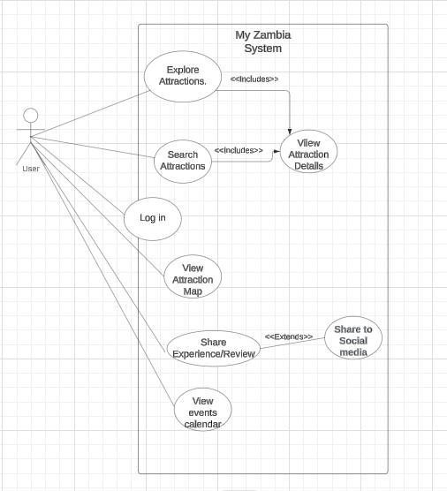
Fig.1. Use case Diagram for My Zambia web application.

4.4 Entity Relationship Diagram.
An Entity Relationship (ER) Diagram is a type of flowchart that illustrates how “entities” such as people, objects or concepts relate to each other within a system.[23]
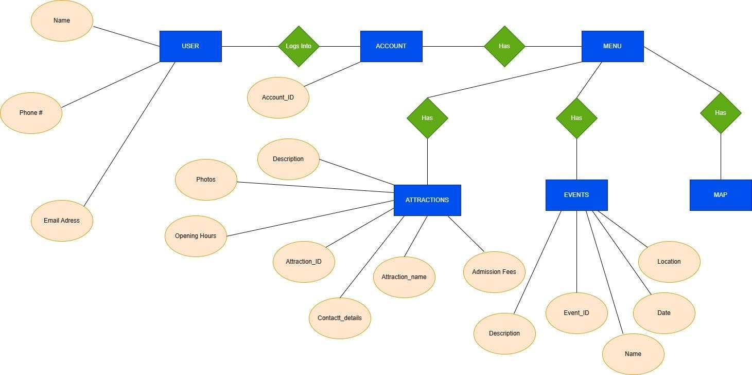
Fig. 2. Entity Relationship Diagram for My Zambia web application.
Entities:
- User
- Account
- Attractions
- Menu
- Events
- Map

4.5 Context Diagram.
A context diagram is a high-level view of a system. It is a basic sketch meant to define an entity based on its scope, boundaries, and relation to external components like stakeholders.[24]

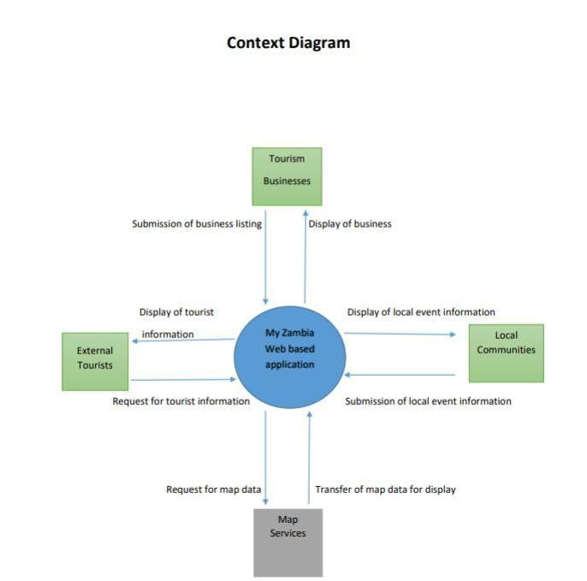

Fig. 3. Context Diagram for My Zambia web application.

4.6 Client Server Achitectural Design
The client-server architecture illustrated below involves a client side where users interact with the web application UI that communicates via HTTP/HTTPS with a Web Server API. Requests to a Search and Filter Engine and a Database Server for user data, attractions, and reviews are managed by the Api Server API. On the server side, an Application Server processes core functions, with a Security and Authentication Server ensuring secure access, a Data Processing and Logic layer handling business logic, and a File Storage Server managing media content. The architecture also incorporates external services like APIs for maps, enabling efficient data processing, secure interactions, and scalable storage solutions.

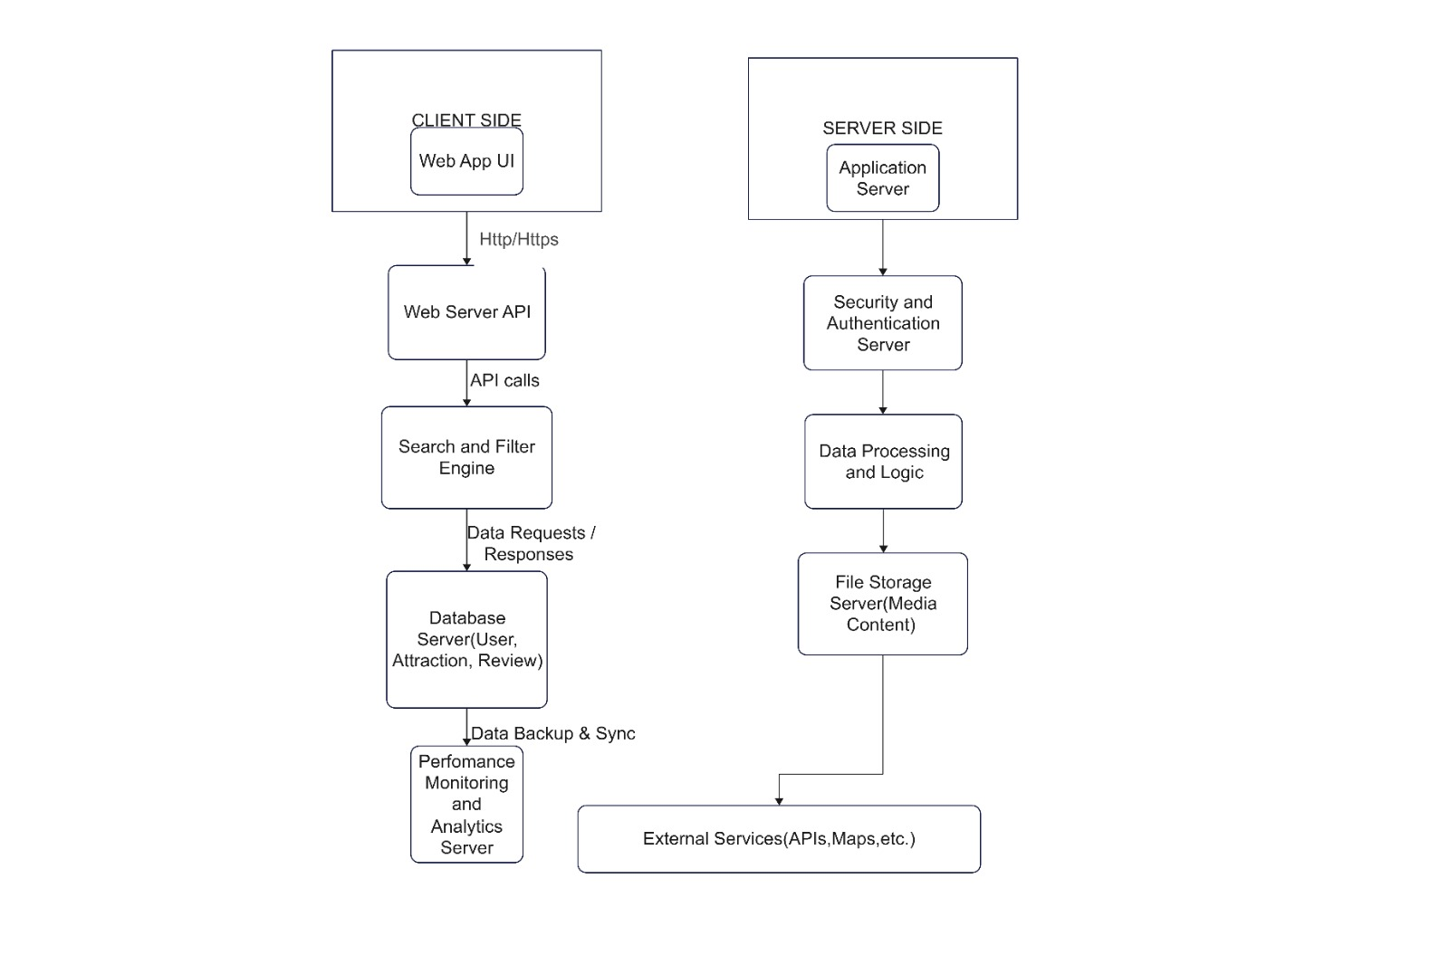

Fig.4. Client Server Architecture for My Zambia web application.

4.7 Conclusion.
The web application aims to create a comprehensive platform that encompasses both popular and lesser-known attractions, providing reliable insights and information about the various destinations. By integrating all the necessary information about destinations, the application aims to solve the problem of inadequate and inaccessible information covering destinations.
This document presented the system design of the web application. Specifically, we employed the use of a Use Case Diagram, Context Diagrams and Entity Relationship Diagram to depict the implementation of the design. The use of the Use Case Diagram provided insight into the interactions between different system modules. Through Entity Relationship Diagram, entities such as user and attractions were identified. By incorporating the Context Diagram, the web applications boundaries between itself and external entities, including the data flow between them, were seen. By exploring the structural blueprint of the web application, clarity to the implementation process has been achieved using the tools employed.

5.IMPLEMENTATION

5.1Introduction
This chapter shows the implementation details of the core functionalities of the MyZambia web application. The different technologies used and the code written will be discussed and shown in the following section.

5.2 System implementation
The following core functionalities were implemented in various ways:
    - The search functionality:
The platform was implemented using HTML to define its structural layout, complemented by CSS to enhance the visual appearance and user experience. A key feature of the system is the dynamic search functionality, which allows users to find relevant data efficiently. When a user begins typing into the search bar, a JavaScript script listens for the input in real time, filters through a dataset, and checks whether the search term matches specific fields such as names, categories, or locations. This provides immediate feedback and streamlines the process of finding relevant information without requiring a full page reload.
The code snippet below demonstrates the basic logic of how this real-time search is implemented:
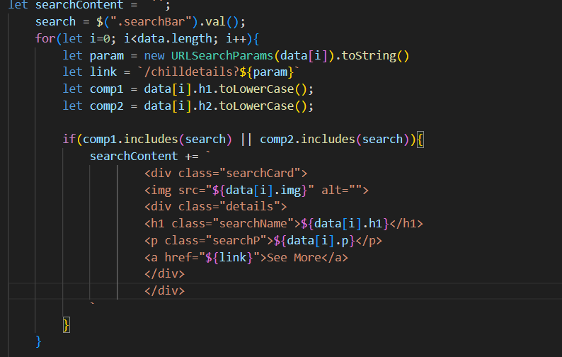

    - The Login/Signup Functionality:
The login functionality was implemented using vanilla JavaScript in order to validate user input in two forms, which are login form and signup form. It checks that the email in the login form is in the correct format and that the password in the signup form is at least 6 characters long. If any input is invalid, the form is prevented from being submitted, and an error message is displayed next to the input field. Event listeners, regular expressions to check the email format, and DOM manipulation to show error messages, are used.
The code below shows the login/signup is achieved.
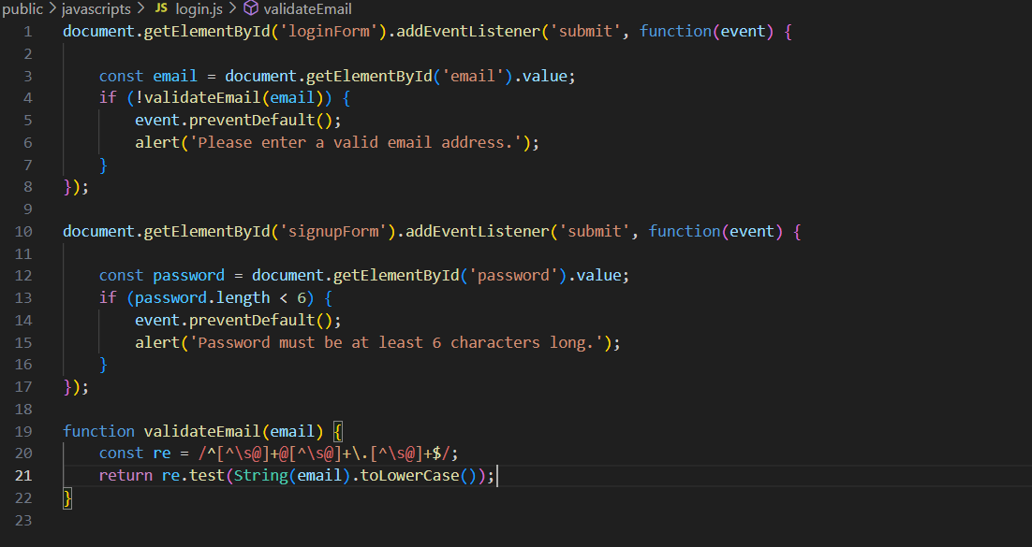

    - Review Functionality:
To enhance interactivity and ensure a smooth user experience, the platform uses JavaScript in combination with jQuery. This setup allows the application to respond to user actions such as clicks, form submissions, and searches dynamically. One of the key features is the use of AJAX (Asynchronous JavaScript and XML), which enables the application to communicate with the server and retrieve or send data without requiring a full page reload. This approach improves performance, reduces server load, and creates a more seamless user experience.
Below is a basic example of how AJAX is implemented using jQuery:
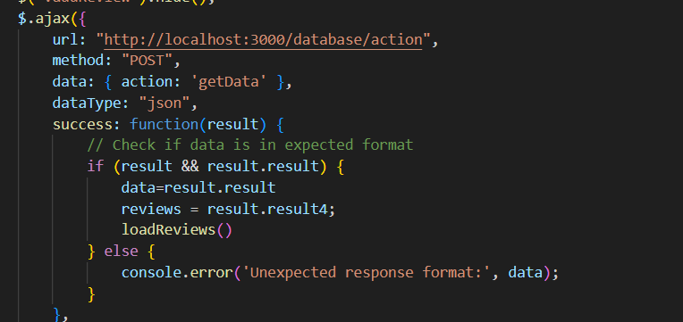
The platform provides a review system where users can view, submit, update, or delete their reviews for a specific location. Reviews are dynamically fetched from the server based on the selected location, allowing users to see feedback from others in real time. If a user has already submitted a review, the system gives them the option to update or delete it. This interactive functionality is powered by JavaScript and jQuery, with AJAX handling the communication between the client and server.
The following code snippet illustrates how this functionality is implemented:
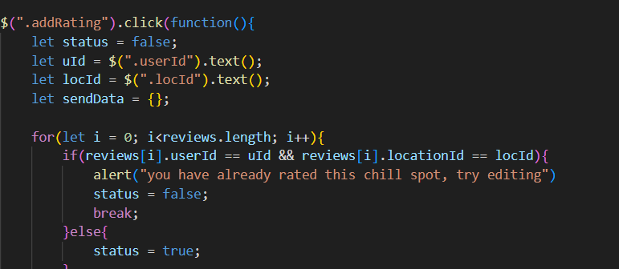
Font Awesome is used to display star ratings, while HTML and CSShandle the structure and styling of the page. This code allows users to add, edit, and delete reviews for a specific location on a webpage. The code below is used to make the POST request to fetch the server.
    - Dash Board Functionalities:
  - Setting Up the Server and Using CORS:
The API is built using Express.js to handle routing and HTTP request processing. To ensure that the front-end can communicate with the server even when hosted on a different domain or port (a common scenario during development and deployment), the API enables Cross-Origin Resource Sharing (CORS). CORS is a security feature implemented by web browsers to control how web applications interact with resources from different origins. By configuring CORS properly, the API allows safe cross-origin requests from the front-end application.
The following code snippet demonstrates how this setup is implemented in the Express.js server:

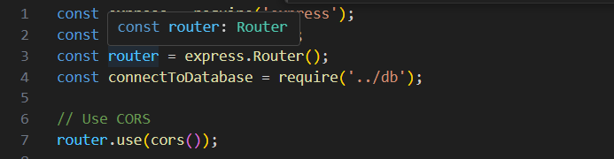

    - Handling POST Requests:
The router listens for POST requests at the /action endpoint. The action is determined by the request body, and the corresponding operation is performed. For instance, getData fetches multiple datasets from the database, while other actions handle specific data manipulation. This is implemented using the code in the code snippet below:
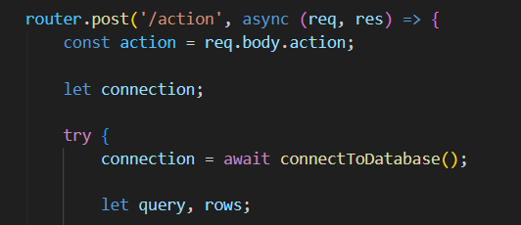

    - Fetching Data (Reading):
The getData action retrieves all data from the chillspots, attractions, news, and review tables and returns it in the response. This allows the front-end to load various types of data dynamically. The code below shows how that is achieved
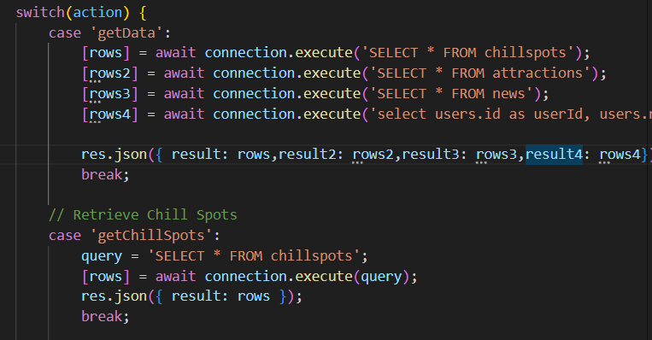

    - Adding Data (Creating):
The addReview action inserts a new review into the review table. It extracts the data from the request body, parses it, and then executes an INSERT query. The code below shows how that is achieved:
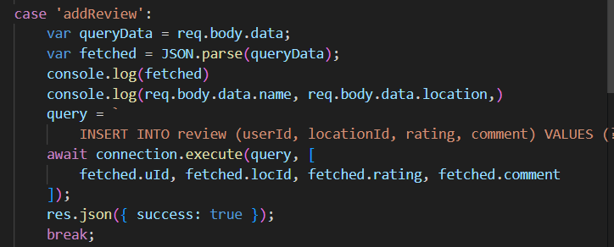

    - Updating Data:
The updateReview action updates an existing review based on the user and location IDs. It uses an UPDATE SQL query to modify the review’s rating and comment. The below shows how that is achieved:
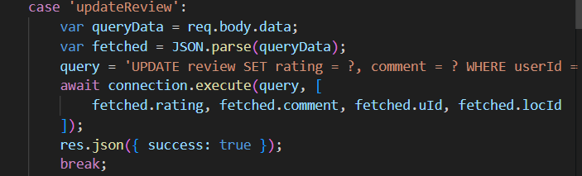

    - Deleting Data:
The delete Review action removes a review from the review table based on the userId and locationId. The API uses a DELETE query to remove the specific review. The code below how that is achieved:
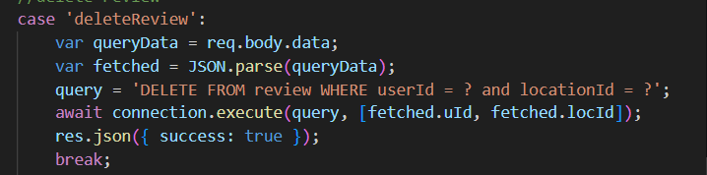

7.CONCLUSION AND RECOMMENDATIONS

7.1 Introduction

In this chapter, we evaluate the success of the "My Zambia" platform by reflecting on the extent to which its objectives were achieved. The assessment examines how effectively the project met its intended goals, discusses the key challenges encountered during development and implementation, and identifies areas for future enhancement. Additionally, we propose recommendations for improving the system and suggest alternative methodologies that could be considered in future iterations.7.2 Conclusion

7.2.1 Objectives

7.2.1.1 Main Objective
The main objective of this project was to design a web-based platform providing comprehensive information about Zambia's tourist attractions, facilitating better planning and exploration for both tourists and locals.

7.2.1.2 Secondary Objectives
The specific objectives were as follows:
- To systematically gather and categorize information on Zambian tourist attractions, landmarks, and events: This objective was met with a user-friendly database of tourist information.
- To design an interactive and intuitive interface: An interactive web interface was successfully created, although further refinement is possible for better mobile compatibility.
- To collaborate with local businesses and cultural organizations: This objective was partially achieved. While some partnerships were established, others faced logistical challenges.
- To integrate feedback from tourists and locals: User feedback was solicited, but further collection is recommended to fine-tune functionalities.
In summary, the majority of the objectives were successfully met, though future enhancements are needed to improve partnerships and mobile accessibility.

7.2.2 Strengths
The "My Zambia" platform has several strengths:
- Comprehensive Information: The platform provides easy access to organized, detailed tourist information, addressing the issue of scattered and incomplete data.
- User-Friendly Interface: The platform offers an intuitive interface for seamless navigation.
- Potential Economic Impact: By promoting less-known tourist spots, the platform encourages local economic development.
- Support for Local Businesses: Local businesses now have a platform to promote their products and services to a wider audience.

7.2.3 Weaknesses
Despite its strengths, the system has some limitations:
- Mobile Optimization: The current interface lacks mobile optimization, reducing usability on smartphones.
- Partnership Development: Difficulty establishing partnerships with key local stakeholders affect the extent of the platform’s collaboration efforts.
- Limited Offline Access: The system requires a consistent internet connection, which may limit access in remote areas.

7.3 Recommendations
To enhance the future development and adoption of the "My Zambia" platform, we recommend the following:
- Mobile Optimization: Prioritize optimizing the system for mobile devices to enhance accessibility.
- Offline Access: Develop features that allow limited offline access to basic tourist information for areas with poor internet connectivity.
- Partnership Expansion: Establish more partnerships with local businesses, tour operators, and cultural organizations to enhance the platform’s offerings.
- User Experience: Continue gathering user feedback and refine the interface based on the evolving needs of tourists and locals.
- Sustainability: Ensure the platform adheres to sustainable tourism practices by promoting eco-friendly activities and conservation efforts.

8.REFERENCES.
1.Explore by Zambia, https://www.zambia.travel/, accessed 8th March, 2024.
2.Zambia Tourism, https://www.zambiatourism.com, accessed 8th March, 2024.
3.Zambia Travel Guide, http://www.zambia-travel-guide.com/bradti_guide.asp?bradt=170, accessed 8th March, 2024.
4.Tripadvisor, https://www.tripadvisor.com/SmartDeals-g293842-Zambia-Hotel-Deals.html, accessed 8th March, 2024.
5.World Bank Open Data, https://data.worldbank.org/indicator/ST.INT.ARVL?locations=ZM, accessed 8th March, 2024.
6.Worlddata.info,https://www.worlddata.info/africa/zambia/tourism.php, accessed 8th March, 2024.
7.Rough guides, https://www.roughguides.com/, accessed 8th March, 2024. 8.Lonely Planet, https://www.lonelyplanet.com/, accessed 8th March, 2024.
9.Hosting Advice, https://www.hostingadvice.com/, accessed 8th March, 2024.
10.Ethical considerations in research, https://www.scribbr.com/methodology/research-ethics/, accessed 8th March, 2024.
11.Benefits of websites, https://aist.global/en/why-travel-agencies-need-a-website, accessed 8th March, 2024.
12.Olidov, E. &. (2023). The importance of the tourism industry for economic development.
13.Bacsia. (2017). Tourism and diversity.
14.al, T. e. (2023). Role of tourism and hospitality business in economic development.
15.People and Places, https://peopleandplacestravel.com, accessed 10th April 2024.
16.
17.Lonely Planet, https://www.lonelyplanet.com/, accessed 10th April,2024.
18.Zambia Travel, https://www.zambia.travel/, accessed 10th April,2024.
19. "A Guide for Toursist," [Online]. Available: https://www.zambiatourism.com/exploring-zambia-guide. [Accessed 20 May 2024].
20. "Understanding Visitor Preferences: A Study of Tourism in Zambia," [Online]. Available: https://www.zambiatourism.com/understanding-visitor-preferences. [Accessed 20 May 2024].
21. K. A. &. Y. Singh, Software Engineeringg (3rd ed.), New Age International Publishers, 2007.
22.I.Sommerville, Software Engneering, Boston: Pearson, 2016.
23. "ER Diagram (ERD) - Definition &amp; Overview | Lucidchart," [Online]. Available: Lucidchart, 2017. https://www.lucidchart.com/pages/er-diagrams. [Accessed 20 May 2024].
24. D. Pedriquez, "What is a Context Diagram (and How Can You Create One)? - Venngage," [Online]. Available: https://venngage.com/blog/context-diagram/#What%20Is%20A%20Context%20Diagram?. [Accessed 20 May 2024].

