Olsztyn 30.04.2025

Sprawozdanie 5

Schemat relacyjnej bazy danych w firmie świadczącej usługi IT

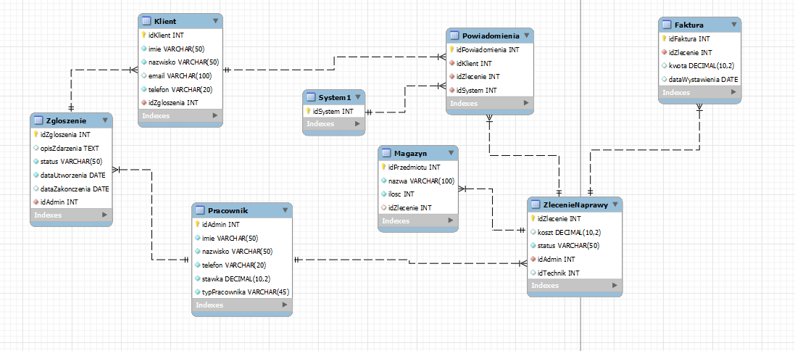

Kod:

-- Poprawiony skrypt MySQL  
 -- Model: Naprawa Systemu  
 -- Data: 2025-04-30

SET @OLD_UNIQUE_CHECKS=@@UNIQUE_CHECKS, UNIQUE_CHECKS=0;  
 SET @OLD_FOREIGN_KEY_CHECKS=@@FOREIGN_KEY_CHECKS, FOREIGN_KEY_CHECKS=0;  
 SET @OLD_SQL_MODE=@@SQL_MODE, SQL_MODE='ONLY_FULL_GROUP_BY,STRICT_TRANS_TABLES,NO_ZERO_IN_DATE,NO_ZERO_DATE,ERROR_FOR_DIVISION_BY_ZERO,NO_ENGINE_SUBSTITUTION';

-- -----------------------------------------------------  
 -- Schema mydb  
 -- -----------------------------------------------------  
 CREATE SCHEMA IF NOT EXISTS `mydb` DEFAULT CHARACTER SET utf8;  
 USE `mydb`;

-- -----------------------------------------------------  
 -- Table `Pracownik`  
 -- -----------------------------------------------------  
 CREATE TABLE IF NOT EXISTS `Pracownik` (  
 `idAdmin` INT NOT NULL AUTO_INCREMENT,  
 `imie` VARCHAR(50) NOT NULL,  
 `nazwisko` VARCHAR(50) NOT NULL,  
 `telefon` VARCHAR(20) NOT NULL,  
 `stawka` DECIMAL(10,2) NOT NULL,  
 `typPracownika` VARCHAR(45) NOT NULL,  
 PRIMARY KEY (`idAdmin`)  
 );

-- -----------------------------------------------------  
 -- Table `Zgloszenie`  
 -- -----------------------------------------------------  
 CREATE TABLE IF NOT EXISTS `Zgloszenie` (  
 `idZgloszenia` INT NOT NULL AUTO_INCREMENT,  
 `opisZdarzenia` TEXT DEFAULT NULL,  
 `status` VARCHAR(50) NOT NULL,  
 `dataUtworzenia` DATE NOT NULL,  
 `dataZakonczenia` DATE DEFAULT NULL,  
 `idAdmin` INT NOT NULL,  
 PRIMARY KEY (`idZgloszenia`),  
 FOREIGN KEY (`idAdmin`) REFERENCES `Pracownik` (`idAdmin`)  
 ON DELETE CASCADE ON UPDATE CASCADE  
 );

-- -----------------------------------------------------  
 -- Table `Klient`  
 -- -----------------------------------------------------  
 CREATE TABLE IF NOT EXISTS `Klient` (  
 `idKlient` INT NOT NULL AUTO_INCREMENT,  
 `imie` VARCHAR(50) NOT NULL,  
 `nazwisko` VARCHAR(50) NOT NULL,  
 `email` VARCHAR(100) DEFAULT NULL,  
 `telefon` VARCHAR(20) NOT NULL,  
 `idZgloszenia` INT NOT NULL,  
 PRIMARY KEY (`idKlient`),  
 FOREIGN KEY (`idZgloszenia`) REFERENCES `Zgloszenie` (`idZgloszenia`)  
 ON DELETE CASCADE ON UPDATE CASCADE  
 );

-- -----------------------------------------------------  
 -- Table `ZlecenieNaprawy`  
 -- -----------------------------------------------------  
 CREATE TABLE IF NOT EXISTS `ZlecenieNaprawy` (  
 `idZlecenie` INT NOT NULL AUTO_INCREMENT,  
 `koszt` DECIMAL(10,2) DEFAULT NULL,  
 `status` VARCHAR(50) NOT NULL,  
 `idAdmin` INT NOT NULL,  
 `idTechnik` INT DEFAULT NULL,  
 PRIMARY KEY (`idZlecenie`),  
 FOREIGN KEY (`idAdmin`) REFERENCES `Pracownik` (`idAdmin`)  
 ON DELETE CASCADE ON UPDATE CASCADE  
 );

-- -----------------------------------------------------  
 -- Table `Faktura`  
 -- -----------------------------------------------------  
 CREATE TABLE IF NOT EXISTS `Faktura` (  
 `idFaktura` INT NOT NULL AUTO_INCREMENT,  
 `idZlecenie` INT NOT NULL,  
 `kwota` DECIMAL(10,2) DEFAULT NULL,  
 `dataWystawienia` DATE DEFAULT NULL,  
 PRIMARY KEY (`idFaktura`),  
 FOREIGN KEY (`idZlecenie`) REFERENCES `ZlecenieNaprawy` (`idZlecenie`)  
 ON DELETE CASCADE ON UPDATE CASCADE  
 );

-- -----------------------------------------------------  
 -- Table `System1`  
 -- -----------------------------------------------------  
 CREATE TABLE IF NOT EXISTS `System1` (  
 `idSystem` INT NOT NULL AUTO_INCREMENT,  
 PRIMARY KEY (`idSystem`)  
 );

-- -----------------------------------------------------  
 -- Table `Powiadomienia`  
 -- -----------------------------------------------------  
 CREATE TABLE IF NOT EXISTS `Powiadomienia` (  
 `idPowiadomienia` INT NOT NULL AUTO_INCREMENT,  
 `idKlient` INT NOT NULL,  
 `idZlecenie` INT NOT NULL,  
 `idSystem` INT NOT NULL,  
 PRIMARY KEY (`idPowiadomienia`),  
 FOREIGN KEY (`idKlient`) REFERENCES `Klient` (`idKlient`)  
 ON DELETE CASCADE ON UPDATE CASCADE,  
 FOREIGN KEY (`idZlecenie`) REFERENCES `ZlecenieNaprawy` (`idZlecenie`)  
 ON DELETE CASCADE ON UPDATE CASCADE,  
 FOREIGN KEY (`idSystem`) REFERENCES `System1` (`idSystem`)  
 ON DELETE CASCADE ON UPDATE CASCADE  
 );

-- -----------------------------------------------------  
 -- Table `Magazyn`  
 -- -----------------------------------------------------  
 CREATE TABLE IF NOT EXISTS `Magazyn` (  
 `idPrzedmiotu` INT NOT NULL AUTO_INCREMENT,  
 `nazwa` VARCHAR(100) NOT NULL,  
 `ilosc` INT NOT NULL,  
 `idZlecenie` INT DEFAULT NULL,  
 PRIMARY KEY (`idPrzedmiotu`),  
 FOREIGN KEY (`idZlecenie`) REFERENCES `ZlecenieNaprawy` (`idZlecenie`)  
 ON DELETE SET NULL ON UPDATE CASCADE  
 );

-- Przywracanie oryginalnych ustawień  
 SET SQL_MODE=@OLD_SQL_MODE;  
 SET FOREIGN_KEY_CHECKS=@OLD_FOREIGN_KEY_CHECKS;  
 SET UNIQUE_CHECKS=@OLD_UNIQUE_CHECKS;