Assignment

Name of Subject: | AJT (01CE0308) | Name of Faculty: | Prof. Sweta Khatana,  Prof. Kunal Khimani, Prof. Reshma Sunil
Date on Notice Board: | 24th July, 2026 | Branch: | Computer Engineering.
Date of Submission: | 20th Nov, 2026 | Semester: | 3
Name of Topic: | Design and Development of an Enterprise Web Application using Java Technologies (JDBC, Servlets, JSP, Hibernate and Spring Framework).

Work | Deadline | Marks | CO Mapping
Definition of Project (Problem statement and Functional requirements) | 31/07/2026 | 5 | CO1, CO2, CO3, CO4, CO5
Database Design & JDBC/Hibernate Implementation  • Database creation  • JDBC Connectivity/ ORM using Hibernate  • CRUD Operations  • Exception Handling | 30/08/2026 | 15 | CO3, CO4
Implementation of AJT Technologies(Servlet, Jsp , Spring, Swing)  • User Interface  • Form Validation  • Session Management  • JSTL & EL Usage  - Spring Dependency Injection / Hibernate ORM etc. | 31/10/2026 | 15 | CO1, CO2,CO4,CO5
Final Submission & Deployment  - Fully functional application  - Source code (ZIP)  - GitHub repository with README  - Deployed application link | 20/11/2026 | 5 | CO1, CO2, CO3, CO4, CO5
Total Marks for CSE Project |  | 40

Detailed Rubrics for Marking

Work | Rubrics
Definition of Project | Project definition submitted before deadline - 5 marks Delay in submission - 3 Marks
Database Design & JDBC/Hibernate Implementation | Well-designed database with 3+ related tables, successful JDBC/Hibernate connectivity, complete CRUD operations and proper exception handling – 15 marks  Minor implementation issues – 12 Marks  Basic database with partial CRUD – 8 Marks  Submitted after deadline – 6 Marks
Implementation of AJT Technologies(Servlet, Jsp , Spring, Swing) | Proper implementation and integration of Servlets, JSP/JSTL, Session Management and Hibernate/Spring with layered architecture – 15 Marks  Three technologies implemented correctly with minor issues – 12 Marks  Basic implementation of two technologies – 8 Marks  Only one technology implemented/poor integration – 6 Marks
Final Submission & Deployment | Complete project submitted before deadline - 5 marks Delay in submission - 3 Marks

NOTE:
- Document with screenshots of the project must be submitted in google classroom. Rename PDF document with enrollmentno_name.
- Each task must be submitted on or before the given deadline.

AJT PROJECT – DATABASE DESIGN & IMPLEMENTATION
ATTENDANCE MANAGEMENT SYSTEM

Database Design Overview

The Attendance Management System is designed as a relational database for managing students, teachers, subjects, course enrollments and daily attendance records. The structure is intentionally detailed enough to demonstrate database relationships, CRUD operations, JDBC/Hibernate integration and exception handling, while remaining practical for a student-level Java web application.

Proposed Database Structure

Table | Purpose | Main Key / Relationship
system_user | Stores login information and user roles for system access. | user_id (PK); role = ADMIN / TEACHER
student | Stores student details and enrollment numbers. | student_id (PK); enrollment_no (UNIQUE)
teacher | Stores teacher information. | teacher_id (PK); user_id (FK)
subject | Stores subjects handled by teachers. | subject_id (PK); teacher_id (FK)
enrollment | Connects students with subjects. | enrollment_id (PK); student_id + subject_id (FK)
attendance | Stores daily attendance for each enrollment. | attendance_id (PK); enrollment_id (FK)

The enrollment table is used because one student can study multiple subjects and one subject can contain multiple students. Attendance is then recorded against a specific enrollment, which keeps the database normalized and avoids duplicating student and subject information.

- Database Creation

Create the MySQL database that will contain all tables required by the Attendance Management System.

Code

CREATE DATABASE attendance_management_system;
USE attendance_management_system;

Screenshot

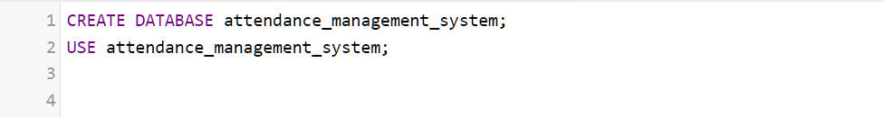

Display Database Tables

Display all tables in the selected database to verify that the database structure has been created.

Code

SHOW TABLES;

Screenshot

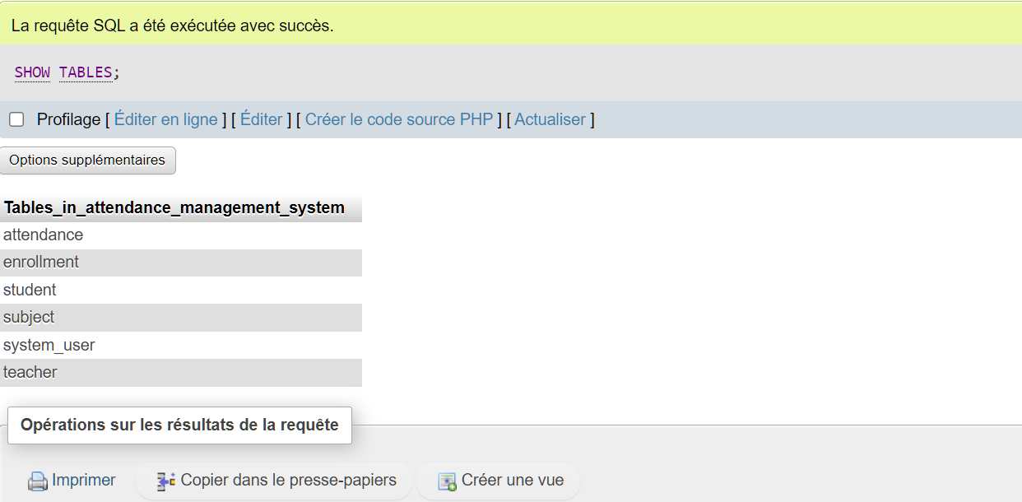

- System User Table Creation

Create the system_user table to support authentication and role-based access. This table can later be connected to the JSP/Servlet login module.

Code

CREATE TABLE system_user (
user_id INT PRIMARY KEY AUTO_INCREMENT,
username VARCHAR(50) NOT NULL UNIQUE,
password VARCHAR(255) NOT NULL,
role ENUM('ADMIN', 'TEACHER') NOT NULL
);

Screenshot

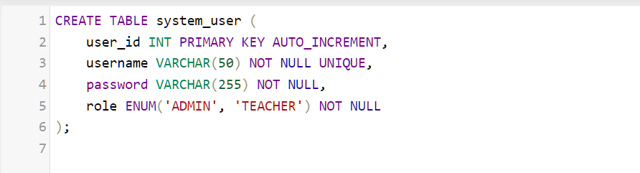

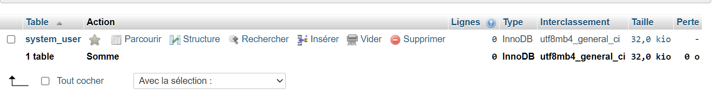

Verify System User Table Structure

Display the System User table structure and verify its columns and primary key.

Code

DESCRIBE system_user;

Screenshot

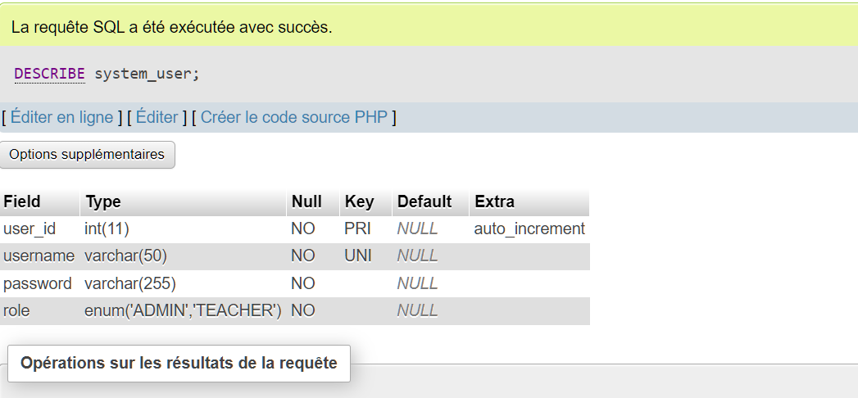

- Student Table Creation

Create the student table to store student information. The enrollment number is unique and can be displayed to the teacher when taking attendance.

Code

CREATE TABLE student (
student_id INT PRIMARY KEY AUTO_INCREMENT,
enrollment_no VARCHAR(20) NOT NULL UNIQUE,
student_name VARCHAR(100) NOT NULL,
email VARCHAR(100) UNIQUE,
semester INT NOT NULL
);

Screenshot

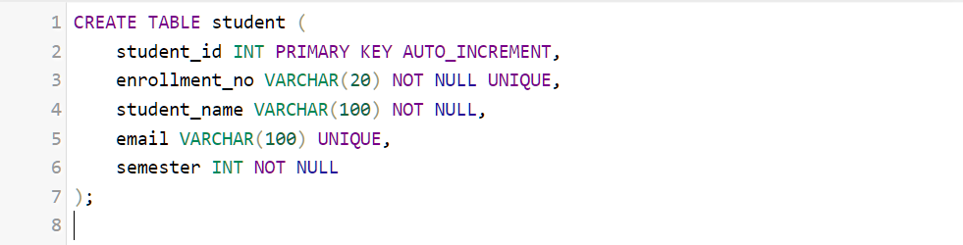

Verify Student Table Structure

Display the Student table structure and verify its columns and primary key.

Code

DESCRIBE student;

Screenshot

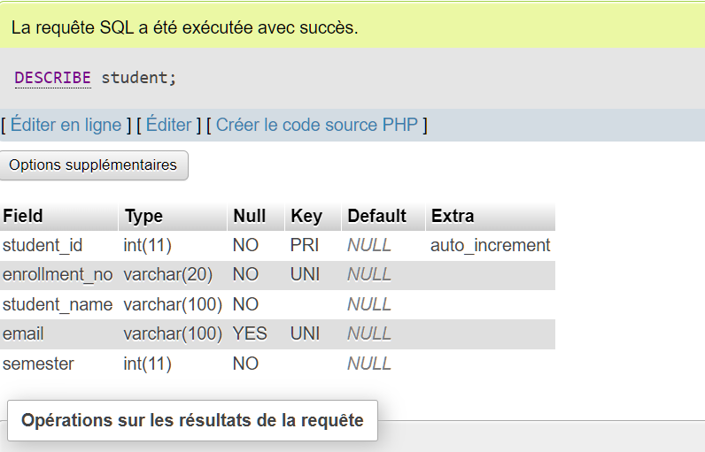

- Teacher Table Creation

Create the teacher table to store teacher information and connect a teacher with a system login account.

Code

CREATE TABLE teacher (
teacher_id INT PRIMARY KEY AUTO_INCREMENT,
user_id INT NOT NULL UNIQUE,
teacher_name VARCHAR(100) NOT NULL,
email VARCHAR(100) UNIQUE,
FOREIGN KEY (user_id) REFERENCES system_user(user_id)
);

Screenshot

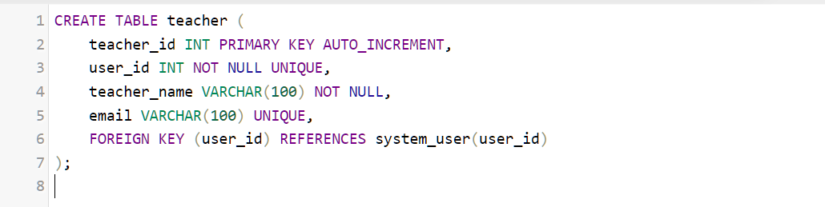

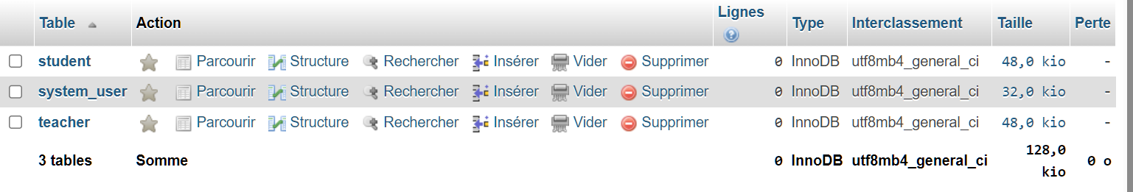

Verify Teacher Table Structure

Display the Teacher table structure and verify its columns and primary key.

Code

DESCRIBE teacher;

Screenshot

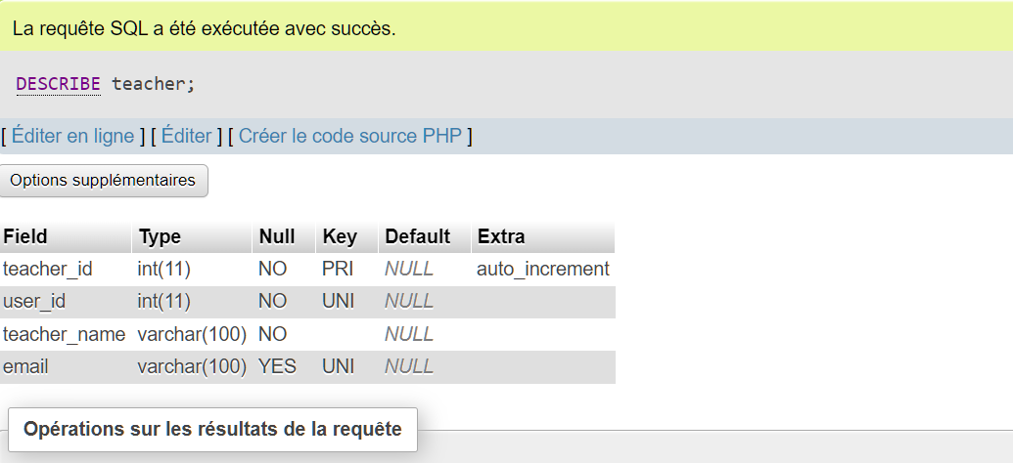

- Subject Table Creation

Create the subject table to store subjects and identify the teacher responsible for each subject.

Code

CREATE TABLE subject (
subject_id INT PRIMARY KEY AUTO_INCREMENT,
subject_code VARCHAR(20) NOT NULL UNIQUE,
subject_name VARCHAR(100) NOT NULL,
teacher_id INT NOT NULL,
FOREIGN KEY (teacher_id) REFERENCES teacher(teacher_id)
);

Screenshot

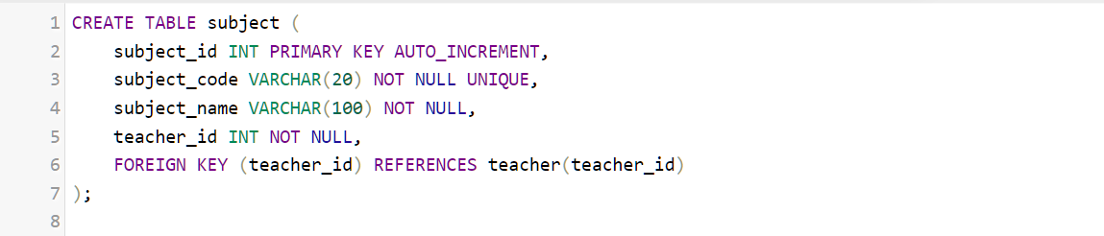

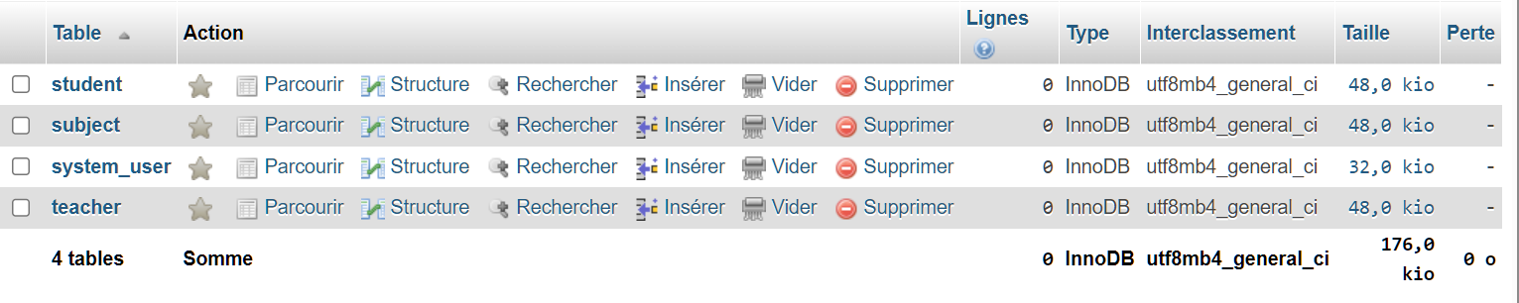

Verify Subject Table Structure
Display the Subject table structure and verify its columns and foreign key.
Code
DESCRIBE subject;
Screenshot
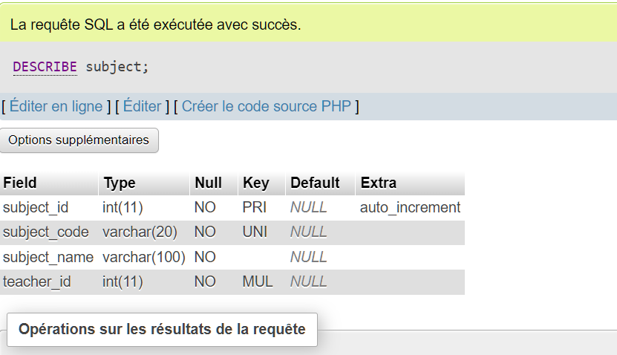
- Enrollment Table Creation

Create the enrollment table to establish the many-to-many relationship between students and subjects. A student can be enrolled in several subjects.

Code

CREATE TABLE enrollment (
enrollment_id INT PRIMARY KEY AUTO_INCREMENT,
student_id INT NOT NULL,
subject_id INT NOT NULL,
enrollment_date DATE NOT NULL,
status ENUM('ACTIVE', 'INACTIVE') DEFAULT 'ACTIVE',
UNIQUE (student_id, subject_id),
FOREIGN KEY (student_id) REFERENCES student(student_id),
FOREIGN KEY (subject_id) REFERENCES subject(subject_id)
);

Screenshot

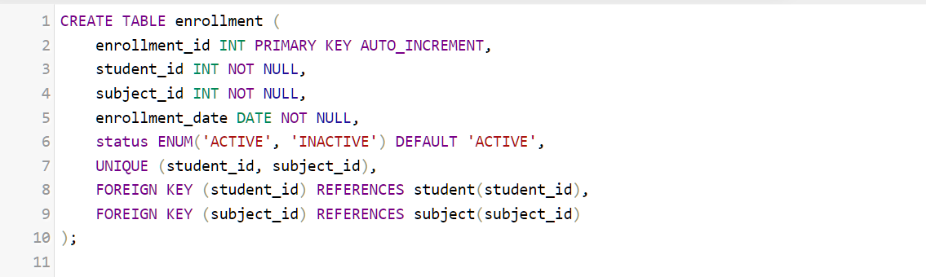

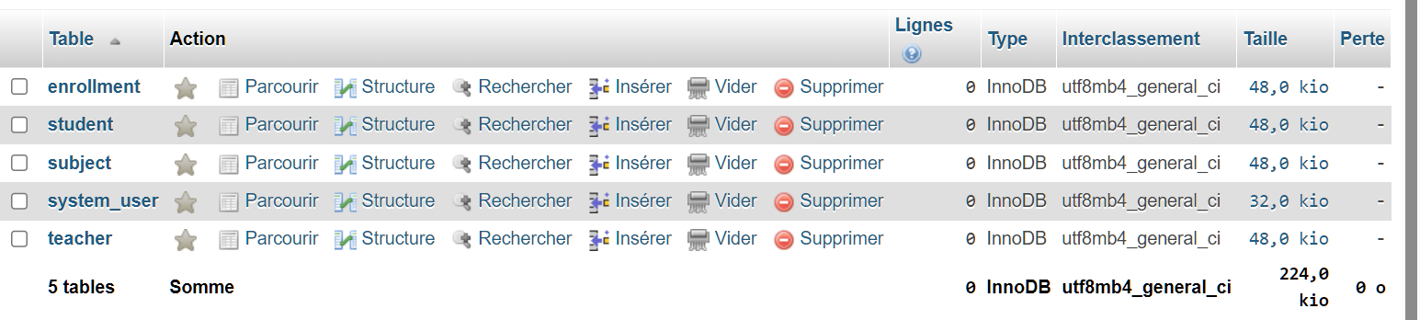

Verify Enrollment Table Structure
Display the Enrollment table structure and verify its columns and constraints.
Code
DESCRIBE enrollment;
Screenshot
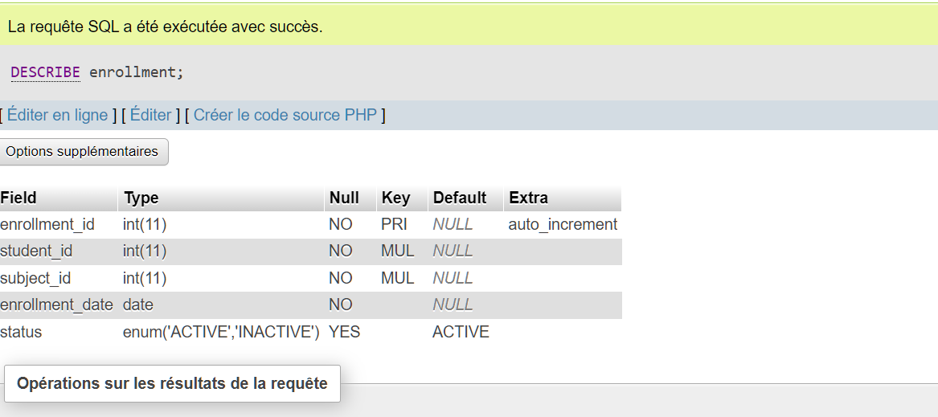

- Attendance Table Creation

Create the attendance table to record the attendance status for each enrolled student on a particular date.

Code
CREATE TABLE attendance (
attendance_id INT PRIMARY KEY AUTO_INCREMENT,
enrollment_id INT NOT NULL,
attendance_date DATE NOT NULL,
status ENUM('PRESENT', 'ABSENT') NOT NULL,
marked_by INT NOT NULL,
FOREIGN KEY (enrollment_id) REFERENCES enrollment(enrollment_id),
FOREIGN KEY (marked_by) REFERENCES teacher(teacher_id),
UNIQUE (enrollment_id, attendance_date)
);

Screenshot

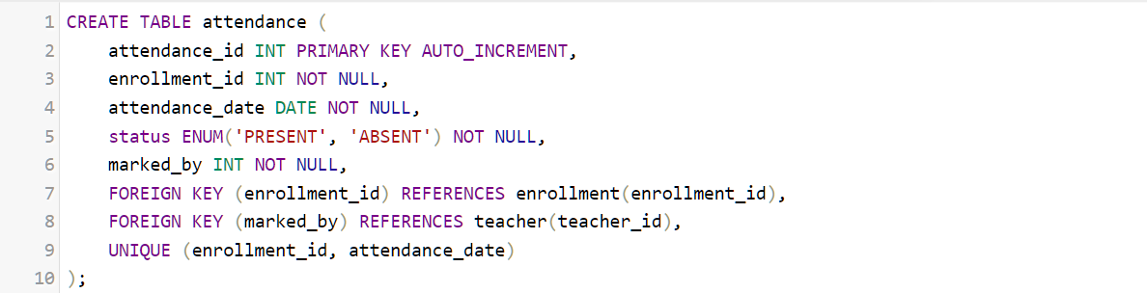

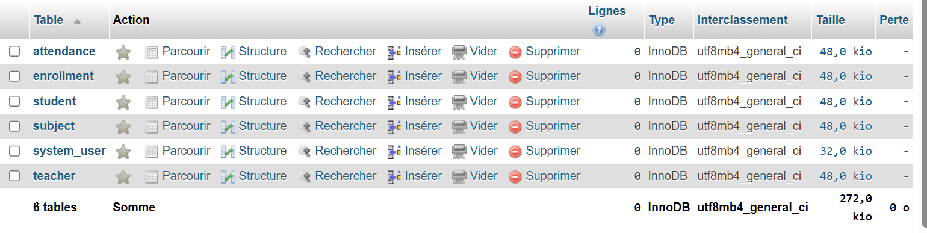

Verify Attendance Table Structure
Display the Attendance table structure and verify its columns and constraints.
Code
DESCRIBE attendance;
Screenshot
