**SE-4458 MIDTERM PROJECT DOCUMENT**

*Ege Demir – 20070006024*

**Project Link :** https://github.com/konege/Airline-Company

**Design Overview :** This Midterm project is a web API developed using .NET, designed to manage airline operations. The API interfaces with a database and adheres to a layered architecture, separating data access, business logic, and entity layers for clarity and maintainability.

**Assumptions**: In the ticket purchasing section, the request model includes fields for date, departure, destination, and passenger's full name. To accurately identify specific flights that might share the same date, departure, and destination, a flight number field has been added. This extra field is crucial for correctly assigning passengers to their intended flights.

**Entity Relationship (ER) Diagram :**

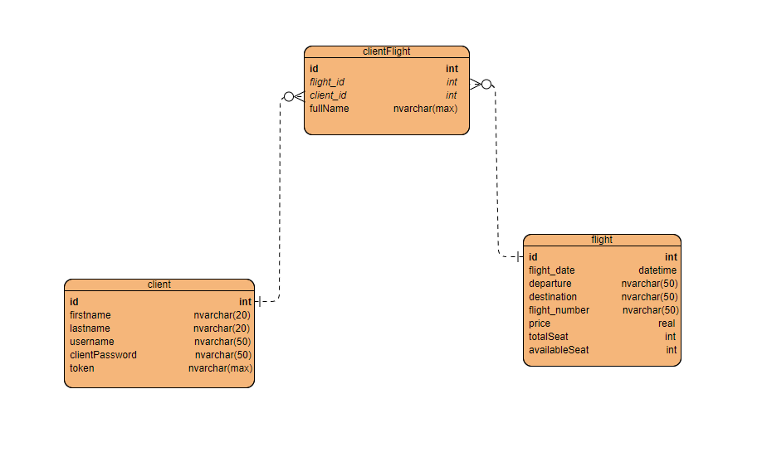

-**Bold** writings are primary key and *italic* writings foreign keys.

**Encountered Issues :** I encountered problems while deploying and no matter what I did, I could not solve the problem. It became more and more complicated.

**Video link :  
  
https://drive.google.com/file/d/1DcUwD9J5EqjBcEZ53EB4aSD28vh36-1f/view?usp=drive_link** **https://drive.google.com/file/d/1ufqWvLIeSH2UjeKO2CtE9vvPg4gIq5Sy/view?usp=drive_link**