SE-4458 Midterm Report

Ege Demir- 20070006024

**Project Link:**

<https://github.com/konege/House-Booking-Company>

**About My Design:**

This project is a web API developed using .NET, designed to manage booking operations. The API interfaces with a database and adheres to a layered architecture, separating data access, business logic, and entity layers for clarity and maintainability.

**Assumptions:**

In the house booking section, the request model includes fields for date, fromDate, toDate, and client's full name. Added house number field to accurately identify specific houses that may share the same features. This extra space is crucial for proper assignment of customer intended homes.

**Entity Relationship Diagram:**

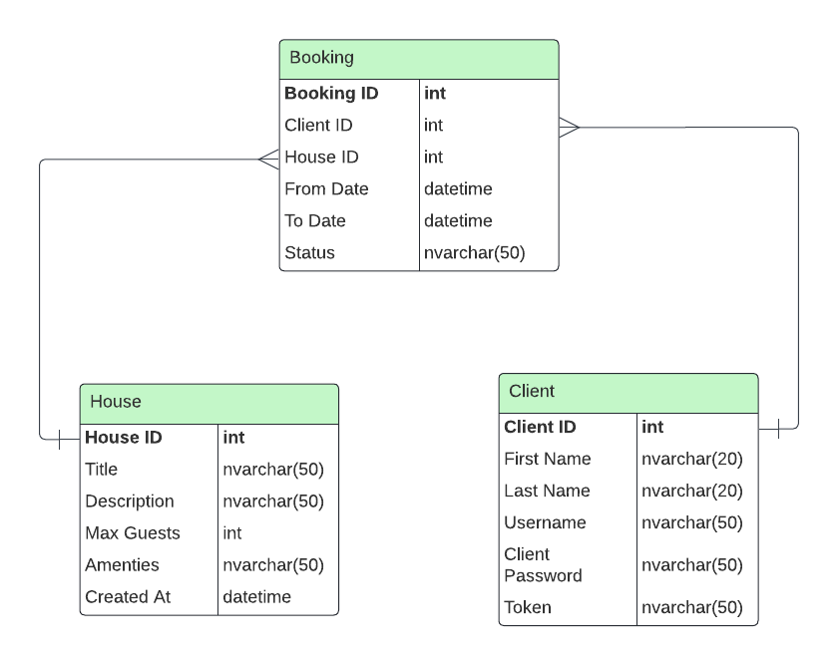

**Presentation Video:**

https://drive.google.com/file/d/13Pc8u4vMi4_Y_FXiJ5r6YOHrUbtY1GaN/view