Technical University Varna

Course work
Software and Internet Technologies
Variant 1

Topic: mini office program
which a simple console graphical interface

Created:
student SIT, Faculty number #23221001, Viacheslav Chubenko, SIT
Teacher:
prof D-r engineer Milena Nikolova Karova

Data for protect course works:

Marks:

Varna 2024

Referat?
target of course work is from paper, teacher gave for us on 14th of November
------------------------------------------------------------------------------------------------------------------------
Variant 1 FN 023221001
Write a program with functions to:
a) Add to an array and file data for students of a group (up to 30): name, faculty number, GPA, age, and gender. Display the current contents of the array (file) on the screen.
b) Overwriting the data for men and women in two separate arrays, determining the corresponding average age (for men and women), and displaying the contents of the arrays and the results on the screen.
c) Determining the youngest female student and arranging the student data in ascending order by age. Display the results on the screen.
Main function main() - with a menu for selecting functions and checking for data status. Using functions with parameter passing.
------------------------------------------------------------------------------------------------------------------------
We will create a program who works on office, the program had a console text graphical interface

I use Visual Studio Microsoft 2012, visual studio 11.0, c++19.
Also I add a commentaries for my program

Analisys
It is my first course work, maybe I can create some of misstakes.

I include 4 libraries, iostream because it is basics library which we use a lot of time, string for working with type of sctring, fstream for working with files, open, change, close.
No included iomanip, because no need fixing digits after comma
Using namespace std; people use basically, no need to write std::cout, std::endl.

What I don’t add it is settings, settings.cfg, which could be included here
in settings I wanted add a pointer, 0 – false, 1 – true, config for remember my choise and read that config every launch.
For example, do you want to ask you about changing your file every launch of programm?
1 – yes, every launch, 0 – no, never ask
protect my file: rewriting – true or false, and recreating.
Developer mode, which showing and include some developers functions
clear data functions
set a minimum and maximum faculty number
set a minimum and maximum average balls
set a minimum and maximum age
skip some input data on input mode
unchanged place on the input data

couldn’t change is constant size of arrays, it is impossible, because size of arrays must be a constant value, I cant write before or after a size of arrays.

I add something not from paper is randomly fill all of data, name of students, FN, avg balls, etc.
writing error if you write, for example you write a letter on the faculty number – you go out with an error 1 in the both cases.

I really don’t want to use string arrays

void gui(){
cout << "1. input data" << endl;
cout << "2. output data" << endl;
cout << "3. owerwriting the data for man and woman" << endl;
cout << "4. female youngest and sorting" << endl;
cout /*<< "5. "*/ << endl;
cout /*<< "6. "*/ << endl;
cout /*<< "7. "*/ << endl;
cout /*<< "8. settings"*/ << endl;
cout << "9. debug(random data)" << endl;
cout << "0. exit" << endl;
}
create a console graphical text interface looks like

1. Input data
Input data must be because it is from my task
So, just read and write: student of name, faculty number, average balls, age, gender
in the first we have this interface
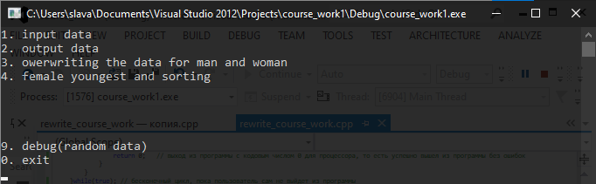
write “1” for go to the first function

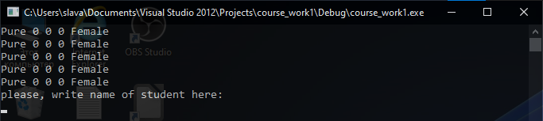
here, you must read and write what is ask
if we write a name and press enter, then name will be visible on the screen
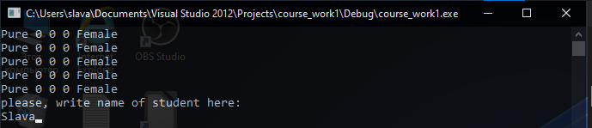
enter
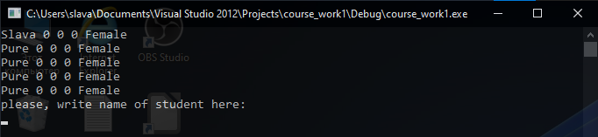
write from keyboard a data
below will be indicate, what you must to write? As you can see, right now I must to write a faculty number

balls
age
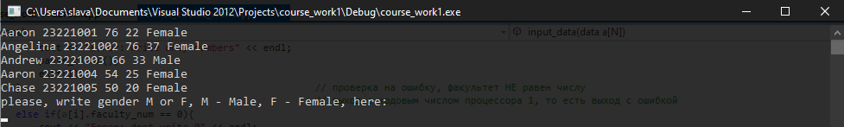
and gender, only F, f or M, m, which means F – Female, M – Male.

1.1 Errors. In type of string, nothing for errors, you can write zero and any types of symbols, because srting contains any symbols, look likes a bug
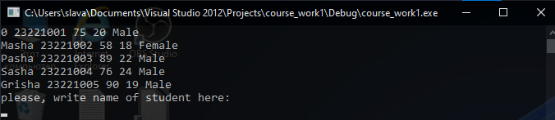
but if you write on the faculty number, average balls, age – 0, you will get an error message and go out, and also if type which not contains int faculty number, double average balls, int age.
On the gender, if you don’t write: M, m, F, f, you will get an error and go out.
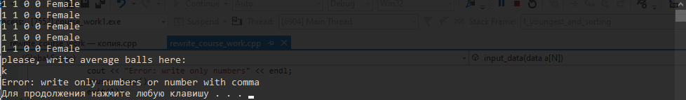
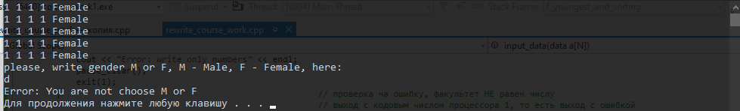
2. Output
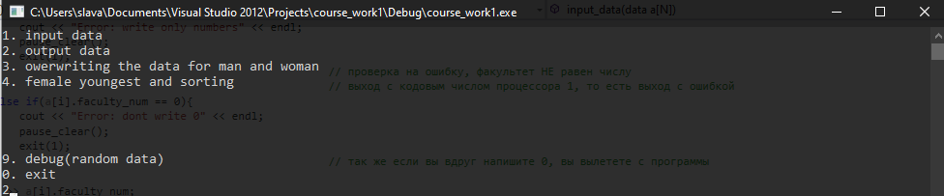
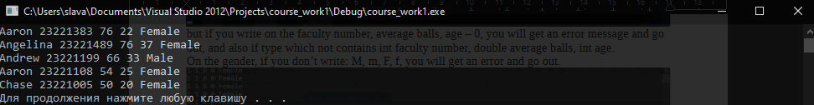
just show for us output information
if you don’t write anything on input of data, you will get something like
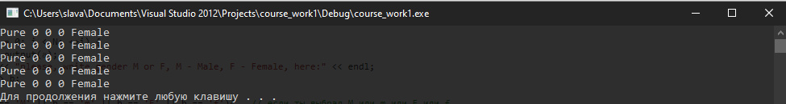
3. overwriting the data for man and woman
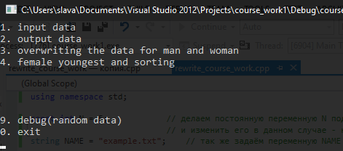
which contains
