Configuration Management with Ansible - Prerequisites

Prepare your Windows environment with the necessary tools and configuration to run an Ansible control node via WSL2 and a managed node on VirtualBox. This involves installing VirtualBox, creating Ubuntu VMs, enabling SSH connectivity, and installing Ansible.

Tools/Software Versions:

1. Operating System & Virtualization:

- Windows 11/10 (64-bit) with WSL2 enabled
- Oracle VM VirtualBox 7.1.10

2. Linux Distribution: Ubuntu 24.04 LTS ISO

3. Ansible: Version 2.16.3 (installed via apt in WSL2)

4. OpenSSH & Python (on Ubuntu VMs):

- OpenSSH Server/Client 3.0.13
- Python 3.12.3

Installation Steps:

Step 1: Set Up WSL2 Control Node:

1. Install Ubuntu-24.04:

wsl --install -d Ubuntu-24.04

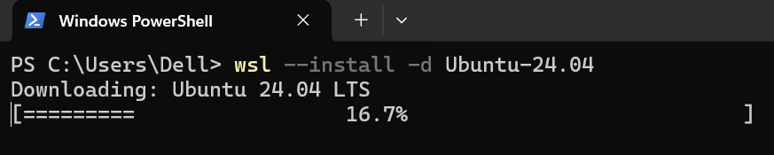

2. Create a User Account and Set up a Password:

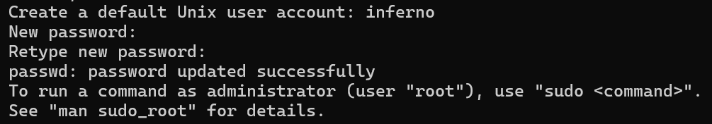

3. Launch Ubuntu:

wsl -d Ubuntu-24.04

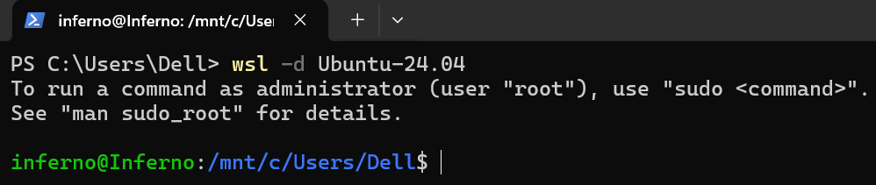

Note: Use quit to log out of Ubuntu.

4. Update and Upgrade:

sudo apt update && sudo apt upgrade -y

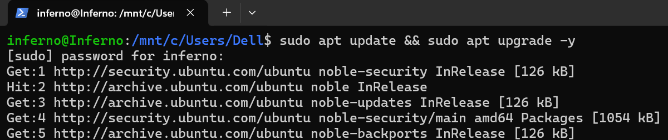

5. Install Ansible and SSH Client:

sudo apt install -y ansible openssh-client

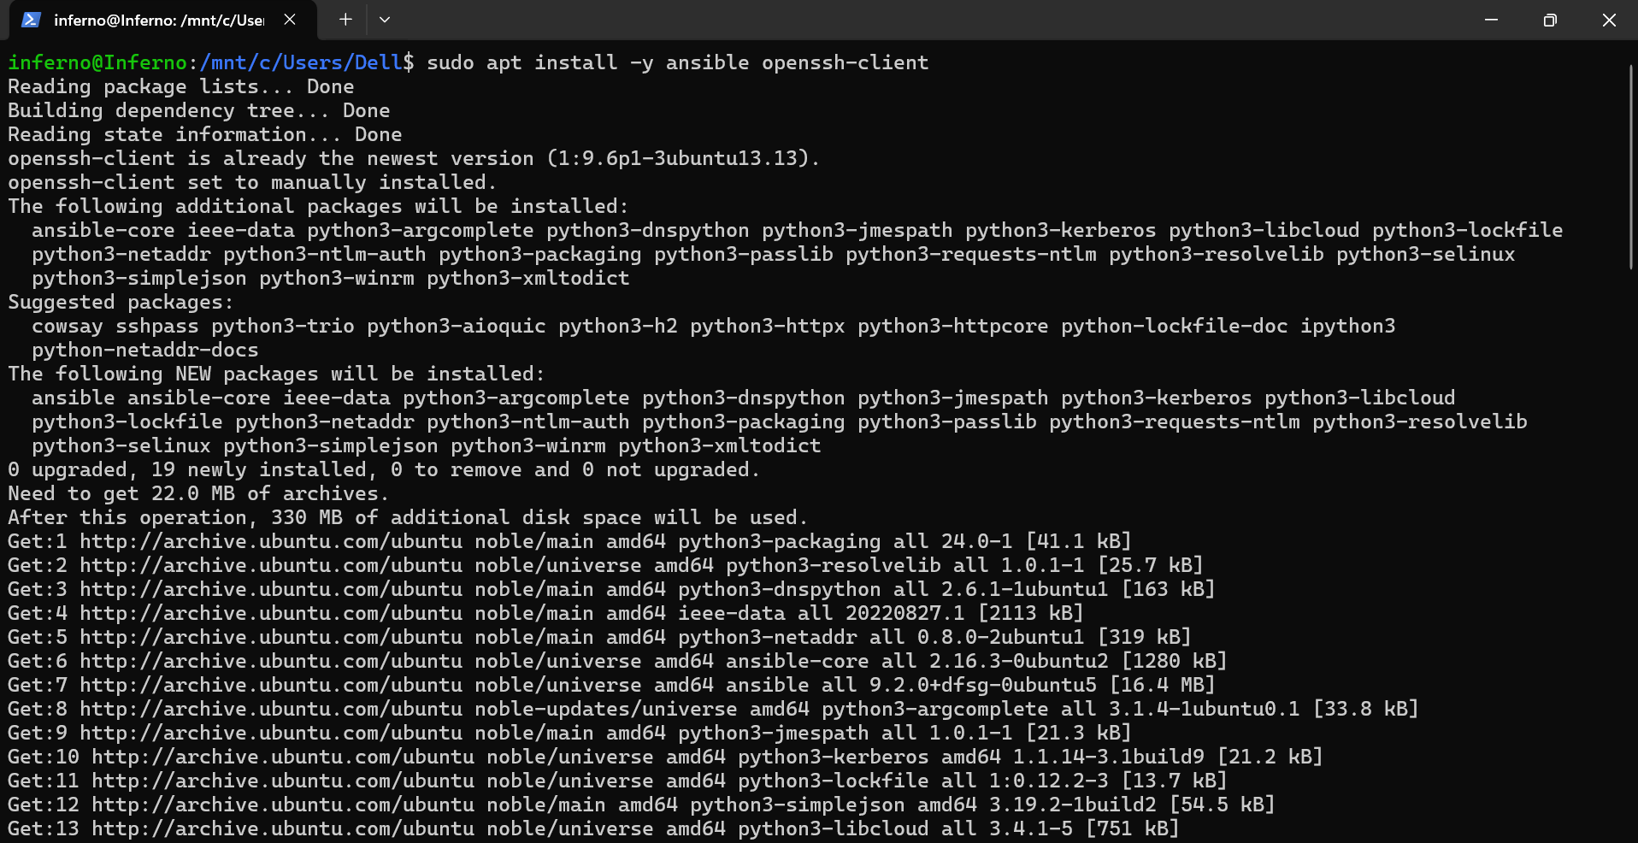

6. Verify Ansible and SSH Client installation:

ansible –version

ssh -V

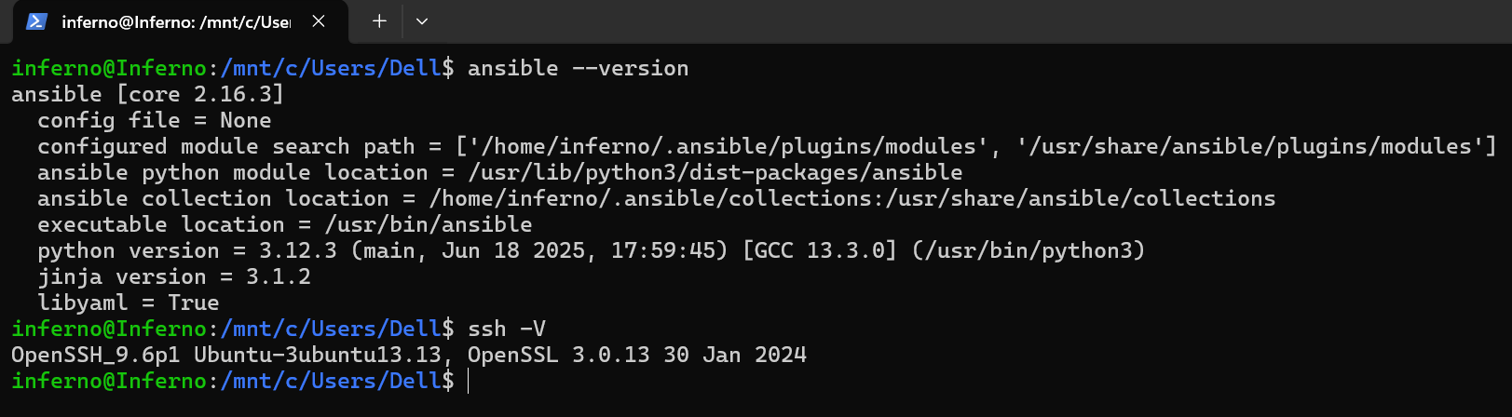

Step 2: Install VirtualBox on Windows

1. Download the VirtualBox Windows Installer:

Download the Windows installer from https://www.virtualbox.org.

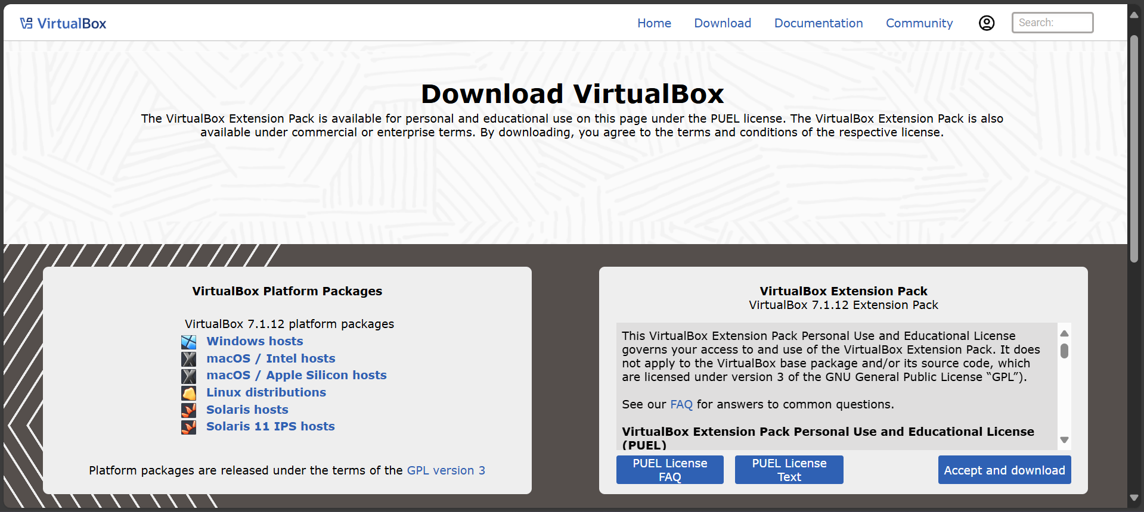

2. Run the VirtualBox Installer:

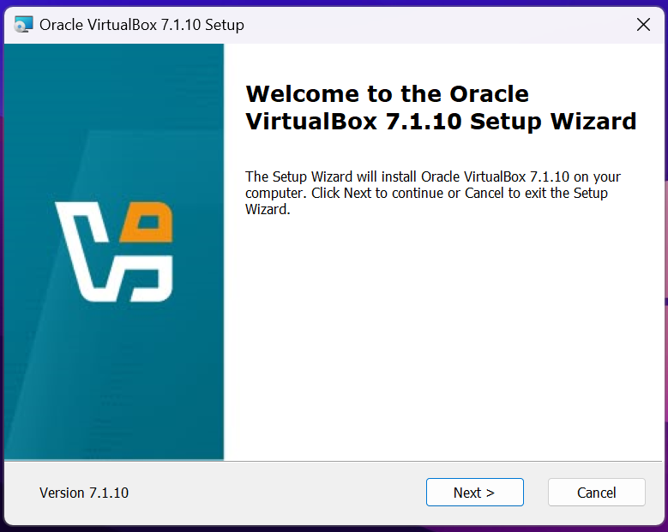

3. Accept the End-User Licence Agreement:

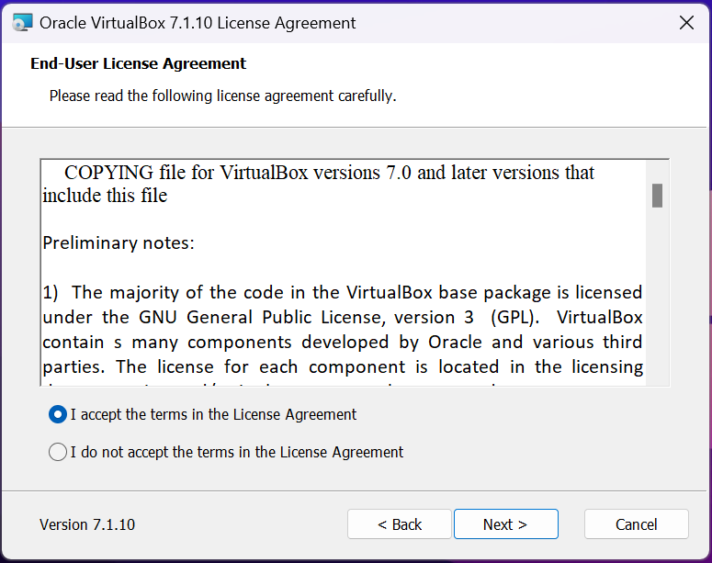

4. Select the VirtualBox Installation Location:

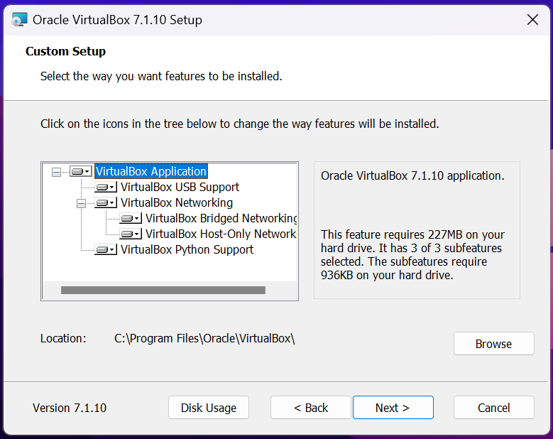

5. Accept the Network Interface Changes:

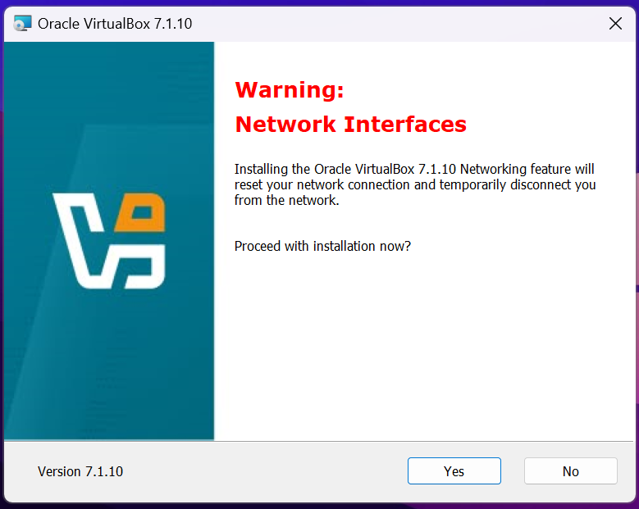

6. Install the Missing Dependencies:

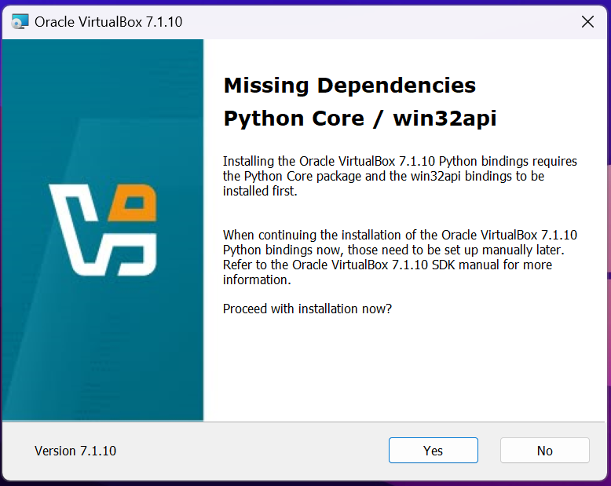

7. Set up VirtualBox Shortcuts:

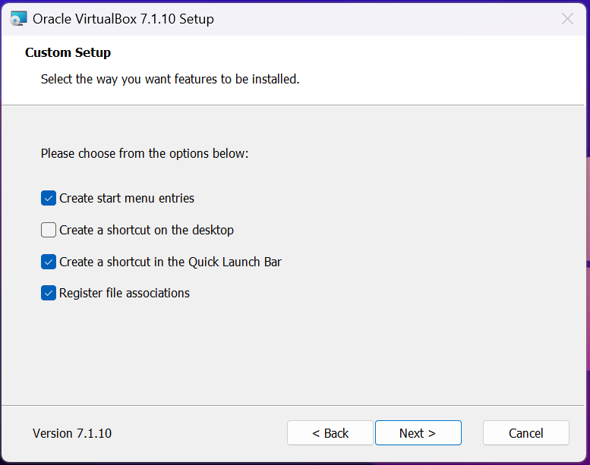

8. Begin the Installation:

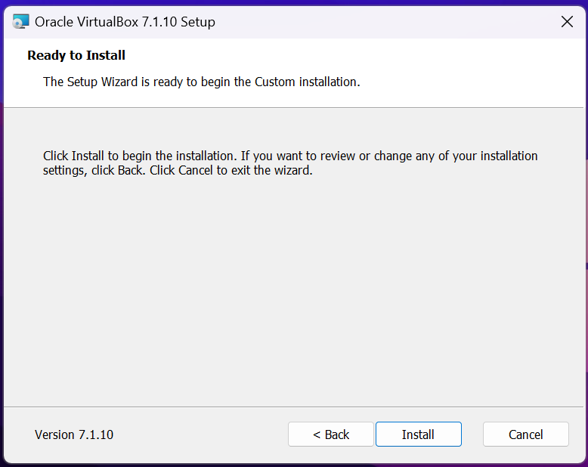

9. Finish the Installation:

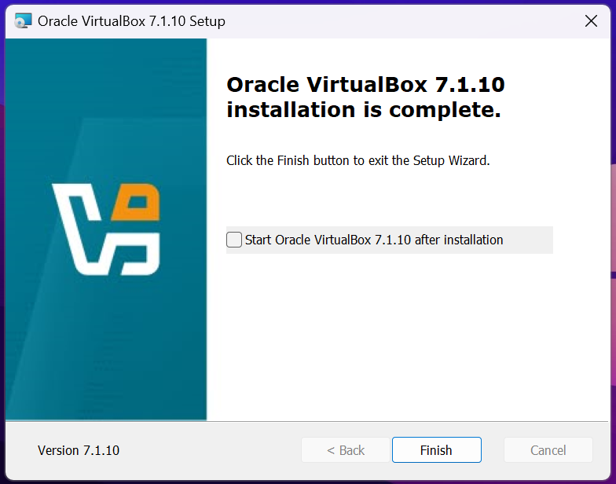

10. Launch VirtualBox:

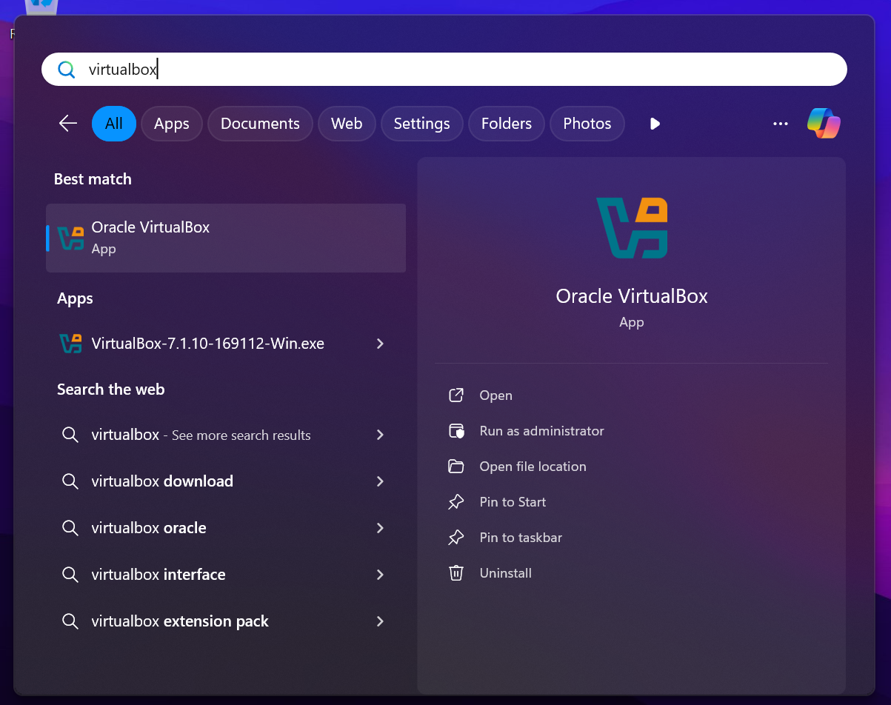

Step 3: Create the Managed Node VM

1. Set up a New VM:

Click New → Name: ansible-target → Type: Linux → Version: Ubuntu (64-bit).

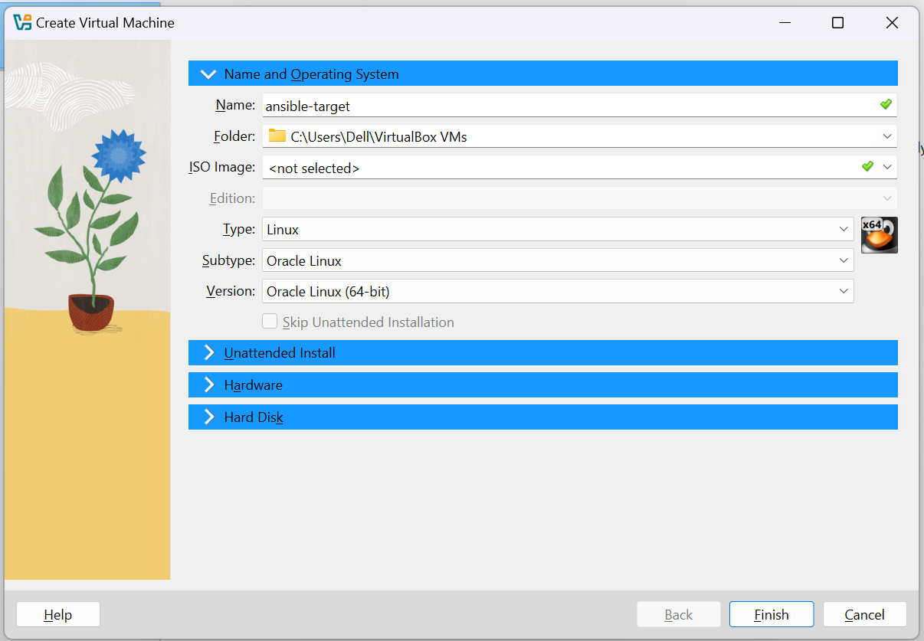

Allocate 1 GB RAM in the Hardware section.

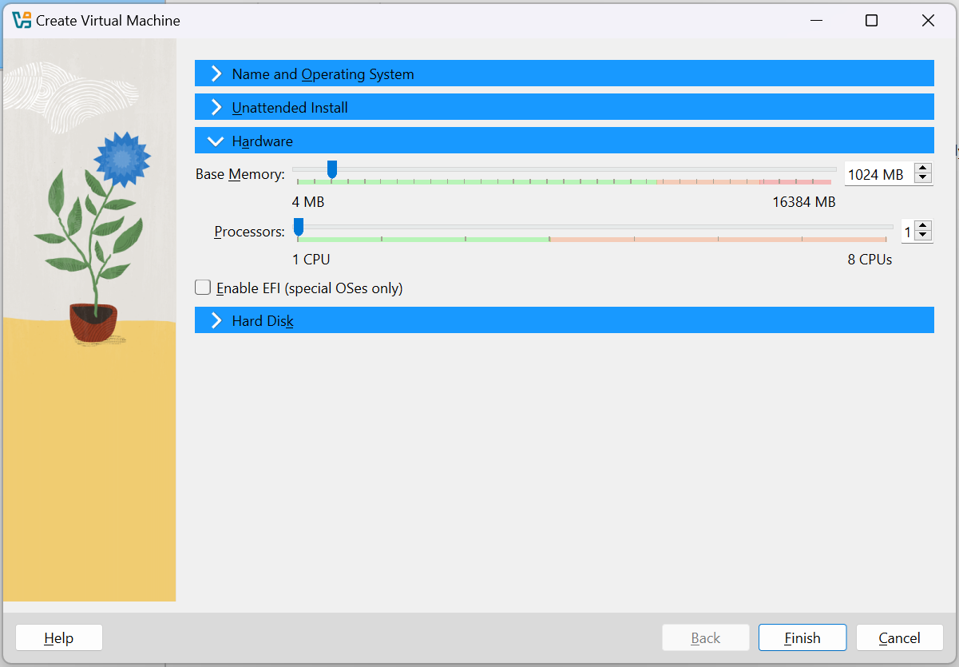

Create a 10 GB dynamically-allocated disk in the Hard Disk section.

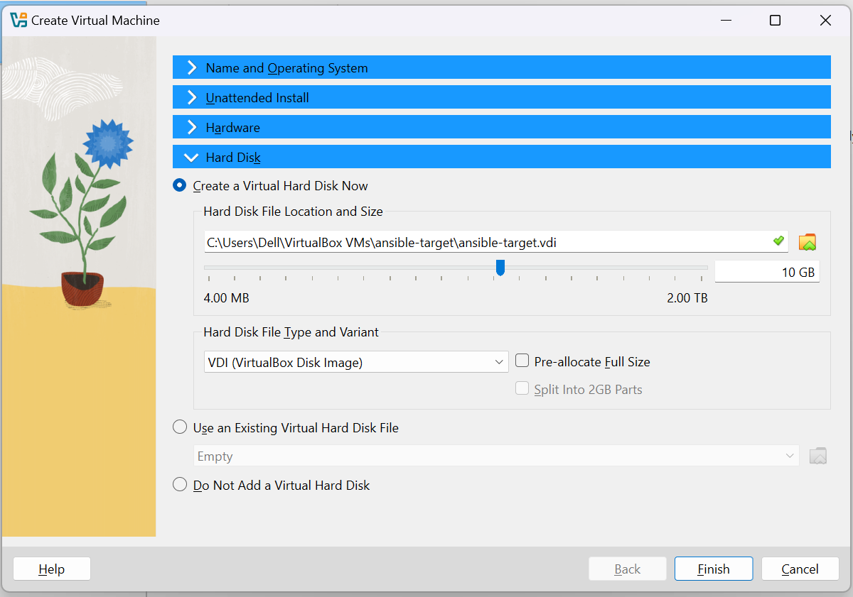

Click Finish to create the VM.

2. Download Ubuntu 24.04 LTS ISO:

Go to https://ubuntu.com/download/desktop and download the latest Ubuntu 24.04.2 LTS ISO file.

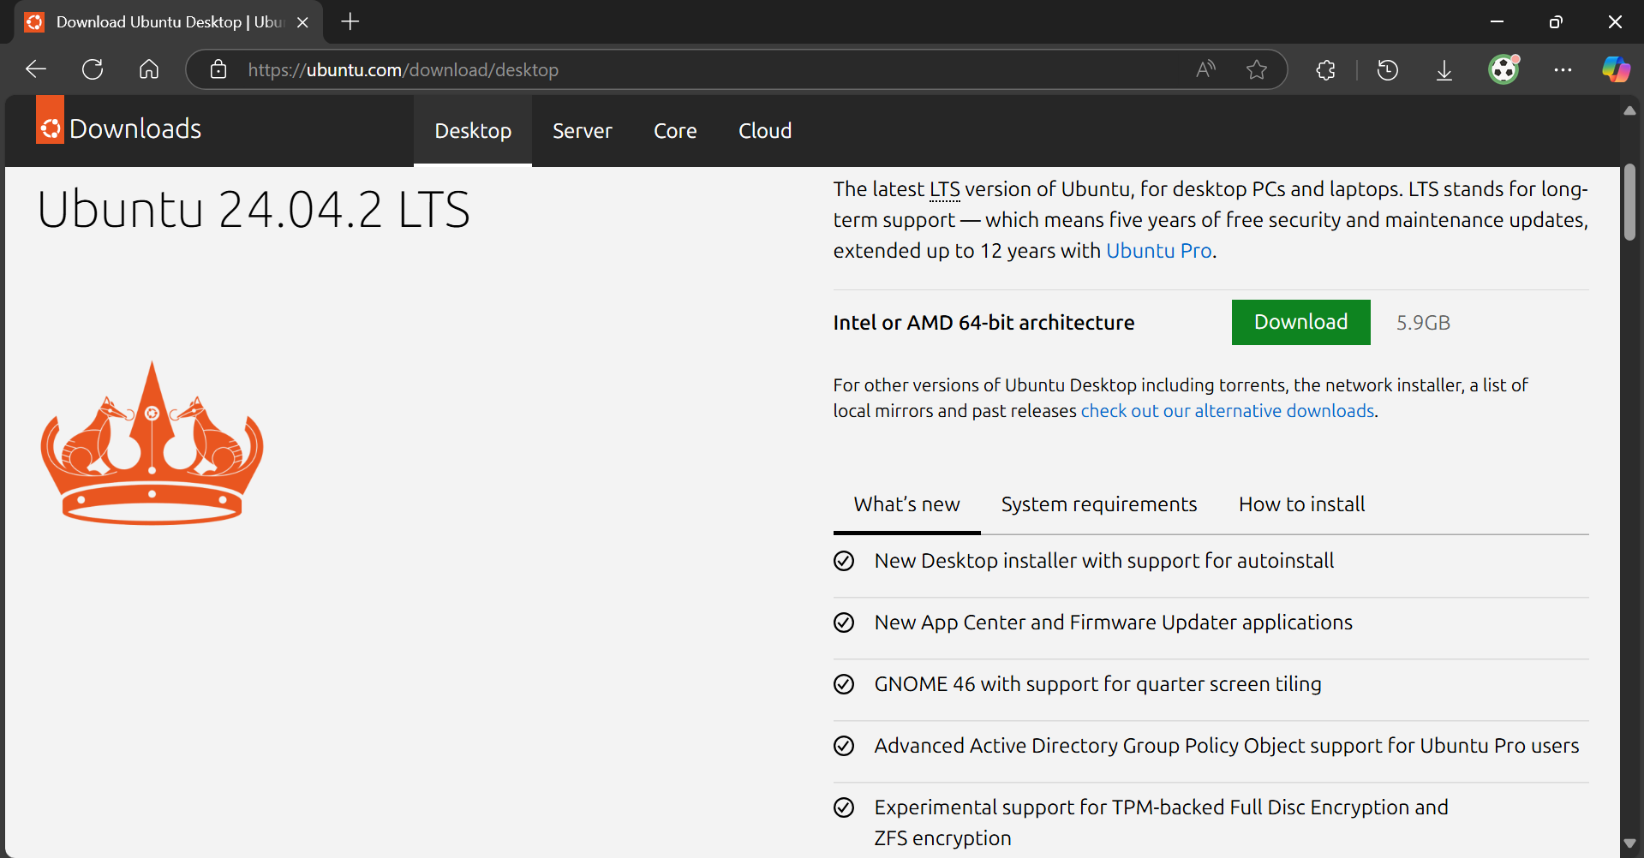

3. Start the VM and mount the Ubuntu 24.04.2 ISO:

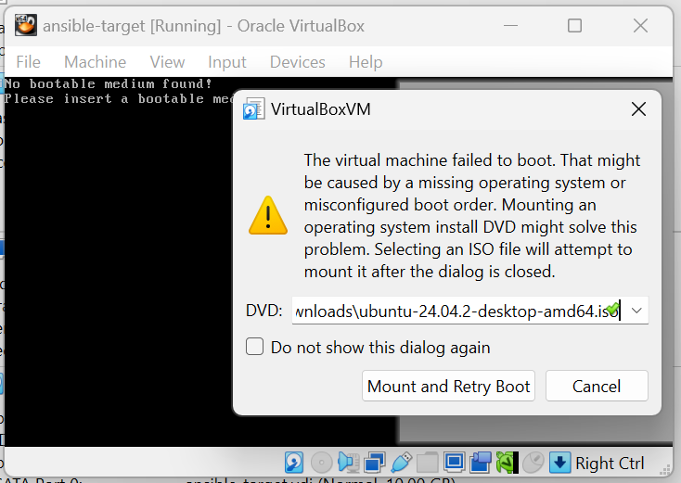

4. Install Ubuntu on the VM:

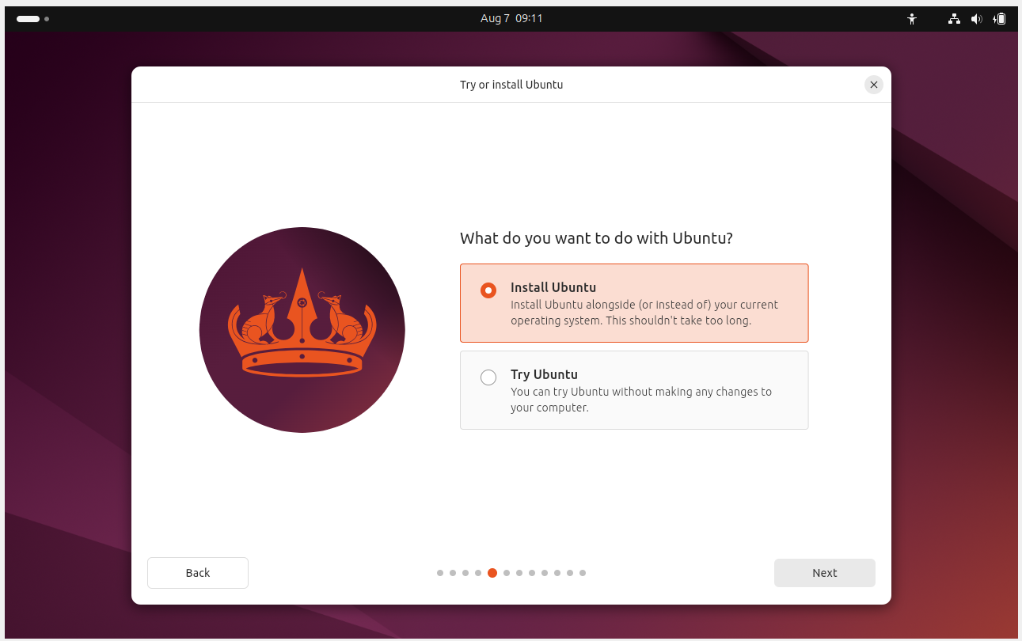

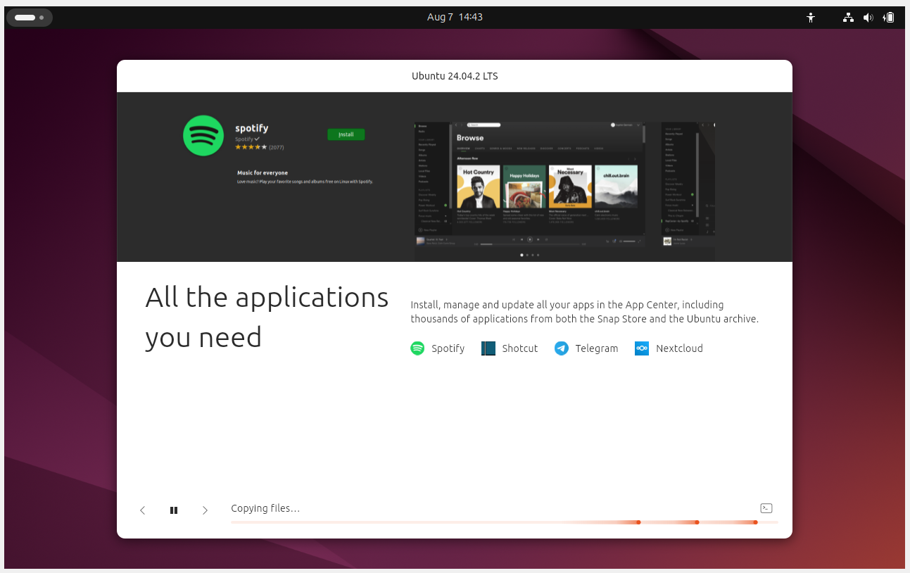

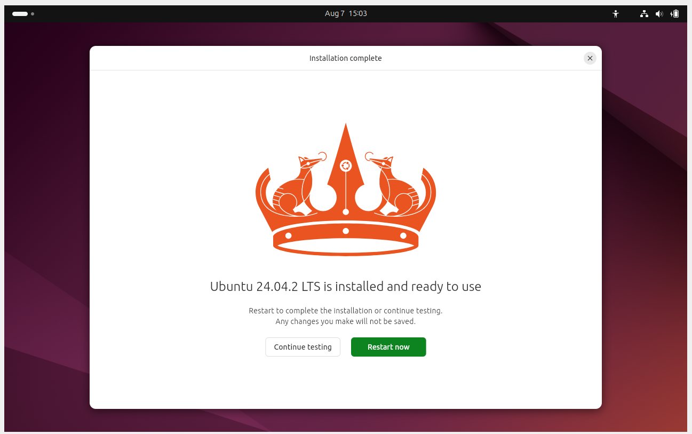

Step 4: Configure Network for VM Connectivity

1. Change the Network Adapter Settings:

- Go to Settings → Network → Adapter 1 → Attached to: Bridged Adapter.
- Select your NIC (Network Interface Card)
- Promiscuous Mode: Deny (default) and Cable Connected: ✓

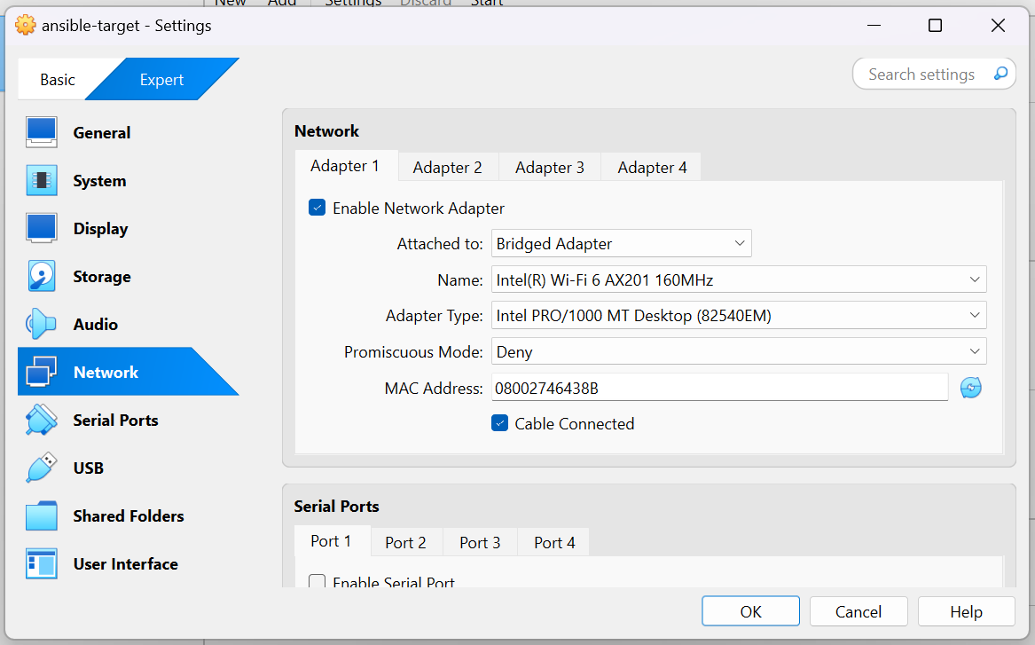

2. Boot the VM and Open the Terminal:

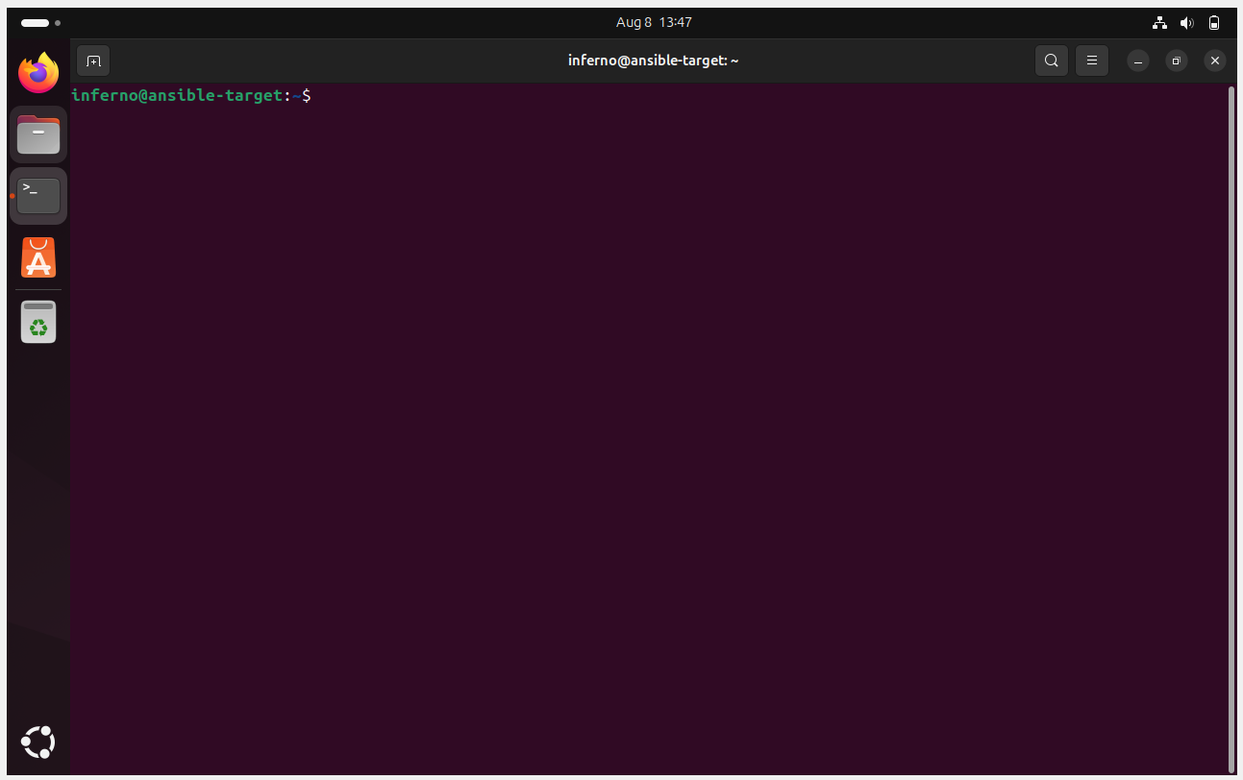

3. Check the Managed Node IP:

ip addr show

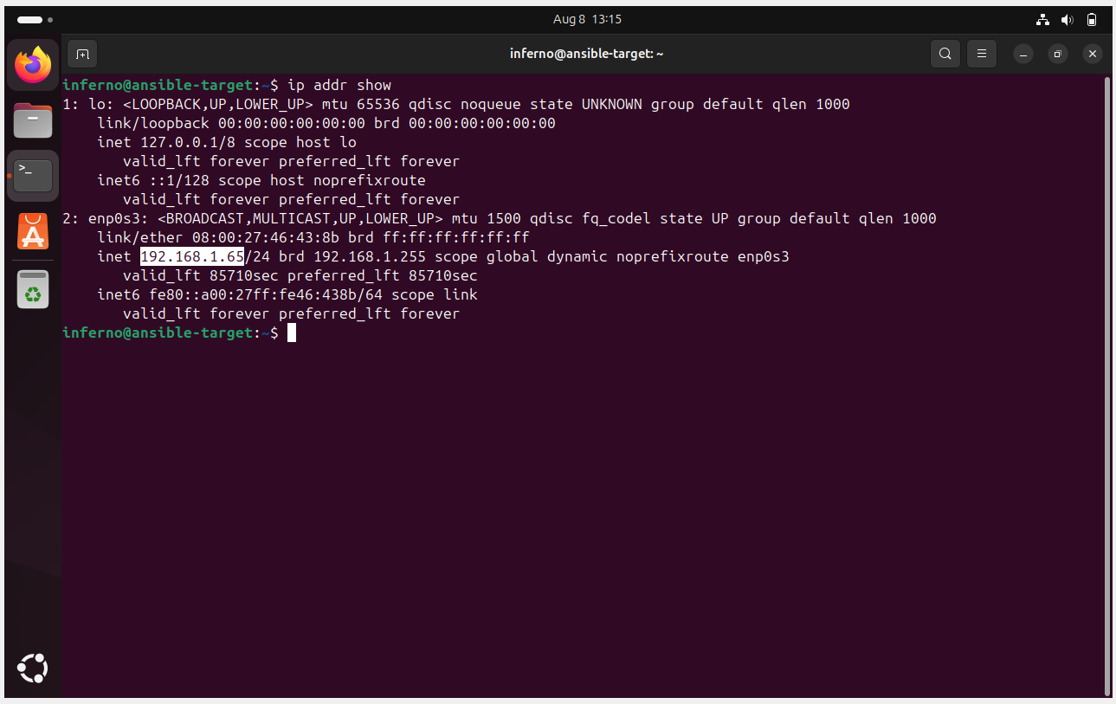

4. Try Pinging the Managed Node through WSL2:

ping 192.168.1.65

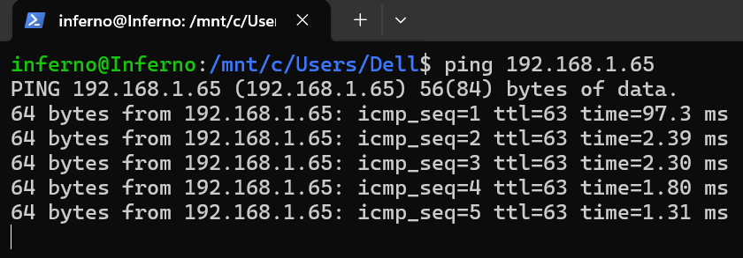

Step 5: Set Up SSH Key-Based Authentication

1. Install SSH on the Managed Node:

sudo apt install -y openssh-server

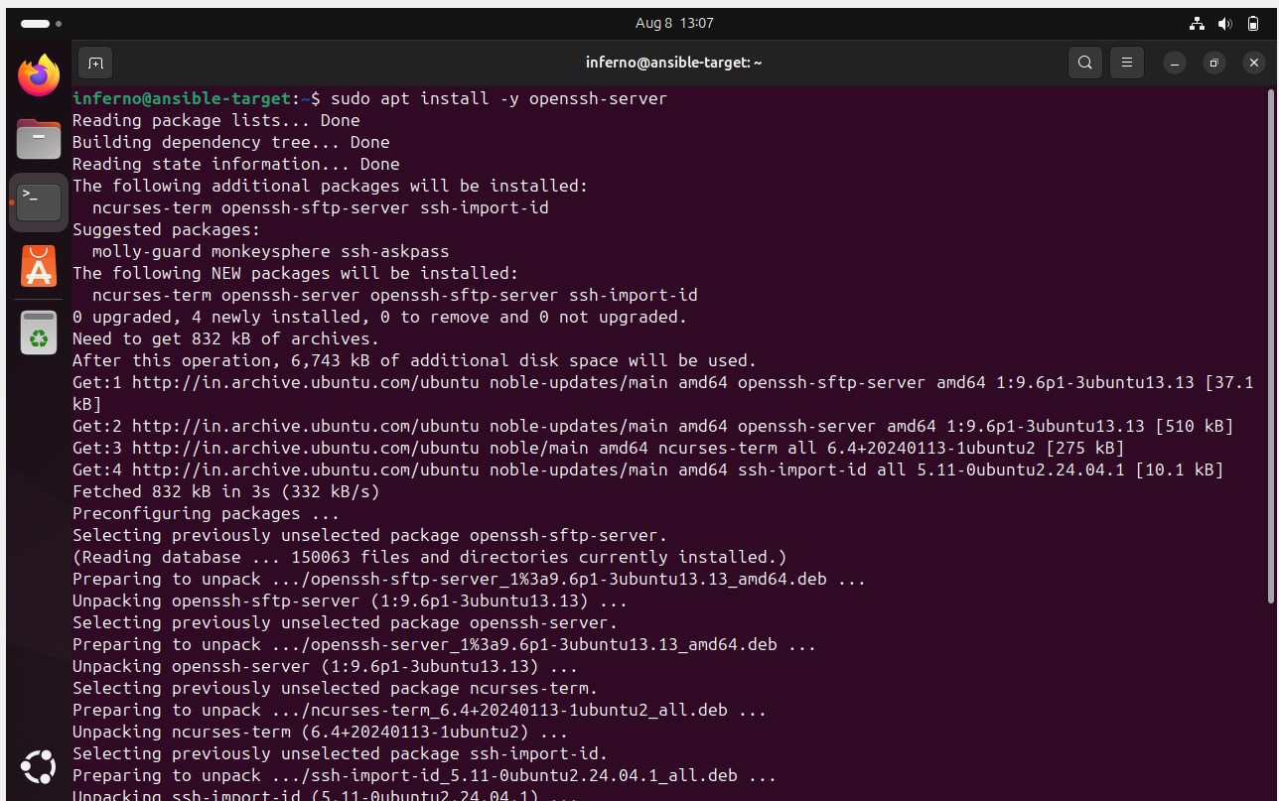

2. Confirm SSH Status:

sudo systemctl status ssh

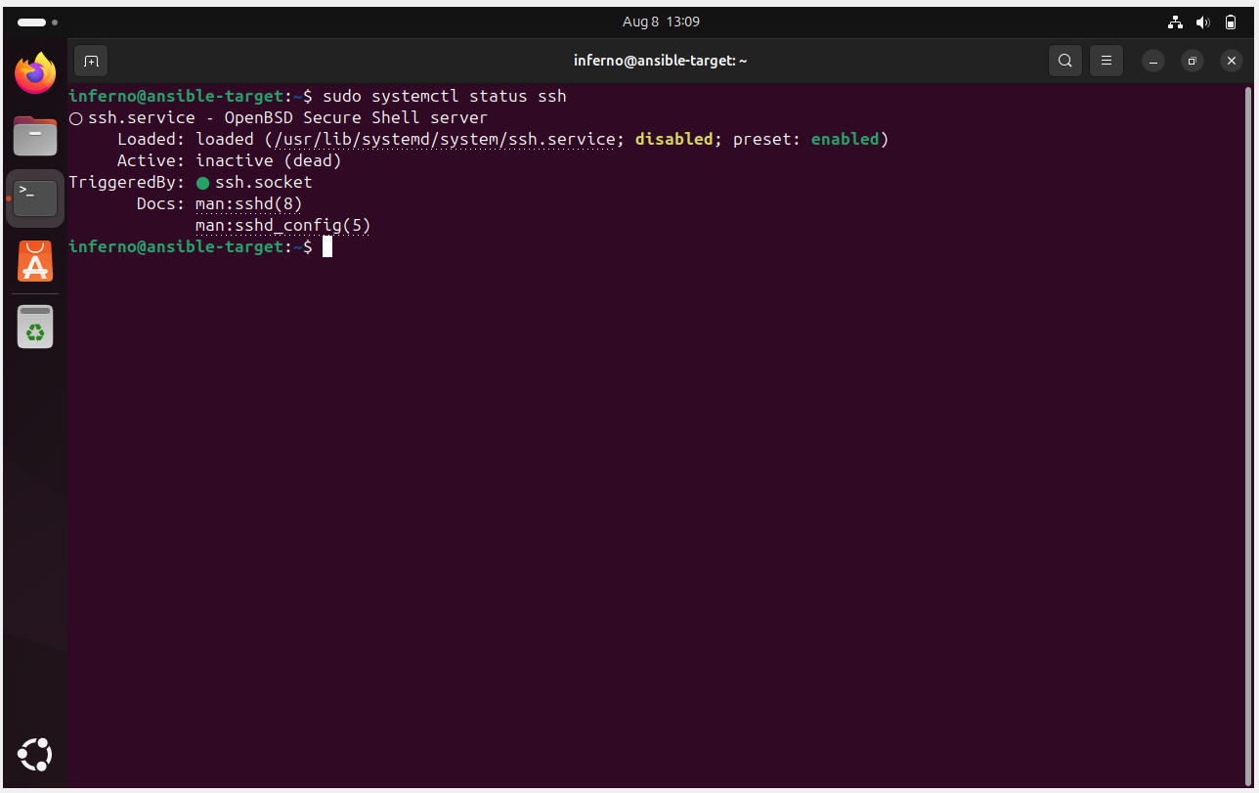

3. Allow ufw to open the SSH port (22):

sudo ufw allow OpenSSH

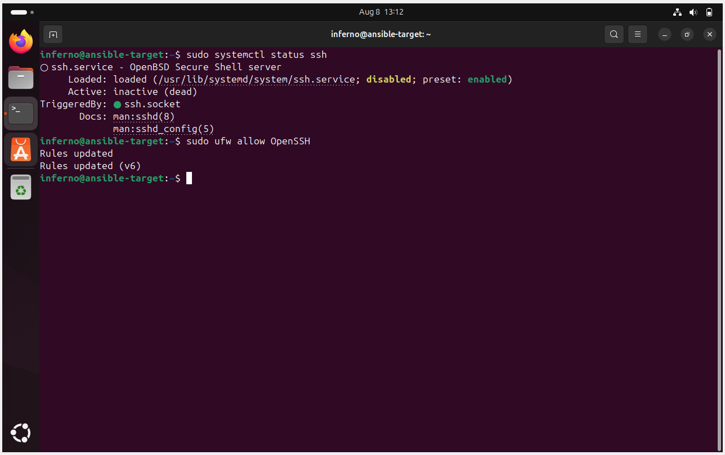

4. Generate an SSH key in WSL2 (Control Node):

ssh-keygen

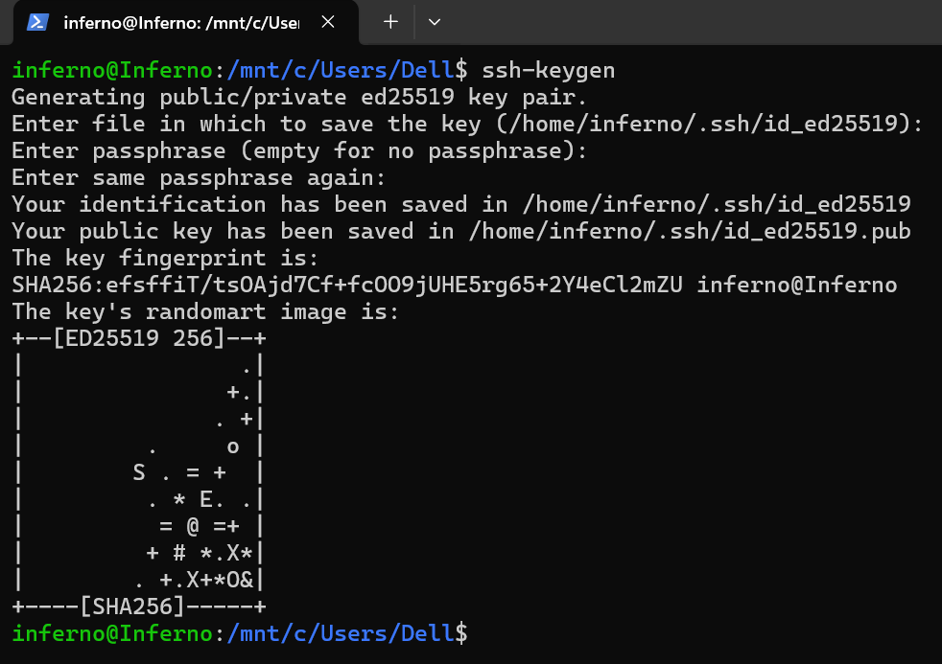

5. Copy the Public Key to the VM (Managed Node):

ssh-copy-id inferno@192.168.1.65

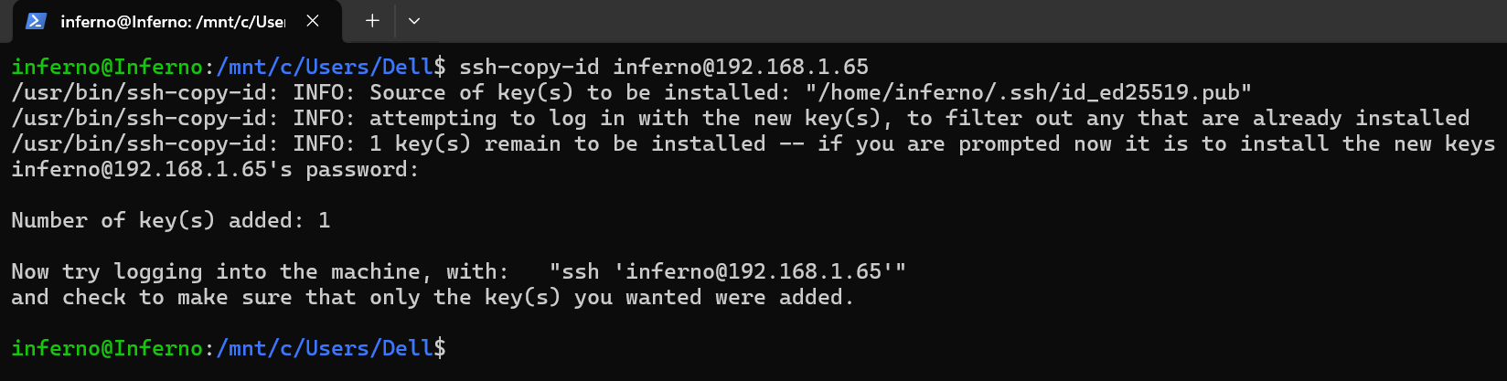

Note: It will ask for the VM’s password once.

6. Test passwordless Login from WSL2:

ssh inferno@192.168.1.65

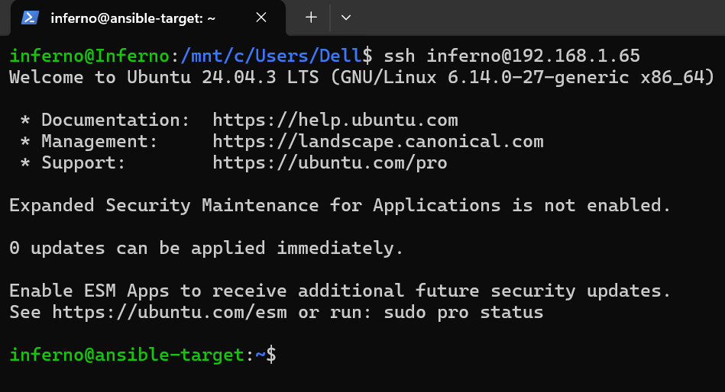

Step 6: Verify System Requirements

Ensure the managed node has Python 3 installed since Ansible uses it on the target.

python3 --version

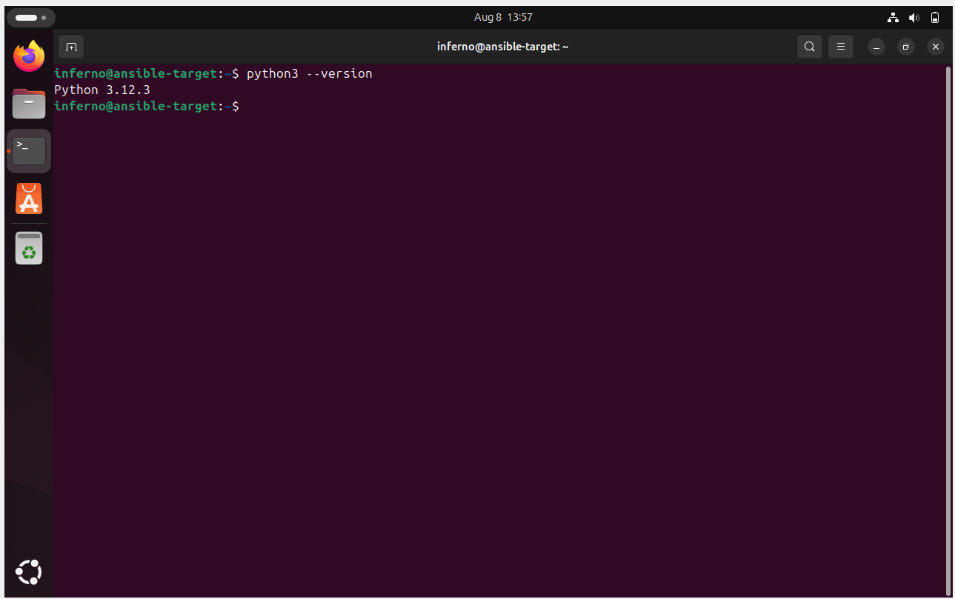

Topics Covered:

1. Prepared a Windows 11 environment for Ansible by using WSL2 (Ubuntu 22.04) as the control node (Ansible installed) and a VirtualBox Ubuntu 22.04 VM as the managed node.

2. Enabled connectivity by configuring Bridged networking, ensuring OpenSSH is running, and setting up SSH key-based authentication from control to target.

