Create and Use Ansible Roles

Problem Statement:

In this lab, we will organize our Ansible tasks into reusable roles. Roles help structure automation projects by separating configuration files, tasks, templates, and variables into well-defined directories. We will create an Apache setup role and execute it on the managed node.

Tools/Software Versions:

1. Operating System & Virtualization:

- Windows 11/10 (64-bit) with WSL2 enabled
- Oracle VM VirtualBox 7.1.10

2. Linux Distribution: Ubuntu 24.04 LTS (Control and Managed nodes)

3. Ansible: Version 2.16.3

4. OpenSSH: Server/Client 3.0.13

5. Python: 3.12.3

Hands-on Steps:

Step 1: Navigate to Project Directory

1. On the control node, create a roles-based project structure:

cd ~
mkdir ansible-roles-demo
cd ansible-roles-demo

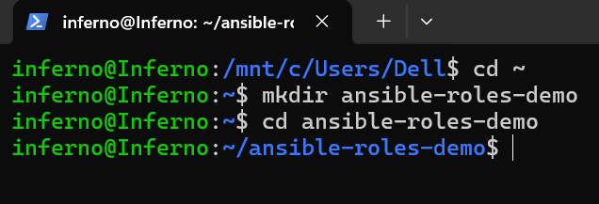

2. Make sure your inventory file from Lab 1 is available or copy it here:

cp ~/inventory .

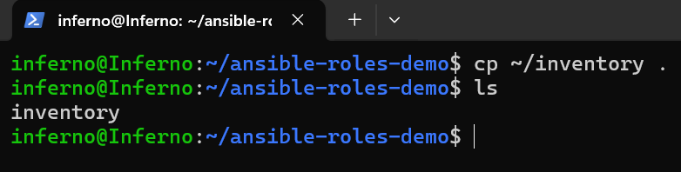

Step 2: Create a New Role

1. Use ansible-galaxy init to generate a role skeleton:

ansible-galaxy init roles/apache_setup

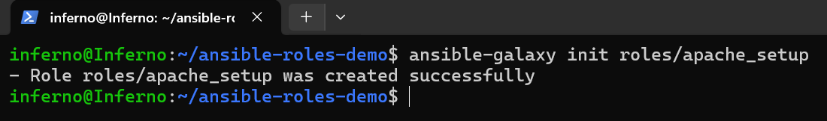

This creates subdirectories for tasks, handlers, templates, vars, etc.

2. Check the structure:

tree roles/apache_setup

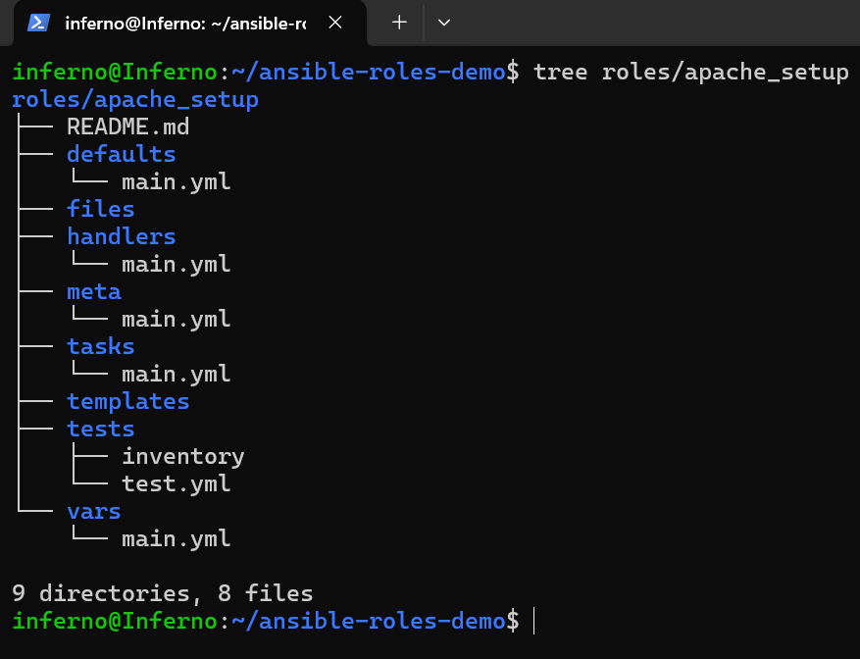

Note: If tree isn’t installed, install it with sudo apt install tree.

Step 3: Define Role Tasks

1. Edit the main tasks file:

nano roles/apache_setup/tasks/main.yml

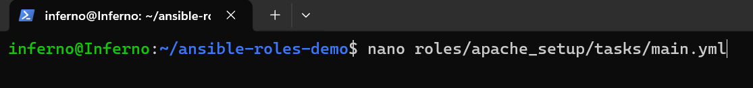

2. Add the following tasks:

---
- name: Install Apache
apt:
name: apache2
state: present
update_cache: yes

- name: Start and Enable Apache Service
service:
name: apache2
state: started
enabled: yes

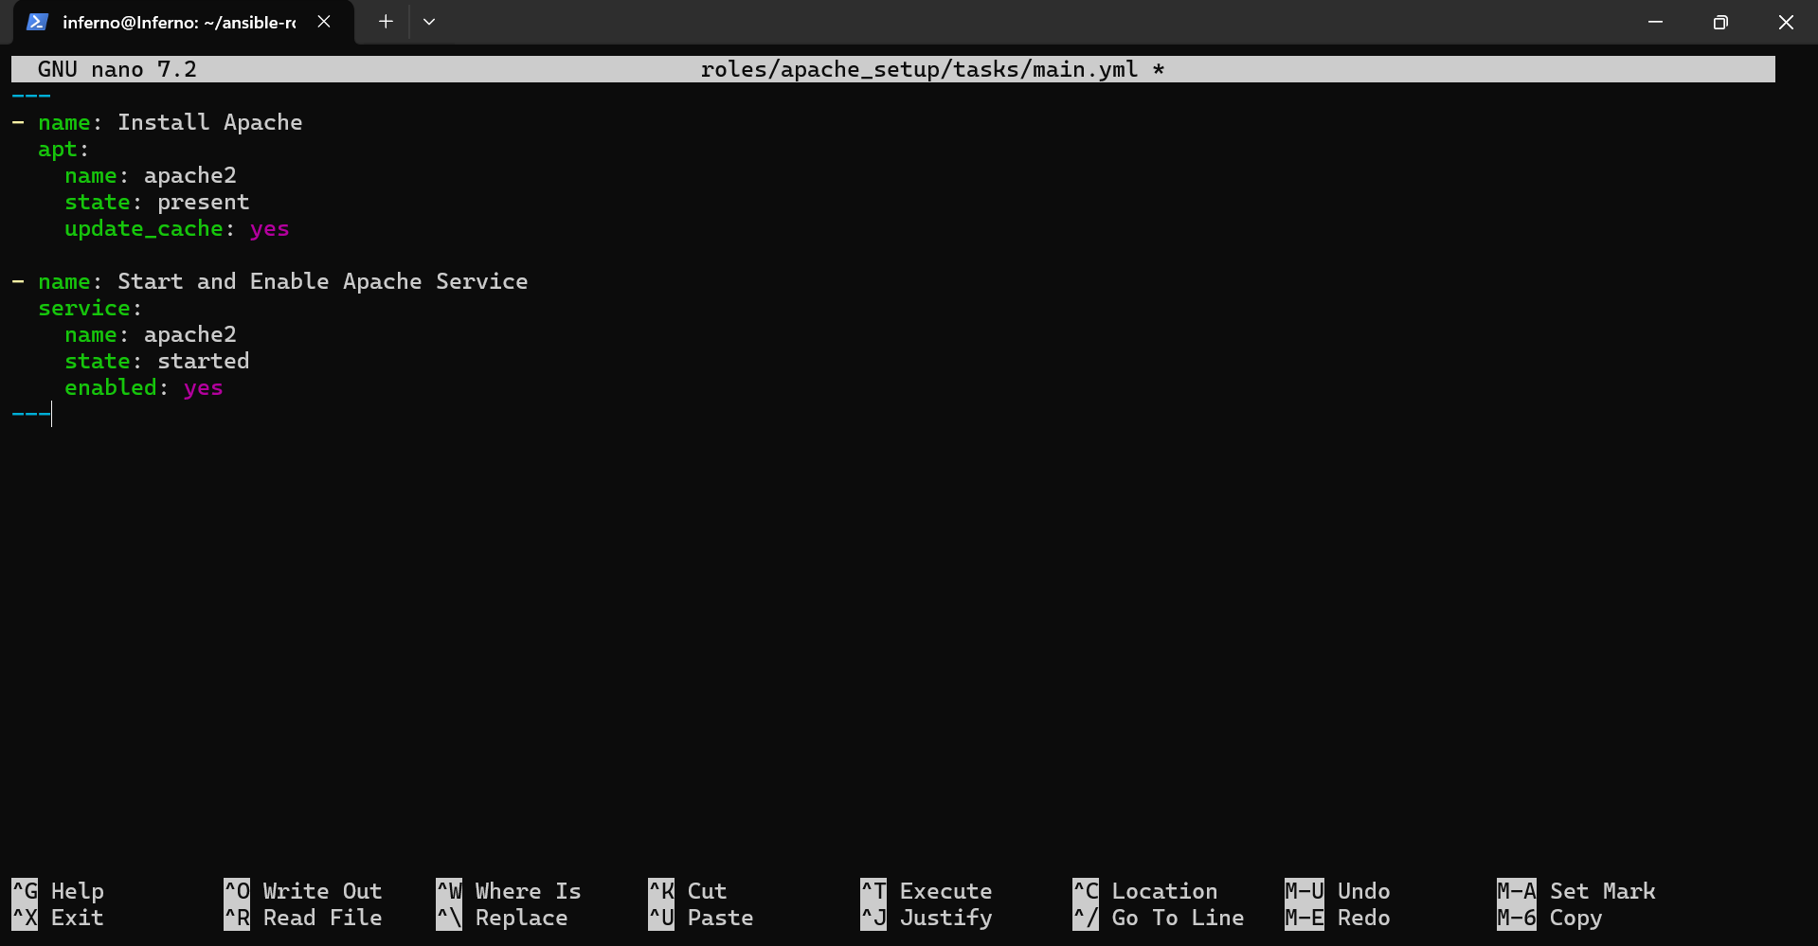

3. Save and exit using CTRL+O, Enter, CTRL+X.

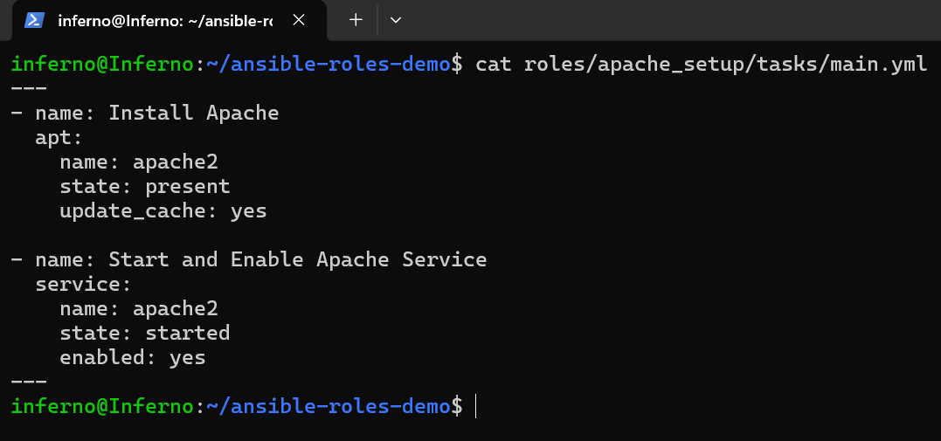

Step 4: Create the Role Playbook

1. In the project root, create a playbook:

nano apache_role_playbook.yml

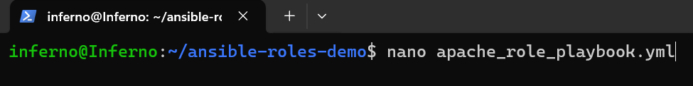

2. Add the following content:

---
- name: Configure Apache using Role
hosts: targets
become: yes
become_method: sudo
roles:
- apache_setup

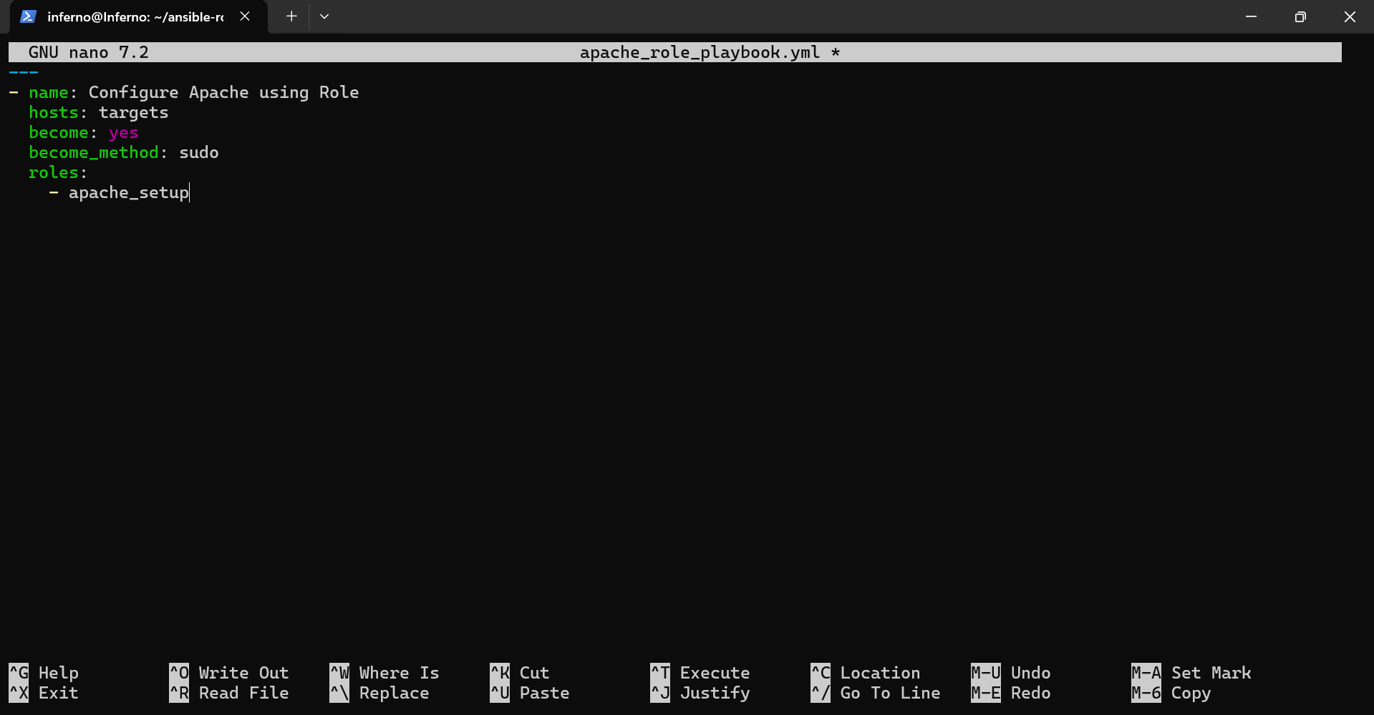

3. Save and exit.

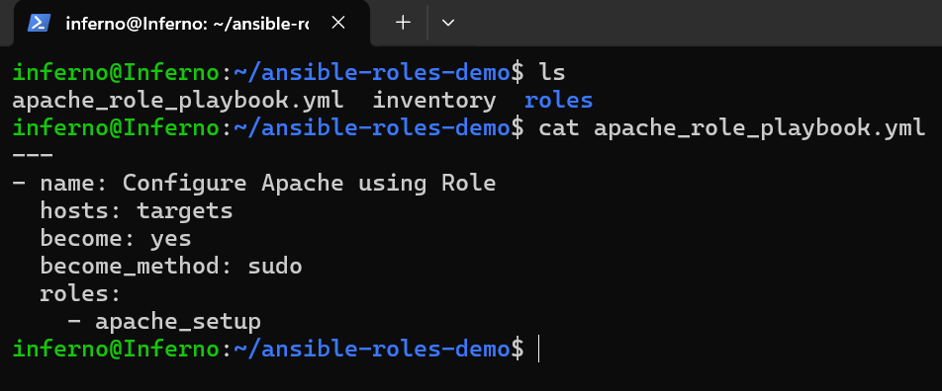

Step 5: Execute the Role Playbook

1. Run the playbook:

ansible-playbook -i inventory apache_role_playbook.yml -K

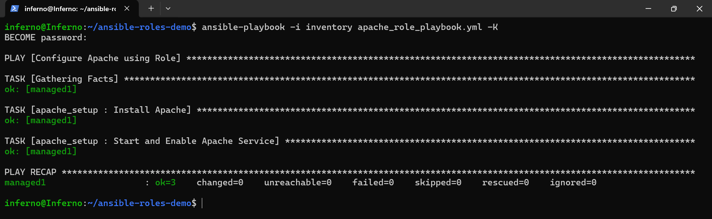

2. Observe the tasks executing from the role.

- changed → task applied a change.
- ok → no changes were needed.

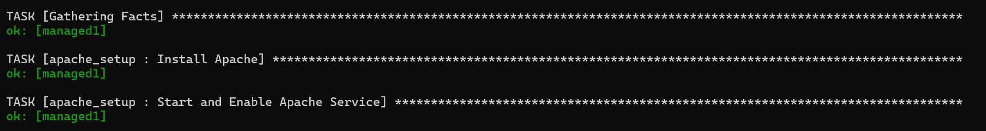

Step 6: Verify Apache Service

From the control node, check Apache version on the managed node:

ansible -i inventory targets -m shell -a "apache2 -v" -K

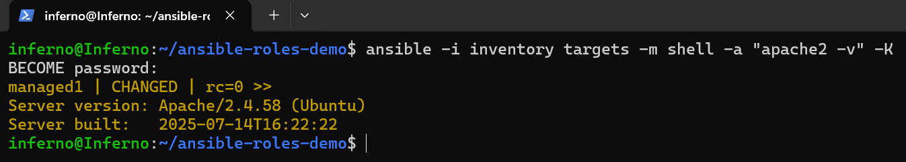

Expected output should show Server version: Apache/2.4.58.

Topics Covered:

1. Created a reusable role structure using ansible-galaxy init.

2. Defined tasks inside the role for installing and starting Apache.

3. Executed a playbook that references a role instead of inline tasks.

4. Verified the service status after applying the role.

