Develop Basic Playbooks

Problem Statement:

In this lab, we will create and execute a basic Ansible playbook to install and manage Apache HTTP Server on the managed node. This introduces YAML-based automation and task execution.

Tools/Software Versions:

1. Operating System & Virtualization:

- Windows 11/10 (64-bit) with WSL2 enabled
- Oracle VM VirtualBox 7.1.10

2. Linux Distribution: Ubuntu 24.04 LTS (Control and Managed nodes)

3. Ansible: Version 2.16.3

4. OpenSSH: Server/Client 3.0.13

5. Python3: 3.12.3

Hands-on Steps:

Step 1: Create a Playbook File

1. On the control node, navigate to your home directory:

cd ~

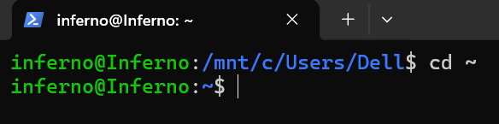

2. Open a new file named install_apache.yml in a text editor:

nano install_apache.yml

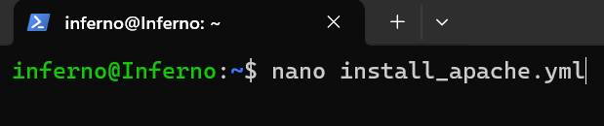

3. Add the following content:

---
- name: Install and Start Apache Web Server
hosts: targets
become: yes
become_method: sudo
tasks:
- name: Install Apache
apt:
name: apache2
state: present
update_cache: yes

- name: Start and Enable Apache Service
service:
name: apache2
state: started
enabled: yes

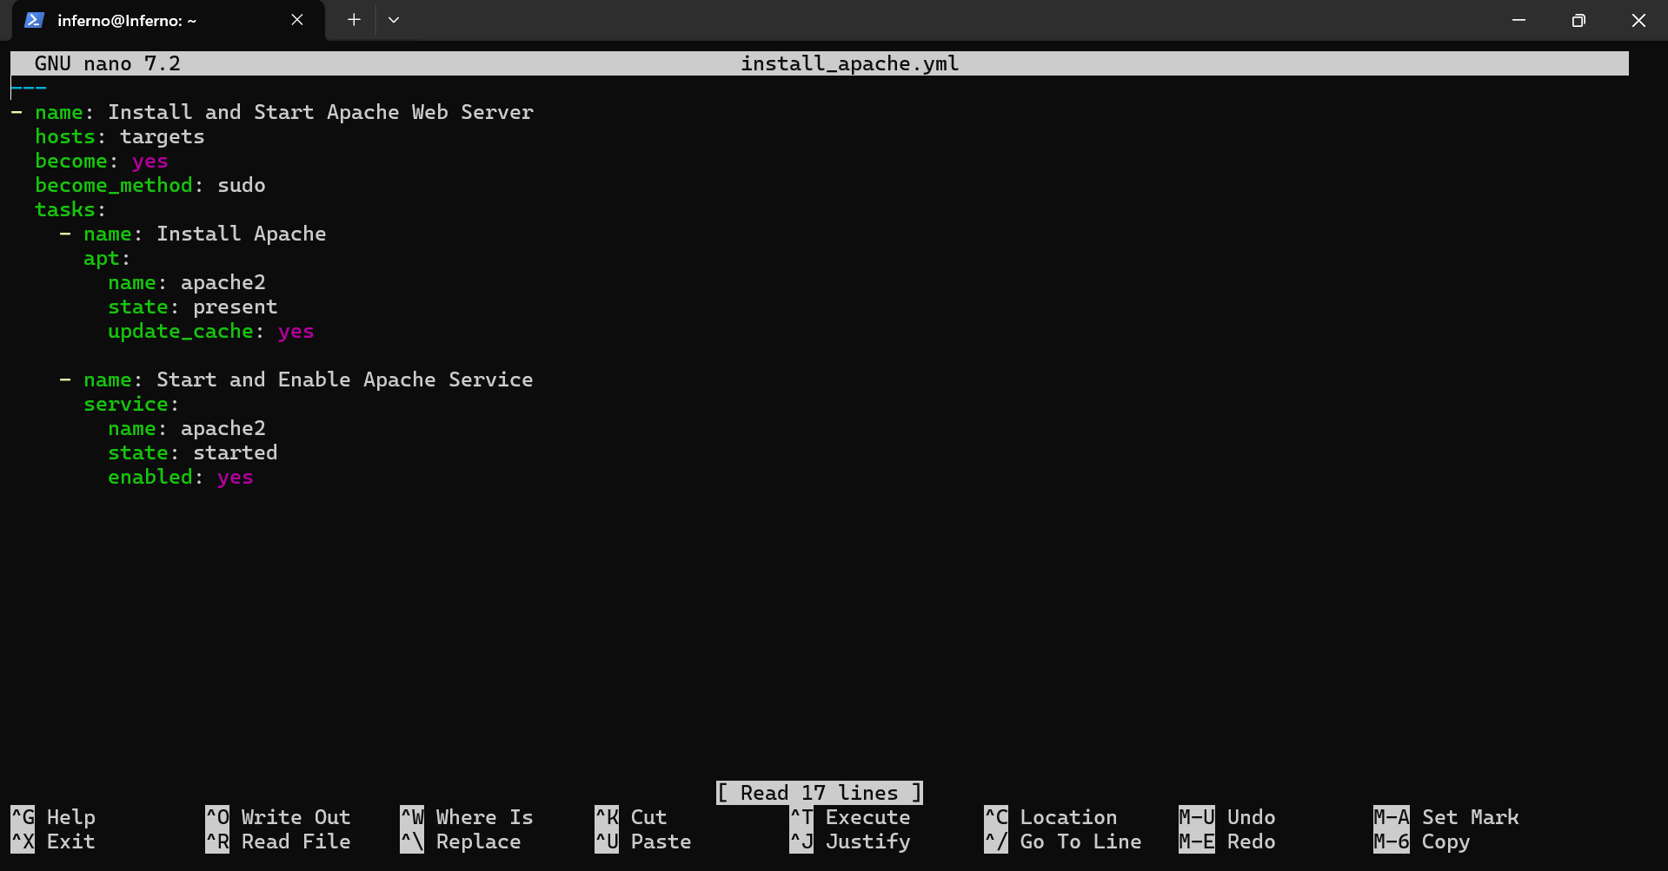

4. Save and close the file with CTRL+O, Enter, CTRL+X.

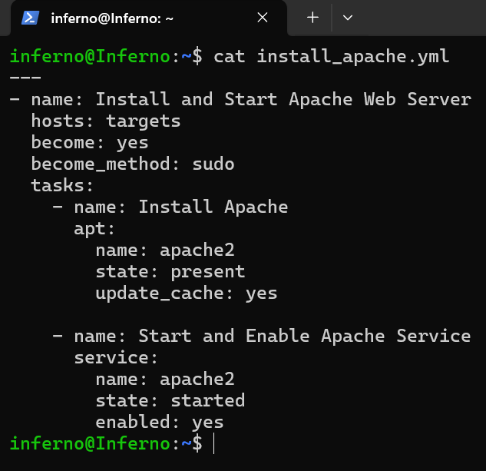

Step 2: Run the Playbook

Execute the playbook against the inventory created in Lab 1:

ansible-playbook -i ~/inventory install_apache.yml -K

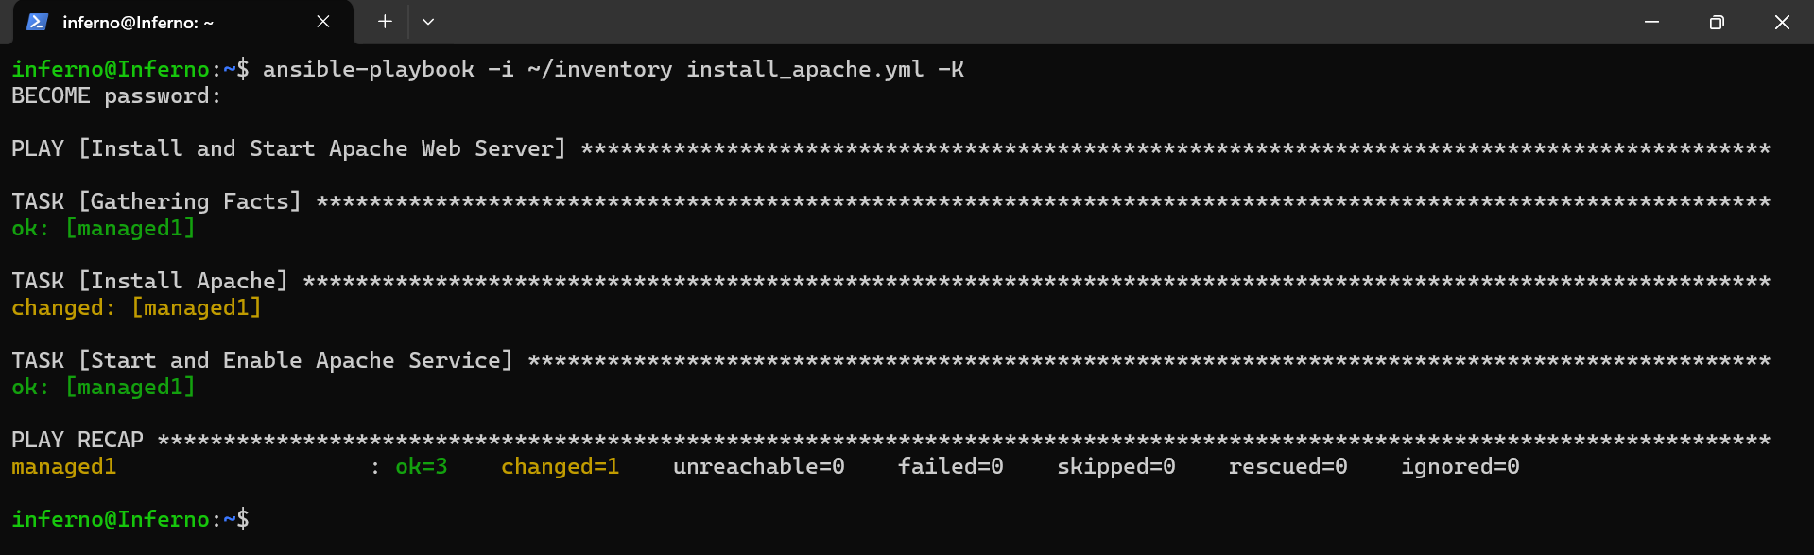

Tasks should show changed if Apache is being installed for the first time.
If already installed, it will show ok.

Step 3: Verify Apache Installation

Check Apache version on the managed node:

ansible -i ~/inventory targets -m shell -a "apache2 -v" -K

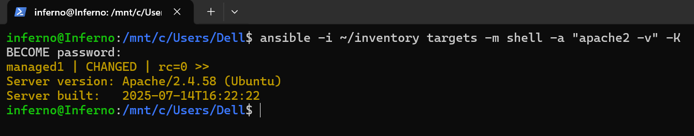

Step 4: Verify Apache Service Status

1. Check the service status from the control node:

ansible -i ~/inventory targets -m service -a "name=apache2 state=started" -K

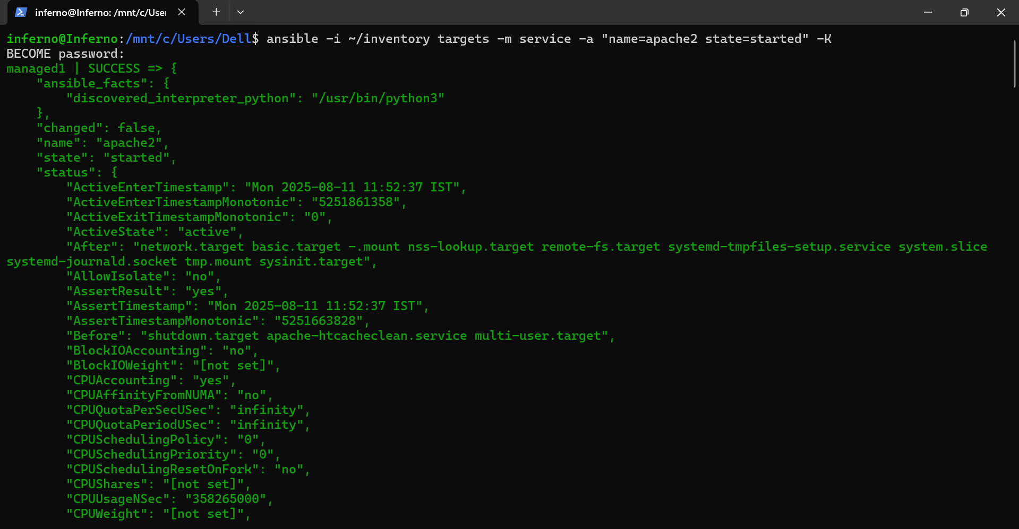

You should see a SUCCESS message with state: started.

2. Open a browser and enter the managed node’s IP address.

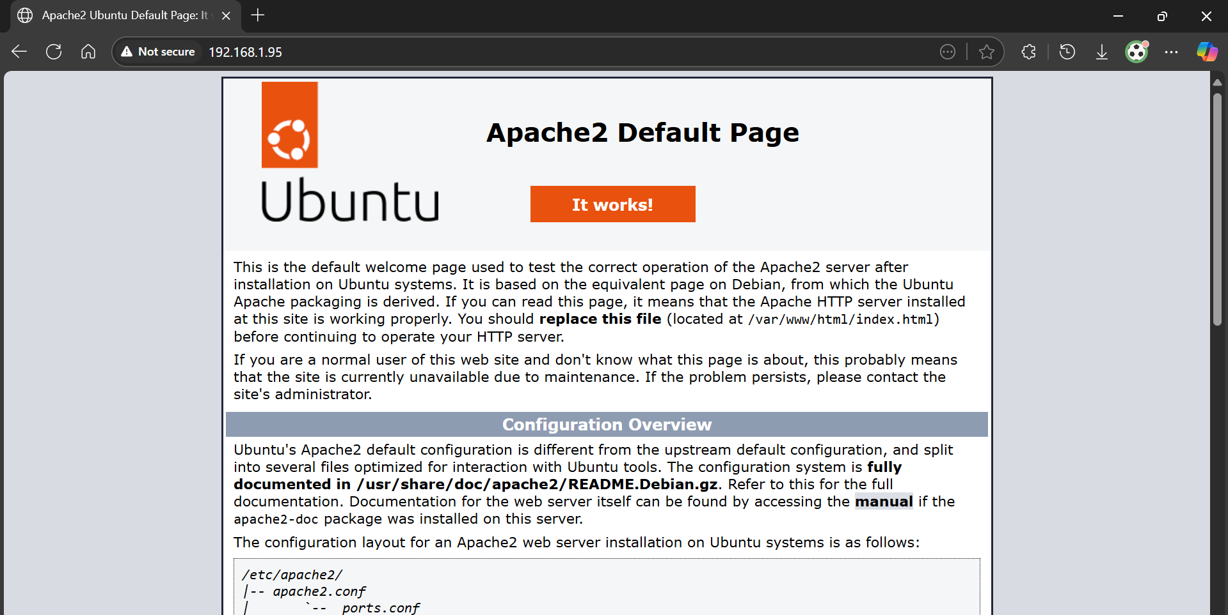

You should see the Apache default page.

Topics Covered:

1. Created a basic YAML playbook to automate software installation.

2. Used Ansible modules (apt, service) to manage packages and services.

3. Verified application installation from the control node.

