Implement Configuration Management for Applications

Problem Statement:

In this lab, we’ll be using Ansible roles, templates, variables, and handlers to deploy and configure a straightforward web application to ensure consistent reproduction across all target environments.

Tools/Software Versions:

1. OS & Virtualization: Windows 11/10 (64‑bit) with WSL2, Oracle VirtualBox 7.1.10

2. Linux: Ubuntu 24.04 LTS (Control & Managed)

3. Ansible: 2.16.3

4. OpenSSH: Server/Client 3.0.13

5. Python: 3.12.3

6. Web Server: Apache2

Hands-on Steps:

Step 1: Create a new application role

1. On the control node, go to your project:

cd ~/ansible-roles-demo

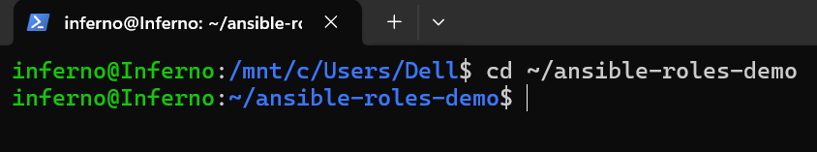

2. Create the role skeleton:

ansible-galaxy init roles/sample_webapp

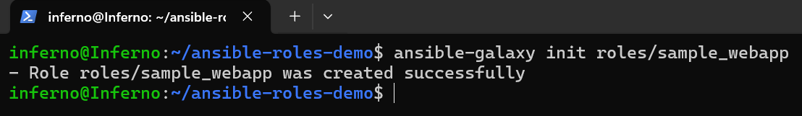

3. Verify structure:

tree roles/sample_webapp

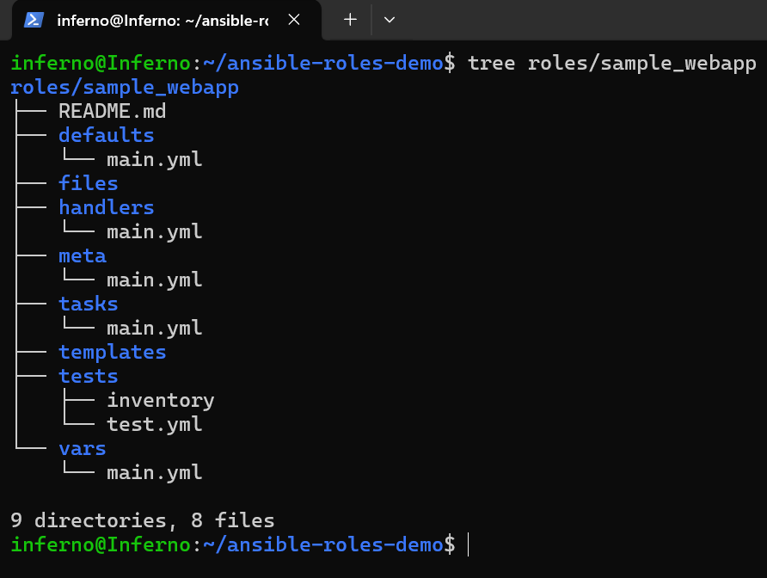

Step 2: Add role variables (app name, docroot, server name)

1. Create vars file:

nano roles/sample_webapp/vars/main.yml

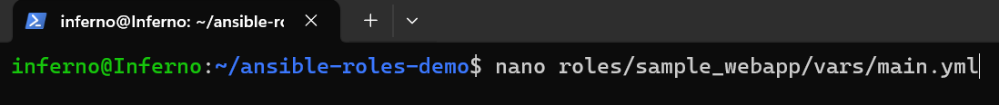

2. Paste:

app_name: "sample_webapp"
app_docroot: "/var/www/sample_webapp"
server_name: "sampleapp.local"
env_banner: "Deployed via Ansible (Lab 4)"

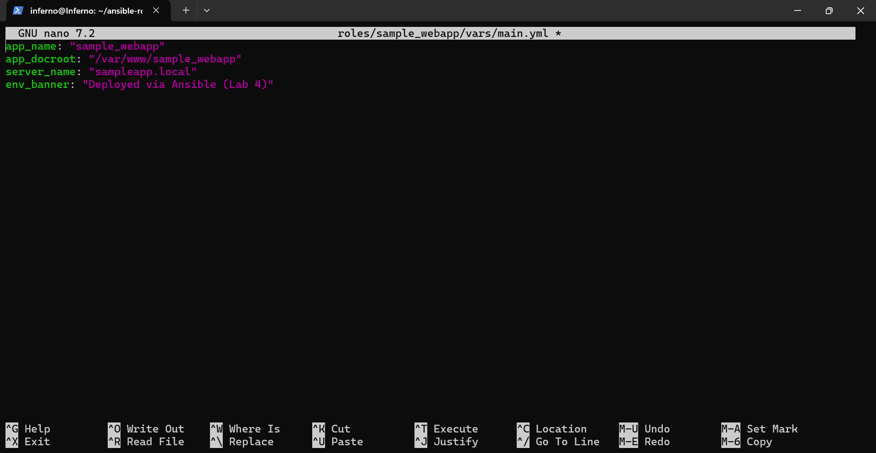

Step 3: Create templates (index and Apache vhost)

1. Create templates directory and index:

mkdir -p roles/sample_webapp/templates
nano roles/sample_webapp/templates/index.html.j2

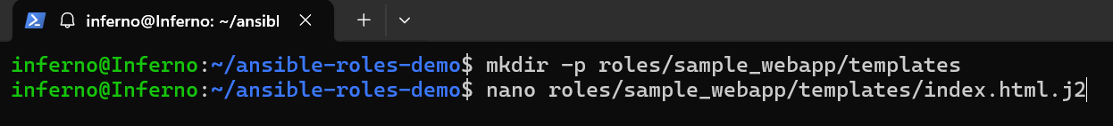

2. Paste:

<!doctype html>
<html>
<head>
<meta charset="utf-8">
<title>{{ app_name }}</title>
<style>body{font-family:sans-serif;margin:3rem} .tag{padding:.4rem .6rem;border:1px solid #ddd;border-radius:6px;display:inline-block}</style>
</head>
<body>
<h1>{{ app_name }}</h1>
<p class="tag">{{ env_banner }}</p>
<p>Document Root: {{ app_docroot }}</p>
<p>ServerName: {{ server_name }}</p>
</body>
</html>

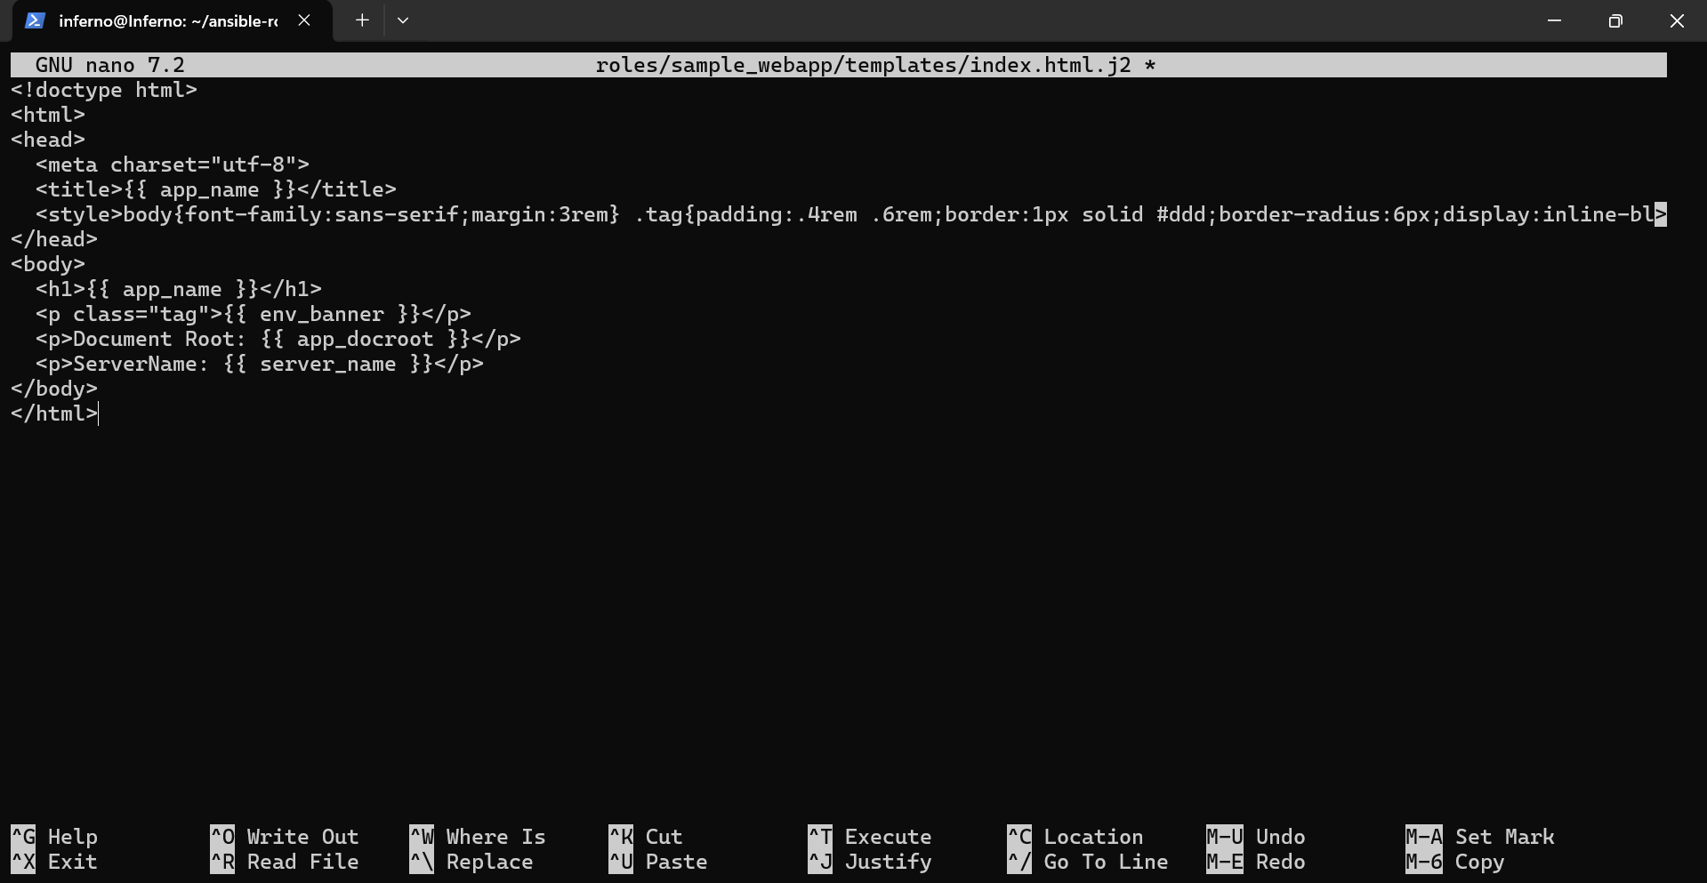

3. Create Apache vhost:

nano roles/sample_webapp/templates/vhost.conf.j2

4. Paste:

<VirtualHost *:80>
ServerName {{ server_name }}
DocumentRoot {{ app_docroot }}

<Directory {{ app_docroot }}>
Options Indexes FollowSymLinks
AllowOverride None
Require all granted
</Directory>

ErrorLog ${APACHE_LOG_DIR}/{{ app_name }}_error.log
CustomLog ${APACHE_LOG_DIR}/{{ app_name }}_access.log combined
</VirtualHost>

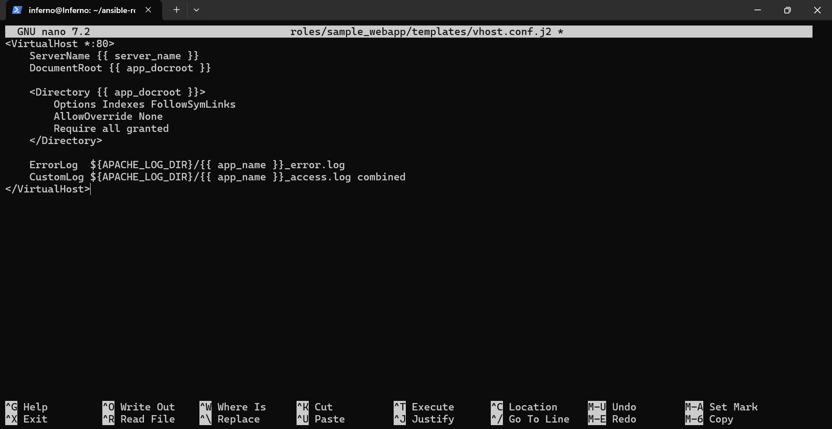

Step 4: Write role tasks (create dirs, deploy files, enable site)

1. Edit tasks:

nano roles/sample_webapp/tasks/main.yml

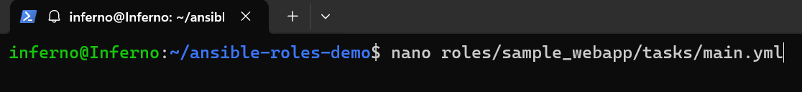

2. Paste:

---
- name: Ensure app document root exists
file:
path: "{{ app_docroot }}"
state: directory
owner: root
group: root
mode: "0755"

- name: Deploy index.html from template
template:
src: index.html.j2
dest: "{{ app_docroot }}/index.html"
owner: root
group: root
mode: "0644"
notify: Restart Apache

- name: Deploy Apache vhost config
template:
src: vhost.conf.j2
dest: "/etc/apache2/sites-available/{{ app_name }}.conf"
owner: root
group: root
mode: "0644"
notify: Restart Apache

- name: Enable vhost
file:
src: "/etc/apache2/sites-available/{{ app_name }}.conf"
dest: "/etc/apache2/sites-enabled/{{ app_name }}.conf"
state: link
notify: Restart Apache

- name: Disable default site if present
file:
path: /etc/apache2/sites-enabled/000-default.conf
state: absent
notify: Restart Apache

- name: Ensure Apache is started and enabled
service:
name: apache2
state: started
enabled: yes

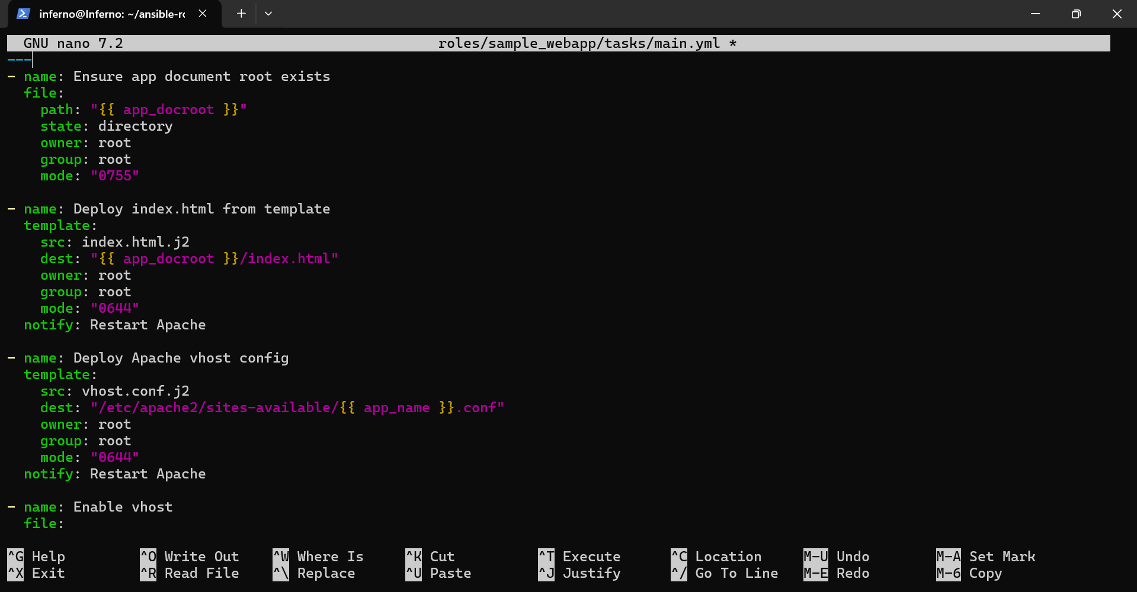

Step 5: Add a handler (restart Apache when configs change)

1. Create handler:

nano roles/sample_webapp/handlers/main.yml

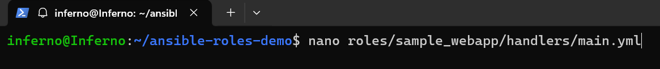

2. Paste:

---
- name: Restart Apache
service:
name: apache2
state: restarted

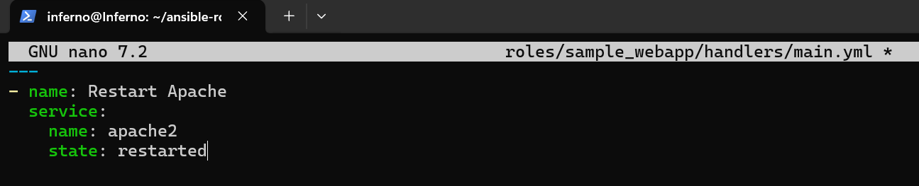

Step 6: Create and run the playbook

1. In the project root, create playbook:

nano deploy_app.yml

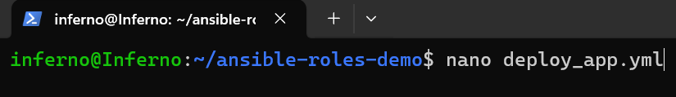

2. Paste:

---
- name: Deploy Sample Web Application with Templates and Handlers
hosts: targets
become: yes
become_method: sudo
roles:
- sample_webapp

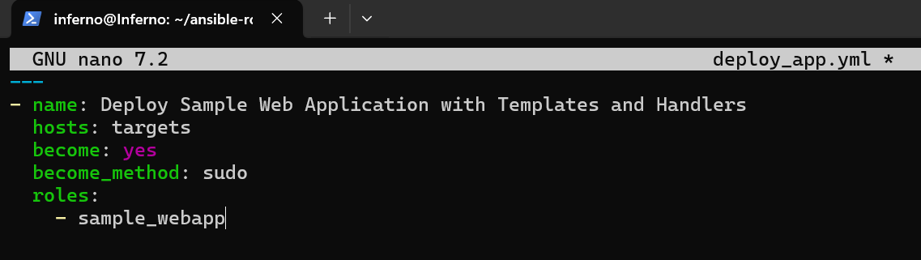

3. Run the playbook:

ansible-playbook -i inventory deploy_app.yml -K

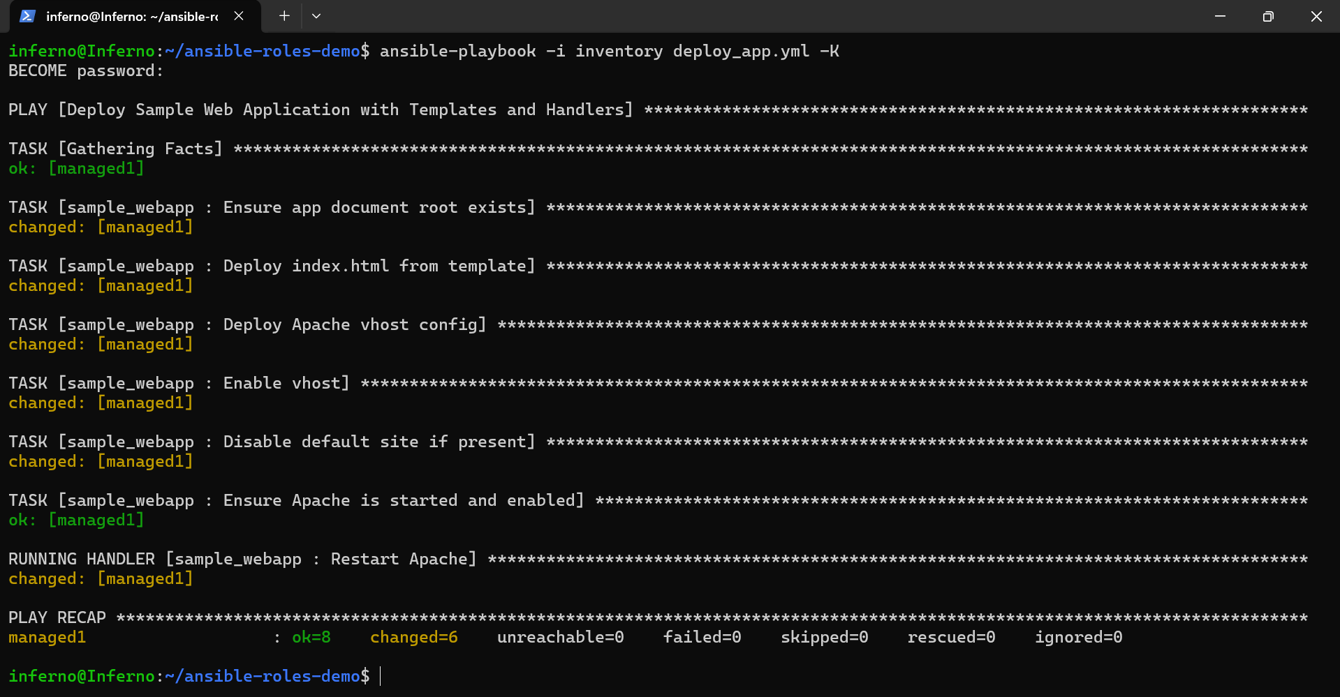

Step 7: Verify deployment from the control node

1. Get the managed node’s IP:

ansible -i inventory targets -m setup -a 'filter=ansible_default_ipv4' -e 'ansible_become=false'

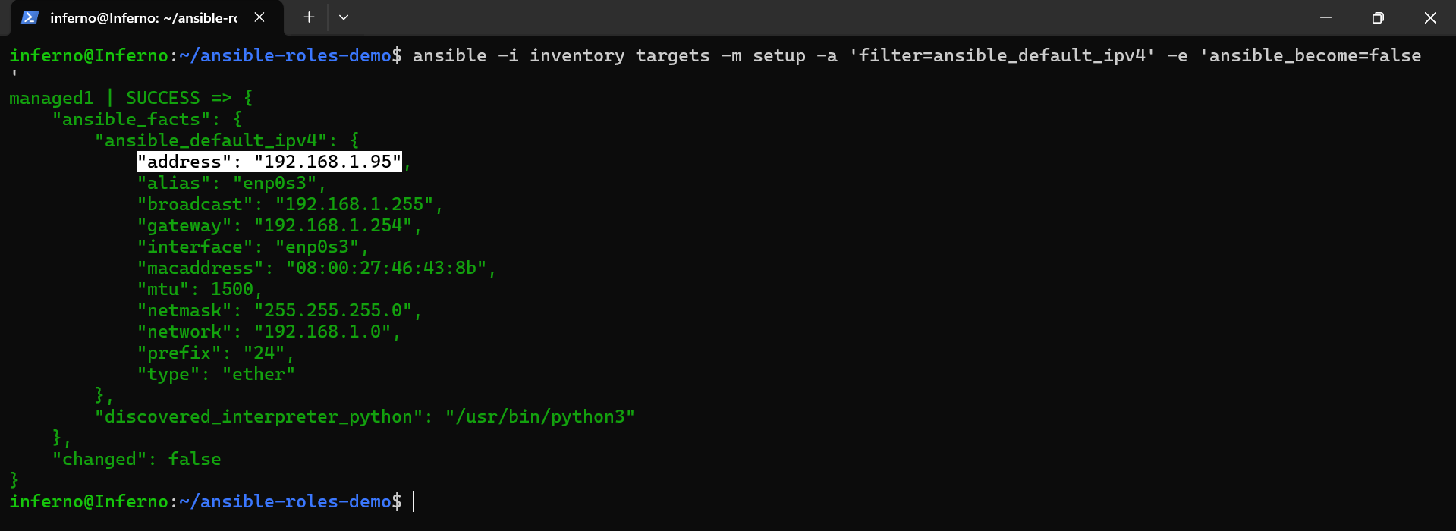

2. Fetch the page:

curl http://<managed_ip>

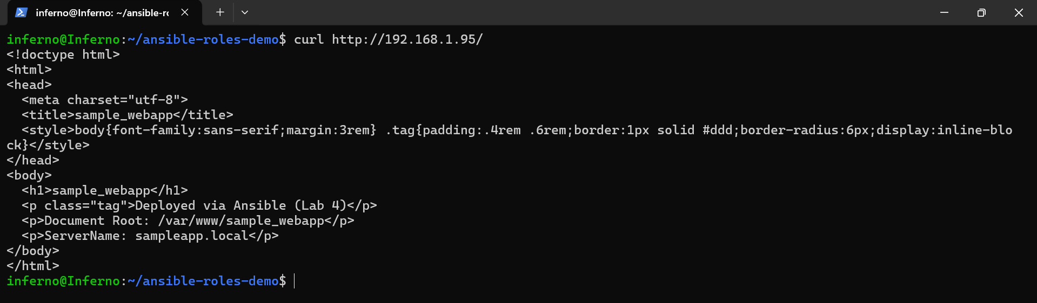

You should see the HTML including app_name and env_banner.

Step 8: Make a config change to see idempotency & handlers

1. Change the env_banner:

sed -i 's/Deployed via Ansible (Lab 4)/Updated via Ansible (Lab 4)/' roles/sample_webapp/vars/main.yml

2. Re-run:

ansible-playbook -i inventory deploy_app.yml -K

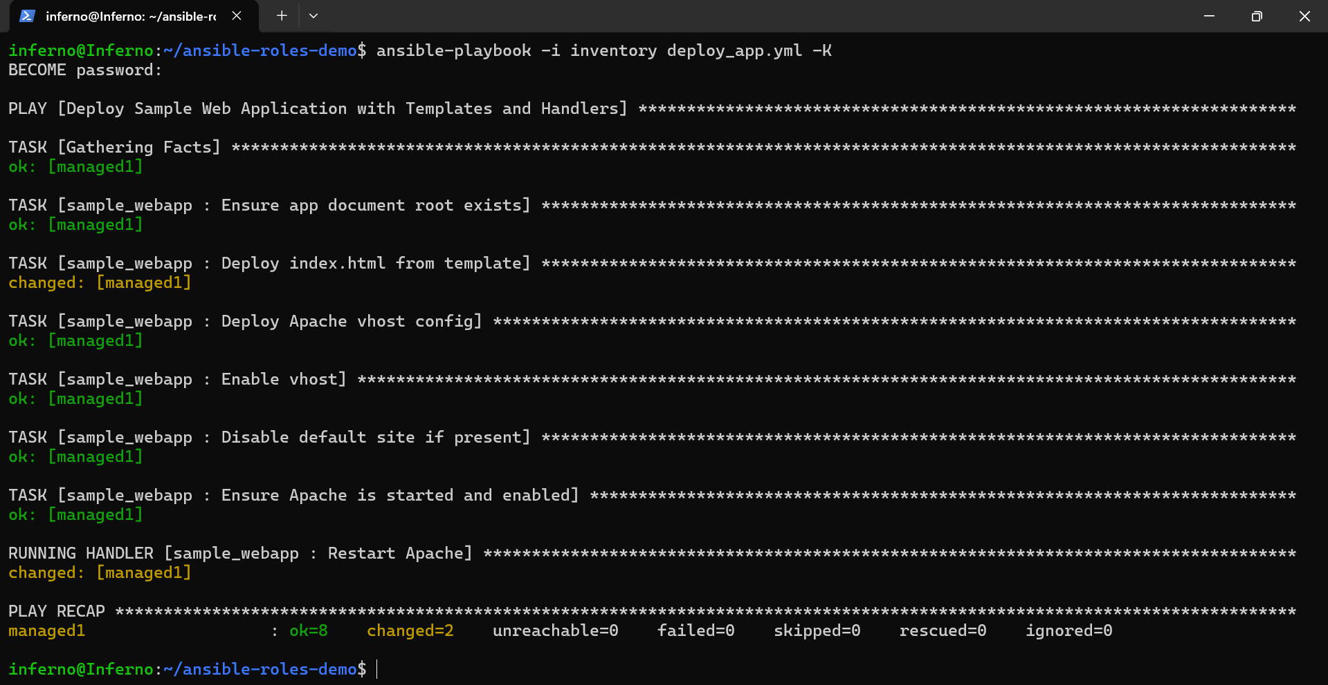

Only the template task should be changed, and Restart Apache handler should run automatically.

3. Verify:

curl http://<managed_ip> | grep "Updated via Ansible (Lab 4)"

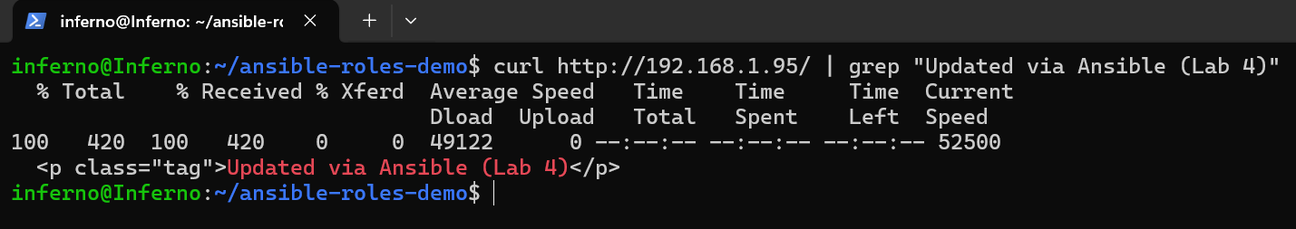

Topics Covered:

1. Modeled an application with role variables, templates, tasks, and handlers for clean, repeatable deployments.

2. Used idempotent tasks and handlers to safely apply changes.

3. Verified deployment remotely using ad‑hoc commands without unnecessary privilege escalation.

