Install and Configure Ansible

Problem Statement:

In this lab, we will install Ansible on our control node (WSL2 Ubuntu 24.04) and configure SSH connectivity to the managed node (Ubuntu VM in VirtualBox). We will then verify that Ansible can communicate with the managed node.

Tools/Software Versions:

1. WSL2 Ubuntu 24.04 LTS (Control Node) with Ansible 2.16.3

2. Oracle VM VirtualBox 7.1.10 (Windows Host)

3. Ubuntu 24.04 LTS (Managed Node) with OpenSSH 3.0.13 and Python 3.12.3

Hands-on Steps:

Given that Ansible has already been installed as part of the prerequisite setup, this hands-on session will focus on its configuration.

If you haven't already, you can install Ansible on your Control Node (WSL2) using:

sudo apt update && sudo apt install -y ansible

Step 1: Verify Ansible Installation

1. Launch the control node terminal:

wsl -d Ubuntu-24.04

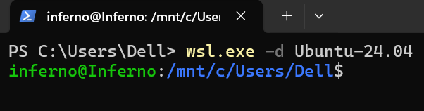

2. Check Ansible version:

ansible --version

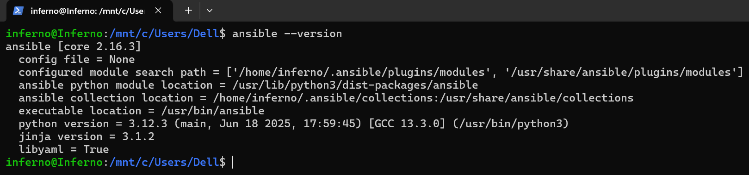

3. Verify SSH client:

ssh -V

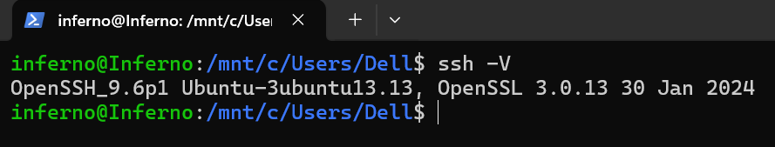

Step 2: Create Inventory File

1. In your home directory, create an inventory file:

nano ~/inventory

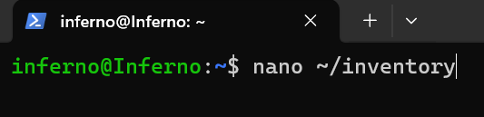

2. Add the following content:

[targets]
managed1 ansible_host=<managed_node_IP> ansible_user=inferno ansible_become=yes

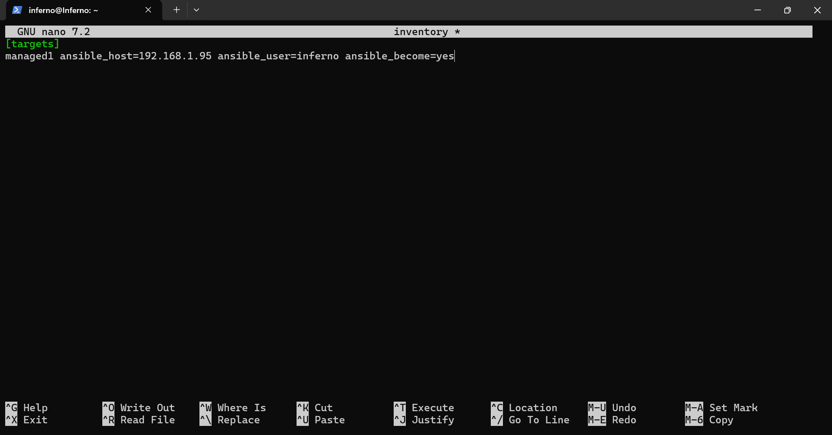

Note: Replace <managed_node_IP> with your VM’s IP.

3. Save and close the editor using CTRL+O, Enter, CTRL+X.

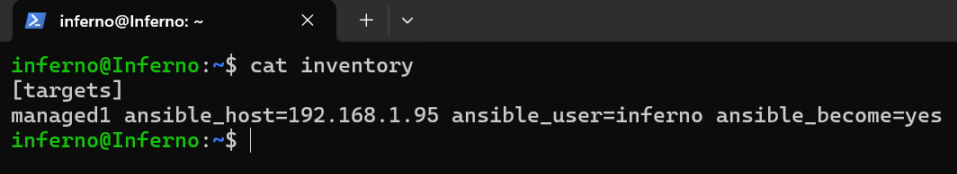

Step 3: Test SSH Connectivity

1. From the control node, connect to the managed node without a password:

ssh inferno@<managed_node_IP>

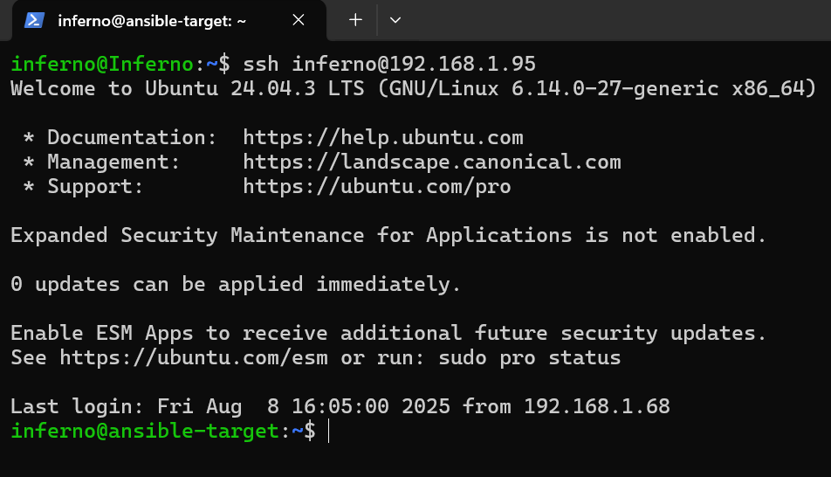

2. If successful, type exit to return to the control node.

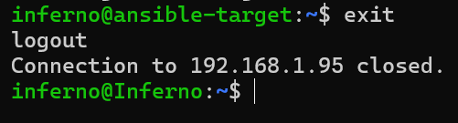

Step 4: Ping Test Using Ansible

Run the ping module to verify connectivity:

ansible -i ~/inventory targets -m ping

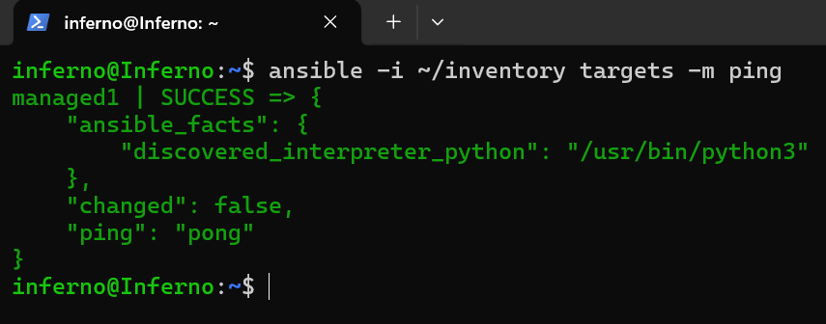

Topics Covered:

1. Installed and verified Ansible on the control node.

2. Configured inventory to define managed hosts.

3. Confirmed Ansible connectivity using the ping module.

