AI-assisted Jenkinsfile Creation

Overview:
This document outlines the step-by-step process of creating a Jenkinsfile using an AI-powered Node.js script integrated with the Groq API (LLaMA 3). This Jenkinsfile will be tailored to your project type and build tool.

Prerequisites
- Node.js installed
- GitHub account
- Jenkins is installed and configured
- Groq account for API access
Step 1: Initialize and Configure Node.js Project
- npm init -y
- npm install express axios dotenv
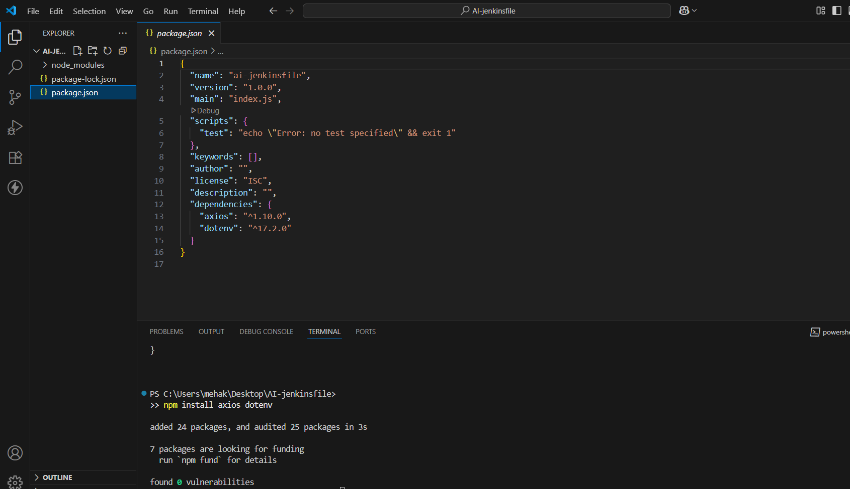

Step 2: Obtain Groq API Key
- Go to https://console.groq.com/keys
- Log in with your email ID
- Click → Create api key
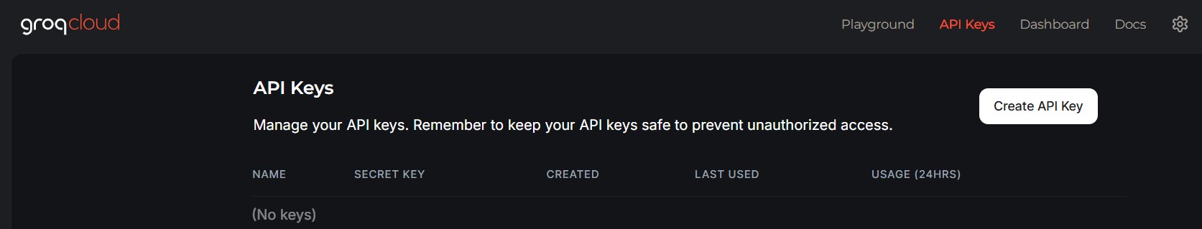
- Write the name of the project for which we need the API key → Submit.
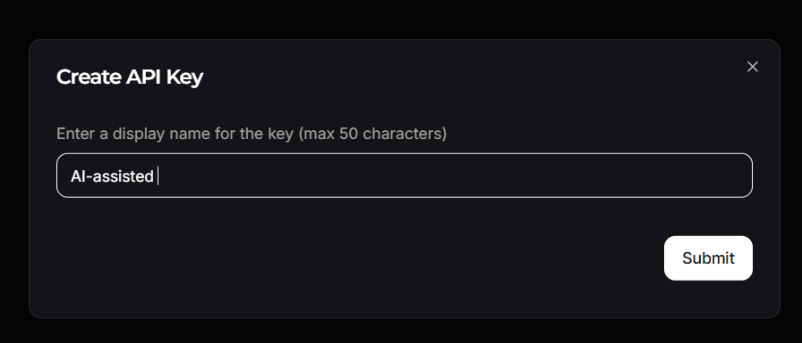
- Copy the generated API key and add it to the .env file of your project.
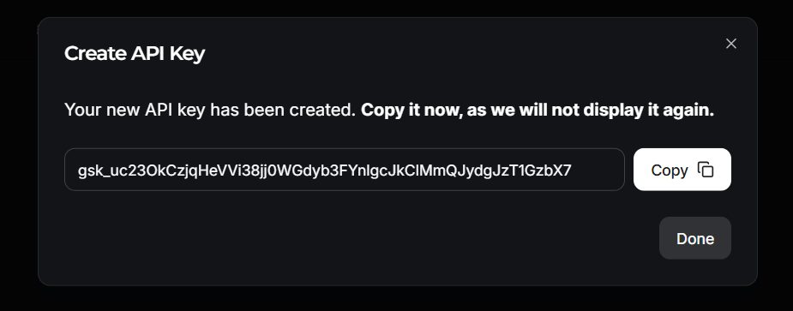

Step 3: Create the Jenkinsfile Generator Script
- This script automatically generates a Jenkinsfile based on our project type and build tool, using the Groq API powered by LLaMA 3.
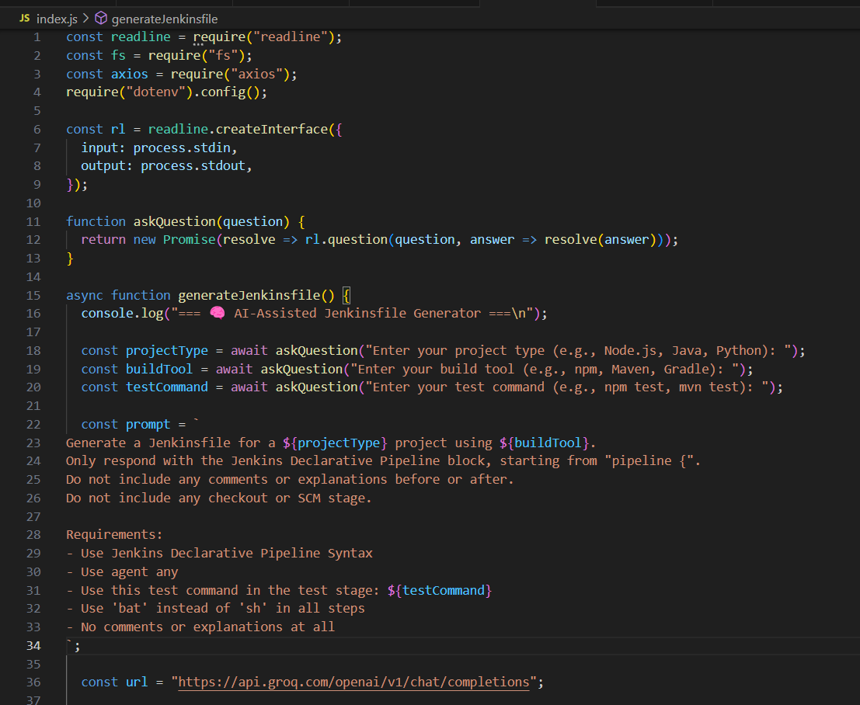
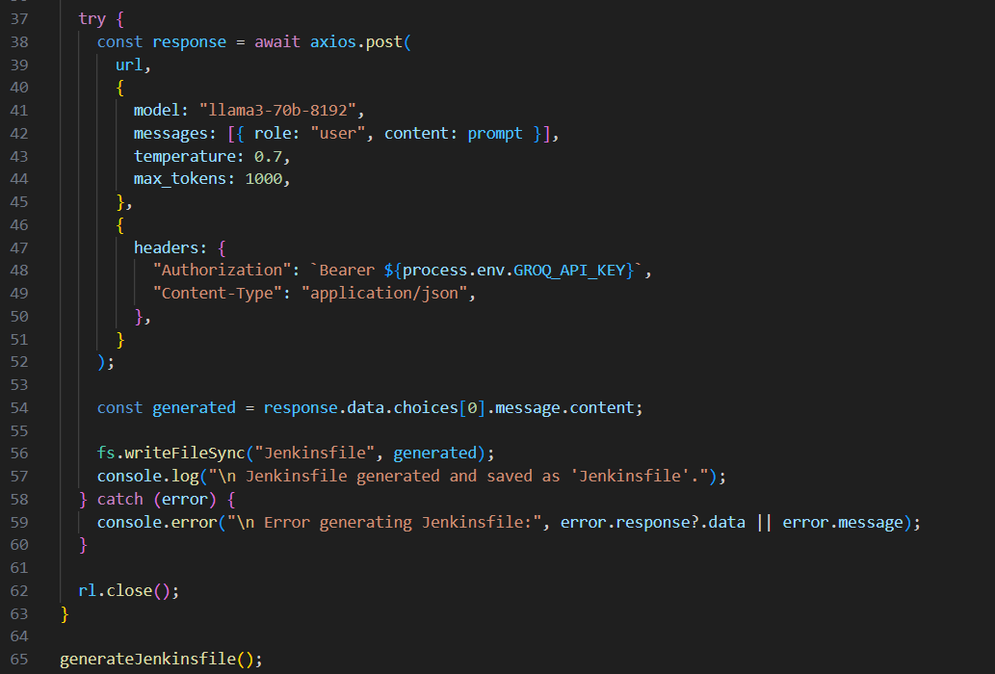

Step 4: Add Unit and Integration Tests
- Install testing dependencies:
  - npm install --save-dev jest supertest

Update package.json
- Make sure your scripts section includes:
  - "scripts": {
- "test": "jest"
  - }
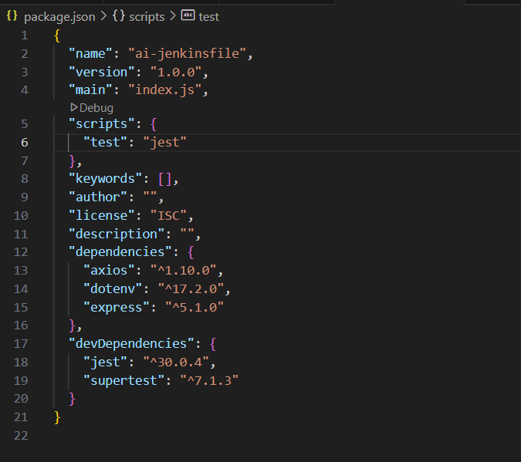
- Create one app.js
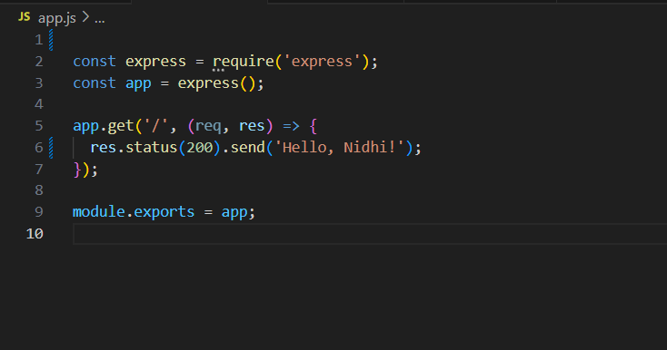
- Create an app.test.js for testing
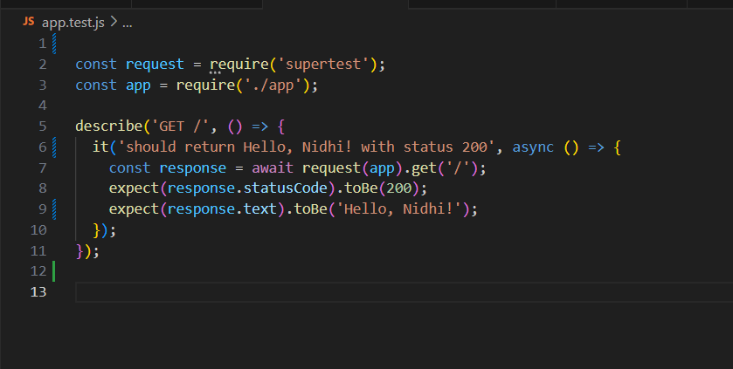
- Run tests:
  - npm test
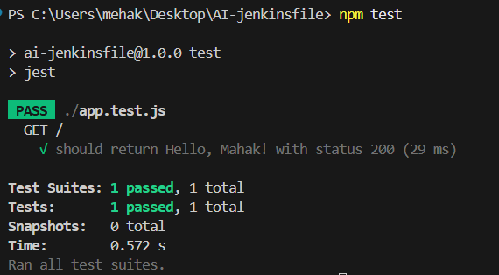
- Test cases are successfully passing.
Step 5: Execute the Script
- Configure the project
- Run it
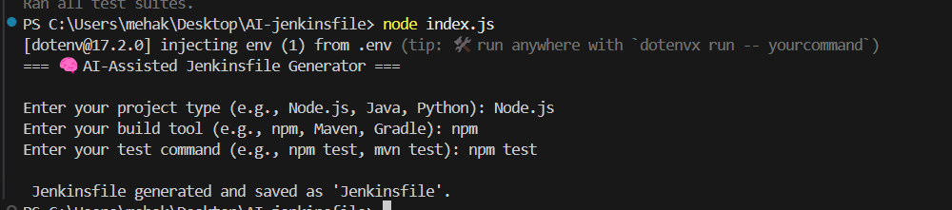
- Jenkinsfile created successfully.

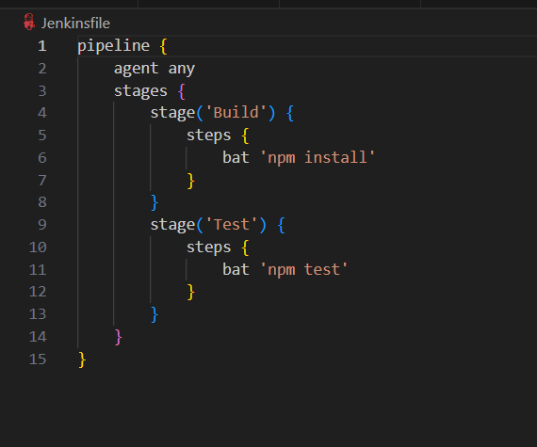

Step 6: Push to GitHub & Set Up Jenkins Pipeline
Note: Add .env to .gitignore
- To verify that the Jenkinsfile is executing correctly, we will build the pipeline in Jenkins.
- Open Jenkins Dashboard
- Create a New Item
- Choose Pipeline → Name your project → Click OK

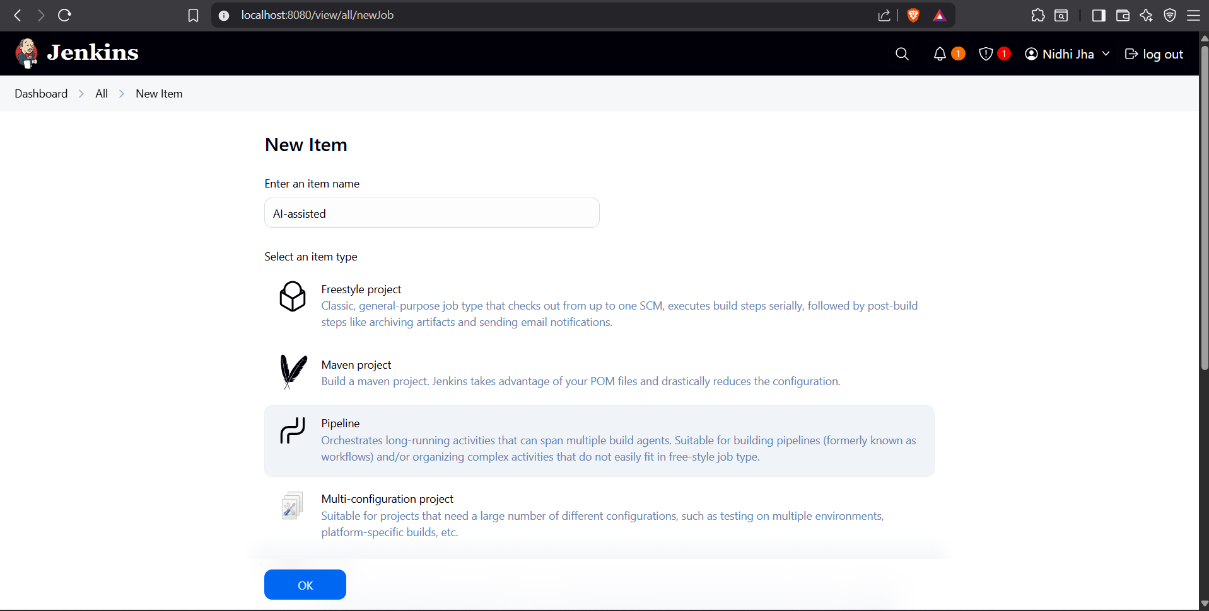
Under Pipeline Configuration:
- Select the Pipeline script from SCM
- Choose Git and paste your repository URL
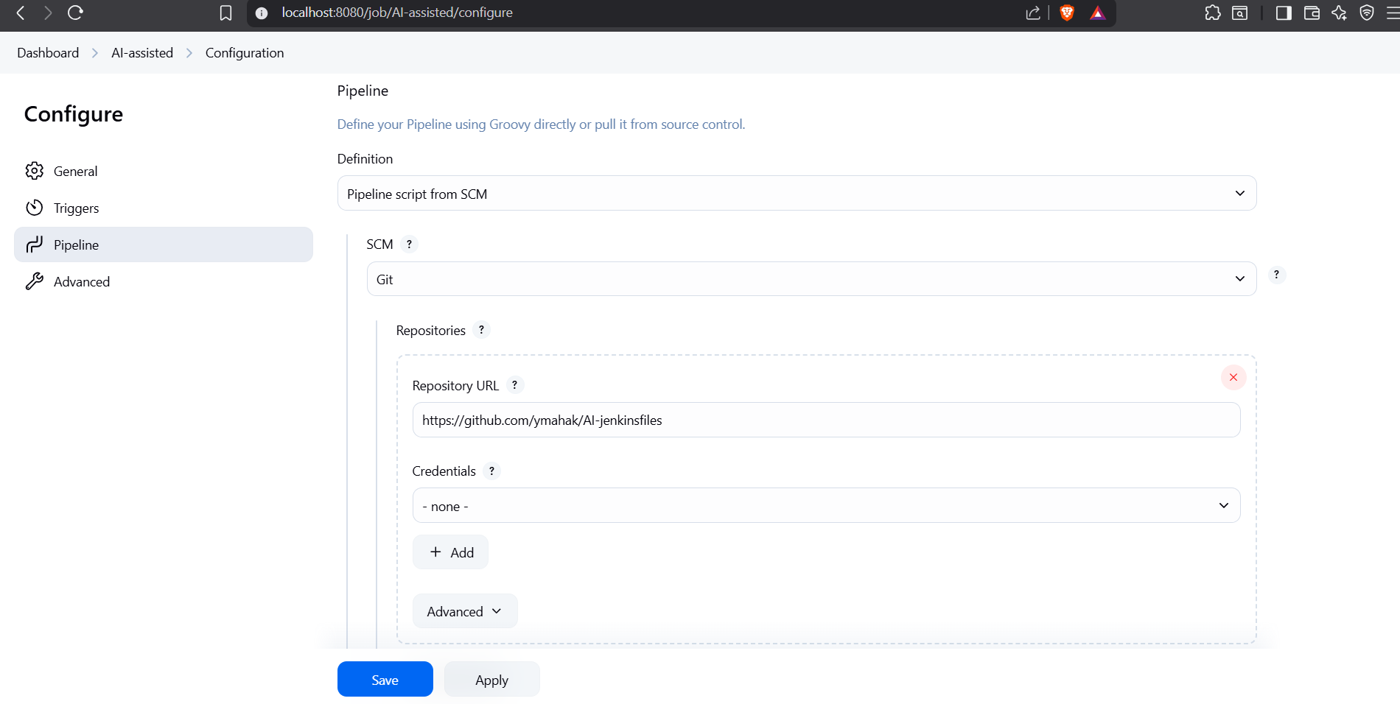
- Apply → Save.
- Click on Build Now.
- Check the console output.
