Configure Build Notification

Overview
This document explains how to configure Jenkins to send build notifications using Gmail. By automating email alerts, teams can quickly respond to build successes or failures and maintain continuous integration (CI) transparency.

Purpose
The purpose of this document is to:
- Configure Gmail SMTP with Jenkins.
- Automate build notifications to teams.
- Provide a reusable configuration for other Jenkins projects.

Step 1: Enable App Password for Gmail

If you have 2-Step Verification enabled:
- Go to: https://myaccount.google.com/apppasswords
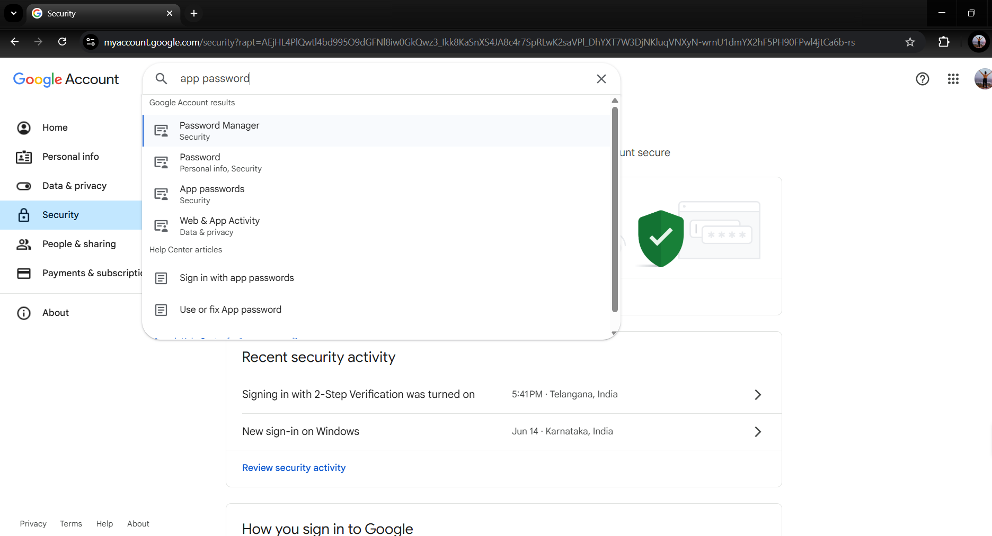

- Login with your Google account.
- To generate a password, enter any name you want to give to the app.
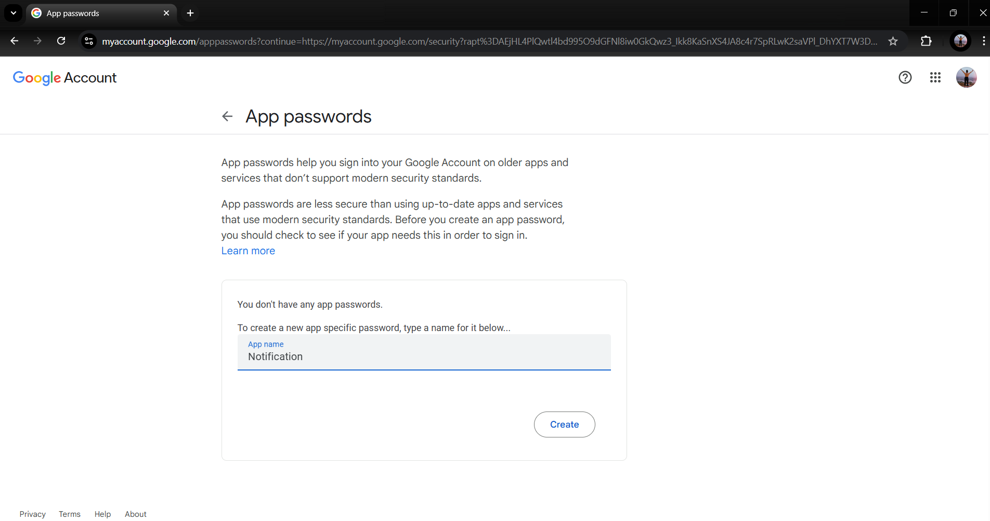
- Click Generate, copy the 16-character password.
Keep the password saved in the notepad.

Step 2: Configure Jenkins Email Notification
- Go to Jenkins Dashboard → Manage Jenkins → System Configuration → System.
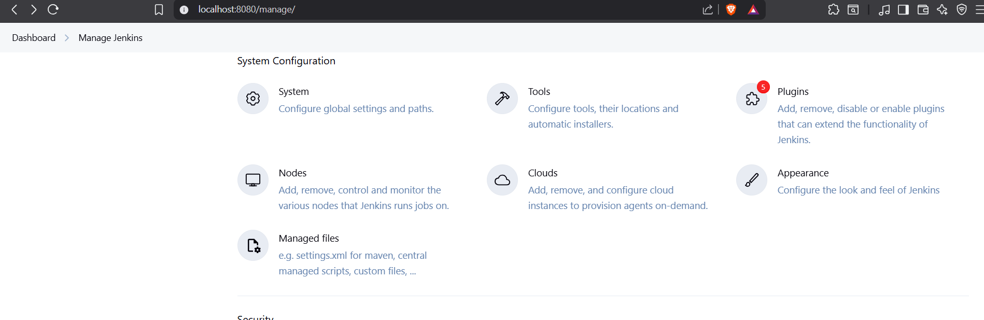
- Scroll to the "E-mail Notification" section.
- Fill the fields:
Field | Value
SMTP server | smtp.gmail.com
Default user e-mail suffix | @gmail.com
Use SMTP Authentication | (checked)
User Name | your-email@gmail.com
Password | App Password
SMTP Port | 465
Reply-To Address | your-email@gmail.com
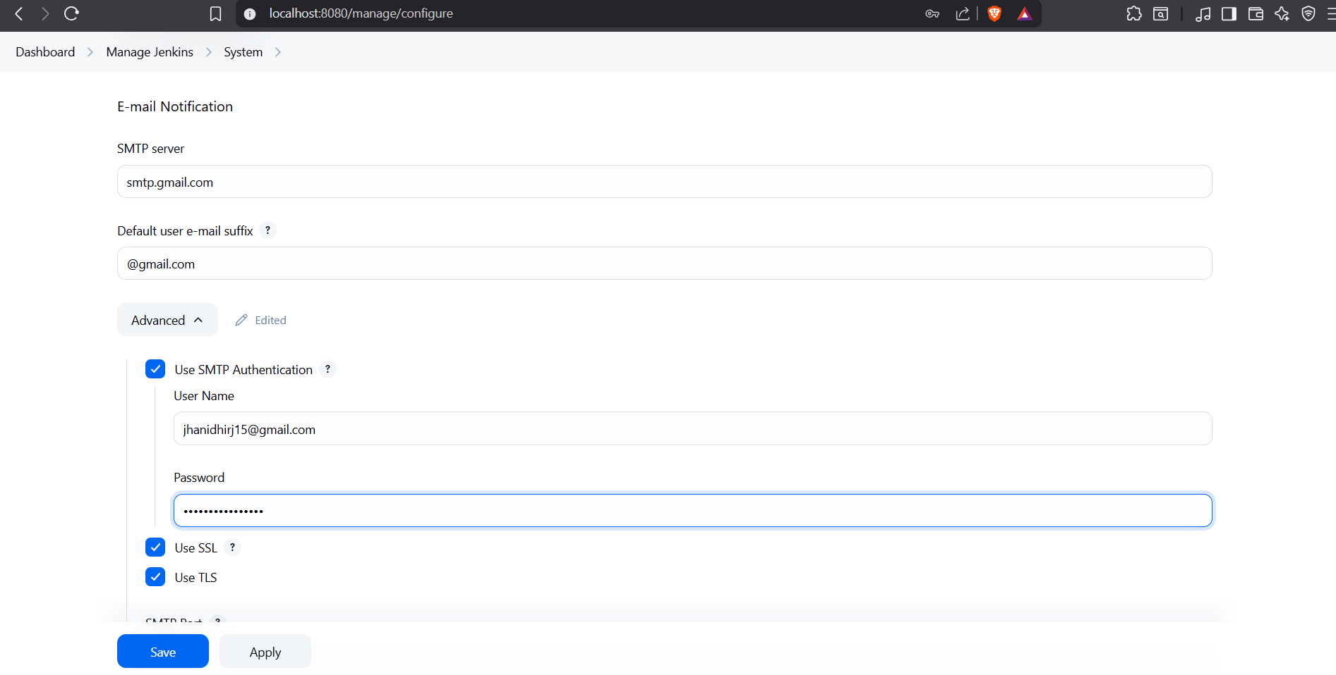
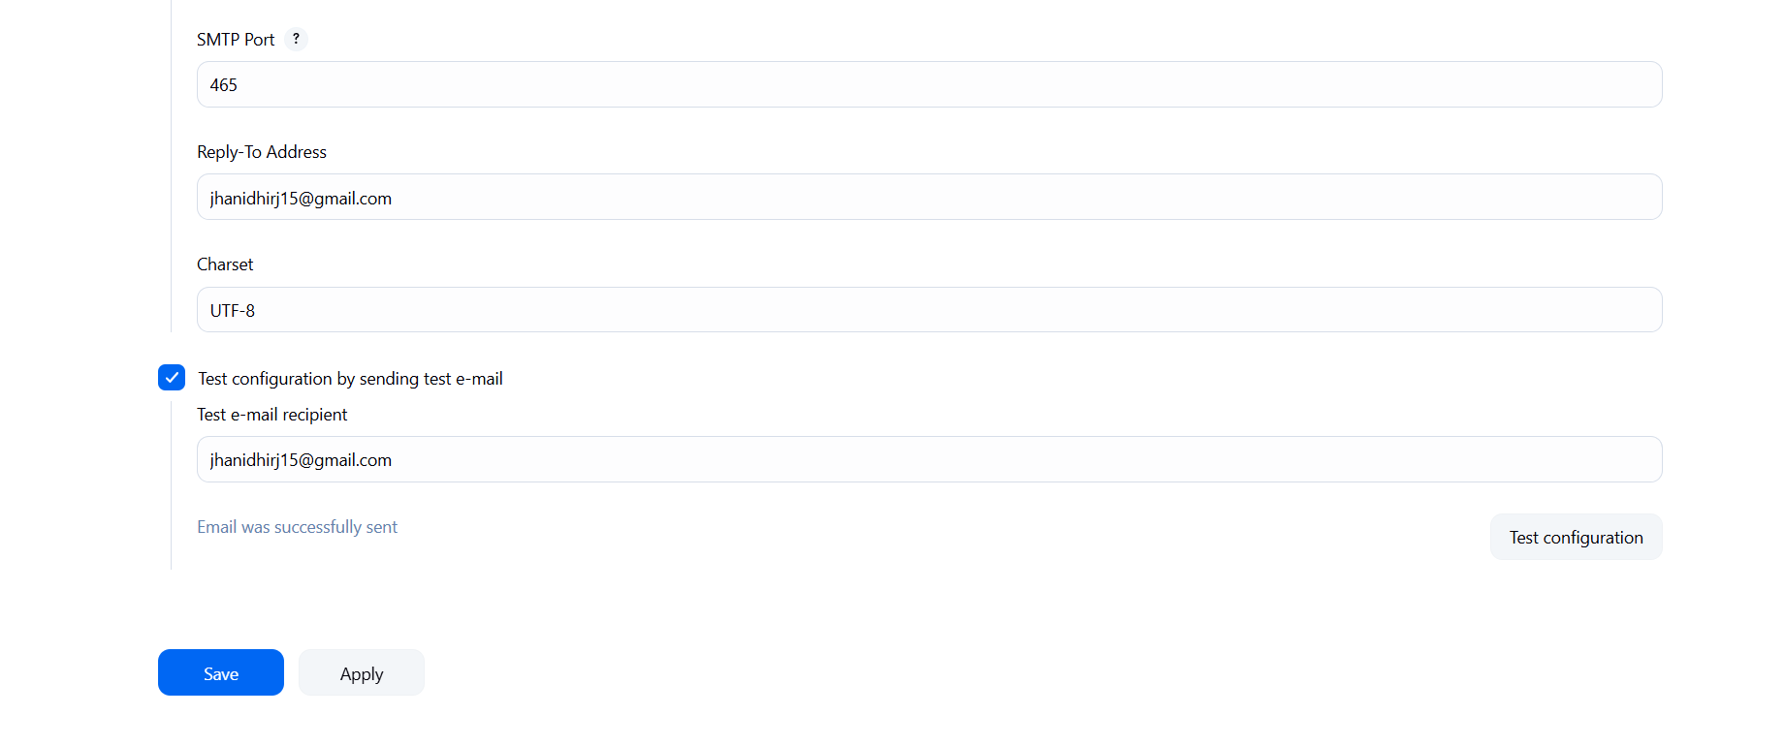

Click “Test configuration by sending test e-mail”, enter your email and check if it works.
- Check your e-mail.

Step 3: Install Jenkins Mailer Plugin
- Go to Manage Jenkins → Manage Plugins → Available
- Search for Mailer Plugin
- Install and restart Jenkins if needed.

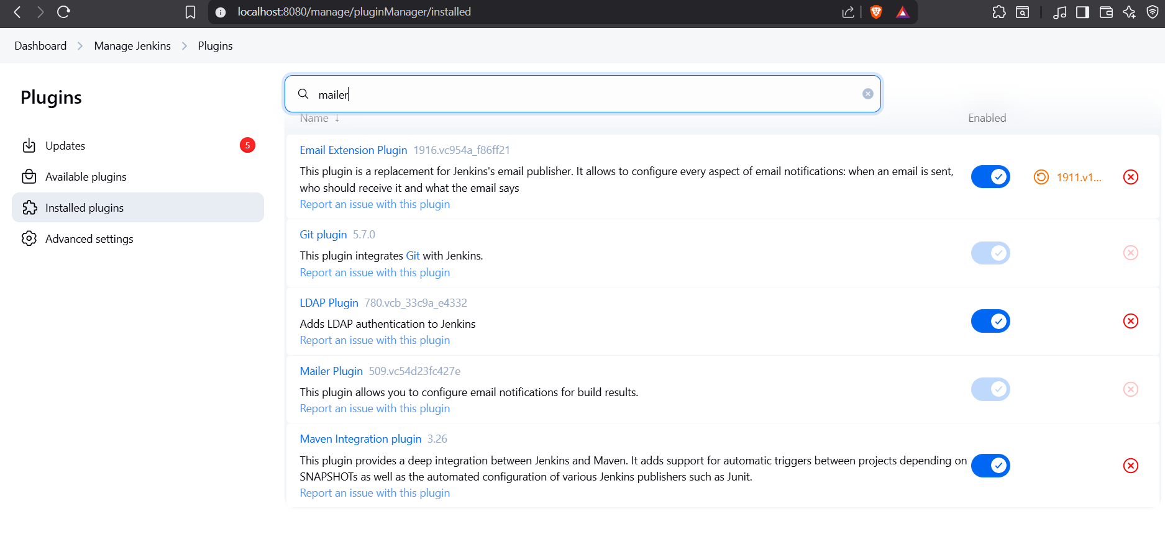

Step 4: Configure Email in Your Jenkins Pipeline (Jenkinsfile)
Add this block in your Jenkinsfile to send email on build failure/success:
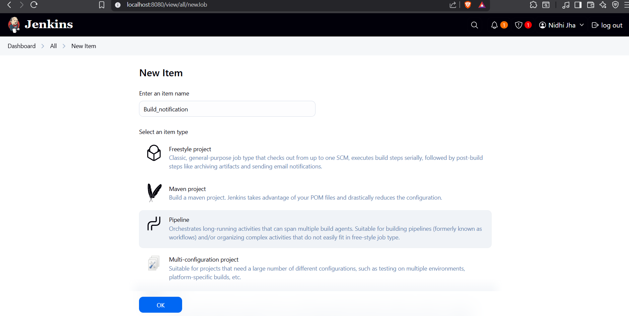
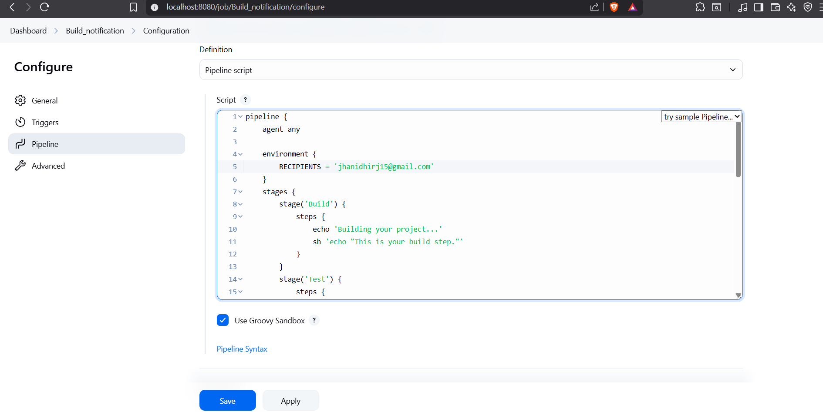

Script inside my pipeline:

pipeline {
agent any
stages {
stage('Build') {
steps {
echo 'Building your project...'
bat 'echo Simulating build process...'
}
}
stage('Test') {
steps {
echo 'Testing your project...'
bat 'echo Simulating test process...'
}
}
stage('Deploy') {
steps {
echo 'Deploying your project...'
bat 'echo Simulating deploy process...'
}
}
}
post {
success {
echo 'Build succeeded. Sending success email notification.'
mail to: 'jhanidhirj15@gmail.com',
subject: "SUCCESS: Job '${env.JOB_NAME} [${env.BUILD_NUMBER}]'",
body: "Good news! Build succeeded.\n\nCheck the details here: ${env.BUILD_URL}"
}
failure {
echo 'Build failed. Sending failure email notification.'
mail to: 'jhanidhirj15@gmail.com',
subject: "FAILURE: Job '${env.JOB_NAME} [${env.BUILD_NUMBER}]'",
body: "Unfortunately, the build failed.\n\nCheck the details here: ${env.BUILD_URL}"
}
}
}

Step 5: Save and Run
- Save the Jenkinsfile
- Trigger the build
- Check the mailbox of the configured recipient after the build completes.
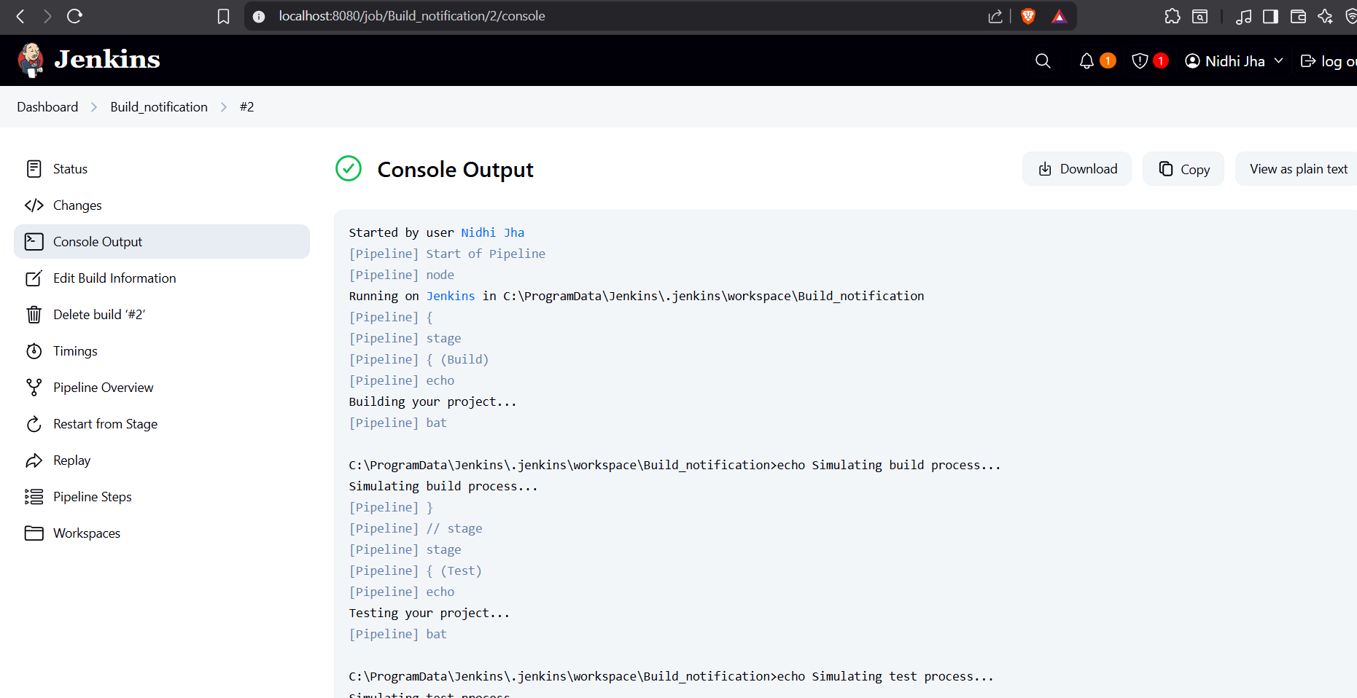
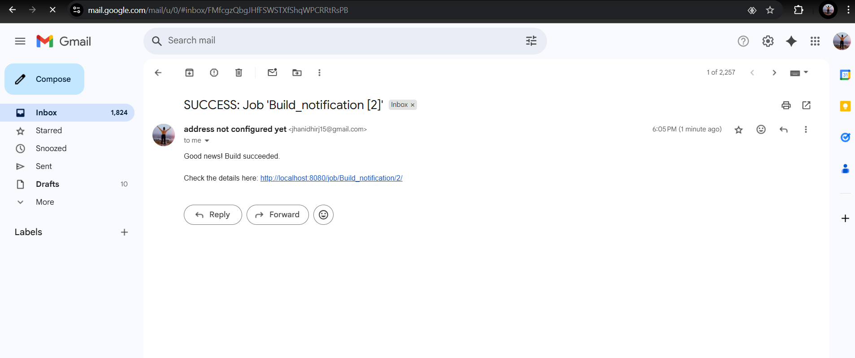

Conclusion:
This configuration automates manual email notification steps during the Jenkins build lifecycle.

This Jenkins setup automates these tasks:
- Configure SMTP: Sets up Gmail SMTP authentication securely with an App Password.
- Send Build Notifications: Automatically sends email alerts on build success or failure.
- Integrate in Jenkinsfile: Embeds the notification steps directly in the pipeline using the mail step.
- Improve Team Communication: Ensures the development team stays informed without manual status updates.
- Reusable Configuration: Provides a reusable setup that can be applied across multiple Jenkins projects.

