Create build automation script

Overview

Purpose
The objective of this document is to provide a guide to automate the build and deployment process of a Node.js application using Jenkins Pipeline. Automating builds increases development efficiency, reduces human error, and enables Continuous Integration (CI).

Scope
This document covers:
- Plugins installation
- Jenkins pipeline job creation
- Integration with a GitHub repository containing a Node.js application and JenkinsFile
- Automating dependency installation, build, and local deployment of the Node.js project

1. Install Jenkins & Required Plugins
- Install Jenkins on your system.
- Make sure essential plugins are installed:
  - Pipeline
  - Git
  - Nodejs Plugin
To install plugins , follow the step:
Manage Jenkins → Plugins → Select the required plugins & install them.
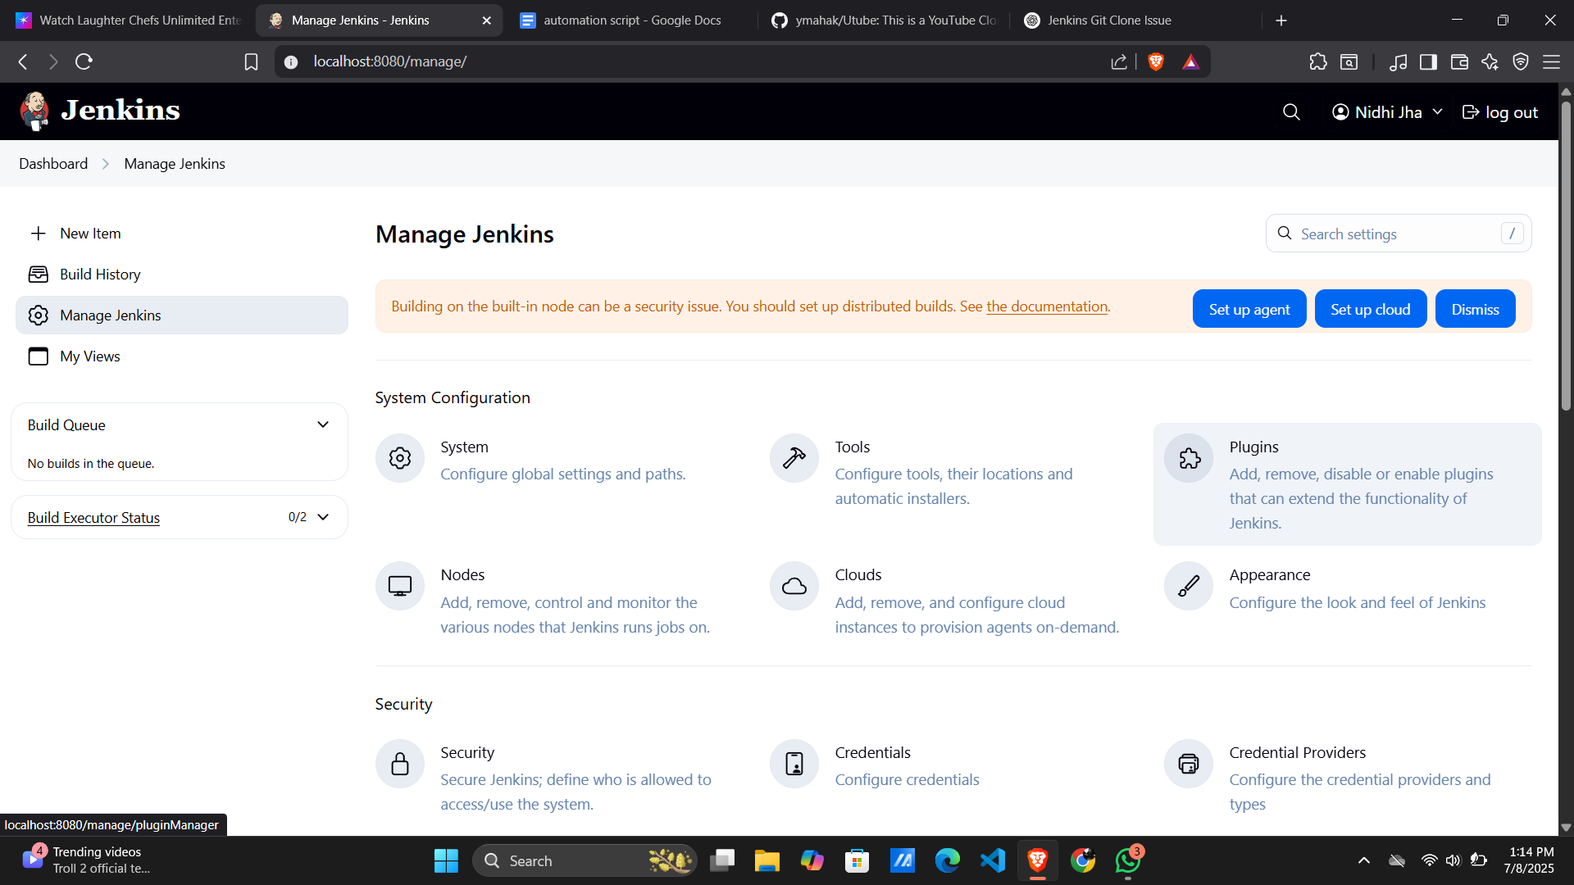

2. Create a Jenkins Pipeline Job
- Go to Jenkins Dashboard → New Item → Create a job.
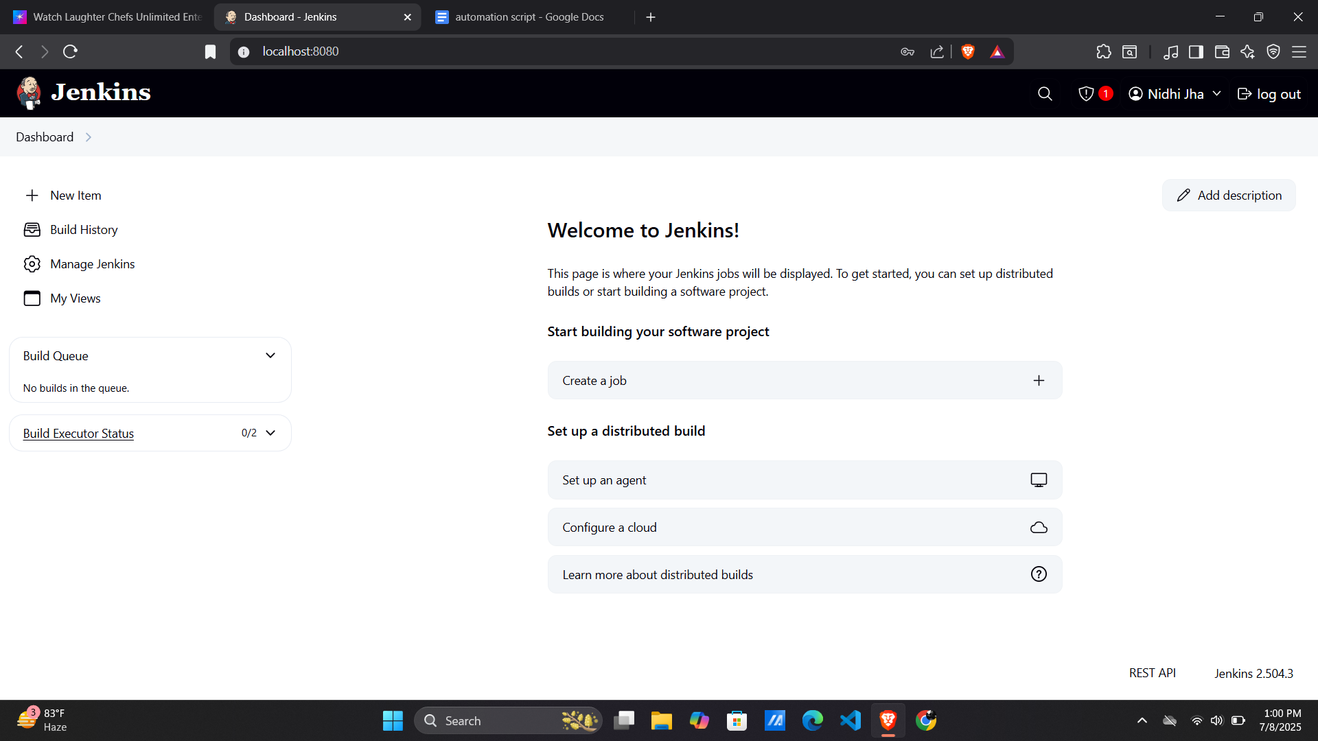
- Enter your job name → (Automation).
- Select Pipeline → Click OK.
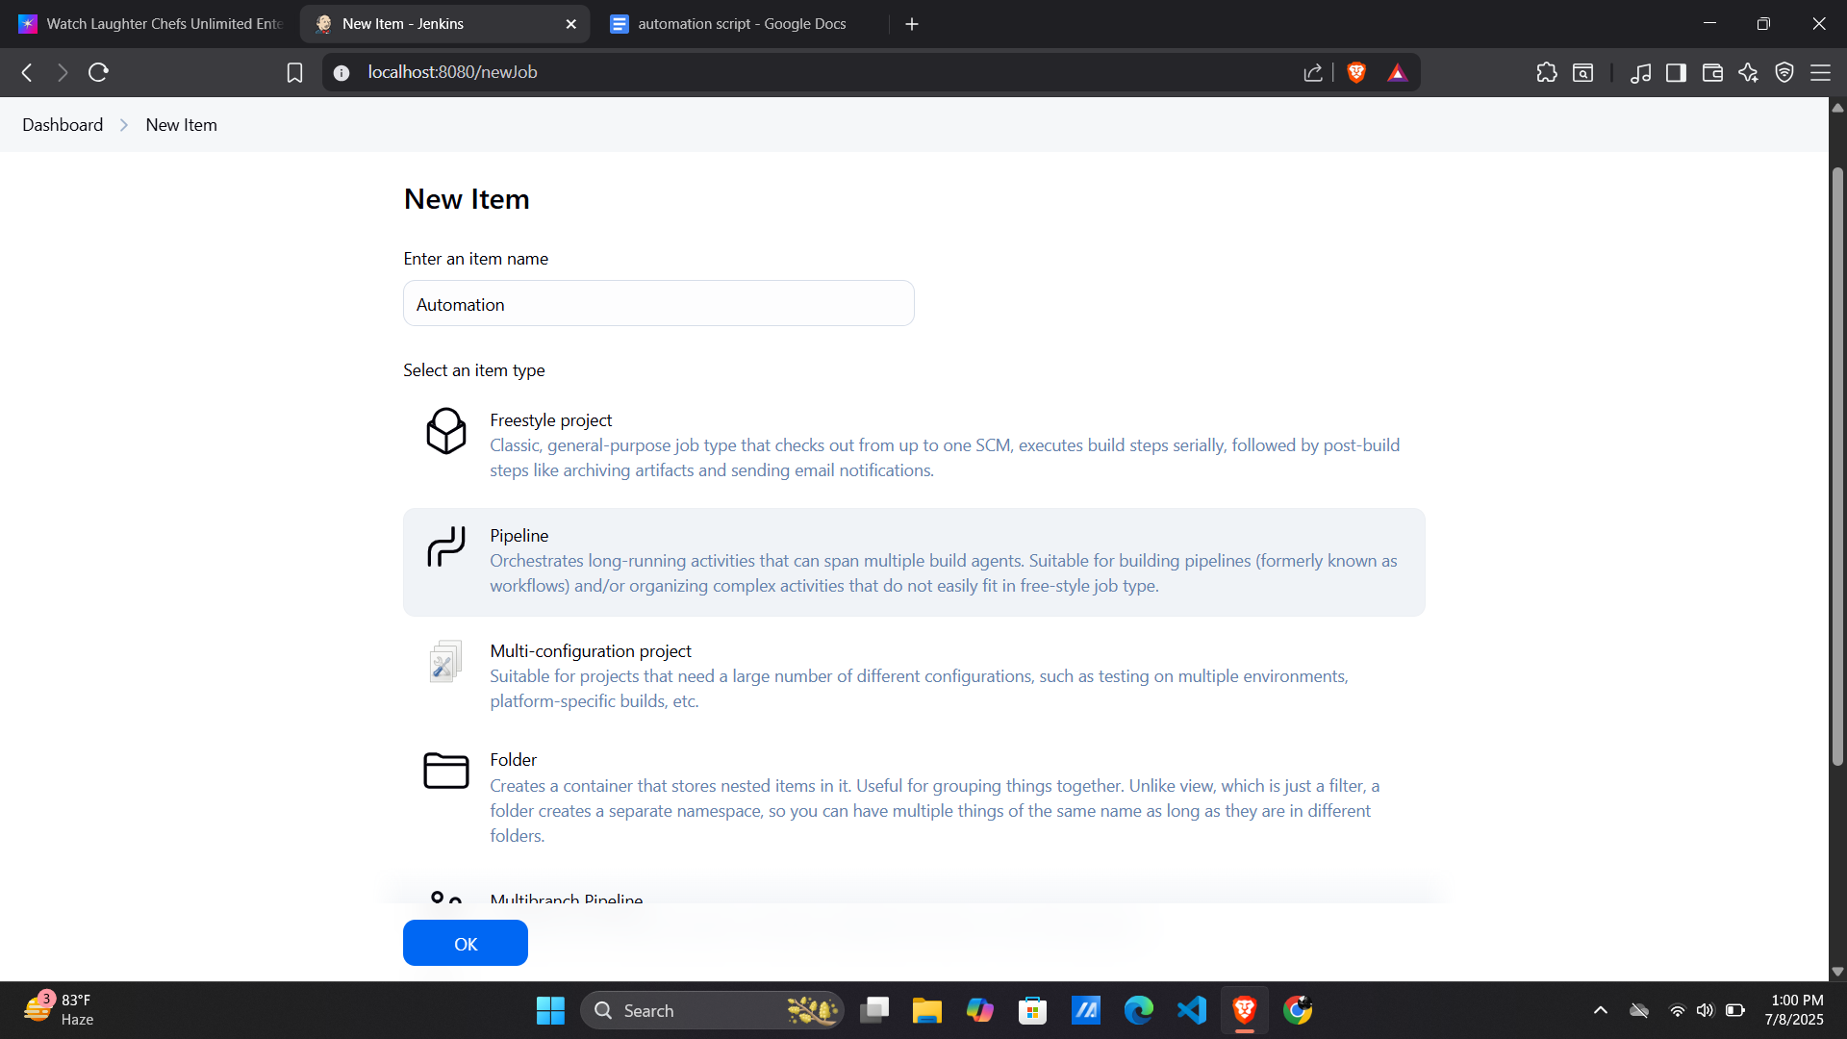

After this , the configuration page will come.

3: Configure GitHub Repository in the Pipeline

If you're storing the Jenkinsfile in your repository, follow the following steps:

Under Pipeline → Definition → Pipeline script from SCM:

Choose Git

Enter your GitHub URL

Add credentials if private

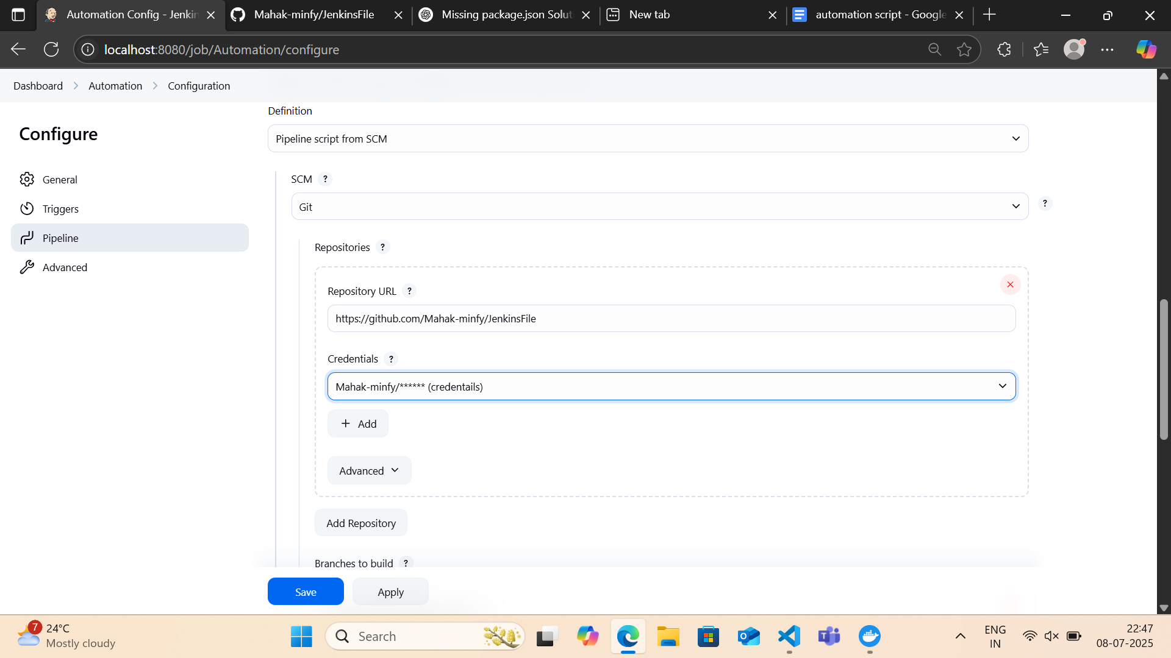

Set the branch (e.g., main).

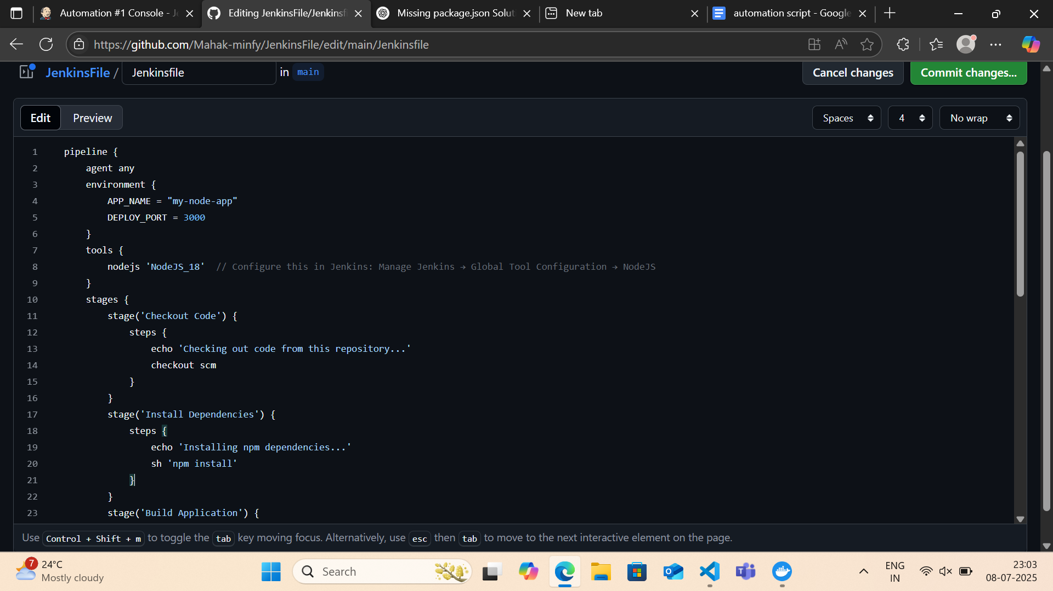
Script Path: Jenkinsfile.

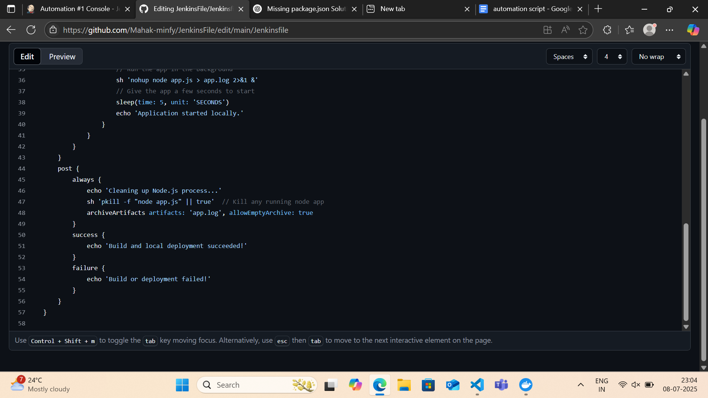
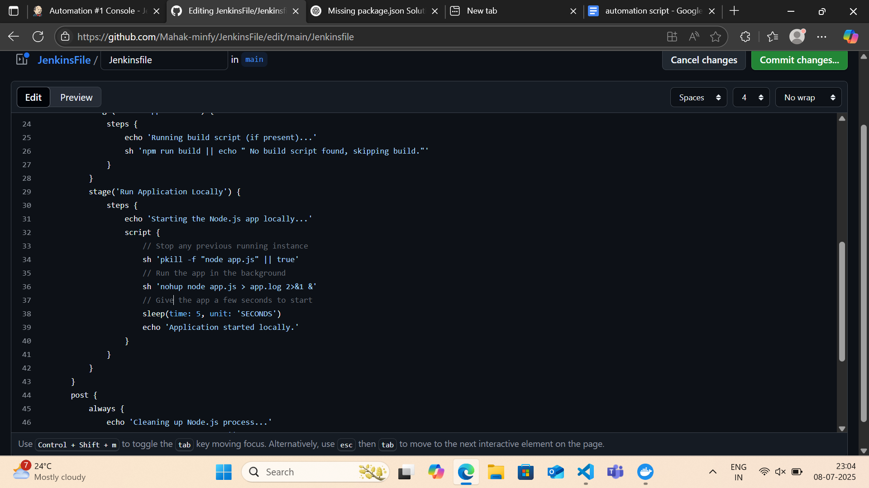

4. Save & Run the Pipeline
- Click Apply & Save.
- Hit Build Now to test.
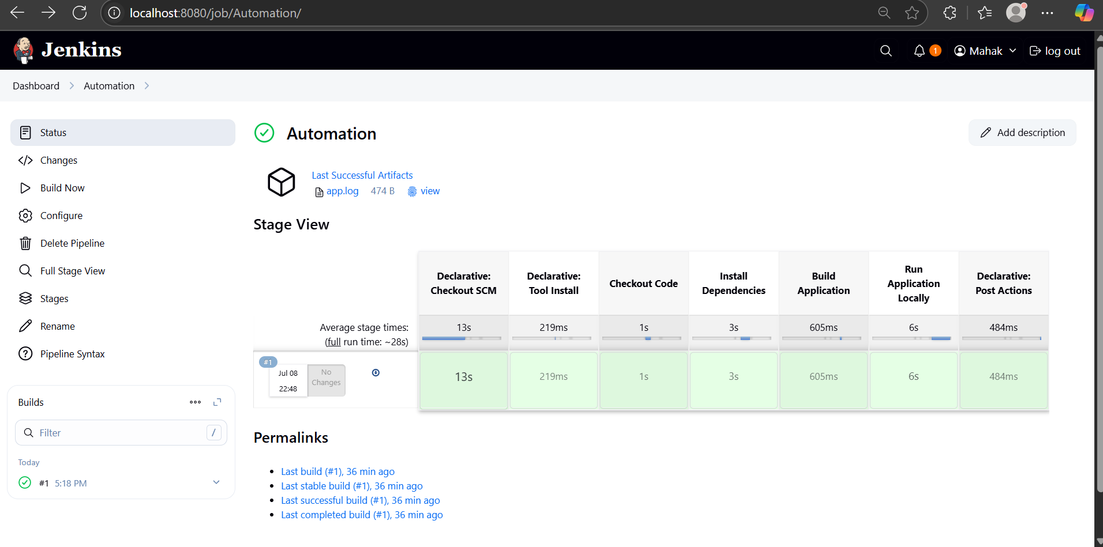

- View logs in Console Output.
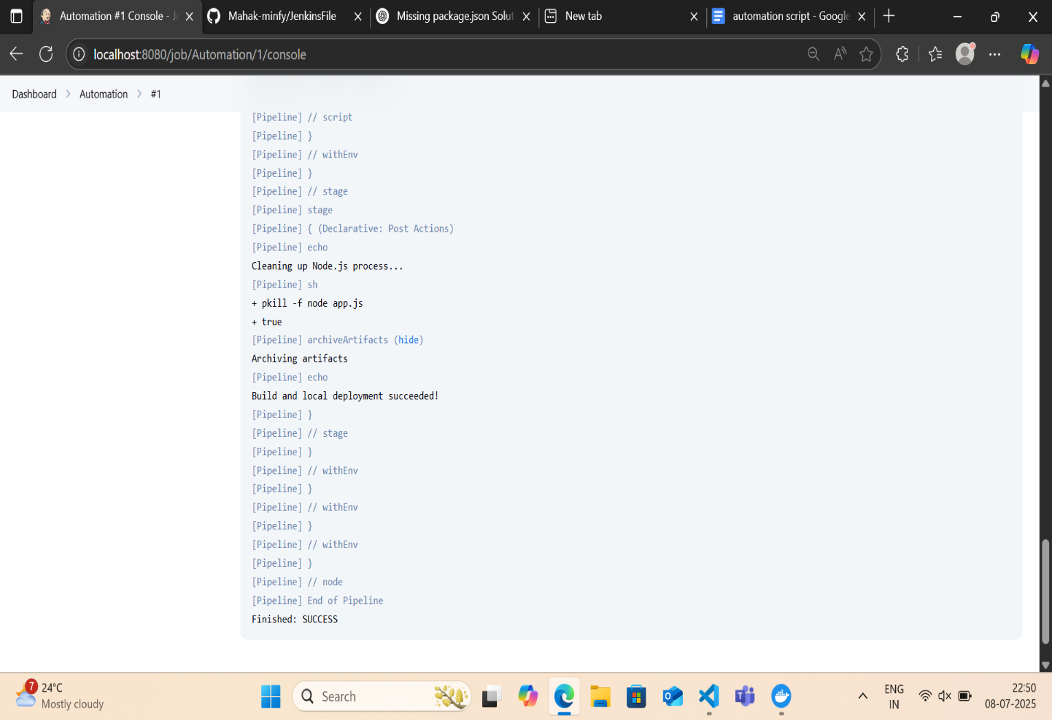

Conclusion:
This script automates manual build and deployment steps.
This Jenkinsfile automates these tasks:
- Checkout: Automatically pulls the latest code from my Git repository.
- Install Dependencies: Runs npm install to install Node.js dependencies.
- Build Application: Runs npm run build if a build script exists.
- Run Application Locally: Starts myr Node.js application (app.js) in the background.
- Clean Up & Archive Logs: Stops the Node.js process and saves logs.

