Install and configure Jenkins CI server

The simplest way to install Jenkins on Windows is to use the Jenkins Windows installer.

Prerequisites
- Minimum hardware requirements:
- 256 MB of RAM
- 1 GB of drive space
- Java

Firstly let’s install Java
Step 1 : Download the Java SE Development Kit 21.0.7 from Oracle.
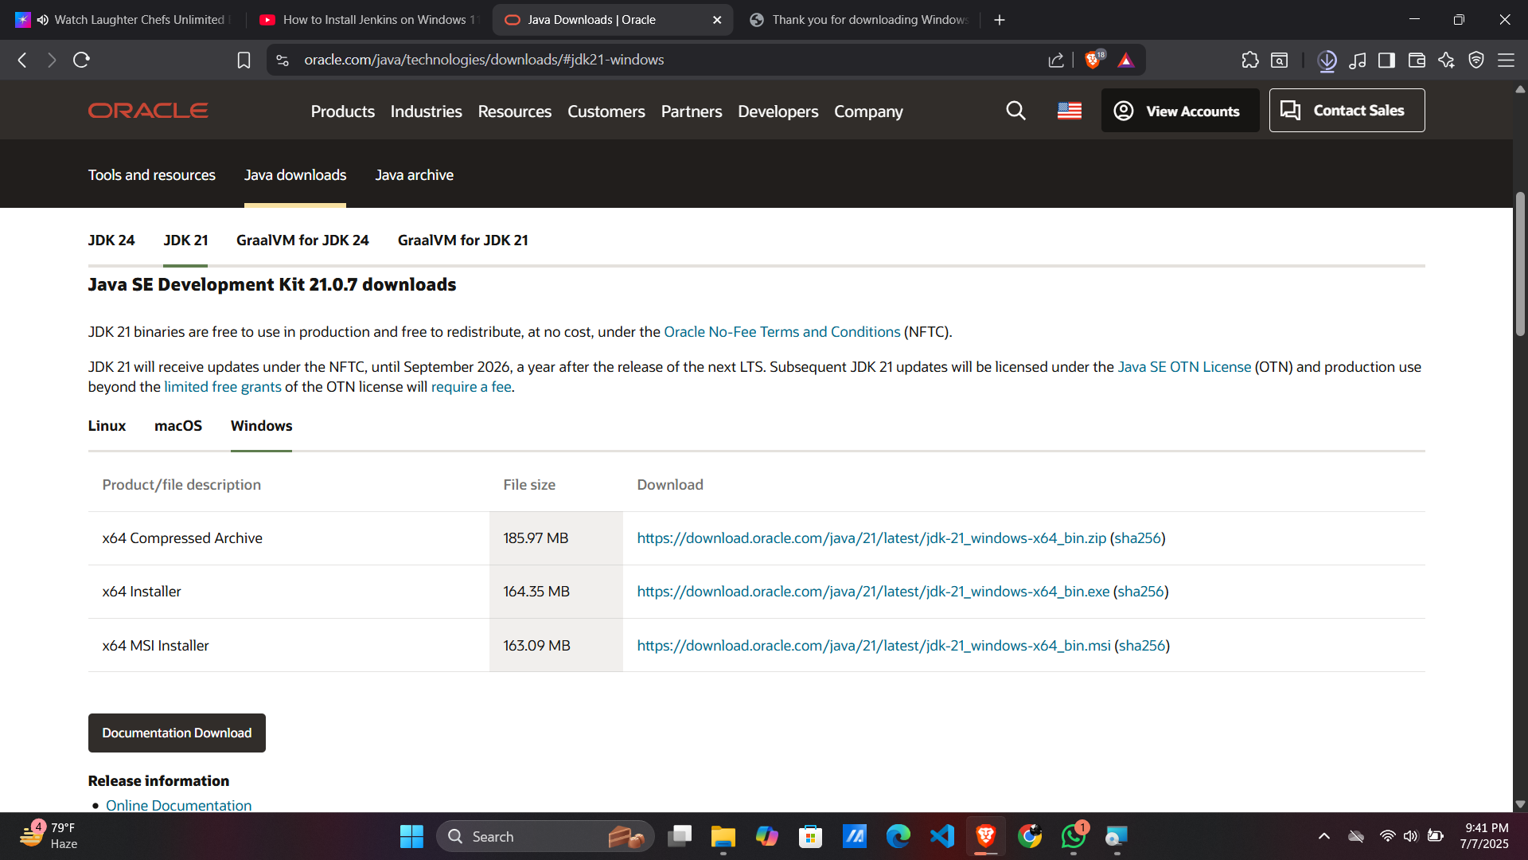

After downloading , install Java on your device. Click → Next.

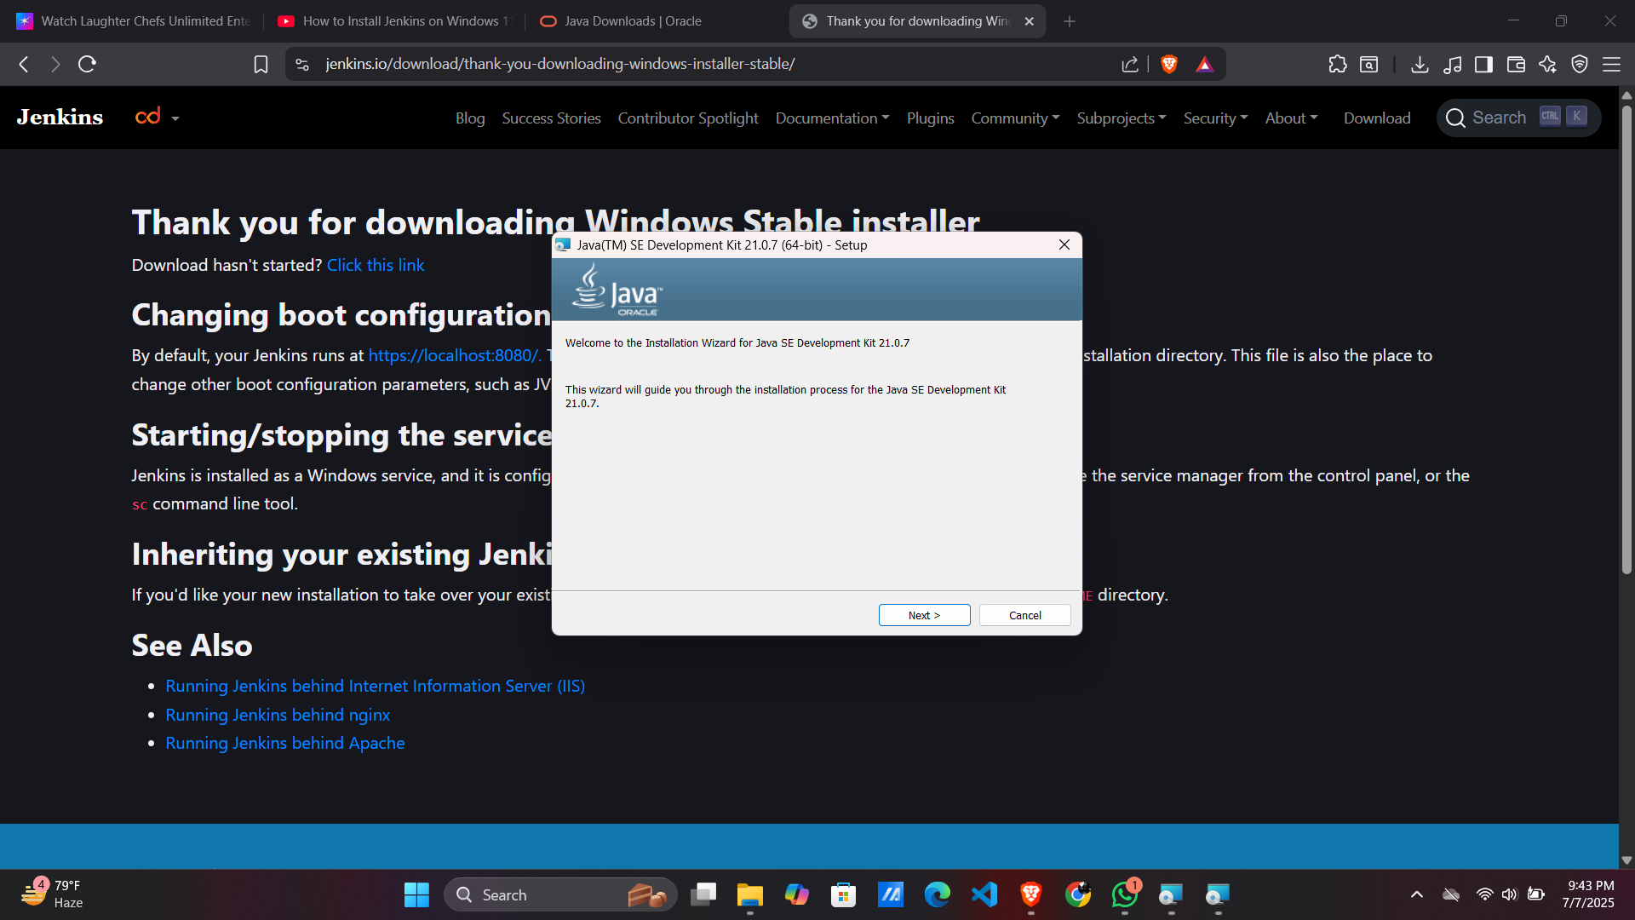
Click → Next . Java is successfully installed in your computer.

Installation steps:
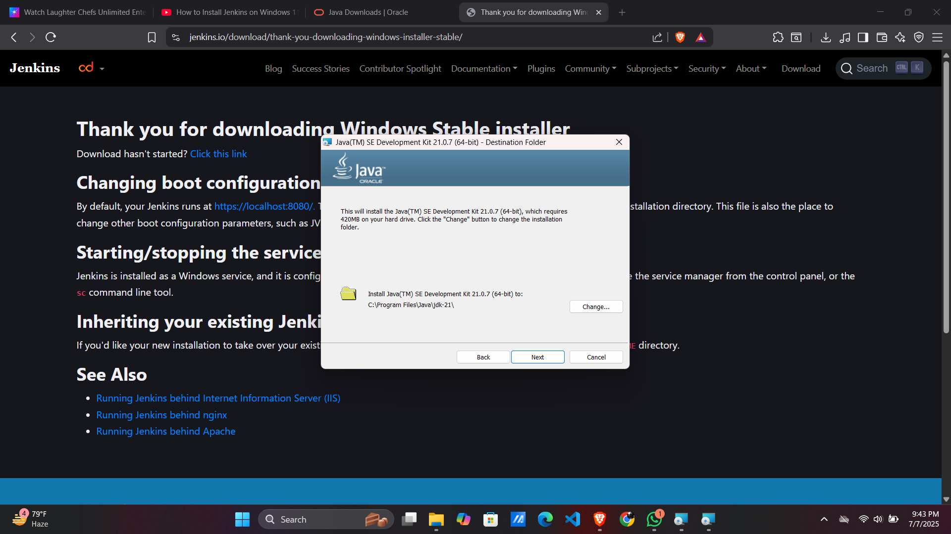
- Download Jenkins for Windows
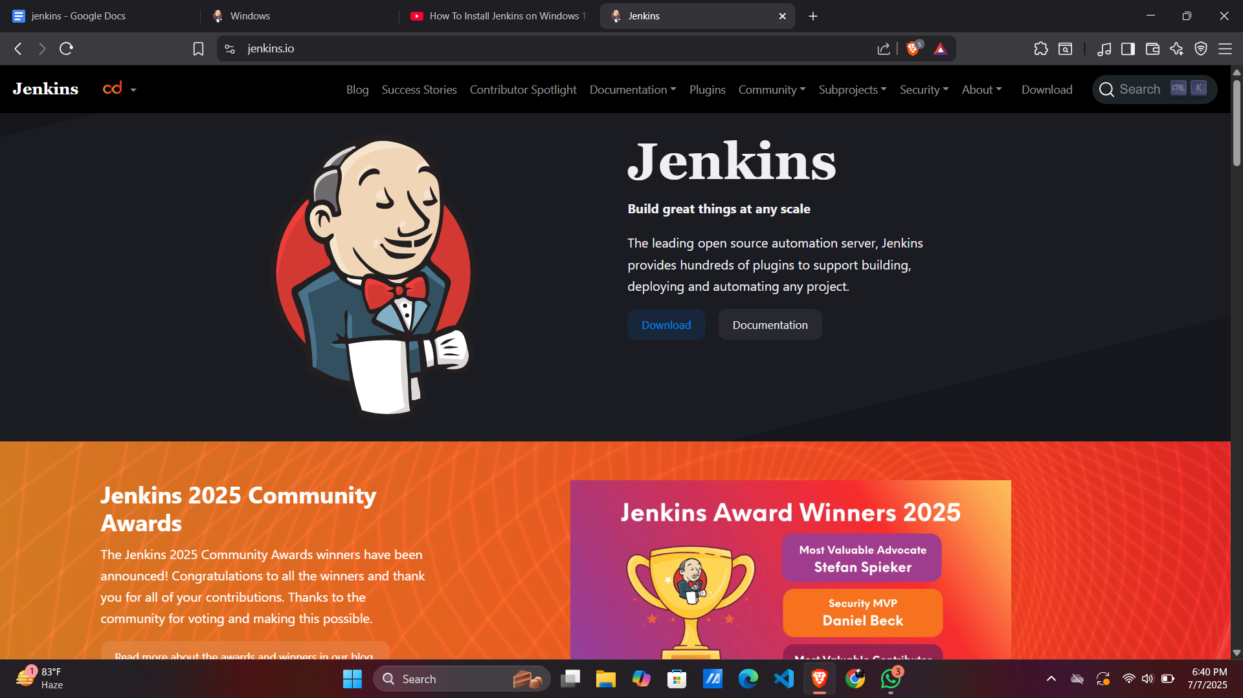

- Download either an LTS release or a weekly release of the Windows installer.
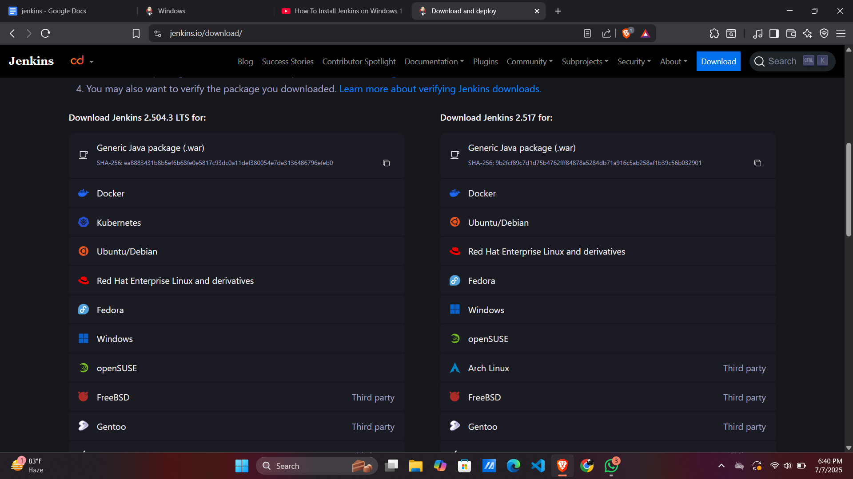

After the download completes, open the Windows installer and follow the steps below to install Jenkins.

Step 1: Setup the Wizard. Click next
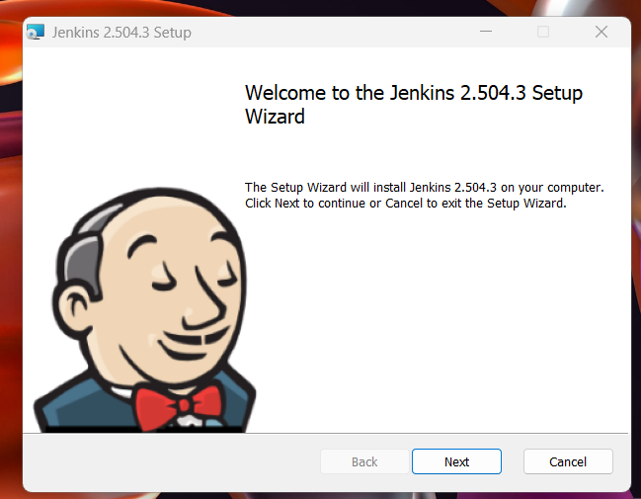

Step 2: Select the destination folder where you want to install jenkins. Click → Next to continue.
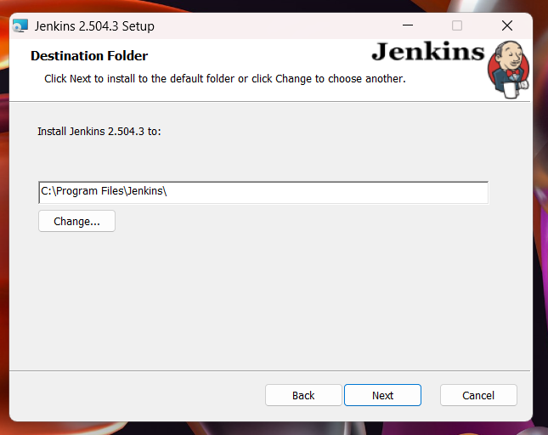

Step 3: Give the Service logon credentials

Specify the domain user name and password with which you want to run Jenkins, click on Test Credentials to test your domain credentials, and click on Next.
- We can also run service as LocalSystem if we only want to run the jenkins in our local machines.
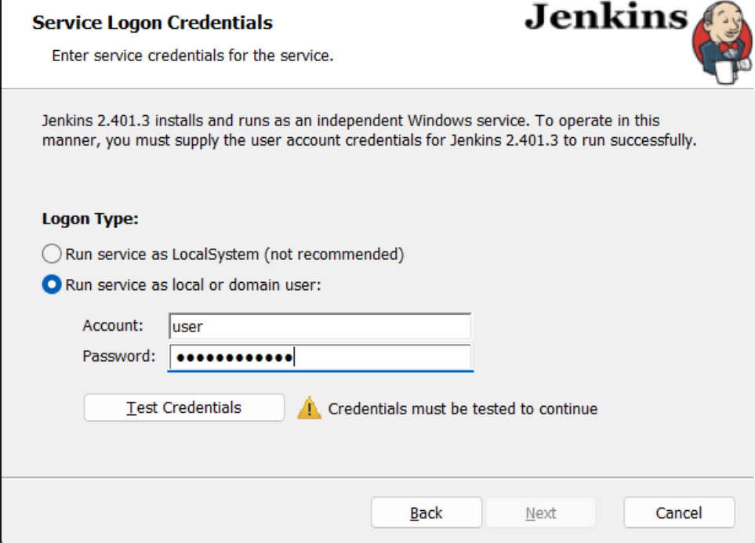

Step 4: Select the Port
Select the port on which you want to run Jenkins, and then click the Test Port button to validate whether the specified port is free on your machine or not.
Test the port and click → Next to continue.

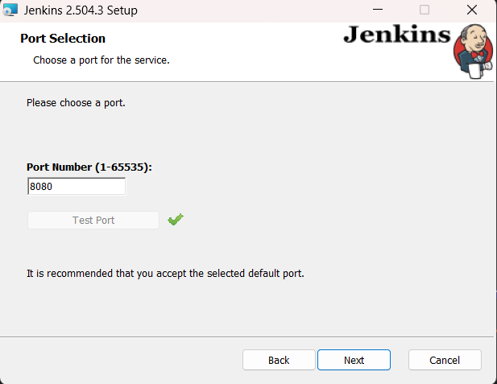

Step 5: Select Java home directory

As we have installed Java earlier, now add the home directory path.
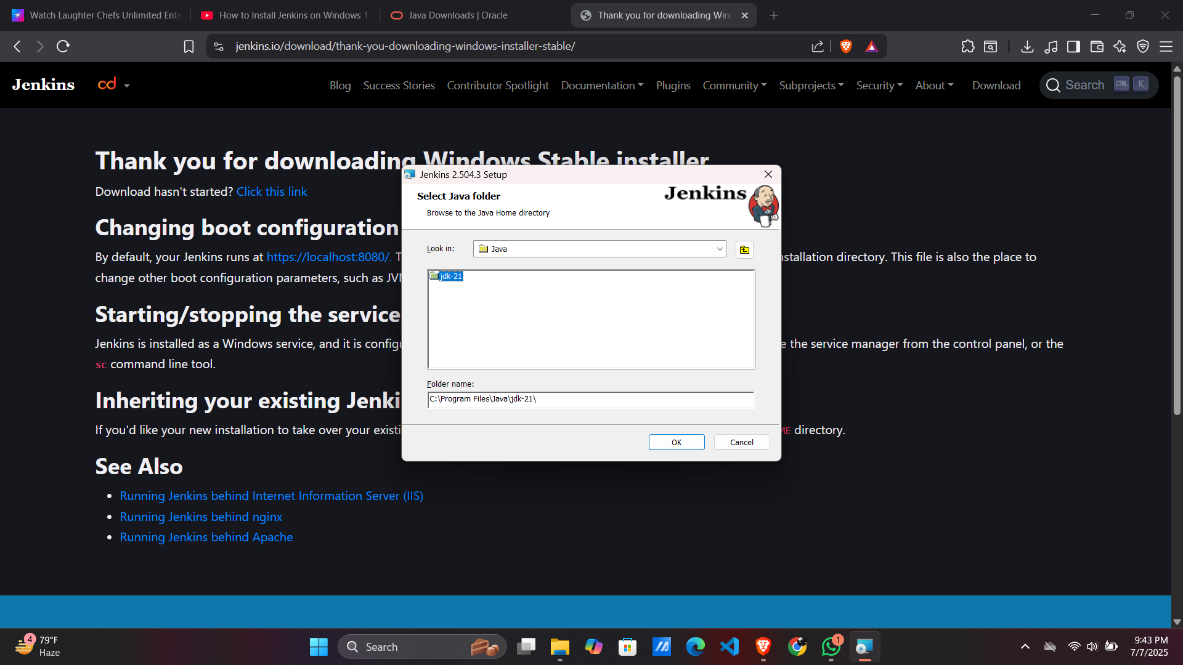
Click → Ok.

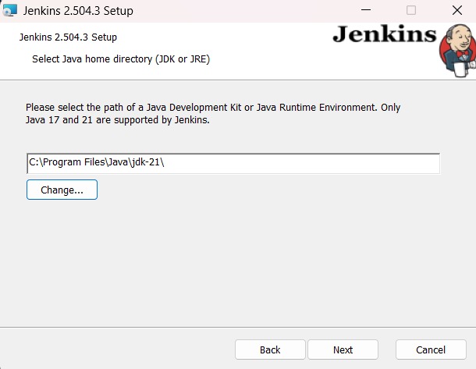

Click → Next.
Step 6: Custom Setup
Select Jenkins and Click → Next.
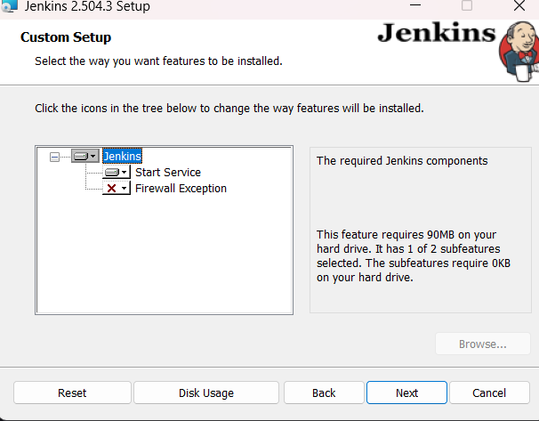
Step 7: Finish Jenkins installation.

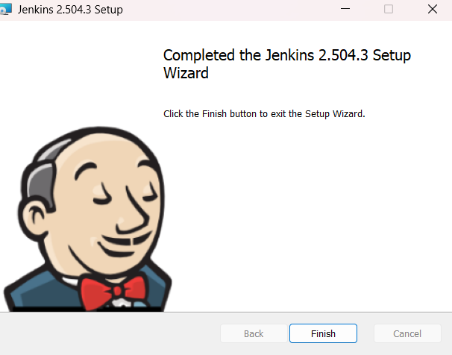

Configure Jenkins

Step 1: Browse to http://localhost:8080 and wait until the Unlock Jenkins page appears.
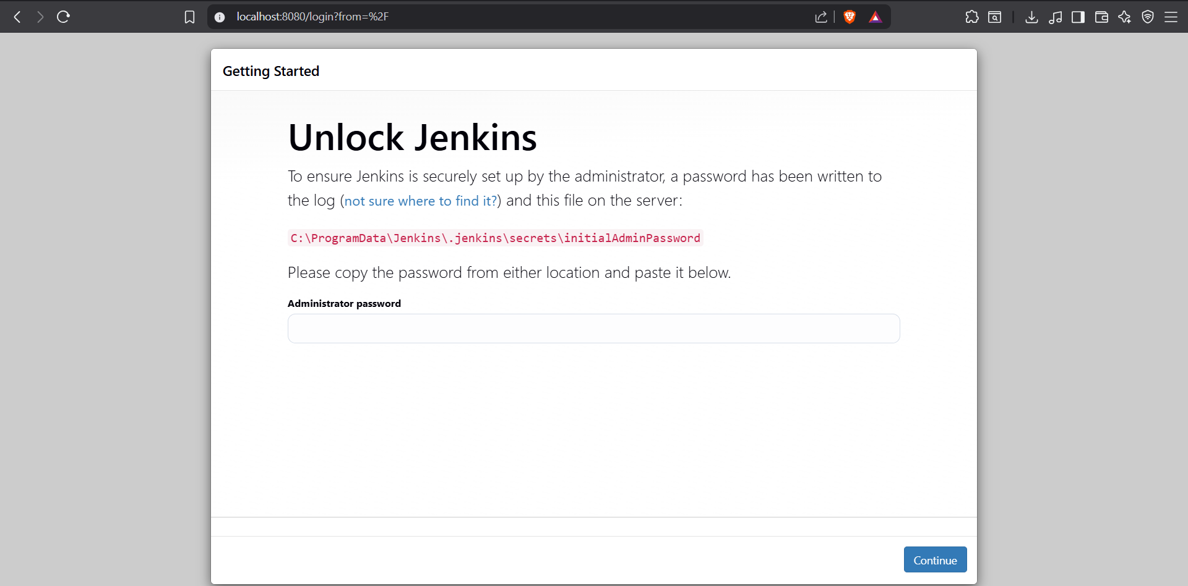

Here the path is given, Copy this path and find the path in your system.

- Open the highlighted file and copy the password from the initialAdminPassword file.

Step 2: Customise Jenkins

- Install the suggested plugins.
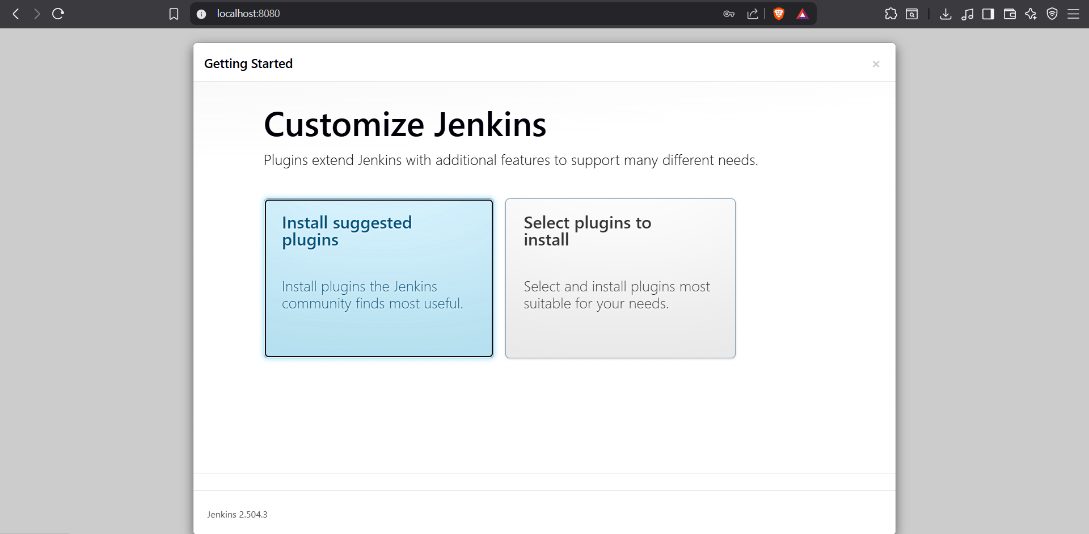

Step 3: The plugins are getting installed.

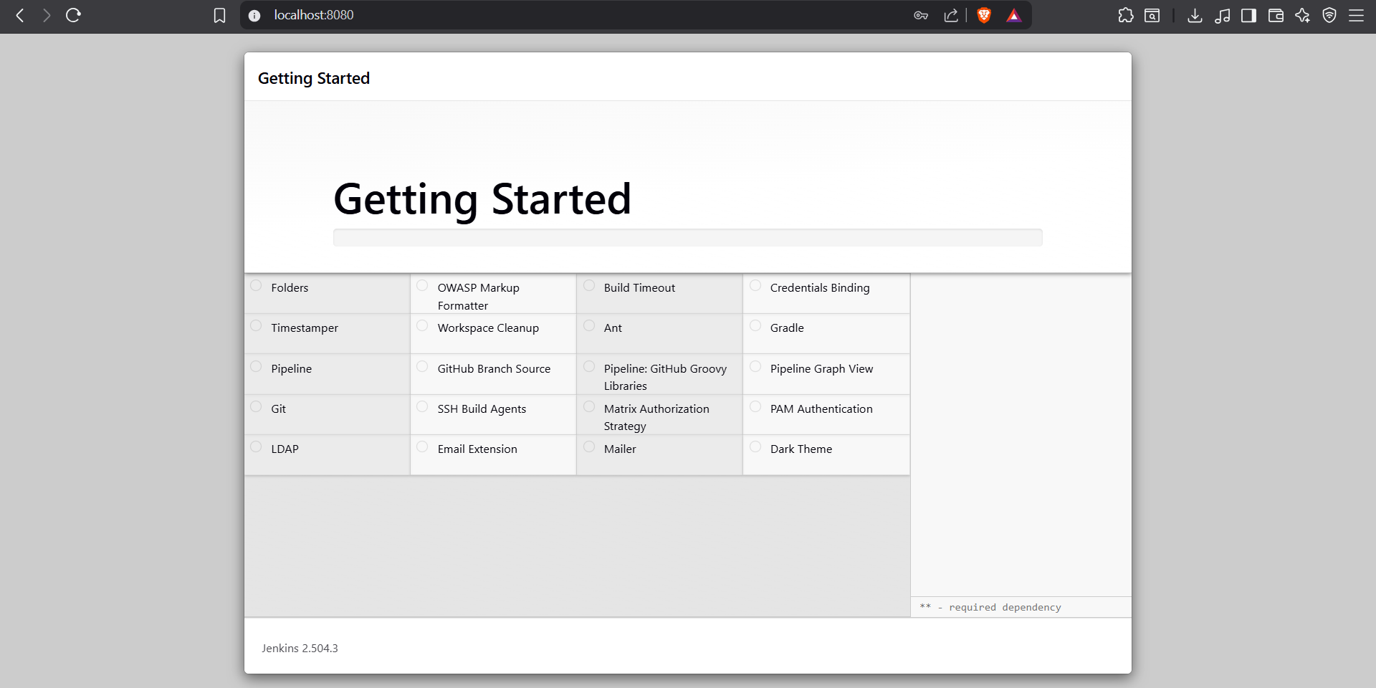

Step 4: Add your Admin User details

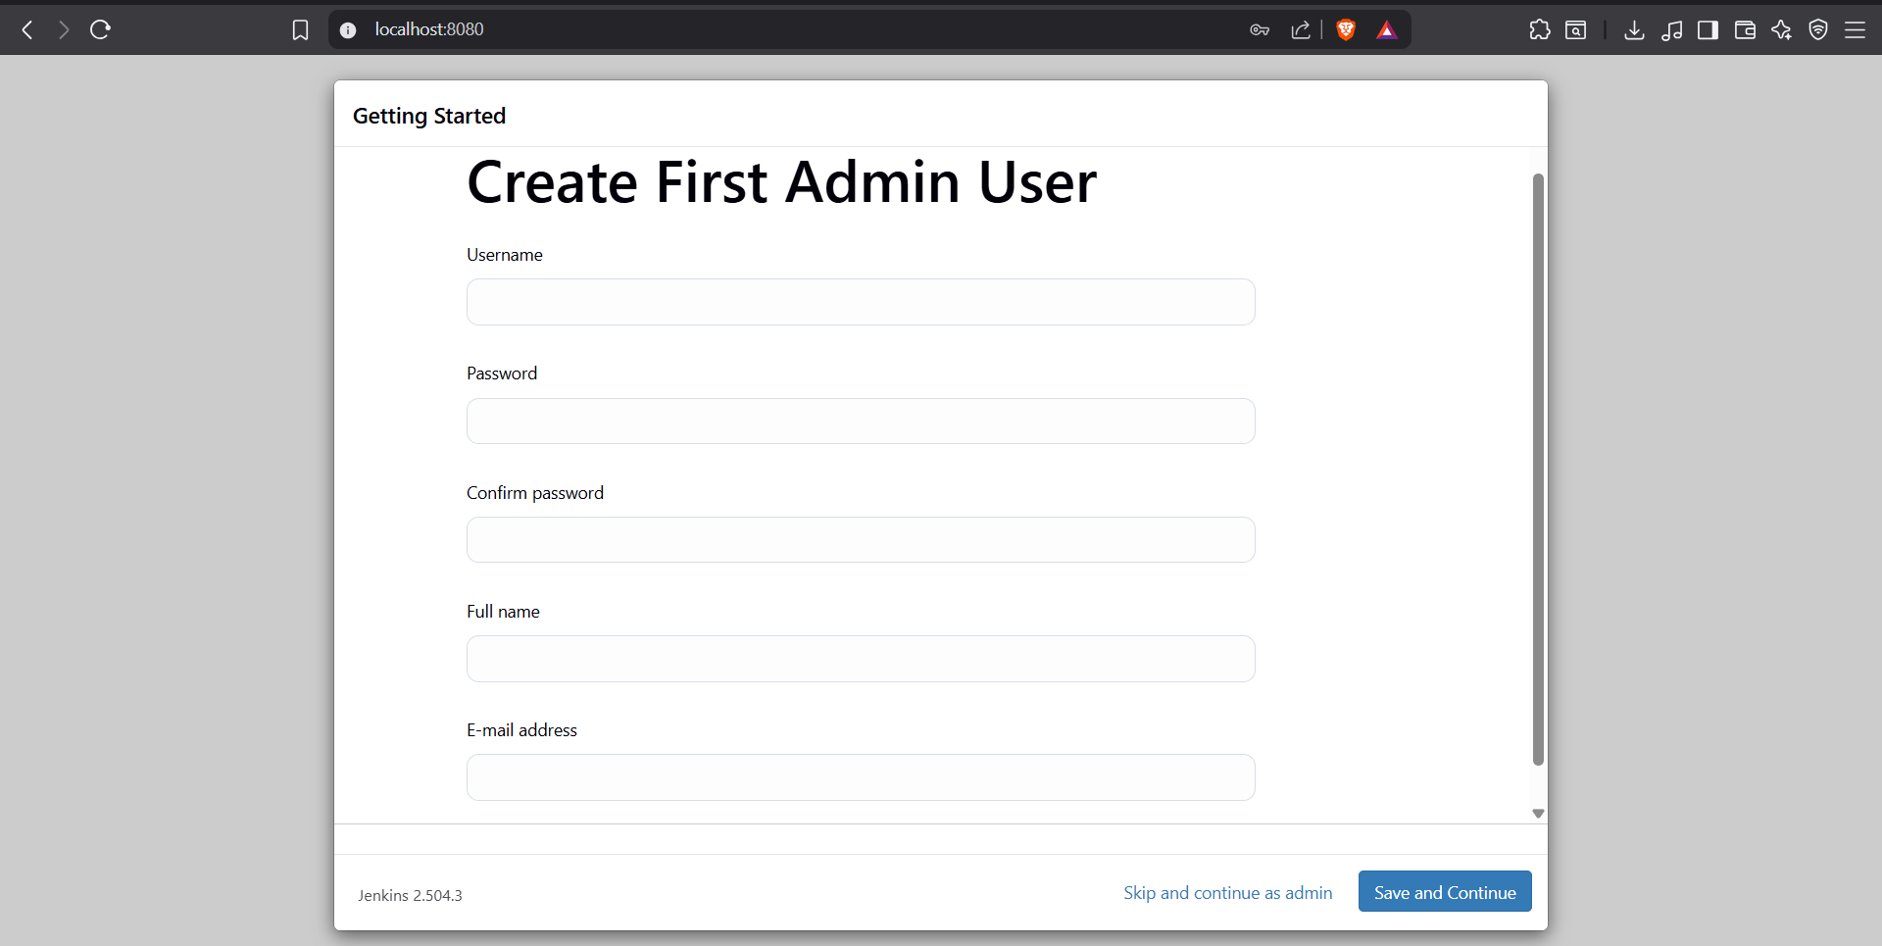

Step 5: Check your URL

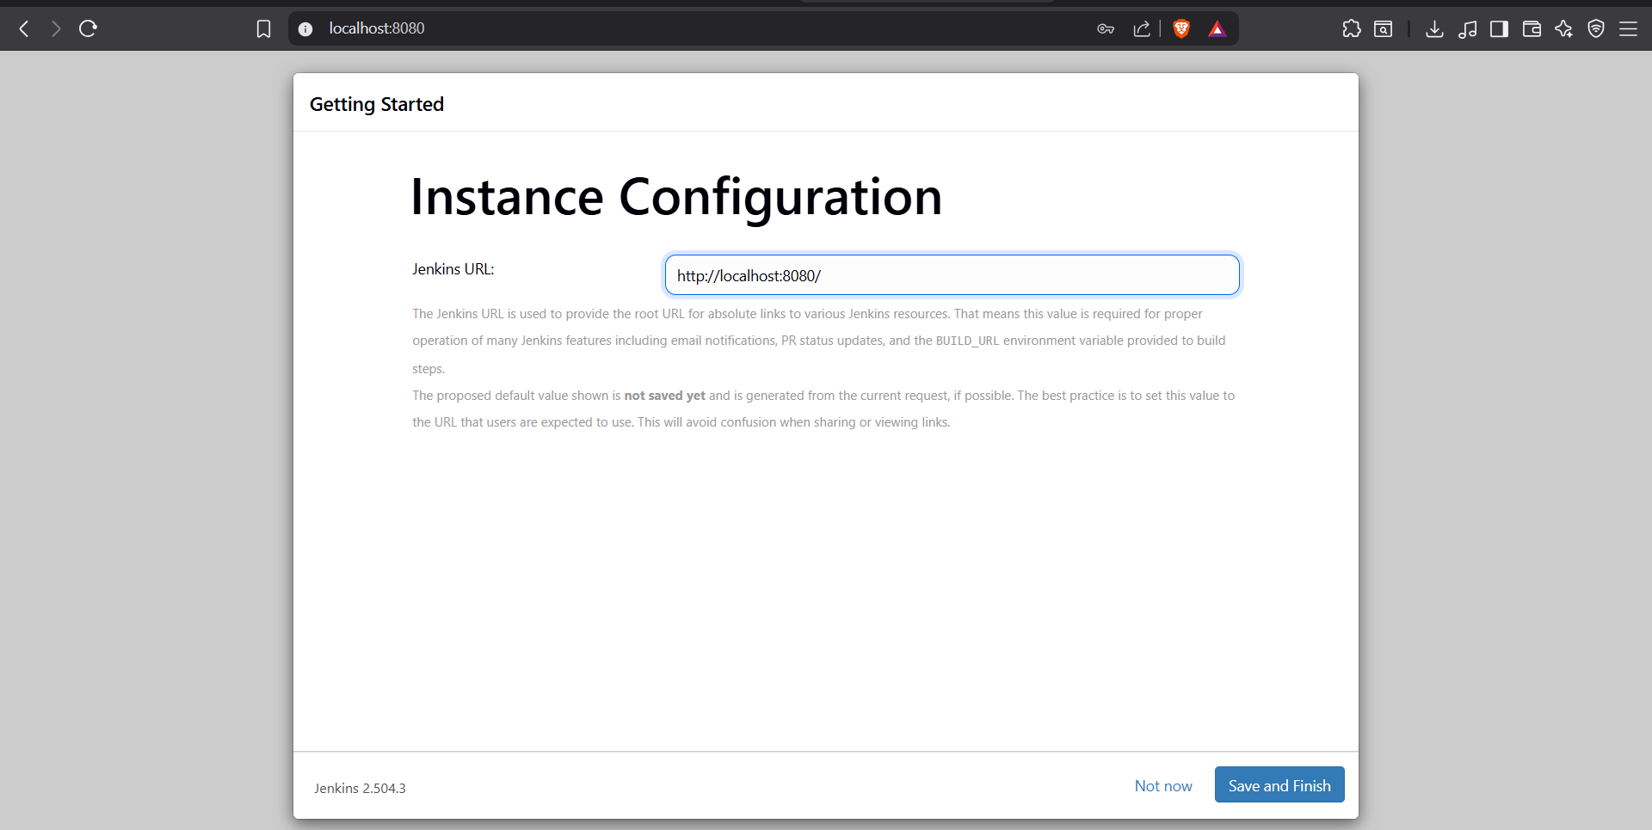

Step 6: Jenkins is ready now! Start using Jenkins.

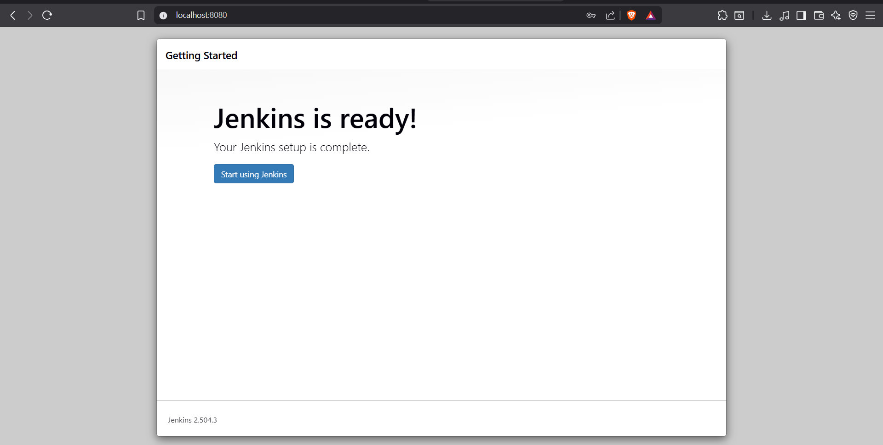

Step 7: Dashboard of Jenkins
