Integrate Automation Testing

Overview

Purpose
The objective of this document is to provide a guide to automate the testing process of a Node.js application using Jenkins Pipeline.
Automating tests improves code quality, enables rapid feedback during development, and forms a key part of Continuous Integration (CI) pipelines.

Scope
This document covers:
- Jenkins installation and required plugin setup.
- Jenkins pipeline job creation for automated testing.
- Integration with a GitHub repository containing a Node.js application and Jenkinsfile.
- Automating dependency installation and executing automated test cases for the Node.js project.
- Publishing and viewing test results in Jenkins.

1. Install Jenkins & Required Plugins
- Install Jenkins on your system.
- Make sure essential plugins are installed:
- Pipeline
- Git
- Nodejs Plugin
- JUnit Plugin

To install plugins , follow the step:
Manage Jenkins → Plugins → Select the required plugins & install them.
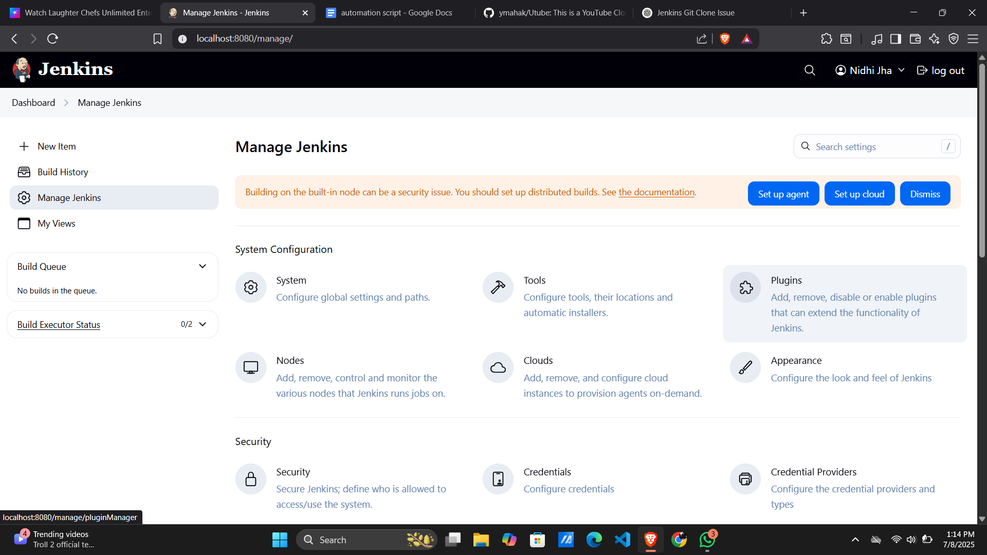

2. Create a Jenkins Pipeline Job
- Go to Jenkins Dashboard → New Item → Create a job.
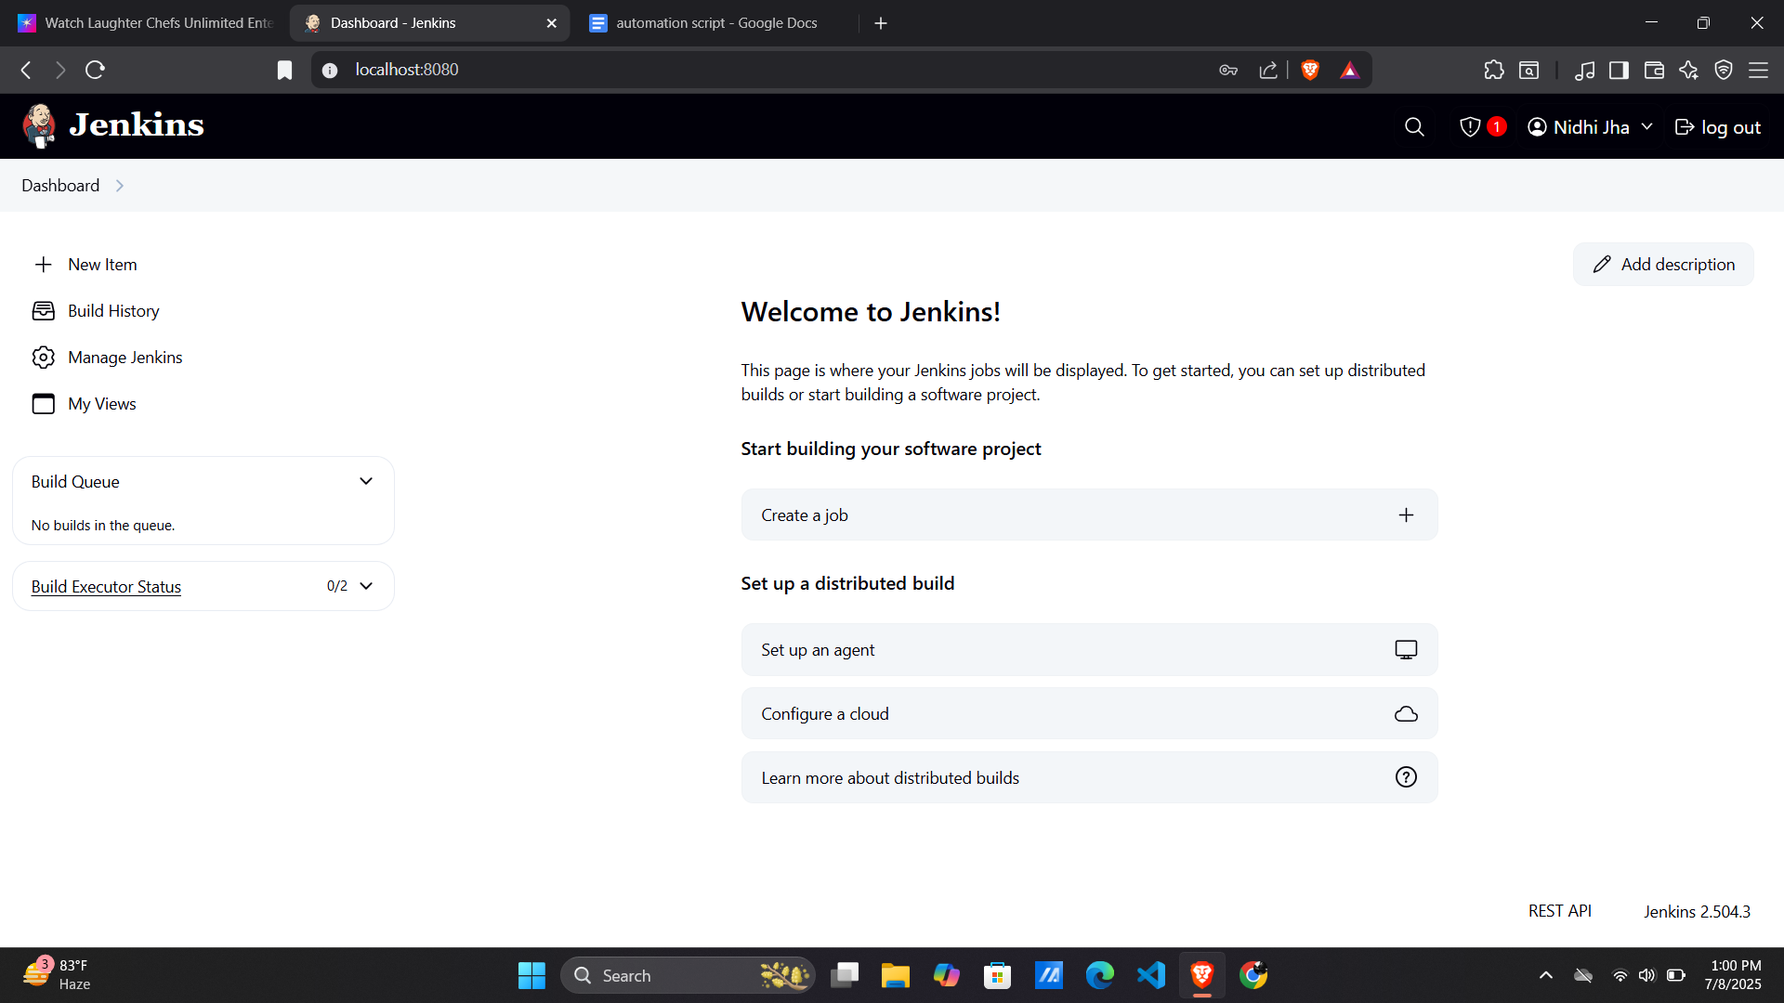
- Enter your job name → (Testing).
- Select Pipeline → Click OK.
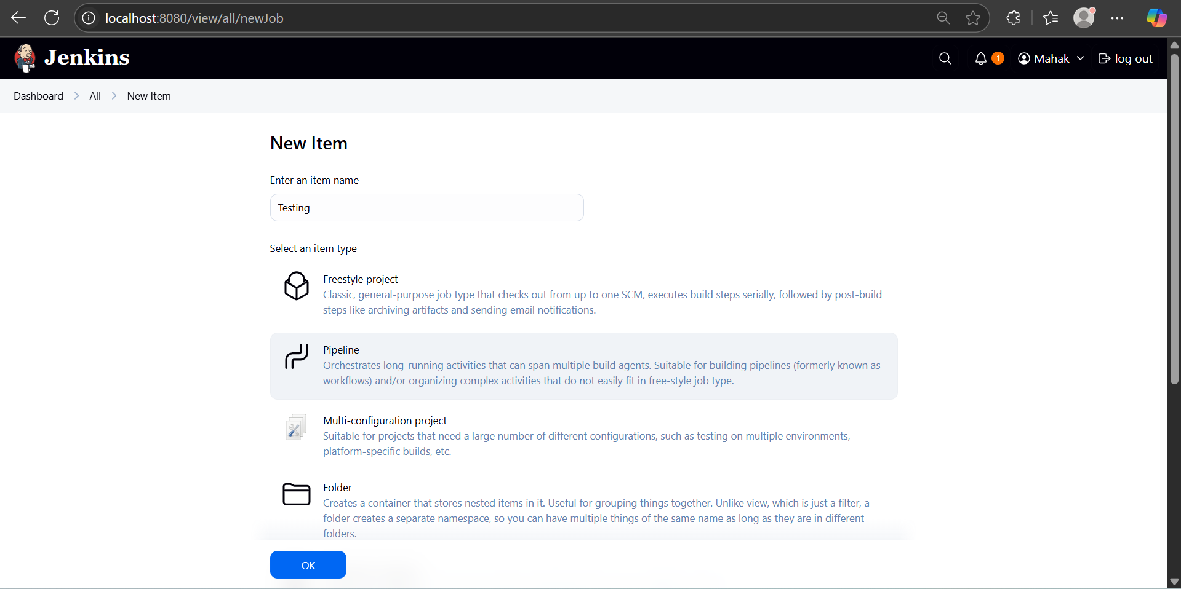

After this , the configuration page will come.
But before configuration, let’s first configure the Node.js application.

3. Configure Node.js Application with Automated Tests

Install Jest & JUnit Reporter :
  - npm install --save-dev jest jest-junit
- Add Scripts in package.json:
"scripts": {
"test": "jest --ci --reporters=default --reporters=jest-junit"
}
- Run Tests Using npm
  - npm test
Output:
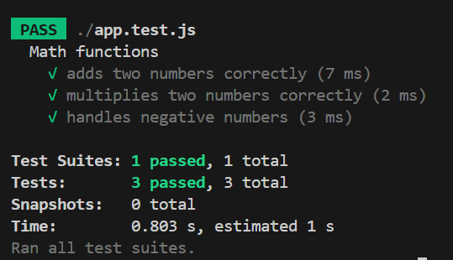

- Configure JenkinsFile in Nodejs Project:
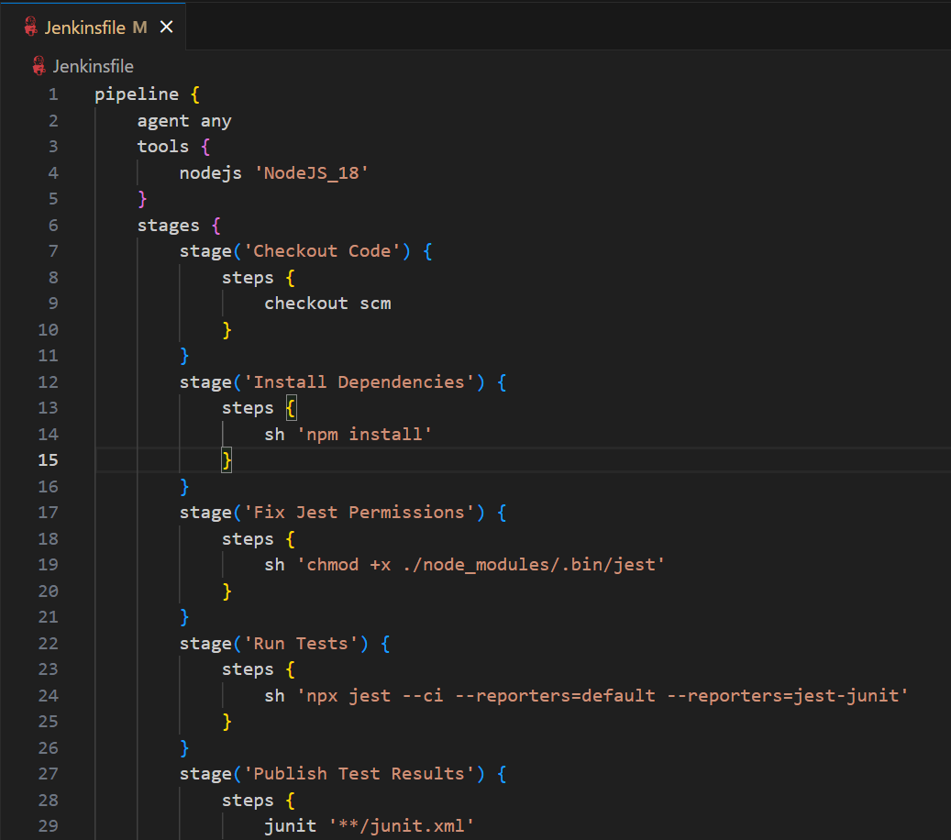
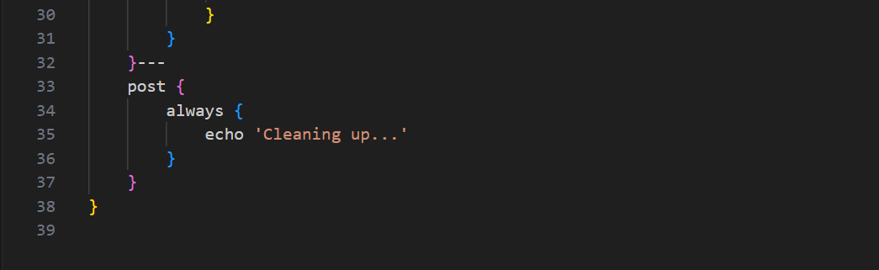

4: Configure GitHub Repository in the Pipeline

If you're storing the Jenkinsfile in your repository, follow the following steps:

Under Pipeline → Definition → Pipeline script from SCM:

Choose Git

Enter your GitHub URL

Add credentials if private

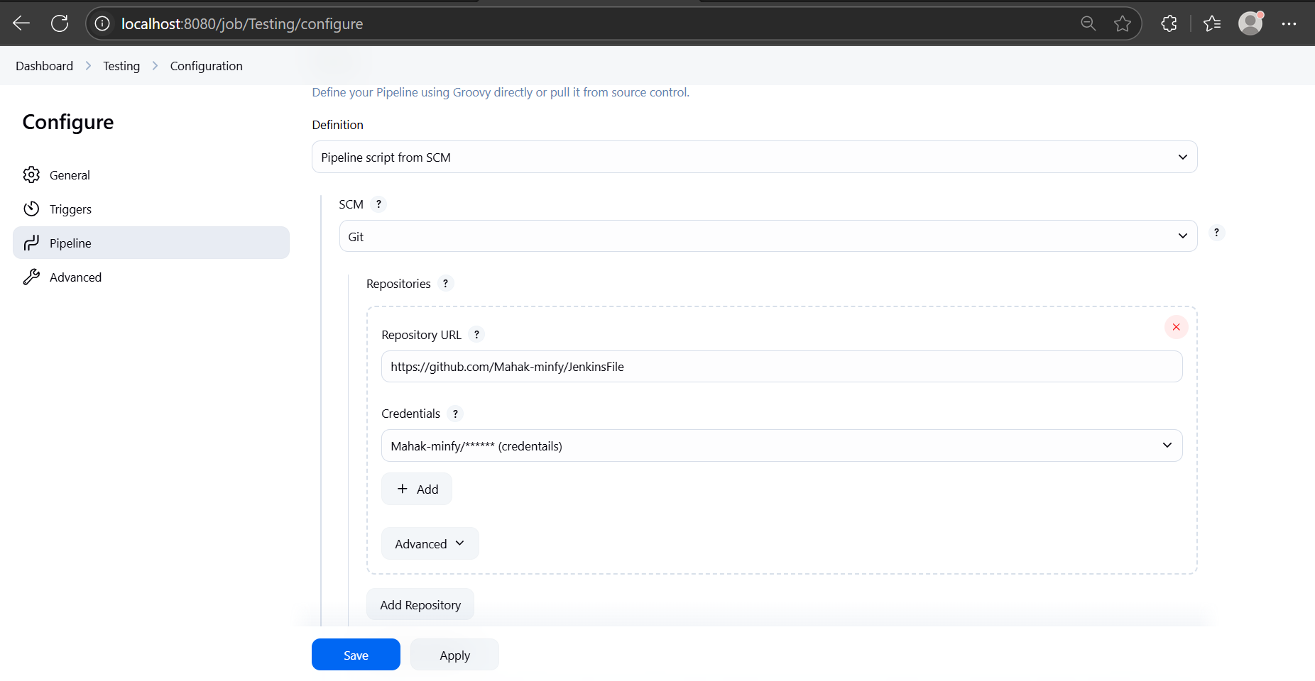

Set the branch (e.g., main)

Script Path: Jenkinsfile.

5. Save & Run the Pipeline
- Click Apply & Save.
- Hit Build Now to test.
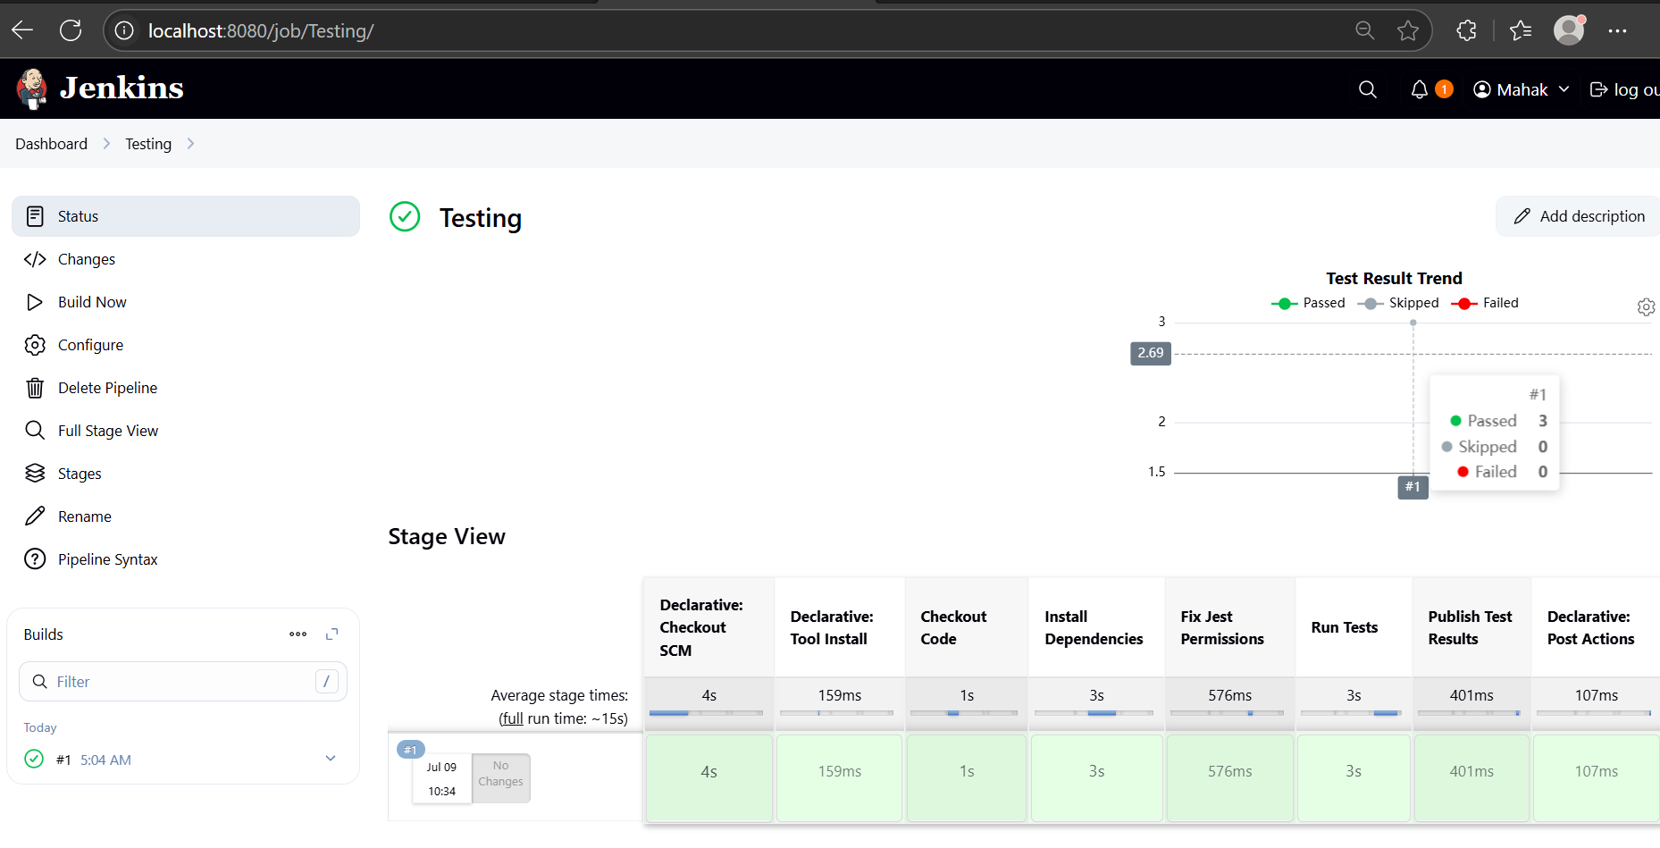
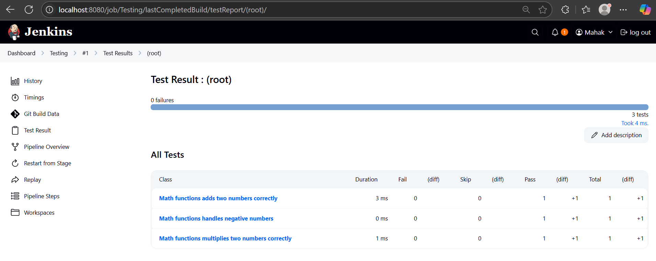

- All tests passed successfully without any failures during automated testing using Jest and JUnit.

- View logs in Console Output.

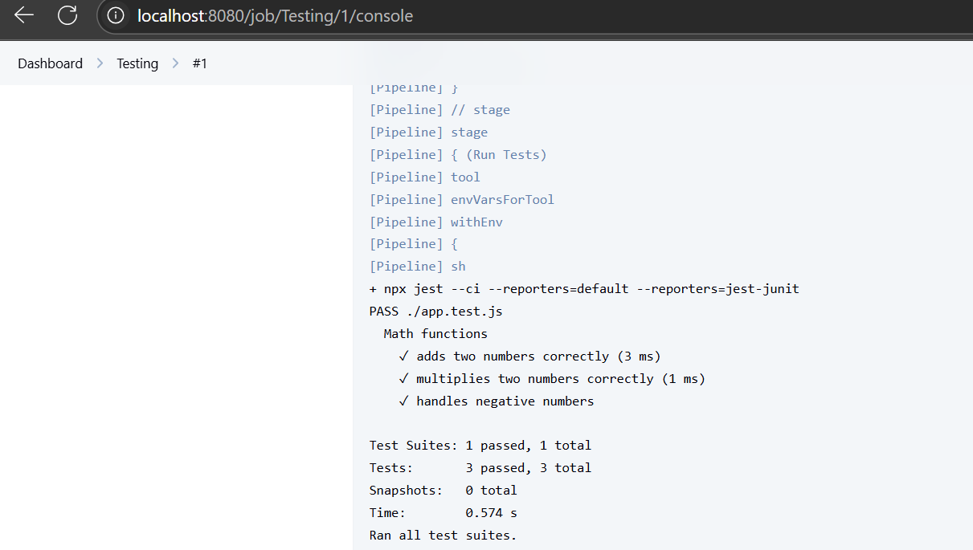

Conclusion:
This script automates manual testing steps.
This Jenkinsfile automates these tasks:
- Checkout: Automatically pulls the latest code from my Git repository.
- Install Dependencies: Runs npm install to install Node.js dependencies.
- Run Automated Tests: Executes npm test to run automated test cases using the Jest framework.
- Publish Test Results: Collects and publishes the test results in Jenkins using the JUnit plugin.
- Clean Up: Performs post-test cleanup actions.

